Lesson 21
Objective: Draw and identify varied two-dimensional figures from given attributes.

Suggested Lesson Structure
 Fluency Practice (12 minutes)
 Concept Development (38 minutes)
 Student Debrief (10 minutes)
Total Time (60 minutes)
Fluency Practice (12 minutes)
- Sprint: Divide by Multiples of 10 and 100 5.NBT.2 (8 minutes)
- Find the Volume 5.MD.5 (4 minutes)
Sprint: Divide by Multiples of 10 and 100 (8 minutes)
Materials: (S) Divide by Multiples of 10 and 100 Sprint
Note: This fluency activity reviews Module 2.
Find the Volume (4 minutes)
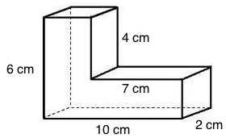
Materials: (S) Personal white board
Note: This fluency activity reviews Topic B.
T: Say the formula for finding the volume of a rectangular prism.
S: Length times width times height.
T: (Project a figure as shown to the right.) Visualize a line that breaks the figure into two rectangular prisms.
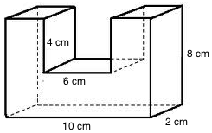
T: Find the volume of the composite figure by adding the volumes of each rectangular prism.
2 cm
S: (Write 6 cm × 3 cm × 2 cm = 36 cubic cm.
7 cm × 2 cm × 2 cm = 28 cubic cm.
36 cubic cm + 28 cubic cm = 64 cubic cm.)
Allow early finishers to continue on to the next figure.
Concept Development (38 minutes)
Materials: (S) Task cards, 6 for each pair of students (Templates 1–4), ruler, set square, protractor, Problem Set (or blank paper)
Note: The drawing tasks in the Concept Development are time-consuming. In order to give students ample time, no Application Problem is included in today’s lesson.
Note: Today’s Concept Development asks students to apply the nested relationships among quadrilaterals that have been explored throughout this topic. It should be conducted following a protocol similar to that of a problem-solving lesson involving word problems. Allow students to wrestle with the drawing tasks and then share the work during the Student Debrief. Allow students to redraw, as necessary, after the Student Debrief discussion. Task cards (24 per set) should be copied in sufficient quantity that pairs of students can share six cards.
T: (Project on the board: Draw a quadrilateral that has two pairs of equal sides. Tell as many names as you can for this shape. Circle the most specific name.) What shape could you draw to satisfy the attributes of this task? Turn and talk. Then, draw your shape.
S: I could draw a parallelogram. It has two pairs of equal sides. A rectangle would work because it has two pairs of equal sides. It says “two pairs of equal sides.” I would draw a square. It has two sets of equal sides. The two sets also happen to be equal to each other. A rhombus would work, too, because it is like a square. It has two sets of equal sides. I could draw a kite. It has two pairs of equal sides. The sides that are equal are just next to each other rather than across from each other.
MP.3
T: Compare your shape with your neighbor’s. Did we all draw the same shape? Is there only one shape that would be correct for this task?

 | NOTES ON  MULTIPLE MEANS  OF ENGAGEMENT:
The task cards for today’s lesson are numbered from simplest to most complex. Differentiate instruction by assigning tasks based on student need.
S: (Share work with partner.)
T: This is the shape I drew. (Project a rectangle.)
Name this shape.
S: Rectangle. Parallelogram. Quadrilateral.
Polygon. Trapezoid.
T: (Record student responses.) Which of the names we listed is the most specific?

 | NOTES ON  MULTIPLE MEANS  OF ENGAGEMENT:
The relationships between sides and angles in quadrilaterals can serve as an interesting extension. Students can explore the effects of changing side lengths on angle size, and vice versa, with online tools like Interactive Quadrilaterals at: http://www.mathsisfun.com/geometry/quadrilaterals-interactive.html.
S: Rectangle.
T: (Circle rectangle on the board.) Is there a quadrilateral that we should not construct for this task? Why not?
S: A trapezoid that is not a parallelogram because it would not have two pairs of equal sides. An isosceles trapezoid would not work for this task because there would only be one set of equal sides.

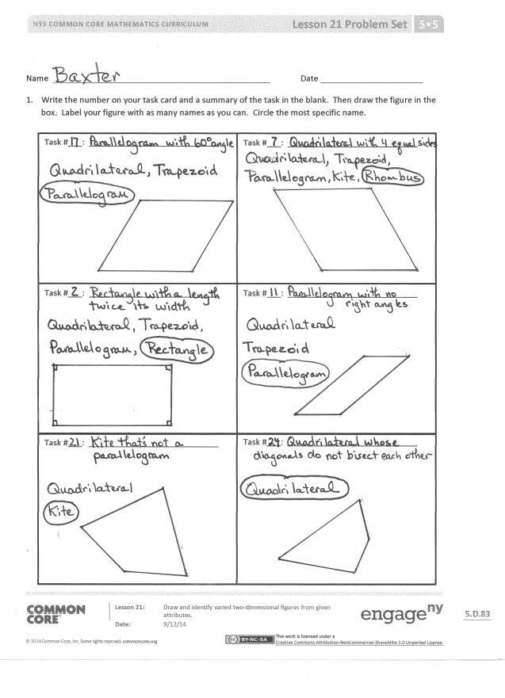
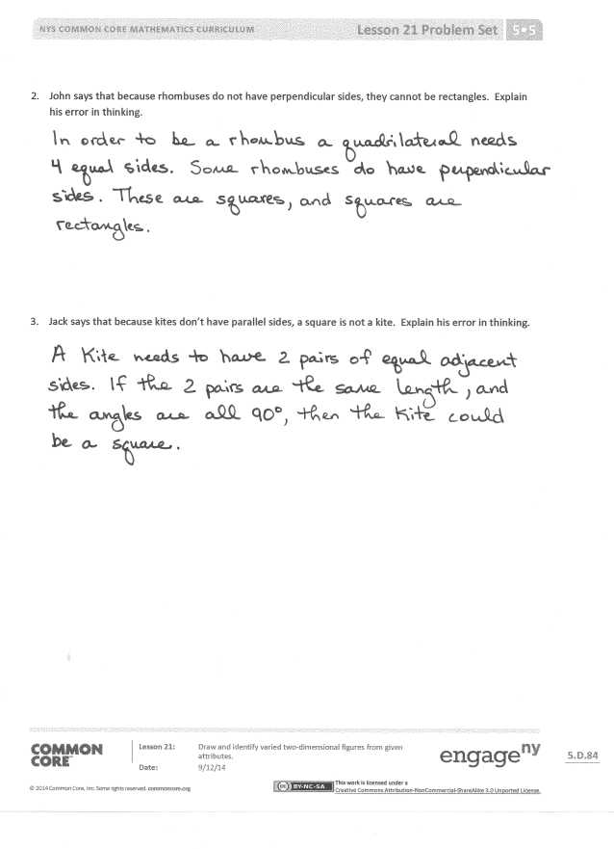
T: Pull six task cards from the envelope on your table. Record the number of the task and a brief summary of the task in the boxes on your Problem Set. Follow the directions on the cards to draw the shapes in the boxes.
S: (Work.)
The Problem Set serves as a recording sheet for the drawings in the lesson. Time should be given for students to share their approaches to constructing the figures on the task cards.
Student Debrief (10 minutes)
Lesson Objective: Draw and identify varied two-dimensional figures from given attributes.
The Student Debrief is intended to invite reflection and active processing of the total lesson experience.
Invite students to review their solutions for the Problem Set. They should check work by comparing answers with a partner before going over answers as a class. Look for misconceptions or misunderstandings that can be addressed in the Debrief. Guide students in a conversation to debrief the Problem Set and process the lesson.
Any combination of the questions below may be used to lead the discussion.
- Find someone who completed two of the same tasks you did. Compare the shapes that you drew. Must they be the same shape to correctly follow the directions on the card? Why or why not?
- Which tasks produced quadrilaterals with the same specific name on everyone’s Problem Set? Which tasks produced the most varied quadrilaterals?
- Choose three of your quadrilaterals, and paste them in the correct part of the hierarchy diagram. Explain why they belong there.
- Explain to your partner how you corrected John’s error in Problem 2.

- What part of a kite’s definition did Jack not understand in Problem 3? How did you correct his thinking?
- How do all the shapes that were drawn today fit the definition of a quadrilateral?
Exit Ticket (3 minutes)
After the Student Debrief, instruct students to complete the Exit Ticket. A review of their work will help with assessing students’ understanding of the concepts that were presented in today’s lesson and planning more effectively for future lessons. The questions may be read aloud to the students.

A
Number Correct: _______
Divide by Multiples of 10 and 100
 | 30 ÷ 10 = |  |  |  | 480 ÷ 4 =
 | 430 ÷ 10 = |  |  |  | 480 ÷ 40 =
 | 4,300 ÷ 10 = |  |  |  | 6,300 ÷ 3 =
 | 4,300 ÷ 100 = |  |  |  | 6,300 ÷ 30 =
 | 43,000 ÷ 100 = |  |  |  | 6,300 ÷ 300 =
 | 50 ÷ 10 = |  |  |  | 8,400 ÷ 2 =
 | 850 ÷ 10 = |  |  |  | 8,400 ÷ 20 =
 | 8,500 ÷ 10 = |  |  |  | 8,400 ÷ 200 =
 | 8,500 ÷ 100 = |  |  |  | 96,000 ÷ 3 =
 | 85,000 ÷ 100 = |  |  |  | 96,000 ÷ 300 =
 | 600 ÷ 10 = |  |  |  | 96,000 ÷ 30 =
 | 60 ÷ 3 = |  |  |  | 900 ÷ 30 =
 | 600 ÷ 30 = |  |  |  | 1,200 ÷ 30 =
 | 4,000 ÷ 100 = |  |  |  | 1,290 ÷ 30 =
 | 40 ÷ 2 = |  |  |  | 1,800 ÷ 300 =
 | 4,000 ÷ 200 = |  |  |  | 8,000 ÷ 200 =
 | 240 ÷ 10 = |  |  |  | 12,000 ÷ 200 =
 | 24 ÷ 2 = |  |  |  | 12,800 ÷ 200 =
 | 240 ÷ 20 = |  |  |  | 2,240 ÷ 70 =
 | 3,600 ÷ 100 = |  |  |  | 18,400 ÷ 800 =
 | 36 ÷ 3 = |  |  |  | 21,600 ÷ 90 =
 | 3,600 ÷ 300 = |  |  |  | 25,200 ÷ 600 =
B
[KEY]

Number Correct: _______
Improvement: _______
Divide by Multiples of 10 and 100
 | 20 ÷ 10 = |  |  |  | 840 ÷ 4 =
 | 420 ÷ 10 = |  |  |  | 840 ÷ 40 =
 | 4,200 ÷ 10 = |  |  |  | 3,600 ÷ 3 =
 | 4,200 ÷ 100 = |  |  |  | 3,600 ÷ 30 =
 | 42,000 ÷ 100 = |  |  |  | 3,600 ÷ 300 =
 | 40 ÷ 10 = |  |  |  | 4,800 ÷ 2 =
 | 840 ÷ 10 = |  |  |  | 4,800 ÷ 20 =
 | 8,400 ÷ 10 = |  |  |  | 4,800 ÷ 200 =
 | 8,400 ÷ 100 = |  |  |  | 69,000 ÷ 3 =
 | 84,000 ÷ 100 = |  |  |  | 69,000 ÷ 300 =
 | 900 ÷ 10 = |  |  |  | 69,000 ÷ 30 =
 | 90 ÷ 3 = |  |  |  | 800 ÷ 40 =
 | 900 ÷ 30 = |  |  |  | 1,200 ÷ 40 =
 | 6,000 ÷ 100 = |  |  |  | 1,280 ÷ 40 =
 | 60 ÷ 2 = |  |  |  | 1,600 ÷ 400 =
 | 6,000 ÷ 200 = |  |  |  | 8,000 ÷ 200 =
 | 240 ÷ 10 = |  |  |  | 14,000 ÷ 200 =
 | 24 ÷ 2 = |  |  |  | 14,600 ÷ 200 =
 | 240 ÷ 20 = |  |  |  | 2,560 ÷ 80 =
 | 6,300 ÷ 100 = |  |  |  | 16,100 ÷ 700 =
 | 63 ÷ 3 = |  |  |  | 14,400 ÷ 60 =
 | 6,300 ÷ 300 = |  |  |  | 37,800 ÷ 900 =

Name Date
- Write the number on your task card and a summary of the task in the blank. Then, draw the figure in the box. Label your figure with as many names as you can. Circle the most specific name.
Task #___: ____________________________
Task #___: ____________________________
Task #___: ____________________________
Task #___: ____________________________
Task #___: ____________________________
Task #___: ____________________________

- John says that because rhombuses do not have perpendicular sides, they cannot be rectangles. Explain his error in thinking.

- Jack says that because kites do not have parallel sides, a square is not a kite. Explain his error in thinking.

Name Date
- Use the word bank to fill in the blanks.
trapezoids parallelograms

All are , but not all are .

kites rhombuses
- Use the word bank to fill in the blanks.

All are , but not all are .

Name Date
- Answer the questions by checking the box.
Sometimes Always
  - Is a square a rectangle?
- Is a rectangle a kite?
- Is a rectangle a parallelogram?
- Is a square a trapezoid?
- Is a parallelogram a trapezoid?
- Is a trapezoid a parallelogram?
- Is a kite a parallelogram?
- For each statement that you answered with sometimes, draw and label an example that justifies your answer.

- Use what you know about quadrilaterals to answer each question below.

  - Explain when a trapezoid is not a parallelogram. Sketch an example.

  - Explain when a kite is not a parallelogram. Sketch an example.

task cards (1–6)
task cards (7–12)
task cards (13–18)
task cards (19–24)

