<https://www.tinkercad.com/things/7XpqwPmR0yH-neat-hillar/editel?tenant=circuits>

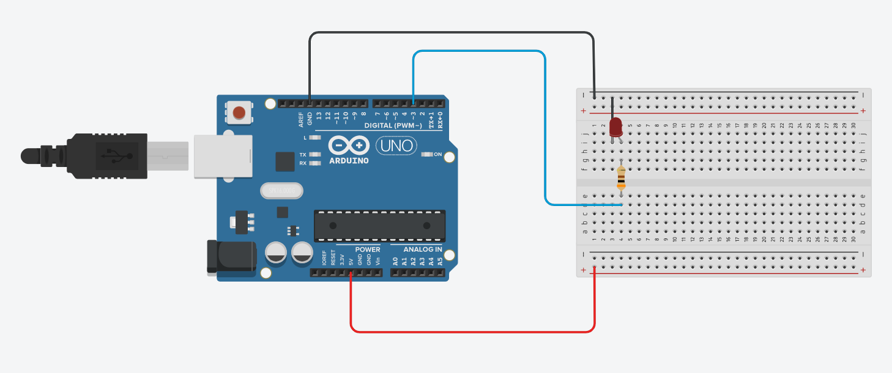

//

void setup()

{

pinMode(LED_BUILTIN, OUTPUT);

pinMode(3, OUTPUT);

digitalWrite(LED_BUILTIN, LOW);

analogWrite(3, 0);

}

void loop()

{

digitalWrite(LED_BUILTIN, HIGH);

analogWrite(3, 1);

delay(1000); // Wait for 1000 millisecond(s)

analogWrite(3, 0);

digitalWrite(LED_BUILTIN, LOW);

delay(1000); // Wait for 1000 millisecond(s)

}