Use Case And Class Diagrams
Popcorn team
Qian Chenxiong
2011/7/1

catalogue
1. preliminary use case diagram 3
1.1 role 3
1.2 use case 3
2. class diagram 4
2.1 client class diagram 4
2.1.1 the whole framework 4
2.1.2 entity object 6
2.1.3 barcode scanning 6
2.1.4 scanning result dealing 7
2.2 server class diagram 9
2.2.1 market server 9
2.2.2 bank server 9

preliminary use case diagram
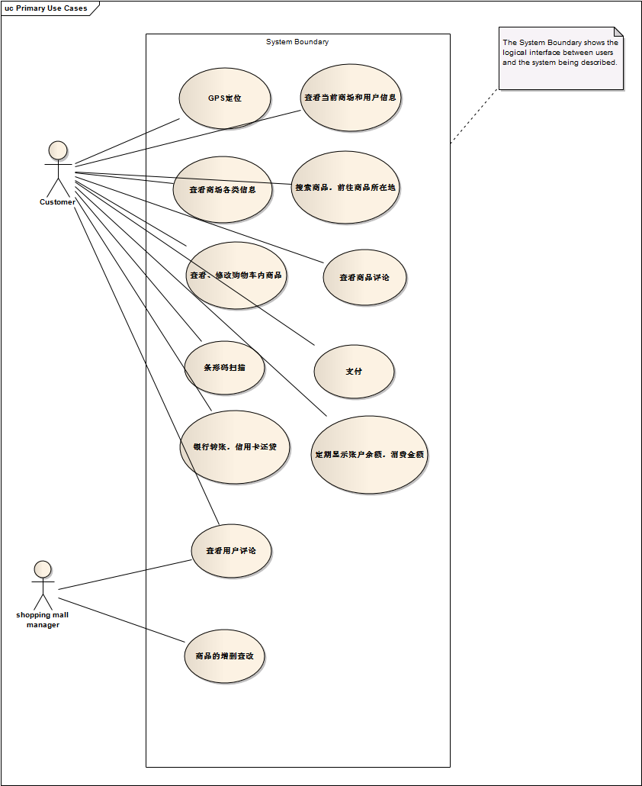

1.1 role
- customer
- market manager

1.2 use case
- customer：
- search market by GPS
- look up for market information
- search product information and its location
- look over the product comments
- scan the product barcodes
- add, delete or change products in shopping cart
- pay money
- look up the remaining sum
- market manager：
- look over the customers’ comments
- add, delete or change products

class diagram

client class diagram

the whole framework
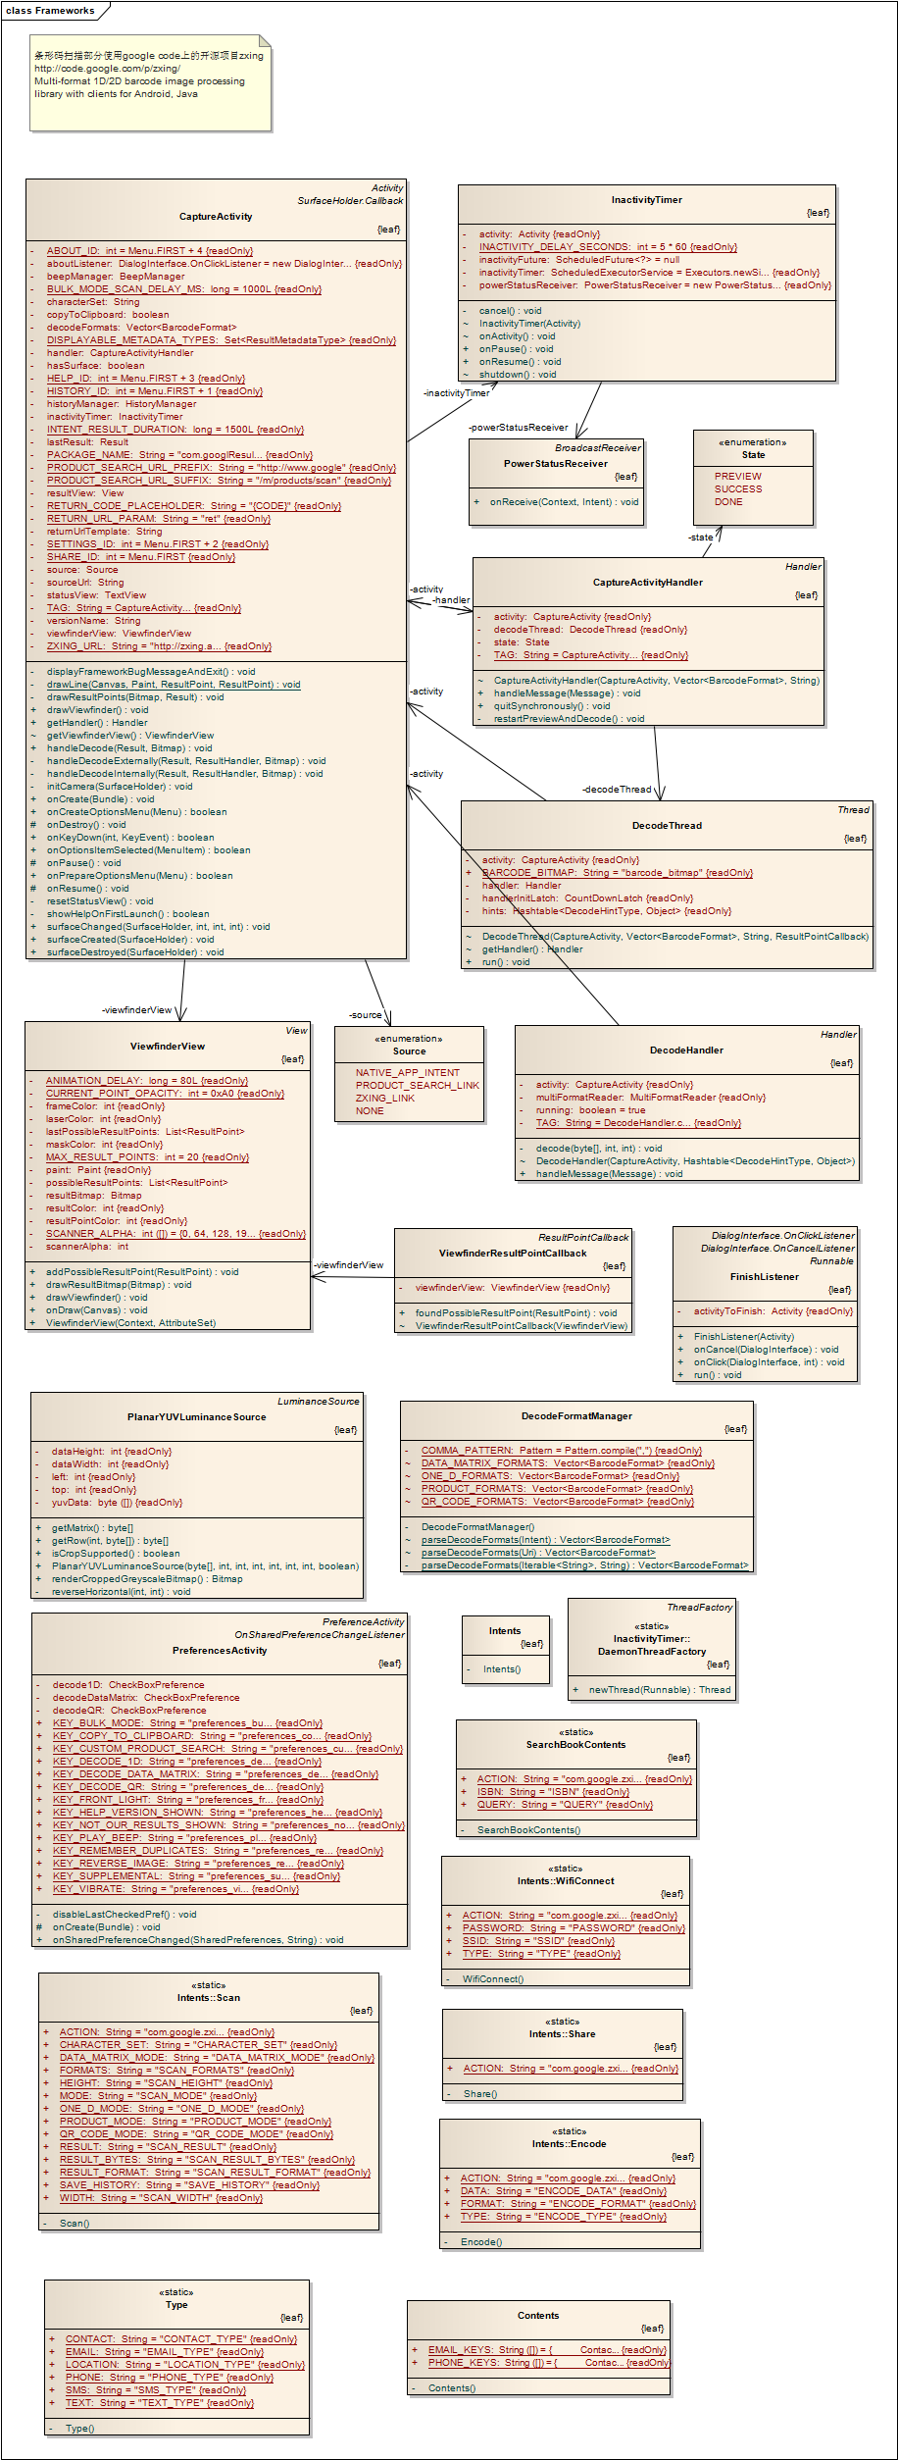

entity object
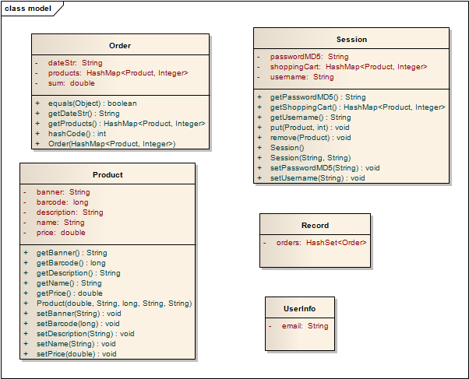

barcode scanning
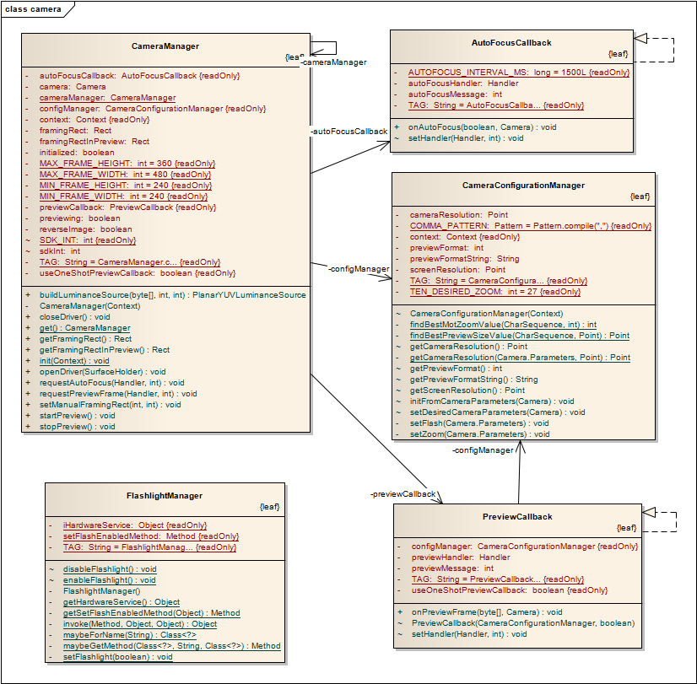

scanning result dealing
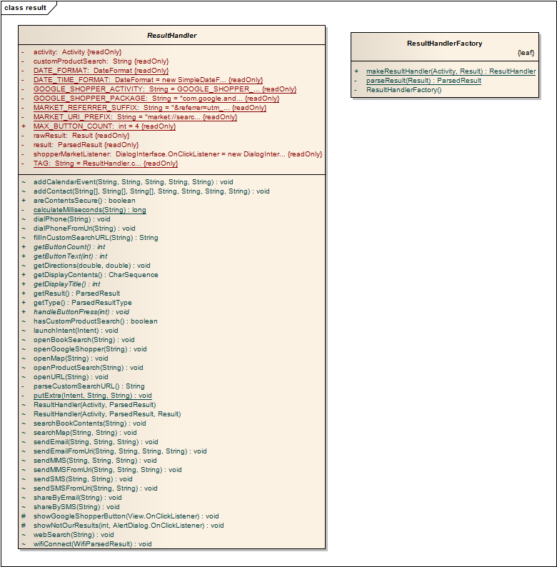
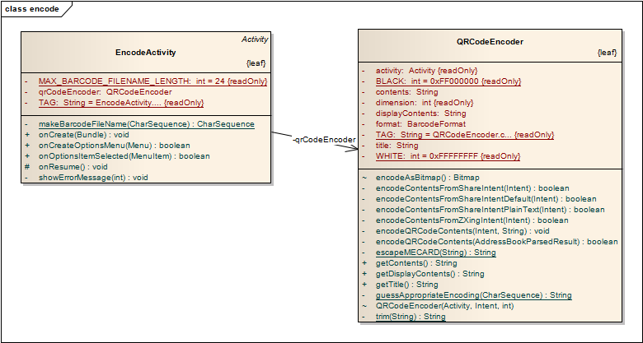

server class diagram

market server
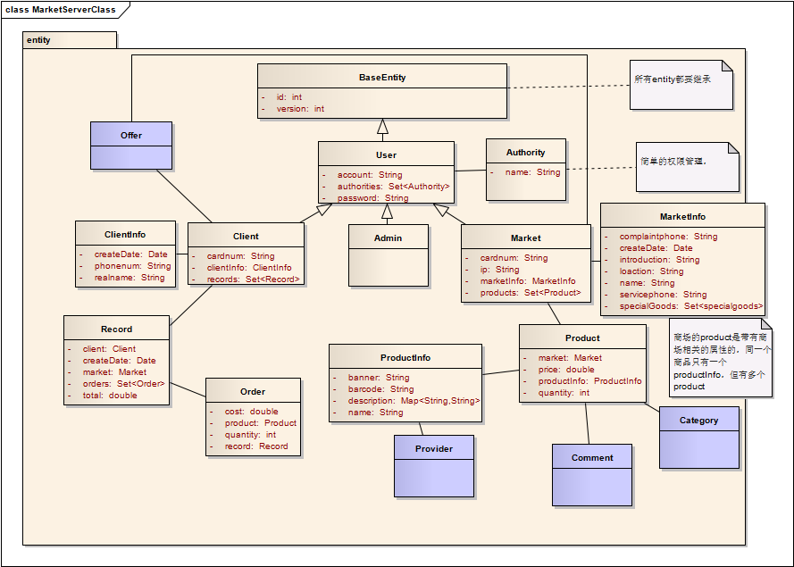

bank server
