# State the applied method(s), technology and the feasibility analysis of the product. (There is no limitation of words)

## 1. Summary

In general, we will combine C/S and B/S architecture in our project. (C/S majors on users who are going to pay for goods with our software and B/S is used by the system administrators to analyze data). The whole architecture will follow the MVC design pattern. Users run the client on their cell phones and backend server system is running on the service provider’s (banks and supermarkets) “Tomcat”. The client is mainly used to access the products’ information, identify the bar code and finish the payment. Besides, the server’s mission is to realize data persistence and offer interfaces for payment and data analysis.

## 2. A brief introduction to business process

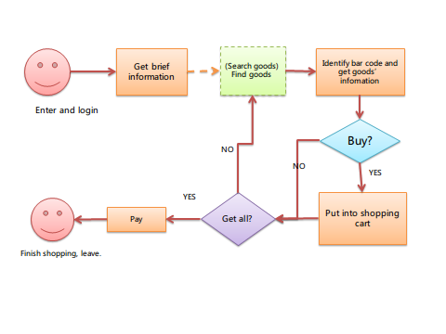

1) User enters the mall and uses the client to login;

2) User receives information about the market;

3) (This step is optional) User searches for goods with the help of client. As a result, the system sends a response if specific goods exist.

4) User finds goods and identifies the bar code of it. The system offers information such as producer, price, production date and so on. Besides, our software is going to provide other users comments on the goods.

5) User puts goods into shopping cart. Go back to step 3 until he get all things he want to buy.

6) User pays for goods with client.

7) User leaves the mall.

## 3. The applied method(s) and technology

**1) Client on cell phone**

According to the business process, client is the only part that interacts with users. Client provide goods information, bar-code identification and payment for users. Here we choose Android to be the operating system our client based on. (We may have an iOS version someday.) The following technology may be used:

a. Basic widgets on Android;

b. Bar-code identification: Camera module, open source Java library ZXing;

c. Network: JSON, https, MD5 encode;

d. Local cache: SQLite;

**2) Server administration panel**

Administrators in banks and markets can use browser to access server. Here we provide them with a web GUI of CRUD (Create, Read, Update and Delete) functions of some data (for example, account information, goods information).

Bank: Transaction records, accounts information and statistics;

Market: products’ information, detailed records of every payment, statistics;

Technology to be implemented:

a. JavaScript library: jQuery.

**3) Server**

Server majors on business logic processing and data persistence. The server program runs on a Tomcat server. It accepts client requests including cell phone client and browser and return messages in response.

Bank: payment processing, account management.

Market: according to users’ input, providing the specific information; providing goods management and account management.

Technology implemented:

a. J2EE Spring 3.x

b. MySql

c. Hibernate

**4. Network**

a. Protocol: HTTP

b. Data form: JSON

c. Security consideration: https and MD5 encode

## 4. the feasibility analysis

**Members and skills:**

All members of the group are well skilled. We have a good understanding of software engineering. Most of us manage Java well and have experience of Android and J2EE development. Although, there may be some difficulties on our road to success, we will overcome them through learning more and helping each other.

**Time**

This project was launched in May 2011. We’ve got our idea fixed and finished basic requirements analysis. Now, July 2011, we start to design. There will be two months for us to produce our software, so we have ample time.

**Technology Conditions**

*1) Cell Phone Client*

a. Android development is now becoming more and more popular. There are thousands of resources that we can refer to. What’s more, Android is an open source system which gives our more freedom. Also, Android does well with Google’s service such as Google Map, Gmail.

b. Bar-code identification has been implemented on Android. There is an open source Java library ZXing we can use. This helps us save a lot of energy.

c. Most Android devices have a good performance.

*2) Server Administration Panel*

a. jQuery is a fast and concise JavaScript Library that simplifies HTML document traversing, event handling, animating, and Ajax interactions for rapid web development. jQuery is designed to change the way that you write JavaScript.

b. jQuery has lots of documentations and many plugins.

*3) Server*

a. The core features of the Spring Framework can be used by any Java application, but there are extensions for building web applications on top of the Java EE platform. Although the Spring Framework does not impose any specific programming model, it has become popular in the Java community as an alternative to, replacement for, or even addition to the Enterprise JavaBean (EJB) model.

b. Hibernate is an object-relational mapping (ORM) library for the Java language, providing a framework for mapping an object-oriented domain model to a traditional relational database. Hibernate solves object-relational impedance mismatch problems by replacing direct persistence-related database accesses with high-level object handling functions.

c. The MySQL database has become the world's most popular open source database because of its high performance, high reliability and ease of use. It is also the database of choice for a new generation of applications built on the LAMP stack.

*4) Network*

Nowadays, most ISPs offer a better network than before. 3G mobile is a good choice. Besides, Wi-Fi covers more places. Therefore the implementation of our system is quite feasible.