|  |
| --- |
| **Use Case And Class Diagrams** |
|  |
|  |
| Popcorn team |
|  |
| **Qian Chenxiong** |
| **2011/7/1** |
|  |

catalogue

1. preliminary use case diagram 3

1.1 role 3

1.2 use case 4

2. class diagram 4

2.1 client class diagram 4

2.1.1 the whole framework 4

2.1.2 entity object 6

2.1.3 barcode scanning 6

2.1.4 scanning result dealing 7

2.1.5 UI BASE CLASS 9

2.1.6 UI COMPONENT 9

2.1.7 Asynchronous task component 10

2.2 server class diagram 10

2.2.1 market server 10

2.2.2 bank server 11

# preliminary use case diagram

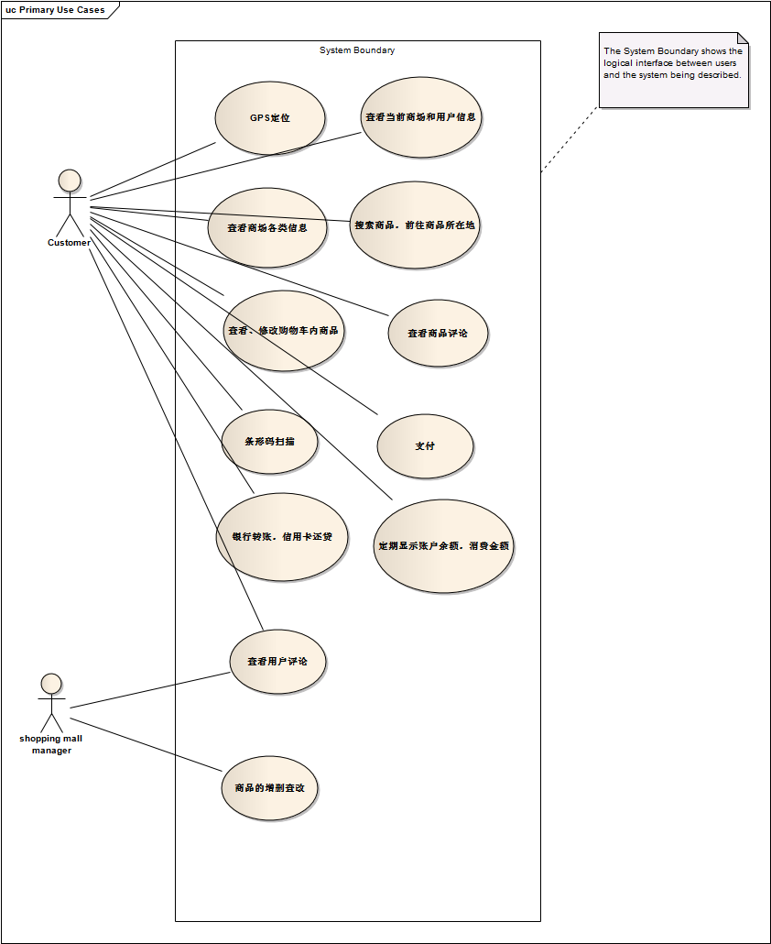

## 1.1 role

* customer
* market manager

## 1.2 use case

* customer：
* search market by GPS
* look up for market information
* search product information and its location
* look over the product comments
* scan the product barcodes
* add, delete or change products in shopping cart
* pay money
* look up the remaining sum
* market manager：
* look over the customers’ comments
* add, delete or change products

# class diagram

## client class diagram

### the whole framework

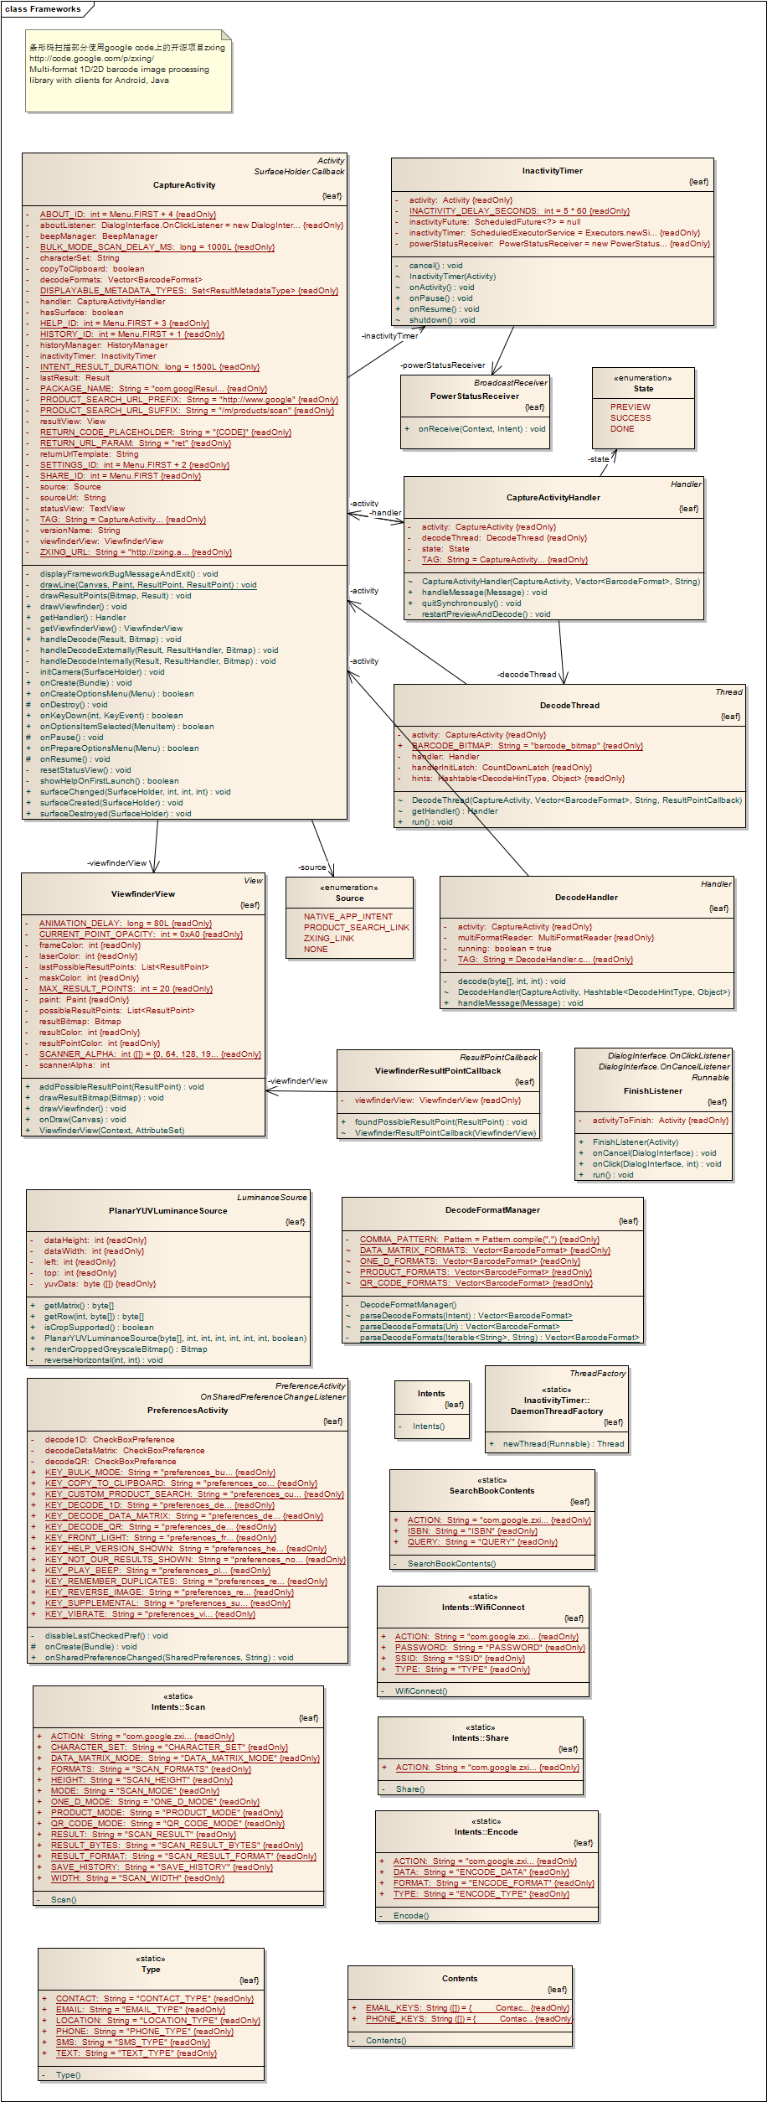

### entity object

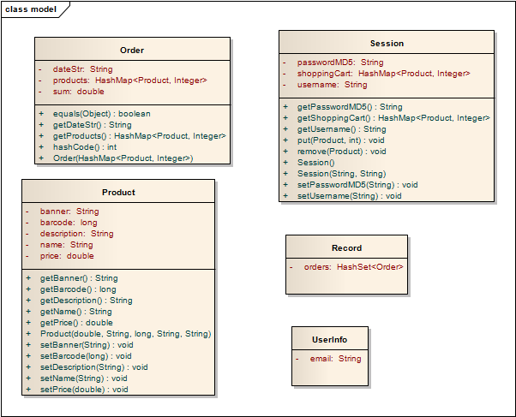

### barcode scanning

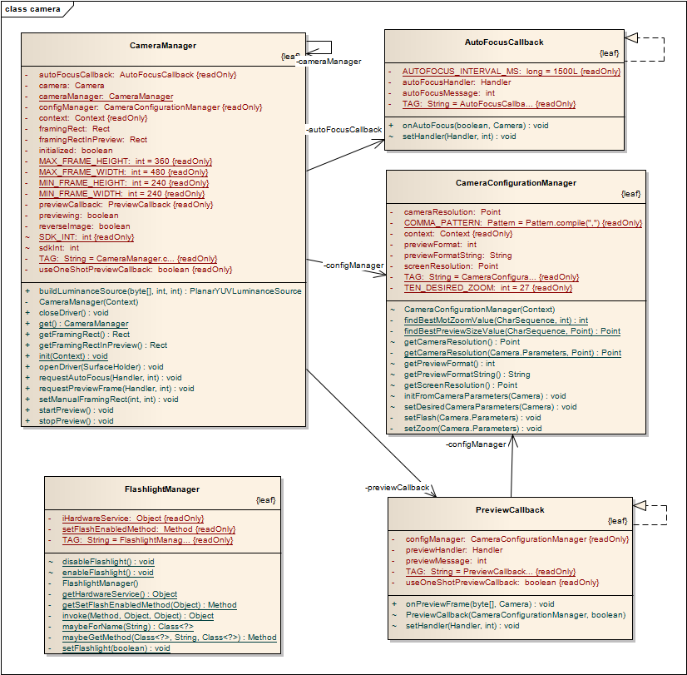

### scanning result dealing

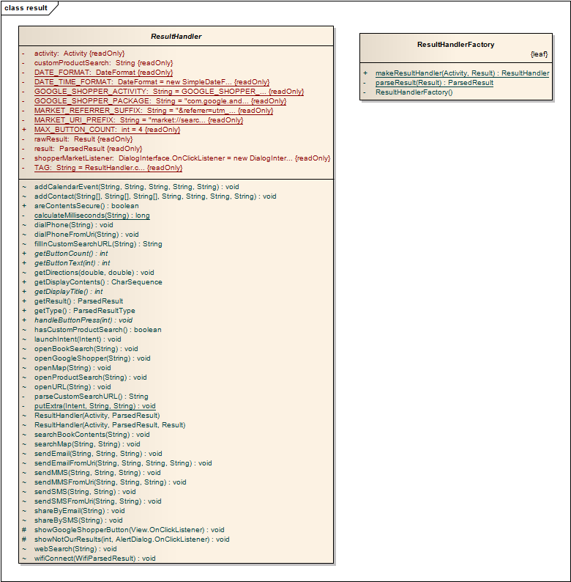

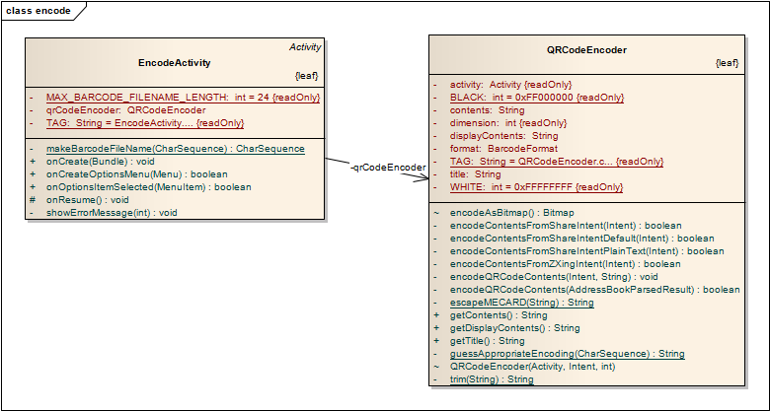

### UI BASE CLASS

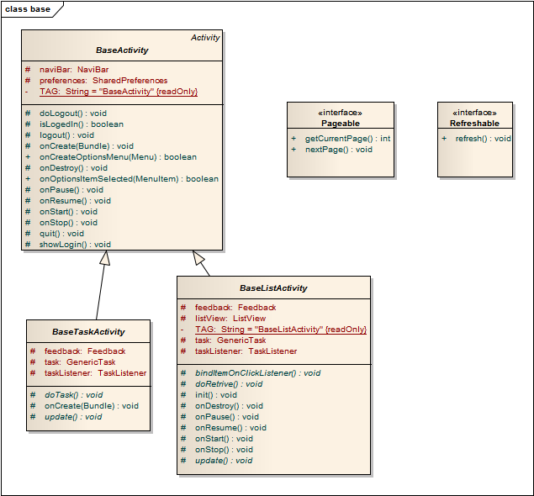

### UI COMPONENT

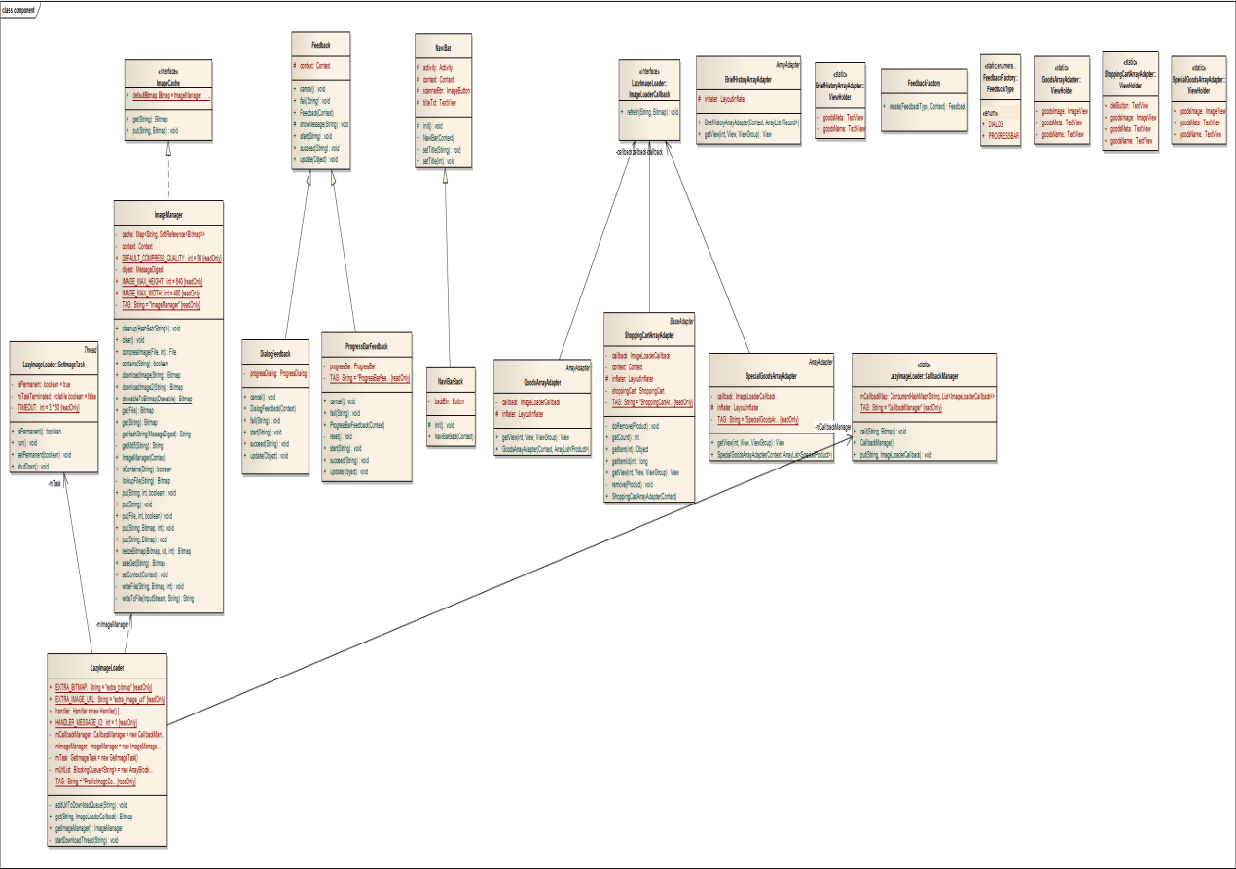

### Asynchronous task component

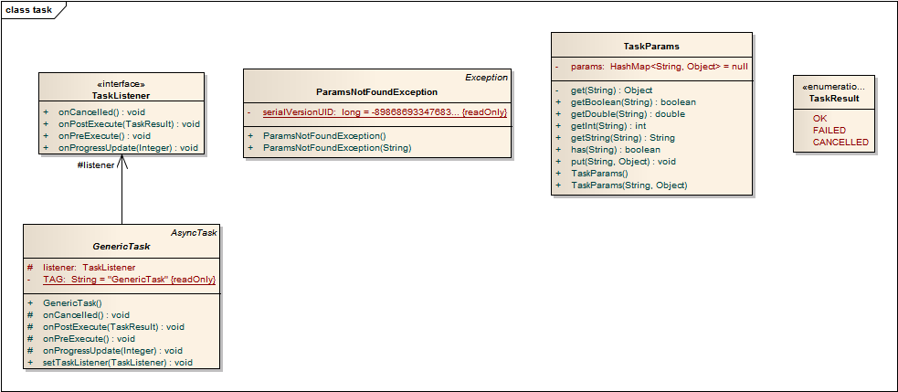

## server class diagram

### market server

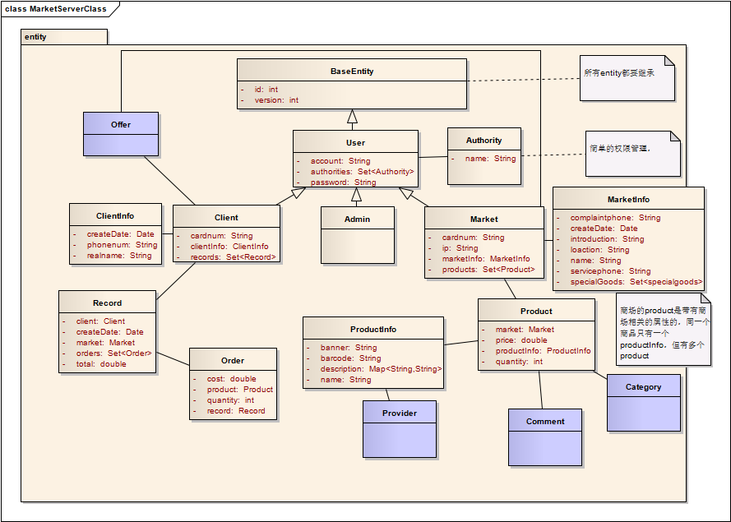

### bank server

