Chapter 7:
21-25: a a a d b
26-30: d c c a a
31-35: a a d c c
36-40: c a d a b
41-45: d a d c b
46.
The monoprogramming requires the whole program is in memory for execution till it is finished. Apparently, the answer is 64MB-4MB = 60MB.
47.
64MB-4MB-10MB=50MB
48. As a monoprogramming operating system, a running program occupies the memory till it is finished. Thus the CPU is idle even when the running programming is accessing I/O devices.
The percentage of time is the CPU idle is 70/(70+10) * 100% = 87.5%
49.
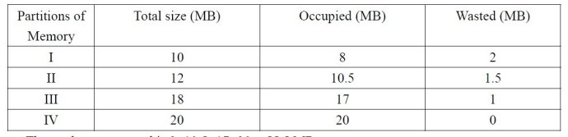
The total memory used is 8+10.5+17+20 = 55.5 MB
The total memory wasted is 2+1.5+1+0 = 4.5 MB
The percentage of memory is wasted is 4.5/60 *100% = 7.5%
50
The total memory wasted is 2+8+10=20MB
The percentage of memory is wasted is 20/60*100%=33%
51. a. The first program uses 4 pages.
b. The second program uses 3 pages.
c. The third program uses 7 pages.
d. 1 page is not used.
e. Total memory wasted is 3+0+1+4=8MB.
f. The percentage of memory wasted is 8/60*100%=13%
52. Total memory = 1000 + 100 = 1100 MB. Number of program = 1100 / 10 = 110.
10 programs can be in memory and 100 programs must be on disk.
53. running, ready, ready, waiting, waiting.
54. 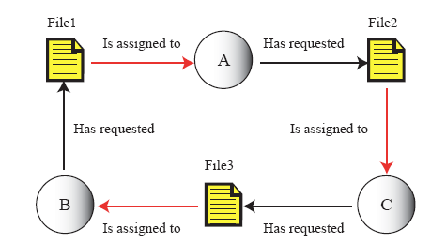
The necessary conditions for deadlock are mutual exclusion, resource holding, no preemption, and circular waiting. From the relationship among A, B, C and file 1, file 2, and file 3, there is a circle along the requesting and assigning arrows. Thus deadlock exists.
55. 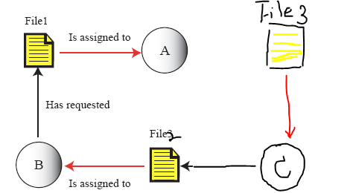
File1 will be assigned to B after A is finished. File 2 will be assigned to C after B is finished. And when C gets file 2, it can be run and finished.

