Chapter 5:
39-40: a b
41-45: a d d d c
46-50: a ba c d
51-55: b a c b d
56-60: d a b c b
61-65: b d c b d
66-70: c d d c c
71-75: a c b c b
76-77: a c
计算机的硬件
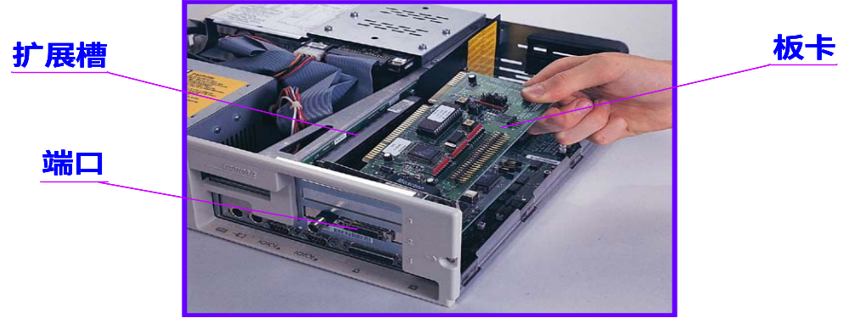
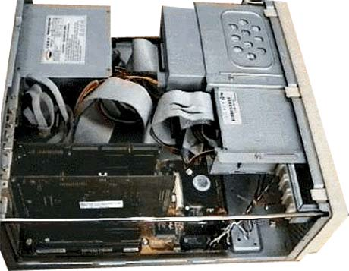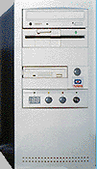

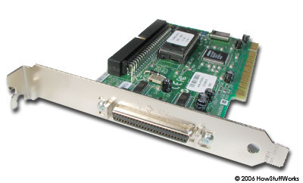SCSI
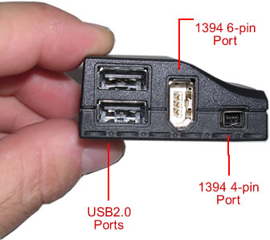
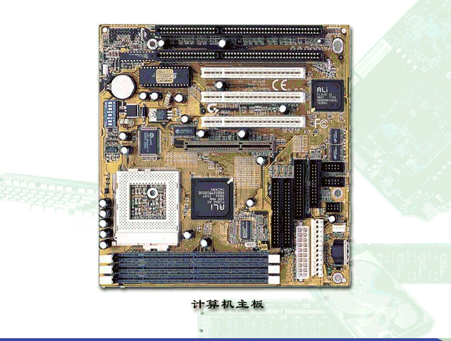
78.
Because each word is 4 bytes, 64MB (megabytes) is 16 mega words, i.e. 2²⁴ words.
24 bit is needed to address each single word in memory.
79.
ASCII is used to represent a character.
Thus, 1 character is 1 byte.
Thus, 24*80 bytes of memory are needed.
80.
The format of the typical instruction used here includes three parts: instruction, memory address, and register.
Assuming data is accessed by word, we know that Log₂¹⁶ is needed for instructions, Log₂¹⁰²⁴ is needed for accessing main memory, and Log₂⁴ is for registers.
Therefore, 4+10+2 = 16 is the minimum size of an instruction.
81. From Exercise 80, we know that 16 bits is used for each instruction. Thus data is also 16 bits in this exercise. The size of each data register is 16 bits.
82. 16 bits.
83. Programs are stored in main memory.
Assuming the memory is accessed by word, the program counter is Log₂¹⁰²⁴=10.
84. For each word is 16 bits, 16 is the size of data bus.
85. Log₂¹⁰²⁴ is used for addressing memory, thus 10 is needed for address bus.
86. There are 16 different instructions, thus the size of control bus is 4.
87. Each controller has 16 registers, so, 2⁴ registers. Total address space is 2¹⁰. Since using isolated U/O addressing, 2¹⁰/2⁴=2⁶ controllers can be accessed.
88. The address bus uses 10 lines which means that it can address 210 = 1024 words. Since the memory is made of 1000 words and the system uses shared (memory-mapped I/O) addressing, 1024 − 1000 = 24 words are available for I/O controllers. If each controller has 4 registers, then 24/4 = 6 controllers can be accessed in this system.

