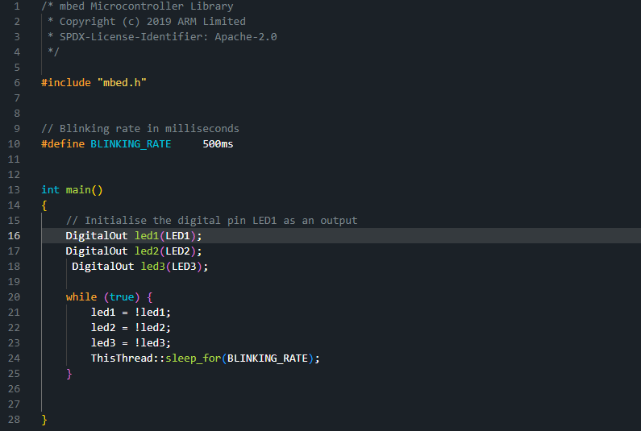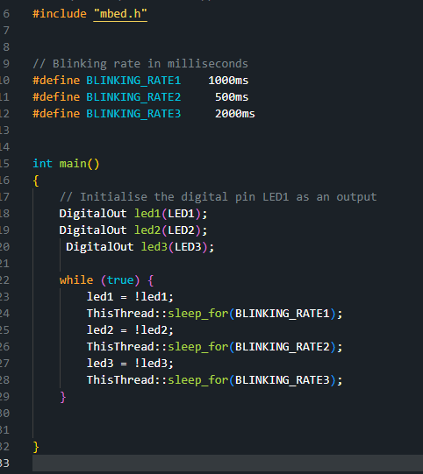

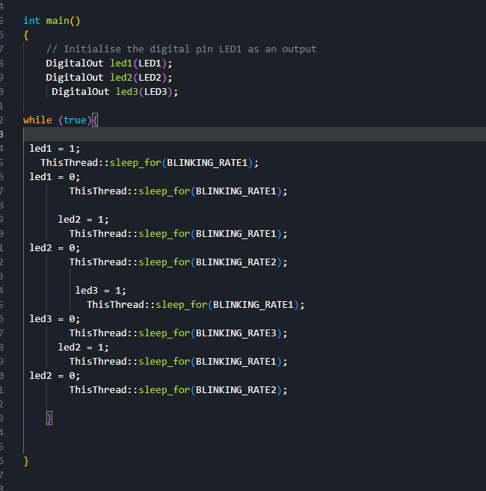
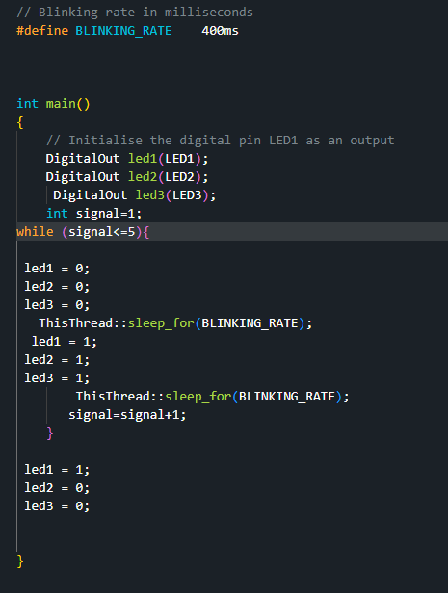
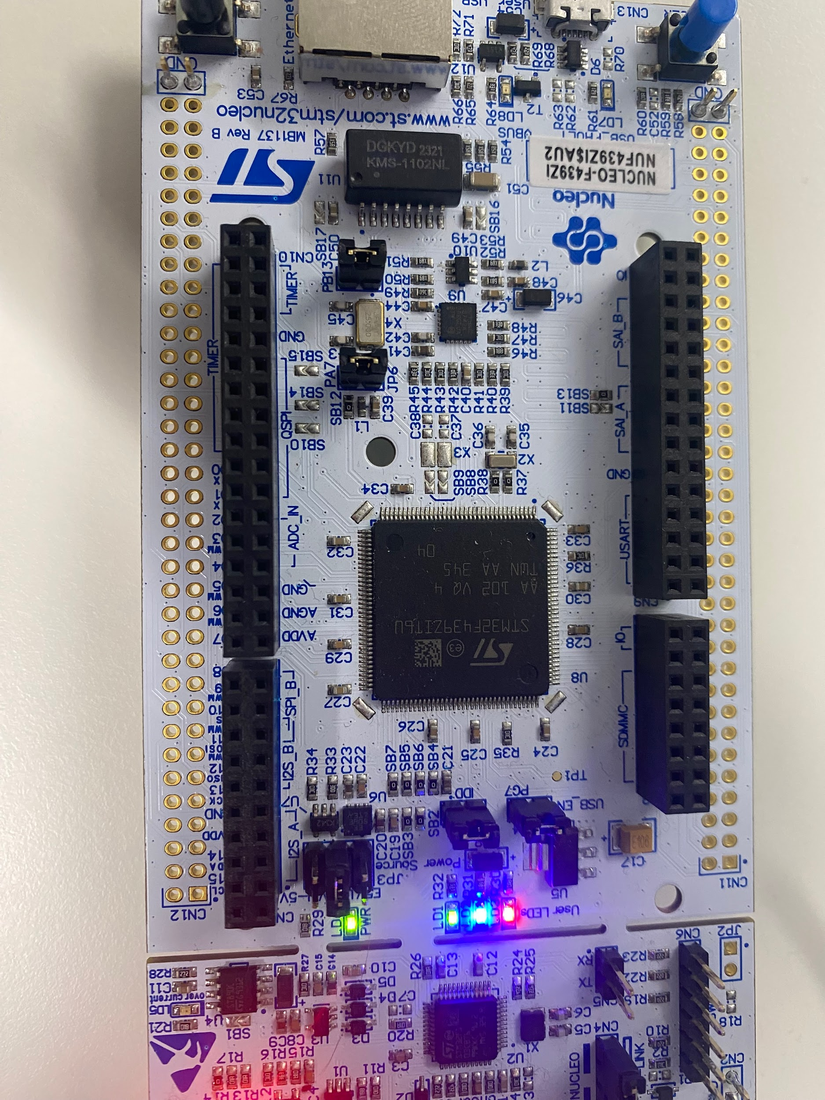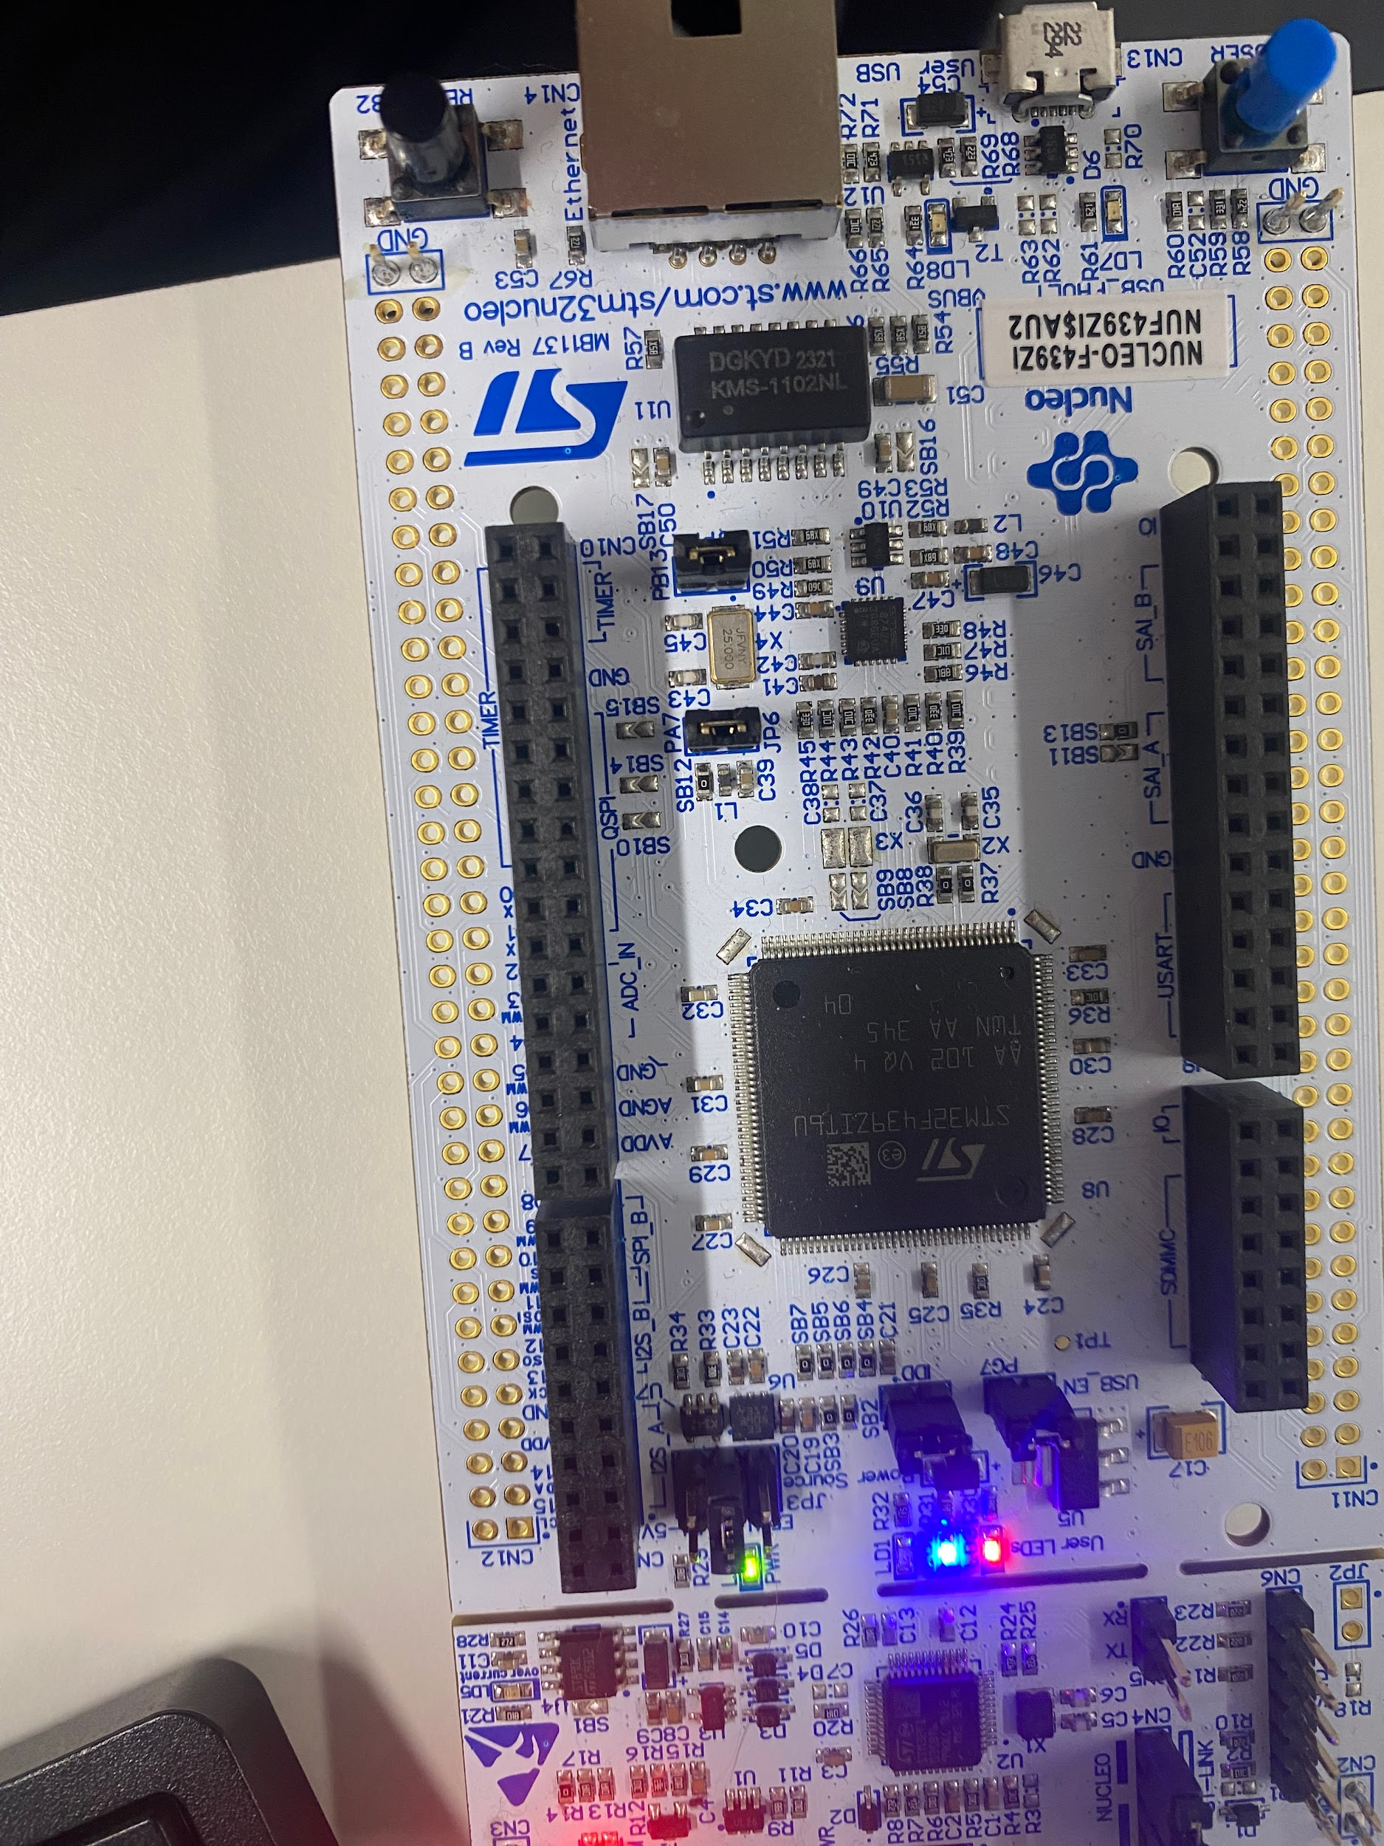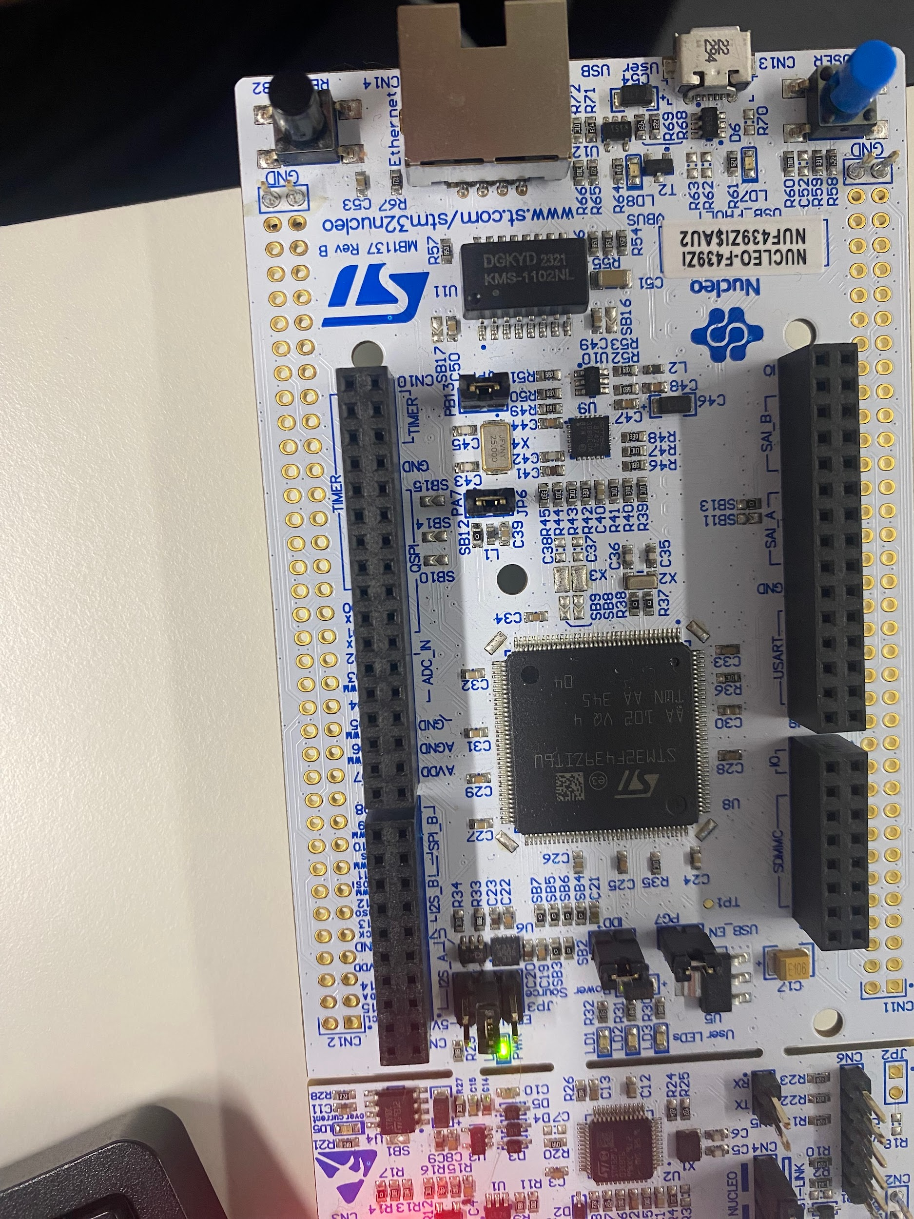

#include "mbed.h"
#include "arm_book_lib.h"
#define blink 500ms

int main()
{
DigitalIn enterButton(BUTTON1);
DigitalIn zero(D2);
DigitalIn one(D3);
DigitalIn two(D4);
DigitalIn three(D5);
DigitalIn four(D6);
DigitalIn five(D7);

DigitalOut alarmLed(LED1);
DigitalOut incorrectCodeLed(LED3);
DigitalOut systemBlockedLed(LED2);

zero.mode(PullDown);
one.mode(PullDown);
two.mode(PullDown);
three.mode(PullDown);
four.mode(PullDown);
five.mode(PullDown);

alarmLed = OFF;
incorrectCodeLed = OFF;
systemBlockedLed = OFF;

bool alarmState = OFF;
int numberOfIncorrectCodes = 0;

while (true) {

if ( zero || one || four || five ) {
alarmState = ON;
}

if ( numberOfIncorrectCodes < 4 ) {
if ( numberOfIncorrectCodes < 3 ) {

if ( two && three && !four && !five && !enterButton ) {
alarmState = OFF;
}

if ( enterButton && !incorrectCodeLed && alarmState) {
if ( two && three && !four && !five ) {
alarmState = OFF;
incorrectCodeLed = OFF;
numberOfIncorrectCodes = 0;
} else {
incorrectCodeLed = ON;
ThisThread::sleep_for(blink);
incorrectCodeLed = OFF;
numberOfIncorrectCodes = numberOfIncorrectCodes + 1;
}
}
} else {
for(int countblink=0;countblink<30;countblink++){
alarmLed = ON;
ThisThread::sleep_for(blink);
alarmLed = OFF;
ThisThread::sleep_for(blink);
}
while(numberOfIncorrectCodes==3){
if ( zero || one || four || five ) {
alarmState = ON;
}
if ( two && three && !four && !five && !enterButton ) {
alarmState = OFF;
}

if ( enterButton && !incorrectCodeLed && alarmState) {
if ( two && three && !four && !five ) {
alarmState = OFF;
incorrectCodeLed = OFF;
numberOfIncorrectCodes = 0;
} else {
incorrectCodeLed = ON;
ThisThread::sleep_for(blink);
incorrectCodeLed = OFF;
numberOfIncorrectCodes = numberOfIncorrectCodes + 1;
}
}
}

}
}else {
for(int countblink=0;countblink<60;countblink++){
systemBlockedLed=ON;
alarmLed = ON;
ThisThread::sleep_for(blink);
alarmLed = OFF;
ThisThread::sleep_for(blink);
numberOfIncorrectCodes = 0;
}
systemBlockedLed=OFF;
}
}
}

—----------------------------------------------------------------------------------------------------------------------
#include "mbed.h"
#include "arm_book_lib.h"
#define blink 500ms

int main()
{
DigitalIn enterButton(BUTTON1);
DigitalIn zero(D2);
DigitalIn one(D3);
DigitalIn two(D4);
DigitalIn three(D5);
DigitalIn four(D6);
DigitalIn five(D7);

DigitalOut alarmLed(LED1);
DigitalOut incorrectCodeLed(LED3);
DigitalOut systemBlockedLed(LED2);

zero.mode(PullDown);
one.mode(PullDown);
two.mode(PullDown);
three.mode(PullDown);
four.mode(PullDown);
five.mode(PullDown);

alarmLed = OFF;
incorrectCodeLed = OFF;
systemBlockedLed = OFF;

bool alarmState = OFF;
int numberOfIncorrectCodes = 0;

while (true) {

if ( zero || one || four || five ) {
alarmState = ON;
}

if ( numberOfIncorrectCodes < 4 ) {
if ( numberOfIncorrectCodes < 3 ) {

if ( two && three && !four && !five && !enterButton ) {
alarmState = OFF;
}

if ( enterButton && !incorrectCodeLed && alarmState) {
if ( two && three && !four && !five ) {
alarmState = OFF;
incorrectCodeLed = OFF;
numberOfIncorrectCodes = 0;
} else {
incorrectCodeLed = ON;
ThisThread::sleep_for(blink);
incorrectCodeLed = OFF;
numberOfIncorrectCodes = numberOfIncorrectCodes + 1;
}
}
} else {
for(int countblink=0;countblink<30;countblink++){
alarmLed = ON;
ThisThread::sleep_for(blink);
alarmLed = OFF;
ThisThread::sleep_for(blink);
}
while(numberOfIncorrectCodes==3){
if ( zero || one || four || five ) {
alarmState = ON;
}
if ( two && three && !four && !five && !enterButton ) {
alarmState = OFF;
}

if ( enterButton && !incorrectCodeLed && alarmState) {
if ( two && three && !four && !five ) {
alarmState = OFF;
incorrectCodeLed = OFF;
numberOfIncorrectCodes = 0;
} else {
incorrectCodeLed = ON;
ThisThread::sleep_for(blink);
incorrectCodeLed = OFF;
numberOfIncorrectCodes = numberOfIncorrectCodes + 1;
}
}
}

}
}else {
for(int countblink=0;countblink<60;countblink++){
systemBlockedLed=ON;
alarmLed = ON;
ThisThread::sleep_for(blink);
alarmLed = OFF;
ThisThread::sleep_for(blink);
numberOfIncorrectCodes = 0;
}
systemBlockedLed=OFF;
}
}
}

—----------------------------------------------
if ( enterButton ) {
if ( one && three ) {
// alarmState = OFF;
// incorrectCodeLed = OFF;
// numberOfIncorrectCodes = 0;
break;
break;
break;
}
// else {
// systemBlockedLed=ON;
// }
}
—----------------------------------------------
int lockedtime=0;

lockedtime=lockedtime+1;
for(int i=0;i<lockedtime;i++){
alarmLed = ON;
ThisThread::sleep_for(blink);
alarmLed = OFF;
ThisThread::sleep_for(blink);
}
—----------------------------------------------
else if ( receivedChar == '2') {
if ( alarmState ) {
uartUsb.write( "GAS ALARM ACTIVE\r\n", 18);
} else {
uartUsb.write( "GAS ALARM CLEAR\r\n", 17);
}
}

out
2GAS ALARM CLEAR
—----------------------------------------------

else if ( receivedChar == '3') {
if ( TempState ) {
uartUsb.write( "TEMP ALARM ACTIVE\r\n", 19);
} else {
uartUsb.write( "TEMP ALARM CLEAR\r\n", 18);
}
}

Out
3TEMP ALARM CLEAR
—----------------------------------------------

out
12GAS ALARM ACTIVE
3TEMP ALARM CLEAR
43TEMP ALARM ACTIVE

