This wasn’t required but I thought it might facilitate grading the project.

Questions Contact: [leutermanns@gmail.com](mailto:leutermanns@gmail.com)  
Build requirements:  
1. MySQL Server  
2. MySQL Connector/NET  
3. MySQL Workbench  
4. Visual Studio (Pref 2017)  
5. If the build has errors you may need to do Project -> Add Reference, to find missing dlls

Required Stuff:

1. Follow Link: <https://dev.mysql.com/downloads/installer/>

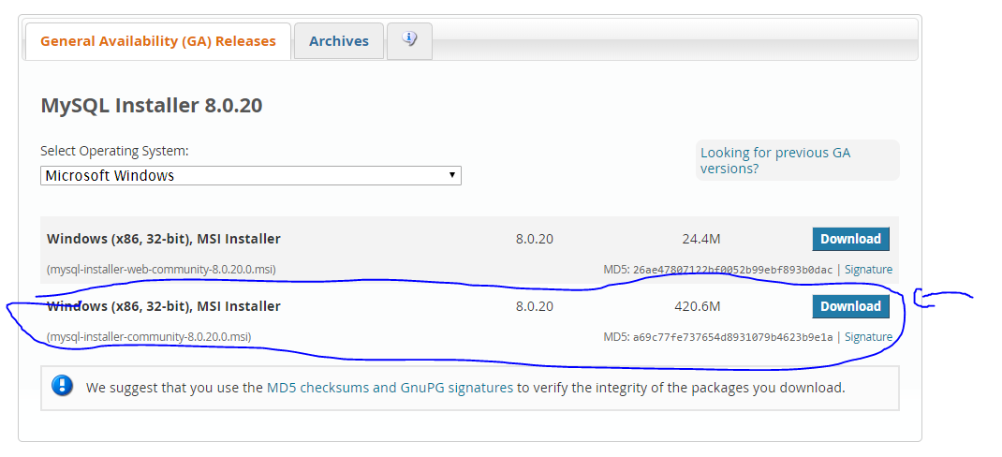

1. Open SQL installer
   1. Click add, you need these three MySQL Server, MySQL Workbench, Connector/NET

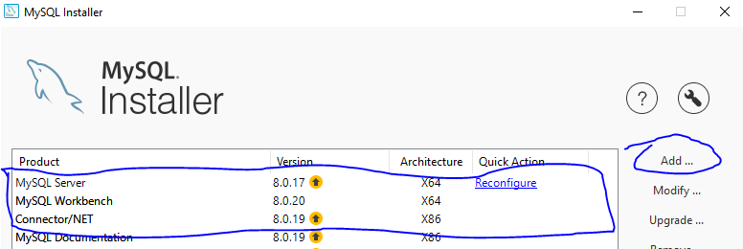

1. Click Reconfigure next to MySQL Server
   1. 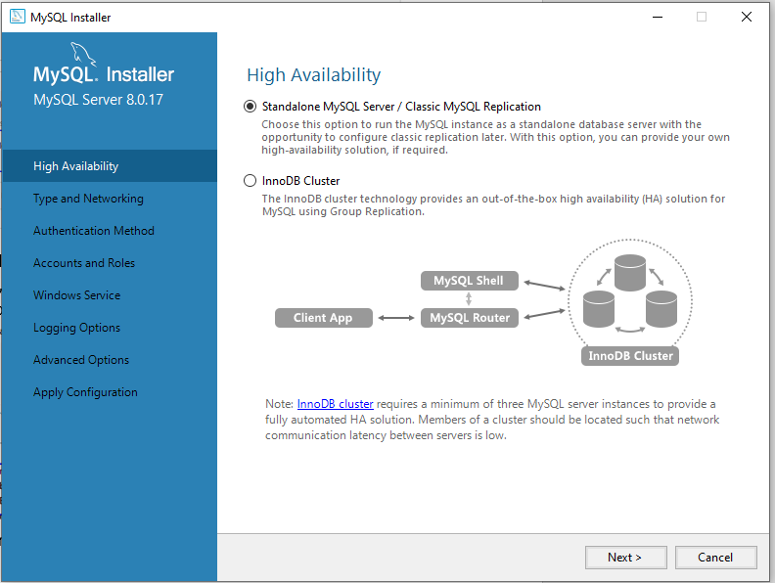
   2. 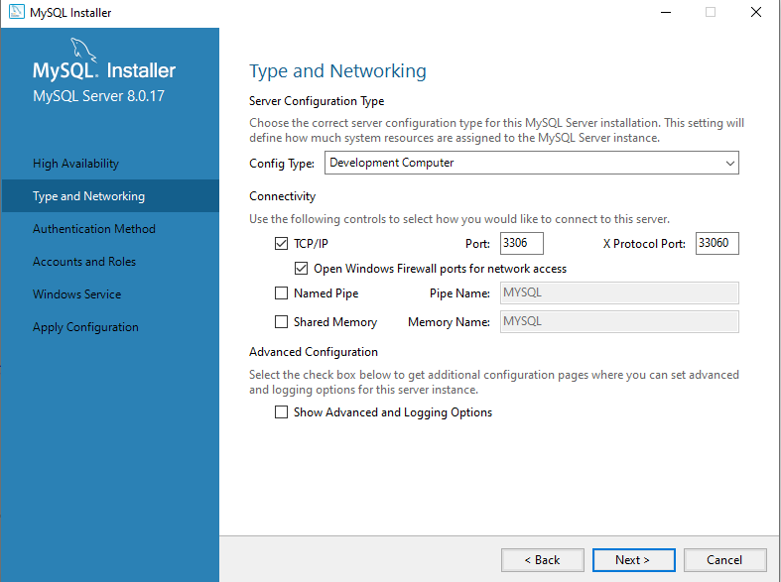
   3. 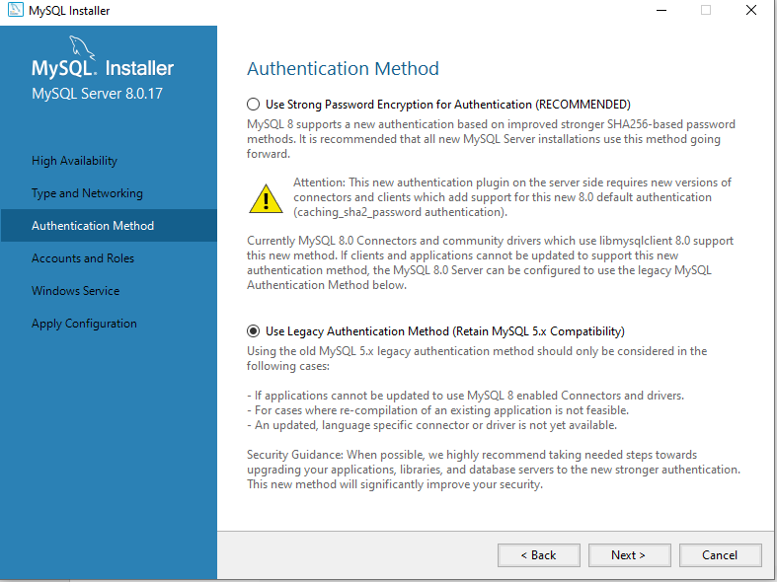
   4. Make a password (this will be the instance password so write it down
   5. 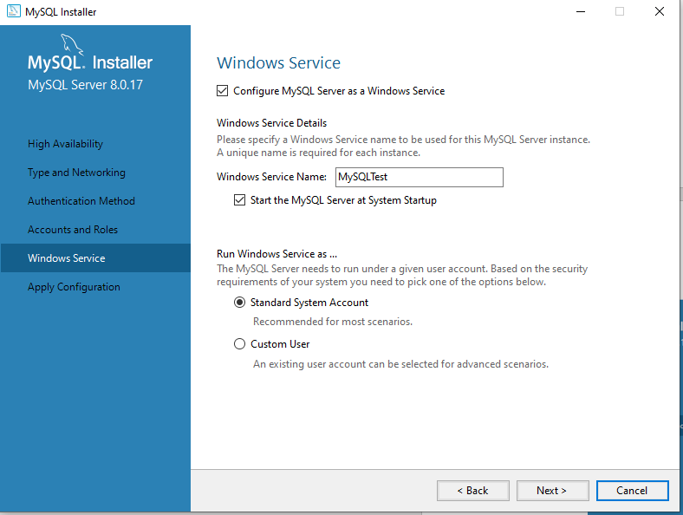
   6. Execute
2. Open Work Bench
   1. Hit the plus sign
      1. 
      2. Name your connection and leave everything else the same
      3. Click the connection
   2. 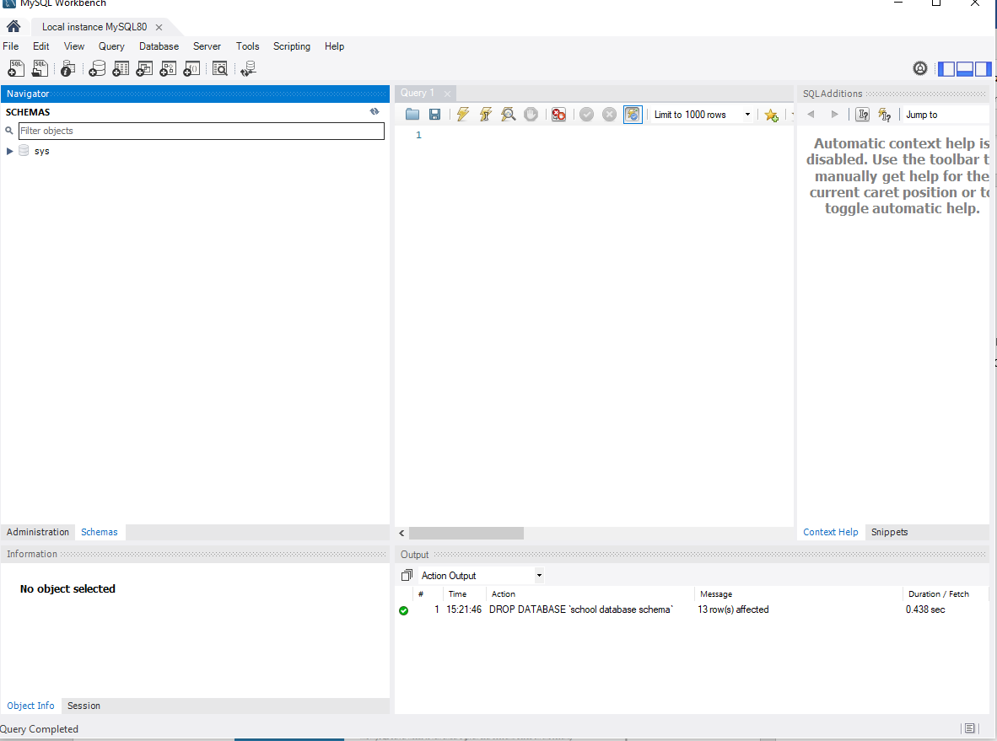
      1. File -> Open SQL Script
      2. Open Creation Scripts and Run
      3. Open Insertion Scripts and Run
3. Open ..\CourseProject\Model\ConnectionSingleton.cs
   1. Modify passwordField to be the password configured in step 3.d