**Summary – Dataset of each strain separately**

**N2 strain:**

**All samples**

|  |  |  |  |  |  |  |
| --- | --- | --- | --- | --- | --- | --- |
| **Comparison** | **Total # Genes** | **All Zero** | **Low Counts** | **Tested** | **Significant** | |
|  |  |  |  |  | **UP** | **Down** |
| N2_treated_vs_untreated | 46,778 | 30,730 | 6,768 | 9,280 | 0 | 3 |

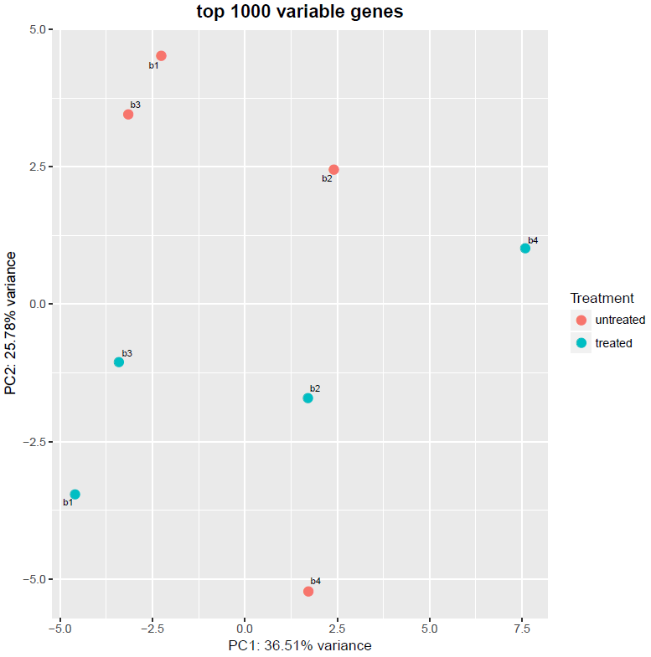

**Removing replica 4**

|  |  |  |  |  |  |  |
| --- | --- | --- | --- | --- | --- | --- |
| **Comparison** | **Total # Genes** | **All Zero** | **Low Counts** | **Tested** | **Significant** | |
|  |  |  |  |  | **UP** | **Down** |
| N2_treated_vs_untreated | 46,778 | 31,230 | 8,896 | 6,652 | 23 | 31 |

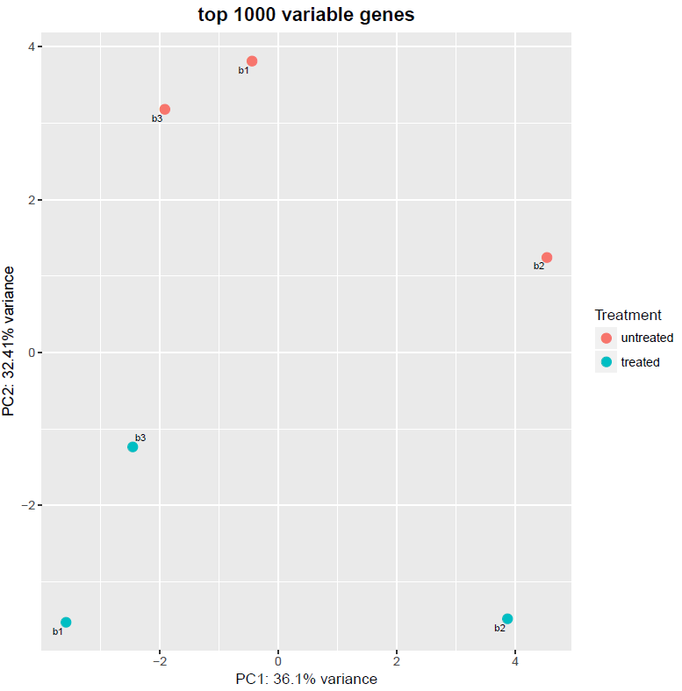

**CL2006:**

**All samples**

|  |  |  |  |  |  |  |
| --- | --- | --- | --- | --- | --- | --- |
| **Comparison** | **Total # Genes** | **All Zero** | **Low Counts** | **Tested** | **Significant** | |
|  |  |  |  |  | **UP** | **Down** |
| CL2006_treated_vs_untreated | 46,778 | 30,710 | 7,077 | 8,991 | 0 | 1 |

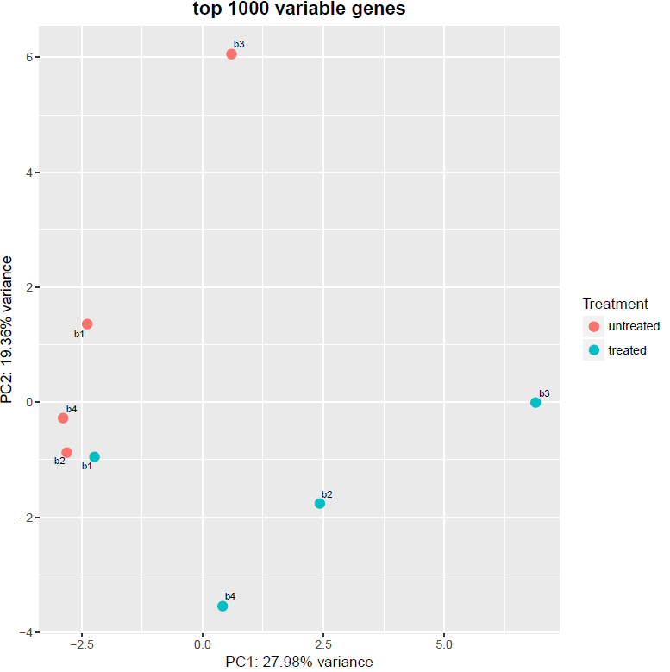

**All samples – batch effect**

|  |  |  |  |  |  |  |
| --- | --- | --- | --- | --- | --- | --- |
| **Comparison** | **Total # Genes** | **All Zero** | **Low Counts** | **Tested** | **Significant** | |
|  |  |  |  |  | **UP** | **Down** |
| CL2006_treated_vs_untreated | 46,778 | 30,710 | 9,806 | 6,262 | 1 | 10 |

**AM140:**

**All samples**

|  |  |  |  |  |  |  |
| --- | --- | --- | --- | --- | --- | --- |
| **Comparison** | **Total # Genes** | **All Zero** | **Low Counts** | **Tested** | **Significant** | |
|  |  |  |  |  | **UP** | **Down** |
| AM140_treated_vs_untreated | 46,778 | 30,934 | 6,787 | 9,057 | 0 | 1 |

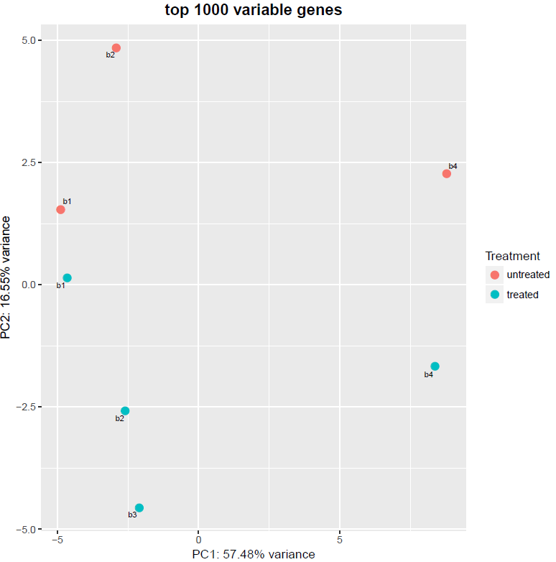

**Removing replica 4**

|  |  |  |  |  |  |  |
| --- | --- | --- | --- | --- | --- | --- |
| **Comparison** | **Total # Genes** | **All Zero** | **Low Counts** | **Tested** | **Significant** | |
|  |  |  |  |  | **UP** | **Down** |
| AM140_treated_vs_untreated | 46,778 | 31,488 | 12,951 | 2,339 | 6 | 16 |

