CHAPTER 4

1. Assume a tables of:  
    A (key , name) , B (key , name)

what kind of joins are displayed in this picture.

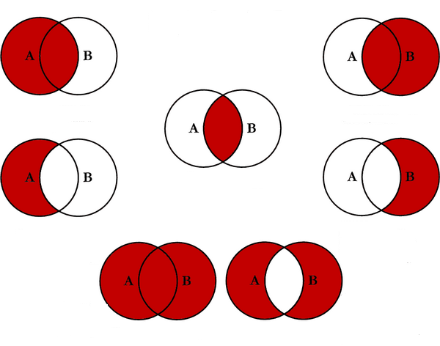

1. Assume a tables of:  
    Emp ( Id, Name, DeptId ) , Dept ( Id, Name)

If there are 10 records in the Emp table and 5 records in the Depttable, how many rows will be displayed in the result of the following SQL query:

SELECT * FROM Emp, Dept

1. Given the following tables:  
     
    sql > SELECT * FROM runners;  
    +----+--------------+

| id | name |

+----+--------------+

| 1 | John Doe |

| 2 | Jane Doe |

| 3 | Alice Jones |

| 4 | Bobby Louis |

| 5 | Lisa Romero |

sql > SELECT * FROM races;

+----+----------------+-----------+

| id | event | winner_id |

+----+----------------+-----------+

| 1 | 100 meter dash | 2 |

| 2 | 500 meter dash | 3 |

| 3 | cross-country | 2 |

| 4 | triathalon | NULL |

+----+----------------+-----------+

What will be the result of the query below?

SELECT *

FROM runners

WHERE id NOT IN (SELECT winner_id FROM races)

1. What will be the output result of this query:  
     
   SELECT *

FROM dbo.test_a

JOIN

(

SELECT id

FROM dbo.test_b

ORDER BY id

) AS a ON a.id = dbo.test_a.id

1. **Which is better a CTE or a subquery? Why?**
2. What is the difference between the APPLY and JOIN operators?
3. What is the difference between self-contained and correlated subqueries?
4. Given two tables created as follows:  
     
   CREATE TABLE test_a ( id NUMERIC );

CREATE TABLE test_b ( id NUMERIC );

INSERT INTO test_a ( id )

VALUES ( 10 ),( 20 ),( 30 ),( 40 ),( 50 );

INSERT INTO test_b ( id )

VALUES ( 10 ),( 30 ),( 50 );

Write a query to fetch values in table test_a that are and not in test_b **without** using the NOT keyword.

1. What is the difference between the result sets when using a UNION and a UNION ALL set operators?
2. Result set from UNION ALL is filtered including duplicate values
3. Result set from UNION is filtered and sorted including duplicate values
4. Result set from UNION ALL is not sorted and it has duplicate values
5. Result set from UNION is filtered and sorted without duplicate values
6. Which of the following is the equivalent of   
   <query 1> UNION <query 2> INTERSECT <query 3> EXCEPT <query4>?

A. (<query 1> UNION <query 2>) INTERSECT (<query 3> EXCEPT <query 4>)

B. <query 1> UNION (<query 2> INTERSECT <query 3>) EXCEPT <query 4>

C. <query 1> UNION <query 2> INTERSECT (<query 3> EXCEPT <query 4>)

D. <query 1> UNION (<query 2> INTERSECT <query 3> EXCEPT <query 4>)

1. In which operator does the order of the input queries matter?
2. Which of the following operators removes duplicates from the result?

A. UNION

B. UNION ALL

C. INTERSECT

D. EXCEPT