Grammar assessment
Read each sentence and try to identify one mistake that needs correcting.
1 If I had known about the traffic, I wouldn't be late now.
MIXED CONDITIONAL > 3^{rd + 2nd}
2 Not only was he late, but he also forgot his notebook.
NEGATIVE INVERSION
3 The painting is thought to be a forgery by experts.
4 By this time next month, I will have been working here for ten years.
FUTURE PERFECT CONTINUOUS
5 The thing that/which I found most difficult was the listening exam.
6 He can’t have stolen the car because he doesn't have a license.
7 The amount of rainfall this month is three times higher than average.
NUMBER + COUNTABLE
AMOUNT + UNCOUNTABLE
8 Despite the heavy rain, the match continued.
9 I remember(ed) to lock / 2 locking the door before I left the house.
10 You can choose whichever of these books you want.
11 No sooner had I arrived than the meeting started.
12 Give the prize to whoever finishes the race first.

Linking words 1
ADDITION LINKING WORDS
In addition, furthermore and moreover
We use these words to add extra information that supports or continues a previous idea.
What happened today on March 11th 2011?

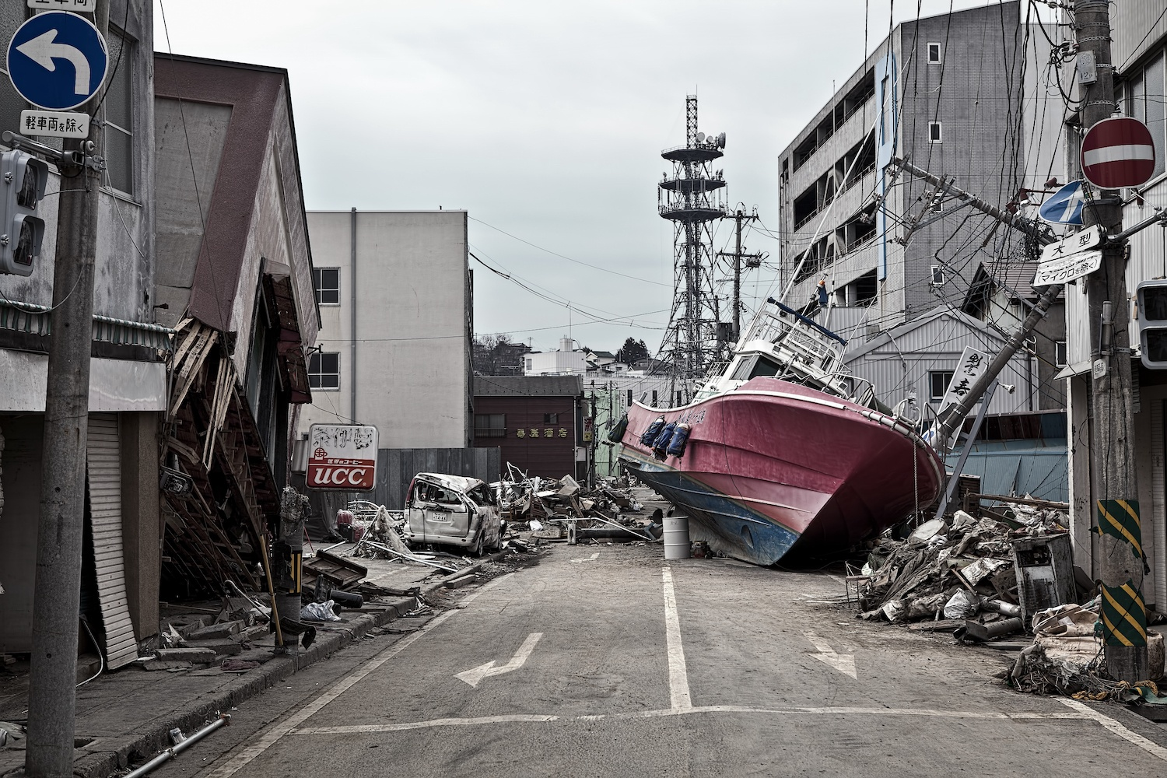

In addition, furthermore and moreover
Three examples
1 The tsunami that struck Japan on March 11th, 2011 knocked out the power supply at the Fukushima Daiichi nuclear plant. > C | A Furthermore, many towns in the area remained largely empty for years because residents were unable to return.
2 Following the disaster, the Japanese government ordered a large-scale evacuation of people living near the power plant. > A | B In addition, powerful explosions destroyed the roofs and walls of some of the reactor units.
3 Hydrogen gas built up inside several reactor buildings after the cooling systems failed. > B | C Moreover, the failure of the cooling systems caused several nuclear reactors to overheat and melt down.

Moreover
1 C
The tsunami that struck Japan on March 11th, 2011 knocked out the power supply at the Fukushima Daiichi nuclear plant. Moreover, the failure of the cooling systems caused several nuclear reactors to overheat and melt down.
Furthermore
2 A
Following the disaster, the Japanese government ordered a large-scale evacuation of people living near the power plant. Furthermore, many towns in the area remained largely empty for years because residents were unable to return.
In addition
3 B
Hydrogen gas built up inside several reactor buildings after the cooling systems failed. In addition, powerful explosions destroyed the roofs and walls of some of the reactor units.

PRACTICE
Try to add a second sentence to these three ideas using moreover, in addition or furthermore
1 Renewable energy is becoming increasingly important in many countries around the world.
Moreover, it helps reduce pollution that harms animals and their habitats.
Furthermore, countries are investing more in solar and wind power to reduce carbon emissions.
Furthermore, many companies invest in building resources.
Moreover, this energy might make all these countries participate in potential missions to other planets in the future.
Furthermore, it can help governments reduce energy costs in the long term.
EXAMPLES
Renewable energy is becoming increasingly important in many countries around the world. Moreover, governments are investing heavily in solar and wind power to reduce their dependence on fossil fuels.
Nuclear power provides large amounts of electricity without producing carbon emissions during operation. Furthermore, it can generate energy continuously, unlike some renewable sources that depend on weather conditions.
Global warming is already affecting weather patterns in many parts of the world. In addition, rising sea levels are threatening coastal cities and low-lying islands.

Linking words
Addition | Contrast
Furthermore | However
In addition | Nevertheless
Moreover | Nonetheless
Alternatives (less formal) | Alternatives (less formal)
Also | Even so
Additionally | Still
As well | Yet

On this day
Do you know what happened on March 11th 2020?


However, nevertheless and nonetheless
We use these words to introduce contrasting information.
Three examples
1 The COVID-19 vaccines were developed in record time and helped reduce the number of severe cases. > B | A However, many people found it difficult to separate their work life from their personal life.
2 Governments introduced lockdowns to slow the spread of the virus. > C | B Nonetheless, many countries initially struggled to distribute them quickly to their populations.
3 Working from home became much more common during the COVID-19 pandemic. > A | C Nevertheless, many hospitals still faced enormous pressure during the worst waves of the pandemic.

However 1B
The COVID-19 vaccines were developed in record time and helped reduce the number of severe cases. Nonetheless, many countries initially struggled to distribute them quickly to their populations.
Nevertheless 2C
Governments introduced lockdowns to slow the spread of the virus. Nevertheless, many hospitals still faced enormous pressure during the worst waves of the pandemic.
On the other hand 3A
Working from home became much more common during the COVID-19 pandemic. However, many people found it difficult to separate their work life from their personal life.

PRACTICE
Try to add a second sentence to these three ideas using however, on the other hand, nevertheless.
1 The COVID-19 vaccines were developed very quickly and helped reduce the number of severe cases.
Nevertheless, some countries such as Iran banned the import of vaccines which led to the death of many people.
Nevertheless, it has been suggested that there are plenty of countries that need to be reached as soon as possible.
Nevertheless, a small number of people reported serious health complications after vaccination.
EXAMPLE
1 The COVID-19 vaccines were developed very quickly and helped reduce the number of severe cases. However, some people remained hesitant to get vaccinated.
Homework
Write a five-sentence paragraph and try to use one linking connector and one contrast connector.
Example
Traveling by train allows you to relax and enjoy the view of the countryside. In addition, you can move around the carriage or visit the buffet car during your journey. Many people find this much more comfortable than sitting in a small car for several hours. Nevertheless, train tickets can be quite expensive if you do not book them several weeks in advance. Most travelers still agree that the speed and convenience make the cost worth it.
Ideas
1 Living in a city ...
2 Working from home ...
3 Getting married young ...
4 Retiring early ...
5 Studying English online ...

