This report is going to describe the web site that has been dedicated to a photography domain, and the team of three people whose work is depicted in the web site. The main focus of the web site is to show to what extend photos might transmit the atmosphere and how it actually influence people just from the first glance, the web site provides a bunch of information about photographs and their work, their contacts, and the style of photos they are shooting in. Eshoot “Emotional shoot” that is how the web site is named, the name itself has quite an understandable meaning so that would easy to target the audience. The web site is focusing on teenagers and people up to 30 years old both female and male. Due to a high demand on professional photographers and with a full understanding of new coming trends the web site would be easy to monetize, for example love stories that are always based on emotions, birthdays, and other events.

The web site is designed to satisfy user experience and make it more comfortable while navigating through it. Almost all photos are clickable with an interactive animation and slide shows in some parts. One of the features of the web site is in its color, in other words the pages the nav-bars and photos are designed in a black & white color style so that makes it easy to remember and associate. The navigation part is quite straight forward with no additional buttons that usually distract users. In terms of the style usage the linear one was considered as the major principle.

To compare, the two web-sites have been taken into consideration both have their advantages and disadvantages. In the following page the screenshot of the first web site would be provided and analyzed accordingly.

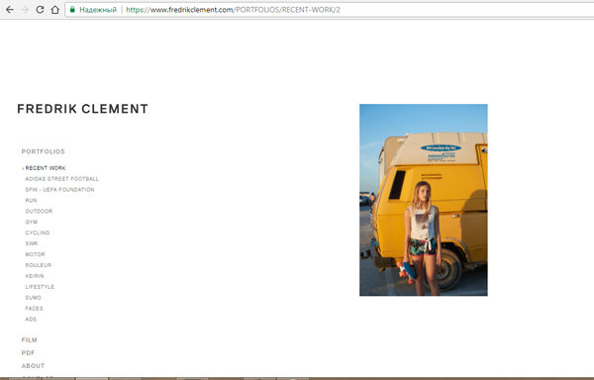

As it has been vividly illustrated the main page of ([www.fredrikclement.com](http://www.fredrikclement.com)) has a specific design with a non-standard nav-bar. When I first entered the web site I was a bit confused where to go further how to novigate to go to another page, so basically the user expreance is quite poor and needs to be standardized. Another collabse that I noticed on the way is scrolling, I could not go down to see the rest of the pages though they apeared to be there, the list goes down if you press on any of the link located on the left side of the page, the point is to consider the scrolling. Besides some pobrlems with useability the web site is seemed to be empty and not consistent. Yet there are some advantages, the content is very appropiate and targeted as a phographer I personally got a lot of experience just by going through the images the web site is filled with. Aslo it consists of different categories that makes it very easy to find any pic you need.Overall the website provides a good content, but still a lot of work remained to be done.

The second web site I found more featured and functioned, however it seemed to be very squared and raw in terms of design.

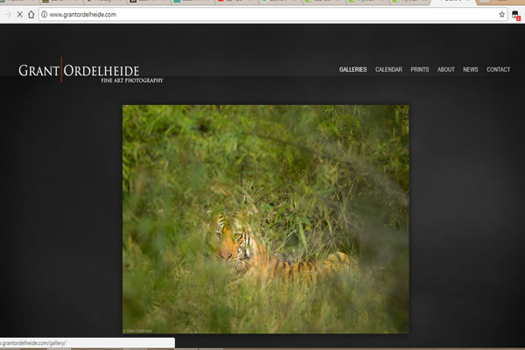

There is a clear objective in the web site, for example it represents the photos of one person that means that it has nothing to do with so called gallery or the web site you can download images from, instead it has been developed to evaluate the skills of the photographer and perhaps hire him to the different projects. From the points above It can be concluded that the overall problem is in design the pictures do not fit the whole frame, they are squared and colored that in this case inharmonious with the background.

“Often those that criticize others reveal what they lack” L.Alder (2016). That rings very much true, but in order to understand how often the quotes are relevant the questionnaire has been designed. The following questions have been asked to evaluate the web site.

1. What the web-site is about?
2. How easy it is to navigate through the web-site?
3. What are the difficulties you faced on the way?
4. Are there any problems with a design?
5. Colors, how fit they are?