TALLINN UNIVERSITY OF TECHNOLOGY
School of Information Technologies
Department of Computer Systems
Study Center for Computer Systems

Levan Salia 145368-MVEB61
IAG0582 Programming II

Homework N1
Variant B02

Tallinn 2017

Declaration of originality
I hereby certify that I am the sole author of this thesis and that no part of this thesis has been published or submitted for publication. All works and major viewpoints of the other authors, data from other sources of literature and elsewhere used for writing this paper have been referenced

Name : Levan Salia
Date : 05/03/2017

Table of contents
Declaration of originality-------------------------------------------------------------------------------2
Task-----------------------------------------------------------------------------------------------------------4
Detailed description of program---------------------------------------------------------------------5
Screenshots------------------------------------------------------------------------------------------------6
List of references-----------------------------------------------------------------------------------------7

Task
variant B02

1. A gambling establishment is looking for profitable clients to invite them for a special event. The data is read from a file into a structure:
a. First name
b. Last name
c. Phone number
d. Total winnings
e. Total losses
2. The output should contain only those customers who make more than the average profit for the establishment, including their win-loss rations, total loss and contact information.
3. List the clients who’ve lost the most first.
4. Output should be stored in a file and displayed on the screen

Detailed description of the program

At the beginning, program reads the data from input file, which provides information about client and stores this information in the structure “persons”.
Reading is done by function “ReadData”, which takes persons and file pointer as arguments. This function also calculated win-lose ratio of all persons and stores in their structure as “ratio”. After that, function calculateAverage is called, which calculates difference between wins and losses for all the clients. And than returns average number of profit.
Once we know average profit, we call method “Output”, which takes “persons” and average profit as arguments. At first, it creates new file to store information in it, then it sorts all the persons based on their losses in decreasing order. While sorting is finished, new loop is started to find the persons, whose average profit is more than all persons average profit. When found, all the information about that client and plus win-loss ratio is displayed.
All the output is displayed on terminal and stored in .txt file called “Output.txt”.

Screenshots

Output in terminal
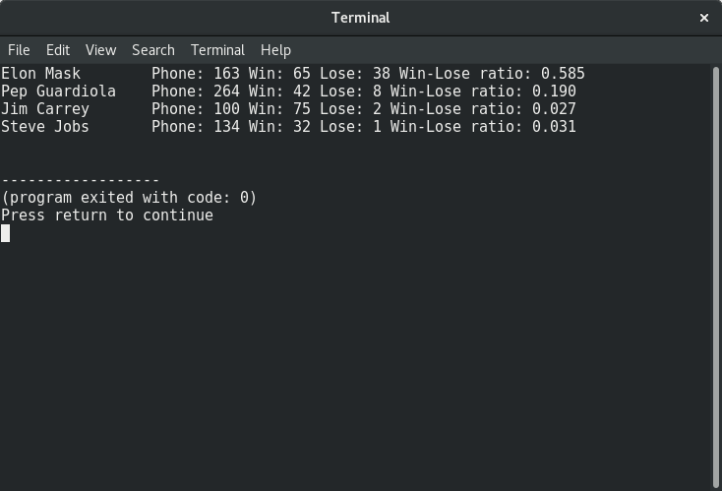
Stored data in file
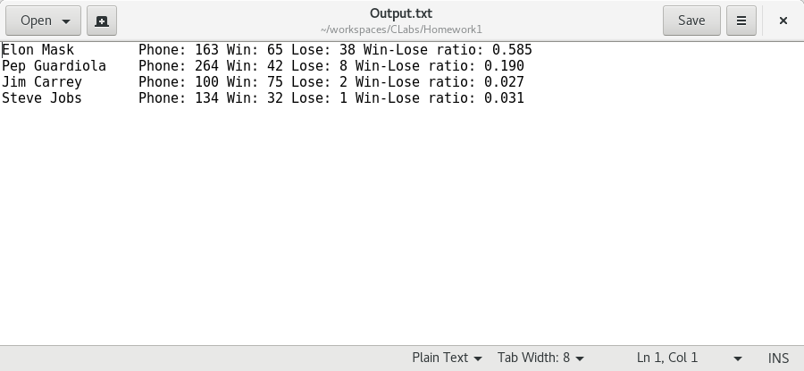

List of references

* http://blue.pri.ee/ttu/programming-ii/code-samples/homework-code-sample/

