**1.Welcome page:**

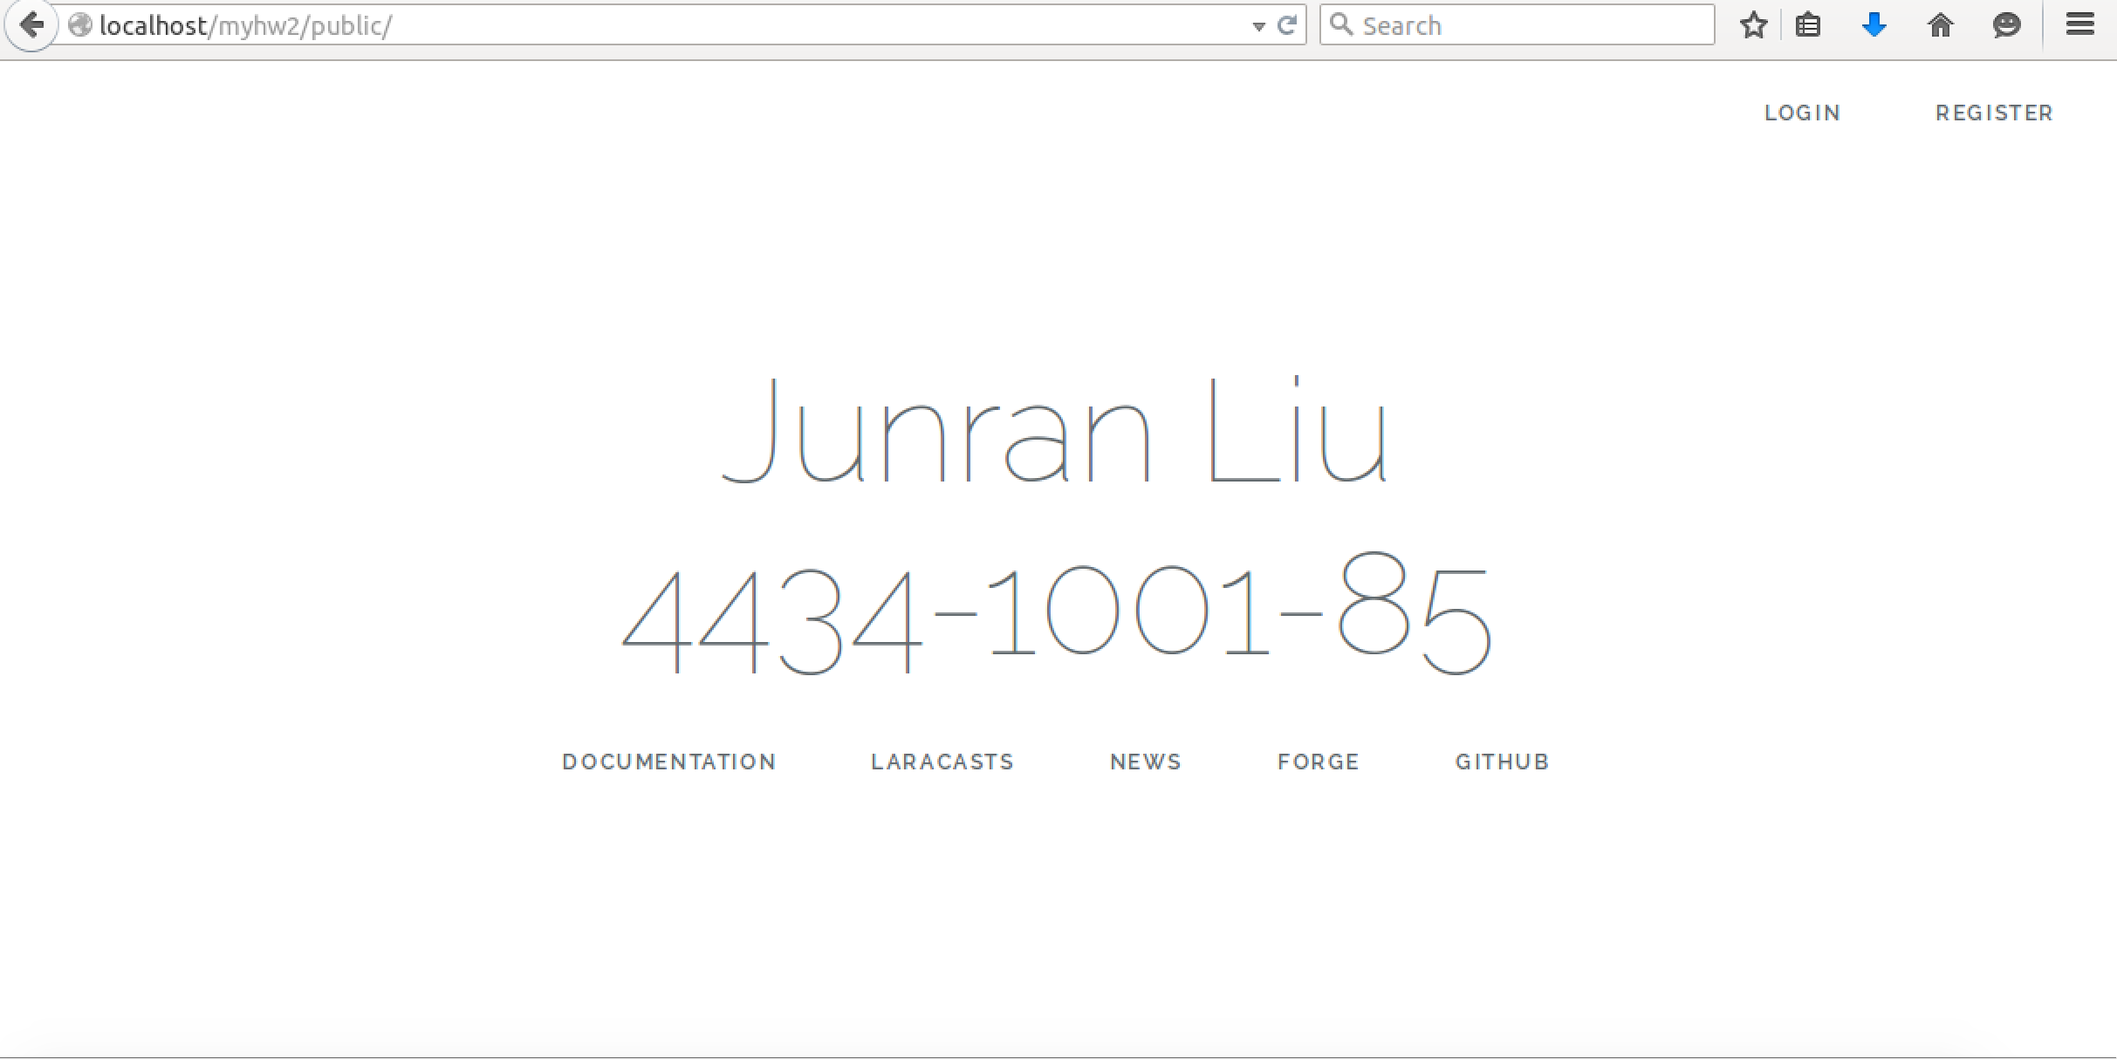

**2.Login and Register:**

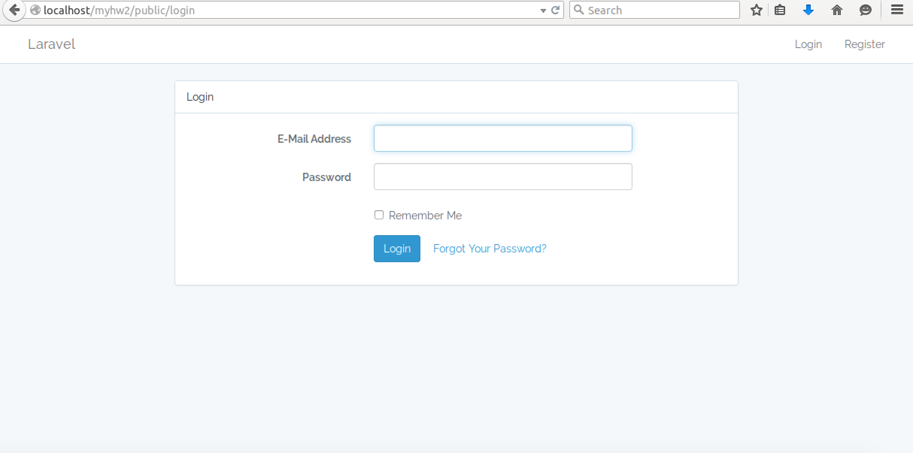

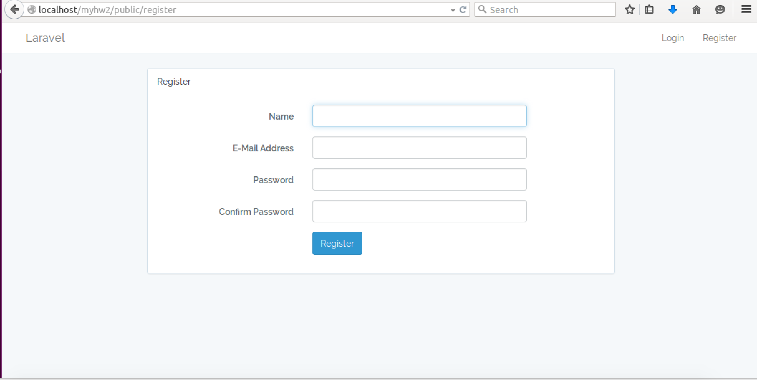

**3.Home page**

Once logged in, if this trainer is not an admin, he/she can see other trainers’ profiles and there is no edit button for him/her.

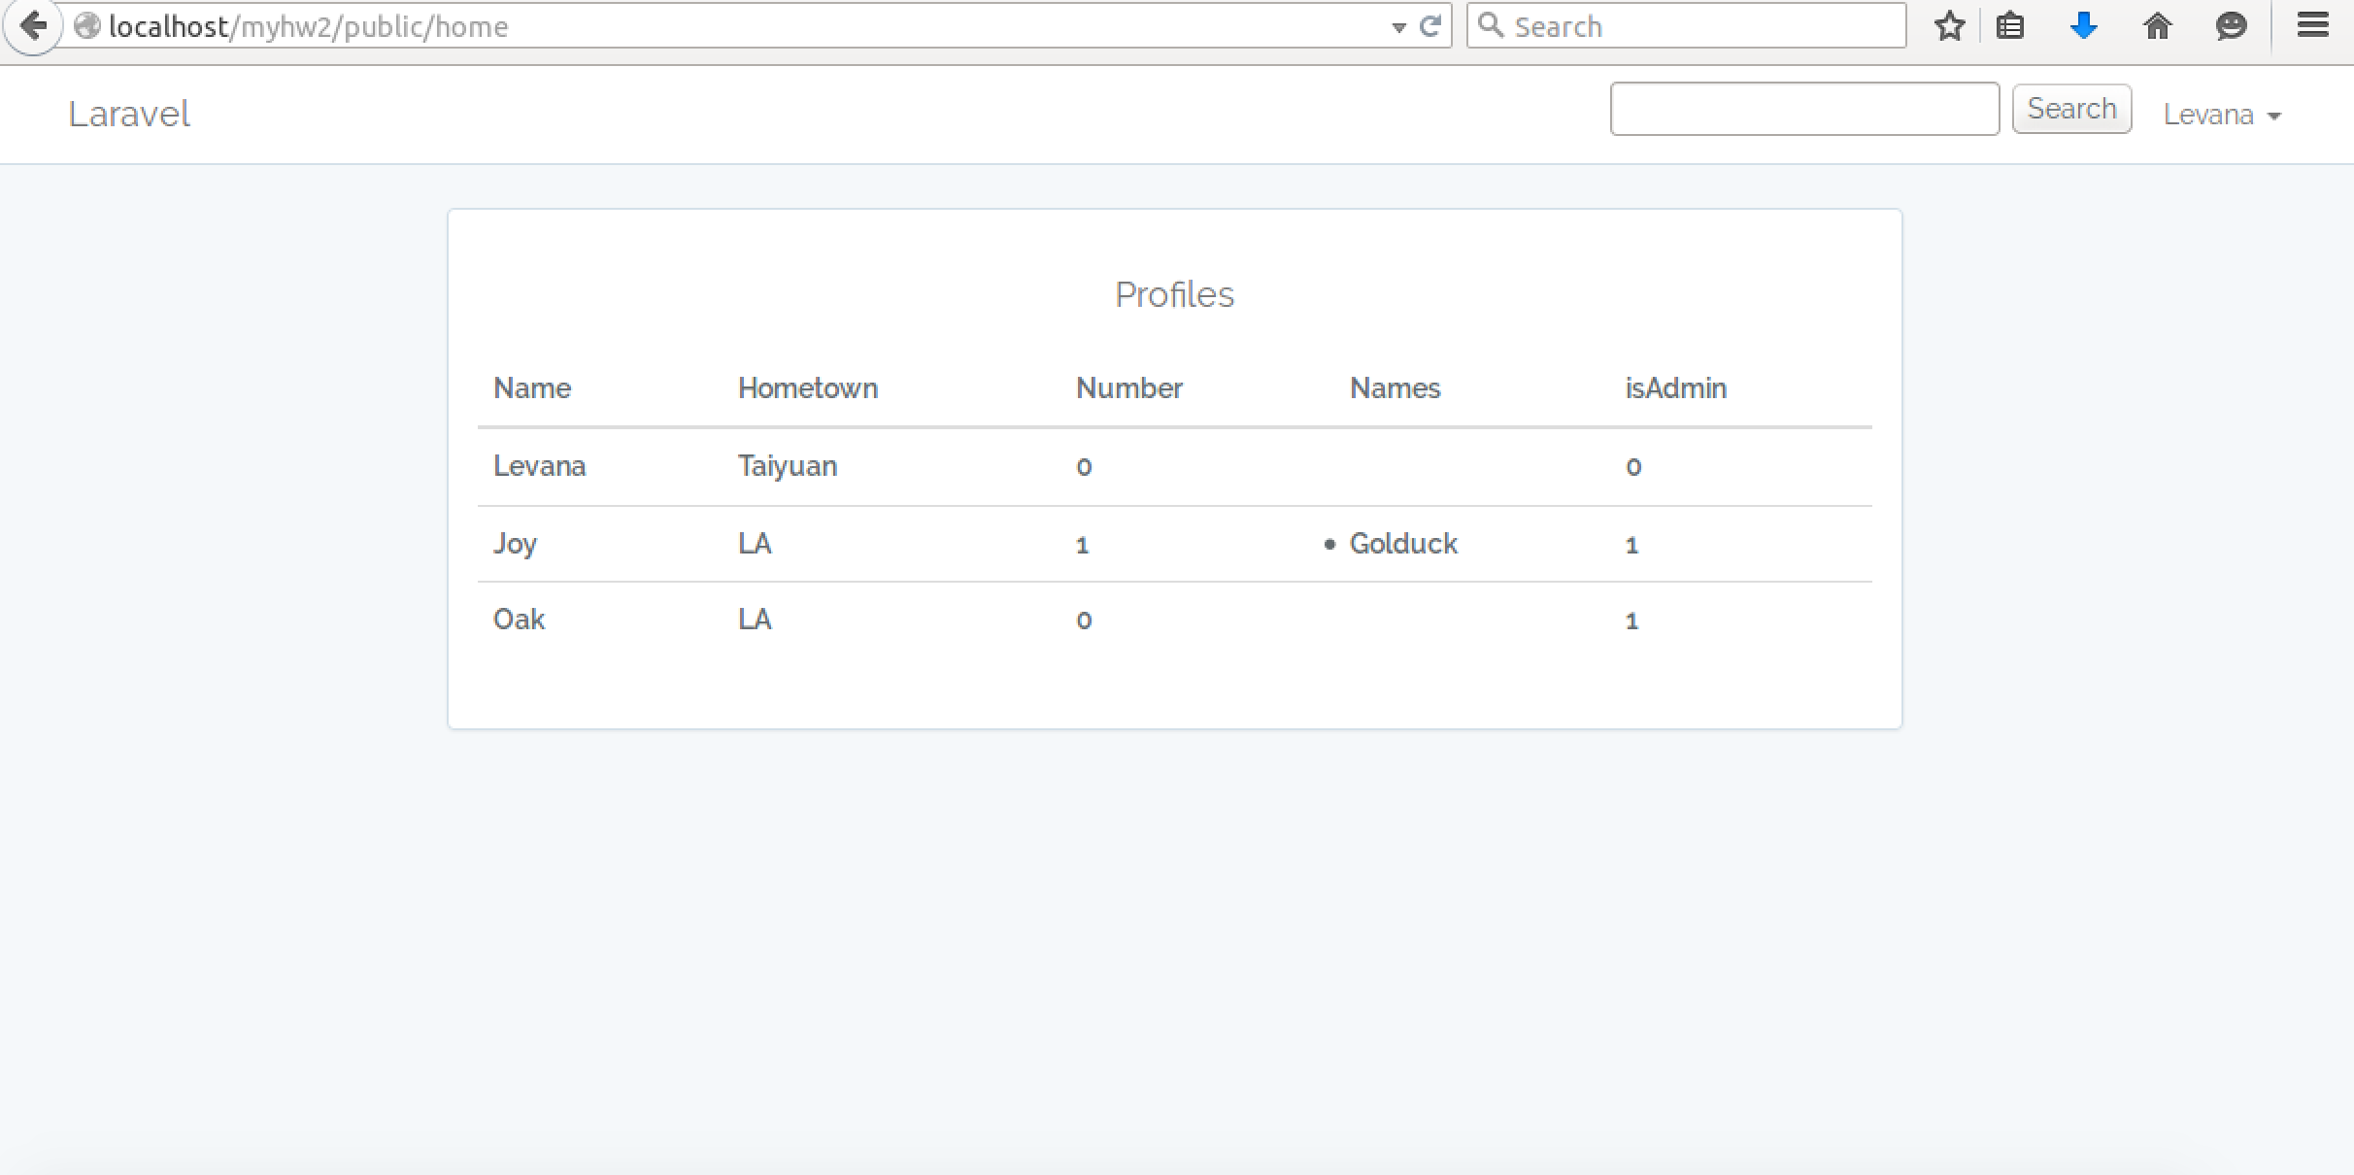

If this trainer is an admin, there are edit buttons for those trainers who already have profile; otherwise, it shows N/A

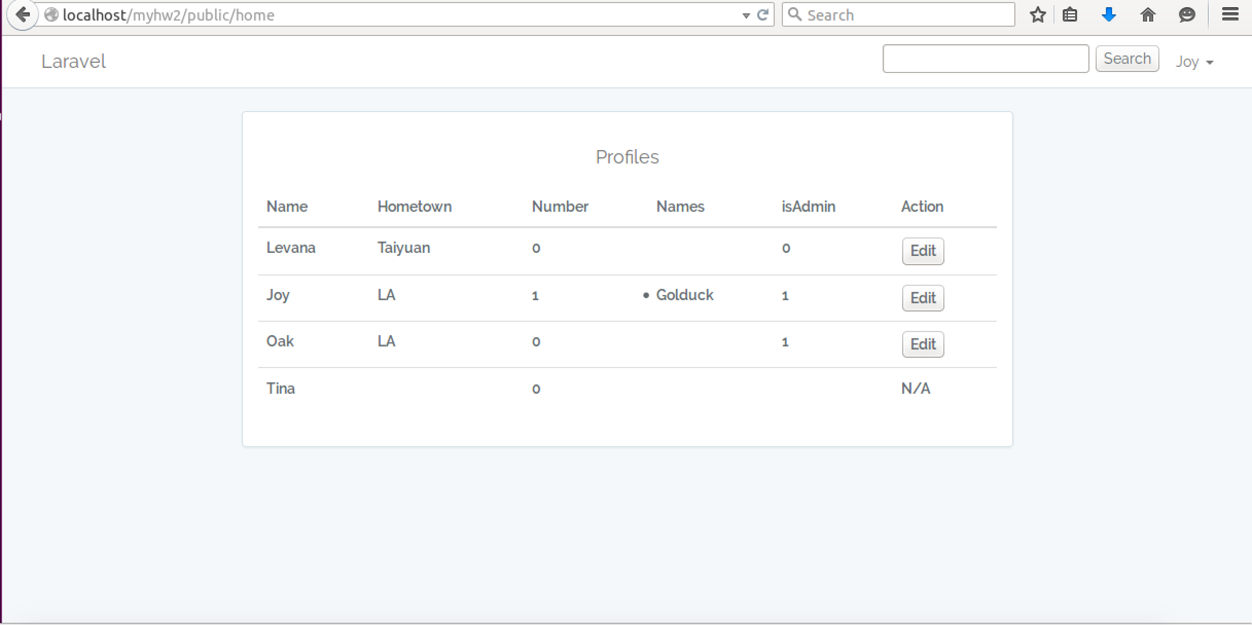

**4.Profile page**

In the Navbar, there is a link to profile page.

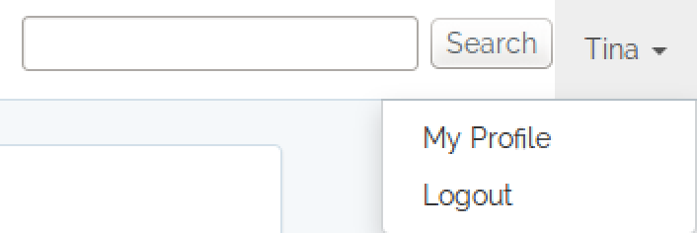

If this trainer hasn’t created her profile yet, once this trainer enters this page, there is a flash message to notify trainer:

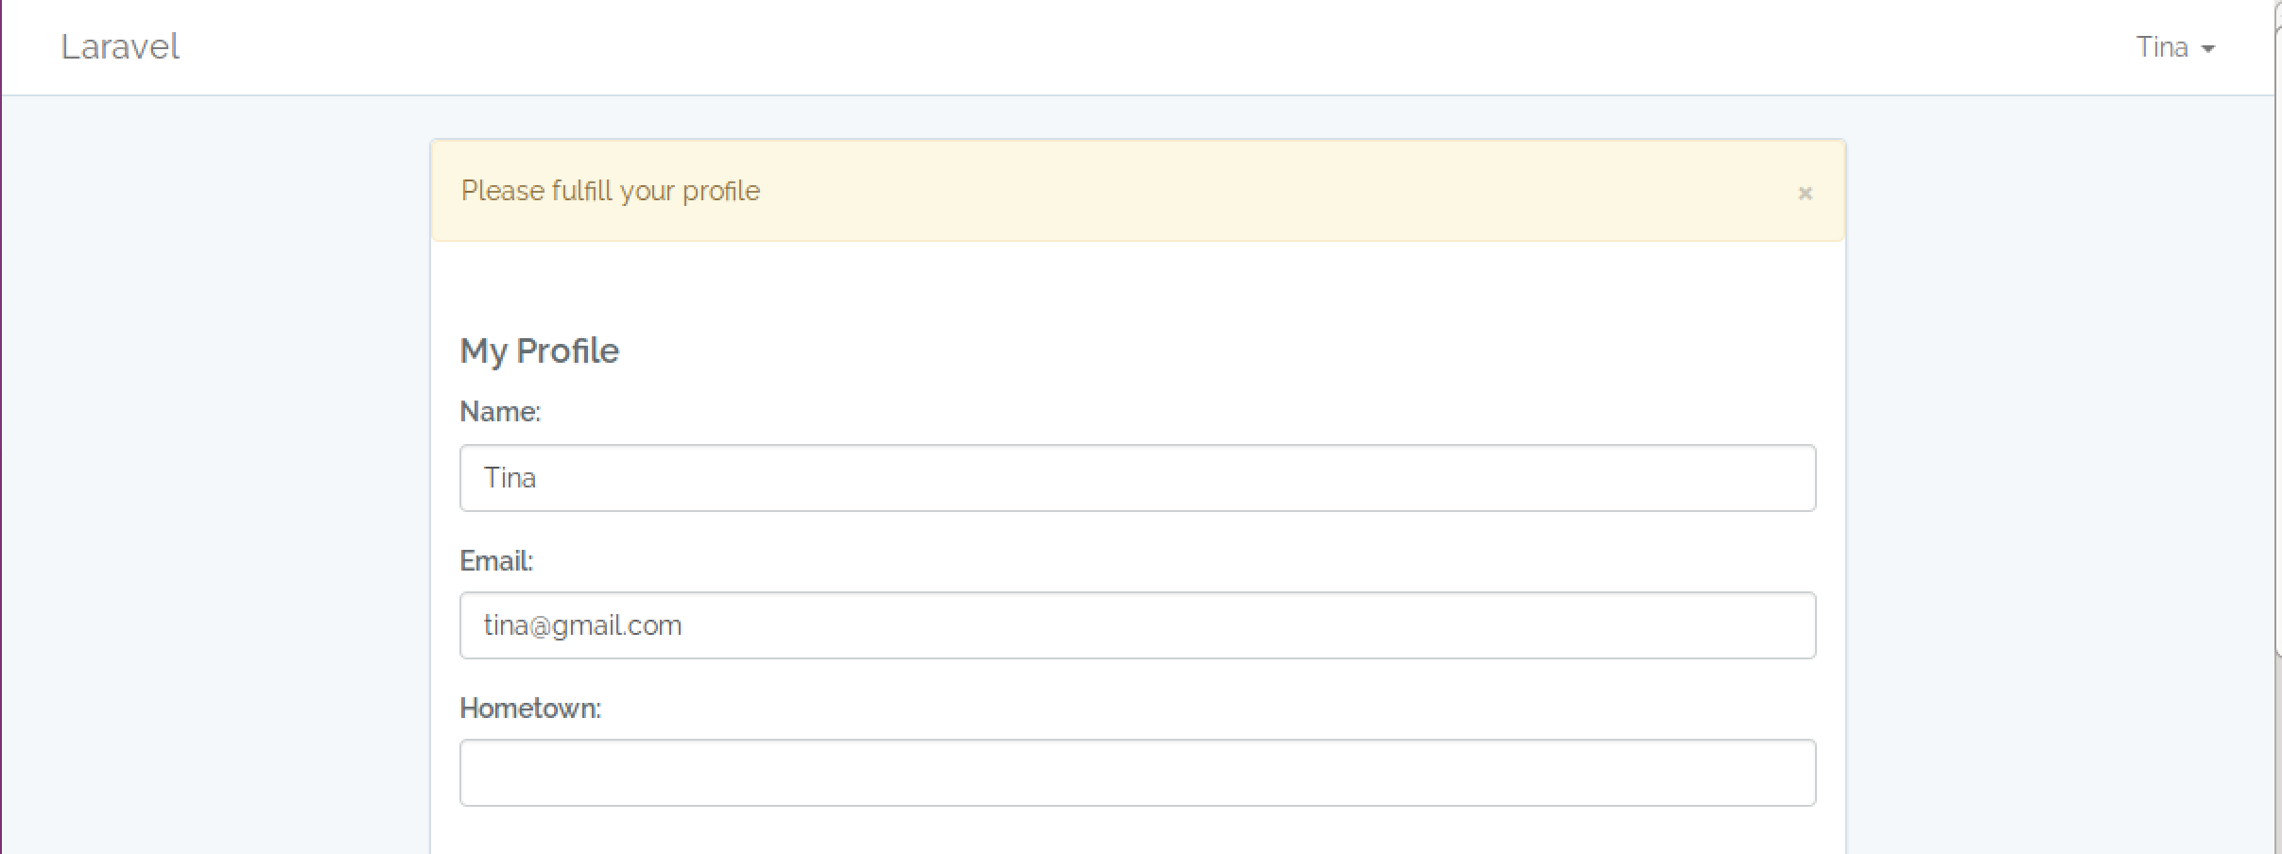

if this trainer has profile, this page will show her profile accordingly:

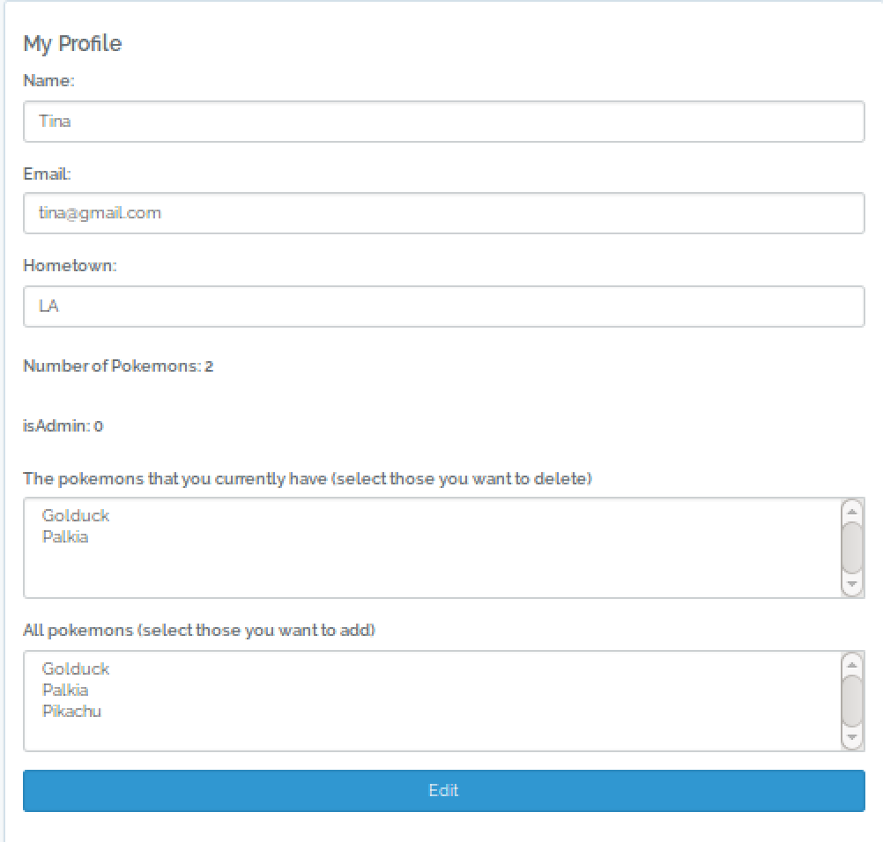

After editing profile, include add or delete pokemon, there will be a flash message on the top of page to notify if edit successfully or fail:



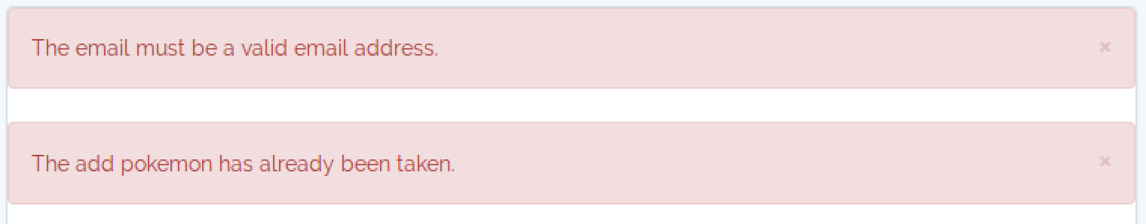

If the current trainer is not an admin, then he/she can’t edit other trainers’ profiles. The edit button won’t show:

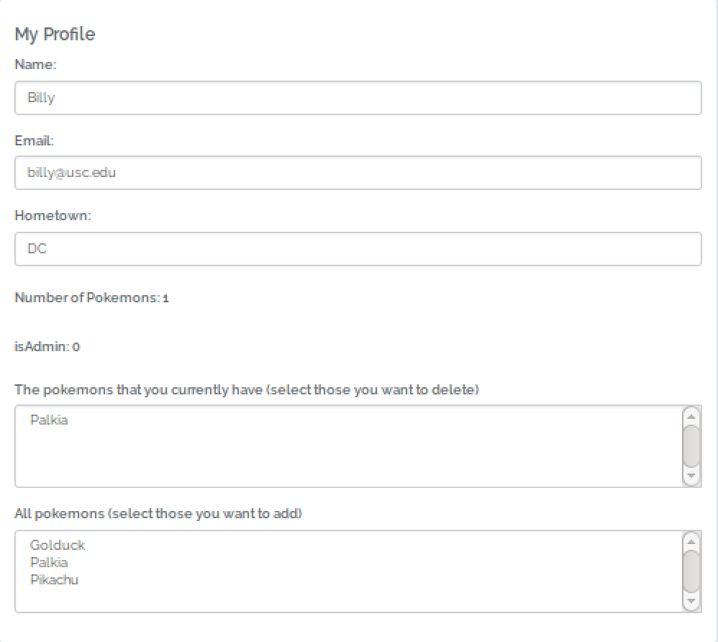

5.Admin page

If current user is an admin, then there is a link in Navbar to admin page:

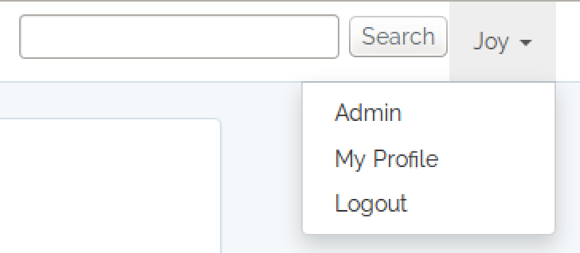

In the admin page:

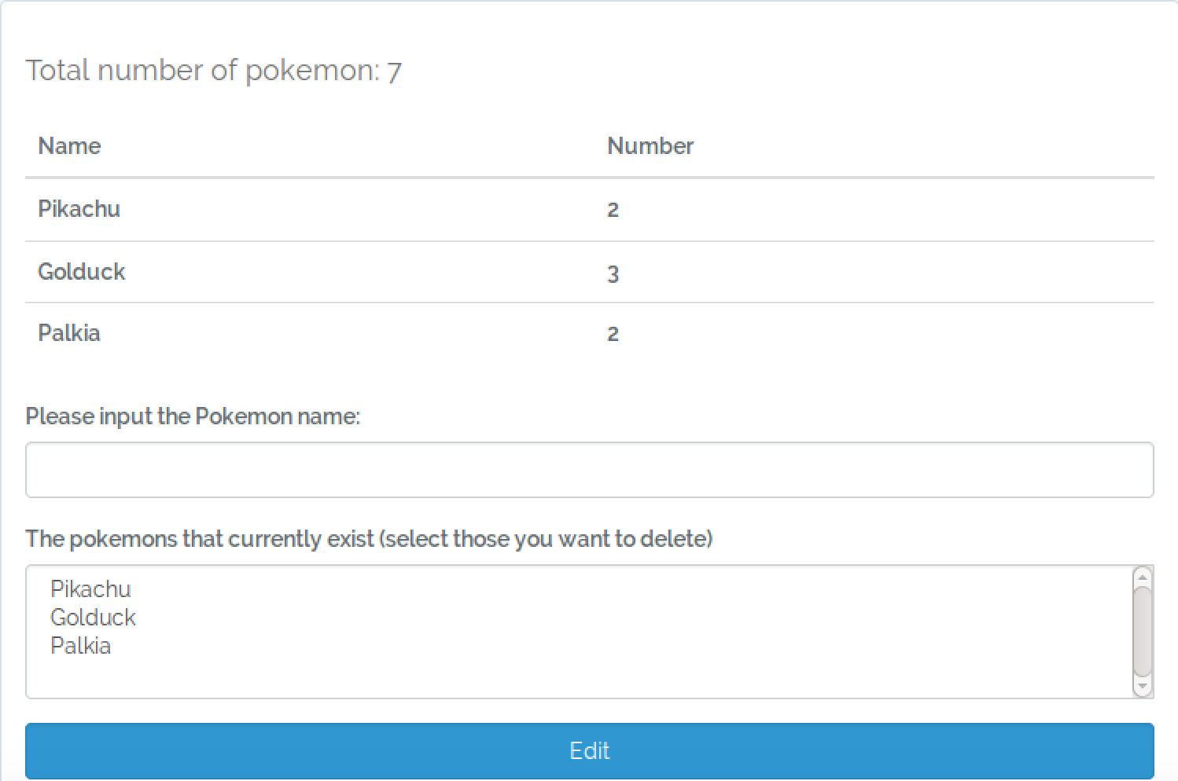

If current trainer is not an admin and try to enter this page, it will show Forbidden:

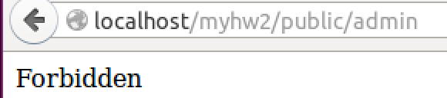

There also have flash messages in the top of page to notify trainer if add or delete is success:





**6.Search Page**

There is a search input on the top of home page:



This search is case-insensitive:

