
International School
Capstone Project 1
Project Proposal
Version 1.0
Date: August 27st, 2026​
Oculide 1.0
The Oculide project – An AI-integrated Monitoring Online Programming Learning & Testing Platform
Date: August 21st, 2026​
Submitted by
Nhi, Tran Thi Yen
An, Le Van
Trang, Huynh Tran Ngoc
Loc, Nguyen Dinh
Long, Pham Van
Approved by
PhD. Dieu, Huynh Ba
Review Panel Representative:
Name Signature Date

Capstone Project 1 - Mentor:
Name Signature Date

Project Code | Document Version | Date | Status
Oculide-2026 | Version 1.0 | August 21st, 2026 | Approved / Proposal

Project Team & Authors
Project acronym | FG
Project Title | Oculide-2026
Start Date | 27 Aug 2026 | End Date | 05 Dec 2026
Lead Institution | International School, Duy Tan University
Project Mentor | PhD. Dieu, Huynh Ba
Scrum master / Project Leader & contact details | Nhi,Tran Thi Yen  Email: nhiyenthitran95@gmail.com  Tel: 0365381549
Partner Organization | Duy Tan University
Project Web URL
Full Name | Student ID / Role | E-mail | Phone
Nhi,Tran Thi Yen | 29204123325/ Scrum master | nhiyenthitran95@gmail.com | 0365381549
An,Le Van | 29211159451/ Team Member | lean80469@gmail.com | 0337629712
Trang,  Huynh Tran Ngoc | 29201125111/ Team Member | tranghuynh120105@gmail.com | 0362871945
Loc ,Nguyen Dinh | 29211162119/ Team Member | nguyendinhloc010605@gmail.com | 0788658021
Long ,Pham Van | 29211156383/ Team Member | phamvanlong050505@gmail.com | 0865073127

Document Approvals
Role | Name | Signature | Date
Instructor / Mentor | TS. Dieu, Huynh Ba | Approved | August 21, 2026
Group Leader | Nhi ,Tran Thi Yen | Signed | August 21, 2026

CONTENTS
1. Introduction 5
1.1 Purpose of the Document 5
1.2 Scope of the Document 5
1.3 Definitions, Acronyms, Abbreviations 6
1.4 References 7
1.5 Overview (Document Structure Overview) 7
2. Project Overview 8
2.1 Background (Project Context) 8
2.2 Business Motivation 9
3.Business Problem Analysis 10
4. Proposed Solution (Oculide's Proposed Solution) 12
4.1 Business Function Diagram (BFD) 13
4.2 System Context Diagram 13
5. Project Objectives 14
5.1 General Objective 14
5.2 Specific Objectives 14
6. Project Scope, Assumptions, and Constraints 15
7. System Architecture and Technology Stack 17
8. Week Implementation Plan 18
9. Estimated Resources and Costs (Resources & Costs - Learning) 20
10. Expected Outcomes 21
Appendices 22
Appendix A: Summary of AI & Sandbox Processing Pipelines 22
Appendix B: Preliminary Project Schedule Summary 23
Appendix C: Initial System Context Diagram & Data Flow 23

1. Introduction

1.1 Purpose of the Document
This Project Proposal Document is prepared according to the international standard IEEE 830-1998 to define the context, objectives, scope of development, system integration architecture, and implementation plan for the Oculide project – an AI-integrated Monitoring Online Programming Learning & Testing Platform.
This document serves as the basis for the technical commitment between the Project Development Team and the Instructor (TS. Dieu, Huynh Ba), guiding the subsequent phases including Requirements Analysis (SRS), System Design, Source Code Implementation, and Acceptance Testing.

1.2 Scope of the Document
This document includes the following core content:
- Current Situation & Issues: An analysis of the educational technology (EdTech) landscape and the vulnerabilities and cheating issues in online programming competitions.
- Proposed Solution: Oculide system architecture with Zero-Setup Monaco IDE, SFU LiveKit WebRTC Streaming, AI Proctoring (YOLOv8 & MediaPipe), and Docker Auto-Grader Sandbox.
- System Design: Business Function Diagram (BFD), System Context Diagram, and SQL Server database design with 13 tables.
- Plan & Resources: A 9-week implementation plan, resource allocation, and expected outcomes.
The documentation does not include detailed source code, AI model retraining algorithms, or instructions for installing physical server hardware.

1.3 Definitions, Acronyms, Abbreviations

Terminology / Abbreviations | Definition / Explanation
IDE | Integrated Development Environment – An environment for editing and executing source code.
SFU | Selective Forwarding Unit – A server that coordinates WebRTC video streams to optimize bandwidth.
AI Proctoring | Computer-based automated exam monitoring system using visual processing (Computer Vision).
YOLOv8 | You Only Look Once v8 – A deep learning model for real-time object recognition.
MediaPipe | Google's computer vision library supports face detection and face landmarks.
Sandbox Container | A completely secure, isolated code execution environment based on the Docker Engine.
RBAC | Role-Based Access Control – A mechanism for controlling access based on user roles.
JWT | JSON Web Token – A decentralized authentication standard based on stateless token encryption.

1.4 References
- IEEE Recommended Practice for Software Requirements Specifications (ANSI/IEEE Std 830-1998).
- LiveKit SFU Open-Source Real-Time Video Architecture Specification (2025).
- Ultralytics YOLOv8 Real-Time Object Detection Framework Documentation.
- FastAPI Async Web Framework & Pydantic Data Validation Standards.
- Microsoft Monaco Editor Browser-based Code Editor Documentation.

1.5 Overview (Document Structure Overview)
The document is structured into 10 main chapters and appendices:
- Chapters 2 & 3: Project overview, business context, and business problem analysis.
- Chapters 4 & 5: Proposed Oculide solution, preliminary architecture, and overall/specific goals.
- Chapters 6 & 7: Defining the In/Out Scope, Assumptions, Constraints, and Multilayer Technology Architecture.
- Chapters 8, 9 & 10: Nine-Week Planning, Resource and Cost Estimation, and Expected Results.

2. Project Overview

2.1 Background (Project Context)
In Information Technology (IT) training, practical sessions in the computer lab are a core activity aimed at improving students' coding skills. However, traditional lab management currently reveals two major obstacles:
- Limitations in progress tracking and learning support: With dozens of students in a class, it is difficult for instructors to simultaneously monitor the work process, leading to delays in detecting students who make errors (stuck code) or lose focus.
- The challenge of monitoring in isolated exam environments: When conducting assessments or exams in person in a lab, schools often choose to restrict internet access (restricted LAN) to prevent the use of reference materials or AI (ChatGPT). While this solution blocks online cheating, instructors still face significant difficulties in monitoring physical cheating outside the screen (such as using a mobile phone hidden under a desk, turning to look at a nearby computer, or seeking direct assistance).
To thoroughly address these barriers, Oculide was researched and developed as a unified laboratory management and monitoring platform , capable of operating flexibly in both online and local area network (LAN/Offline-First) environments according to two main operating scenarios:
- During daily learning and practice sessions (Support & Privacy Respect): The system acts as an intelligent teaching assistant. Instructors visually monitor the coding progress and automated test case results of the entire class via a centralized dashboard. In this scenario, the system completely disables cameras and AI monitoring , creating a comfortable and relaxed atmosphere for students.
- During official exams and tests (Transparent & Automated): The system activates Multi-Dimensional Monitoring mode (Screen + Camera + AI Proctoring) . The AI processes directly on the LAN network infrastructure to automatically identify unusual behaviors ( looking down at a phone, losing sight of someone, presence of a second person, unusual gaze direction ) without relying on an external internet connection, and automatically blurs the background to protect students' personal space.

2.2 Business Motivation
The Oculide project was created to provide a comprehensive solution to meet the needs of modernizing programming training for universities and educational institutions, based on three main motivations :

1. Optimal User Experience
- Monaco IDE provides a browser-based programming environment with a zero-setup mechanism , allowing students to start working on assignments immediately without spending time configuring a complex environment.
- Web Workers applications handle DOM events and snapshots directly at the client machine, ensuring smooth, lag-free coding even while streaming monitoring data.
- Instant scoring results (<200ms) are provided thanks to the automated code grading mechanism, enhancing proactiveness and feedback in learning.

2. Automated & Fair Proctoring
- Integrating advanced AI Computer Vision models ( YOLOv8n ONNX format & MediaPipe Face Mesh ) optimizes inference speed, enabling automatic detection of physical cheating and providing real-time alerts to supervisors.
- Combined with the LiveKit SFU (Adaptive Simulcast Profile) video streaming server , it enables multi-directional surveillance video streaming with extremely low latency, ensuring absolute transparency for exams without overwhelming the invigilators.

3. Infrastructure Security & Cost Efficiency
- Resource & Bandwidth Optimization: Applying intelligent video resolution (180p compression for the entire Grid View matrix, only upscaling to 720p when the Supervisor zooms in for inspection), saving up to 80% of LAN/WAN network bandwidth.
- Absolute server security: Completely isolate the student submission compilation environment using Docker Warm Pool combined with gVisor Runtime , thoroughly preventing risks of malware attacks, execution of dangerous commands, or privilege escalation (Container Escape) to take over the server.
- Leveraging existing infrastructure: This helps schools make the most of their existing computer labs without incurring additional costs for expensive specialized hardware.

3.Business Problem Analysis
Based on surveys of actual programming competitions, the project team has compiled four core business problems and their serious consequences:

Problem | Description (Detailed description) | Consequence
Sophisticated Cheating in the Programming Contest | Students can easily switch browser tabs to search Google/ChatGPT, copy and paste code from external sources, or use their personal phones and ask someone sitting next to them to help solve it. | This leads to inaccurate assessments of actual competence, a loss of academic fairness, and a decline in the reputation of the training program.
Bandwidth and Video Stream Server Bottleneck | When 50-100 students simultaneously turn on their webcams to stream live HD video to the instructor's computer, bandwidth becomes congested and the server's CPU becomes severely overloaded. | The monitoring interface was laggy and the camera stream connection was interrupted, preventing the instructor from monitoring the exam room.
Risk of Infrastructure Leaks & Attacks from Student Code | Code submitted by students to the server, if executed directly on the host operating system, may contain malicious code (deleting files, running endless loops that consume RAM/CPU, network attacks). | The server crashed, posing a risk of root access or leakage of exam data and personal information.
Proctoring Fatigue | Supervisors cannot simultaneously manually monitor dozens of small camera screens to detect glances away or hidden cheating attempts. | Many cases of cheating are overlooked, causing fatigue and stress for instructors, but the effectiveness of supervision is not high.

4. Proposed Solution (Oculide's Proposed Solution)
Oculide proposes a comprehensive integrated solution model consisting of five core components:
1. Zero-Setup Web IDE: Integrates Monaco Editor (the core of VS Code) supporting multi-language syntax highlighting (Python, C++, Java), basic code suggestions, and automatically reports browser violation events (blur, tab switch, paste event).
2. SFU WebRTC Live Streaming: Use LiveKit SFU to receive video camera streams from students and distribute them to the instructor's Panoptic Grid View interface via Simulcast (view grid at 160p, click to view details at 720p).
3. AI Proctoring Engine: Captures snapshots every 15-30 seconds and sends them to AI Workers (combining YOLOv8 for phone/object detection and MediaPipe for face/gaze detection). When a violation is detected, the system immediately sends a notification via WebSocket.
4. Secure Docker Auto-Grader Sandbox: Place the project code in the Redis queue, Celery Worker retrieves the code and initializes a Docker Container that disconnects from the network (--network none), limiting CPU/RAM for secure test case grading.
5. Centralized Database & Analytics: A SQL Server database with 13 tables storing all tightly related data (Users, ExamRooms, Questions, TestCases, Submissions, Violations, LiveKitTokens).

4.1 Business Function Diagram (BFD)

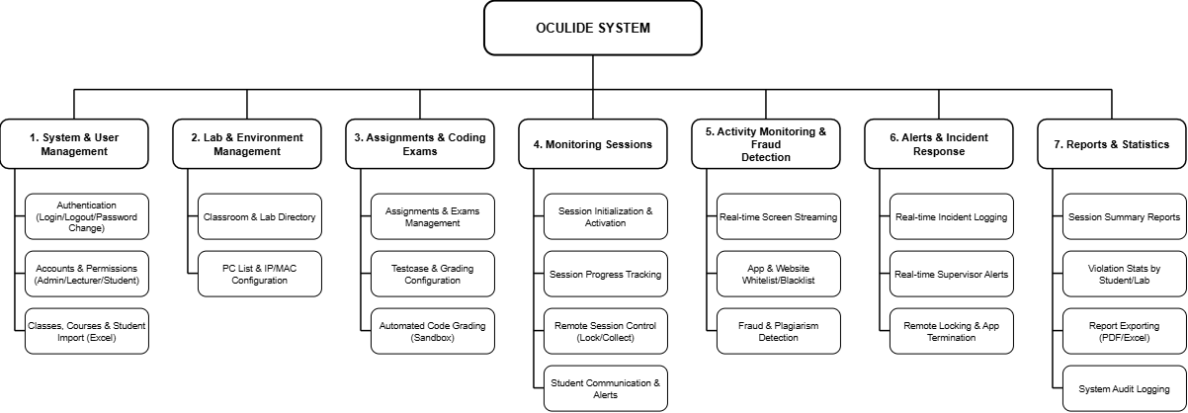

4.2 System Context Diagram

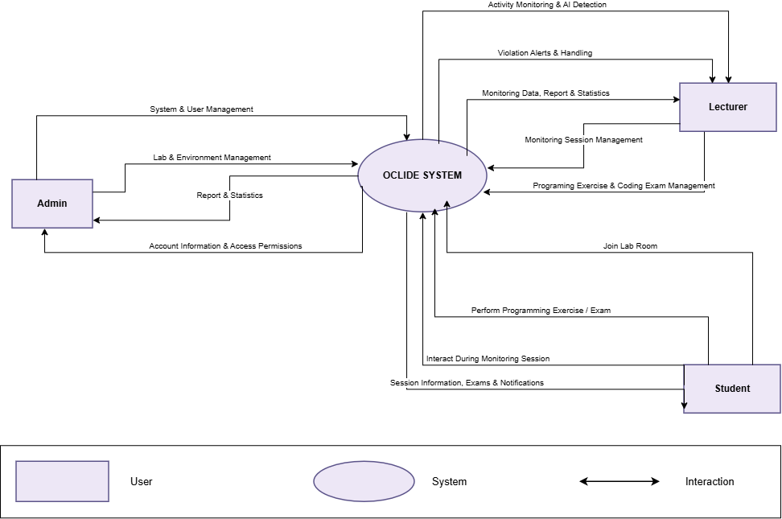

5. Project Objectives

5.1 General Objective
Successfully built the 'Oculide' web application system, integrating a browser-based coding environment, automated scoring in a Docker Sandbox, and a real-time AI-powered exam monitoring system using WebRTC cameras, without overloading server infrastructure resources.

5.2 Specific Objectives
1. Detailed Database Design: Detailed analysis of business requirements and design of a standard relational database on SQL Server, including 13 core tables (Users, ExamRooms, ExamQuestions, TestCases, Submissions, ViolationLogs, LiveKitTokens...).
2. Building the Monaco Web IDE: Developing a web interface for exams that integrates the Monaco Editor, supporting multilingual coding, automatic tab switching event handling, full-screen exit, and copy-paste blocking.
3. Integrated SFU Video Streaming: Integrating the LiveKit SFU server allows streaming student camera footage to the instructor's Panoptic Grid View using a bandwidth-optimized Simulcast mechanism.
4. AI Proctoring Development: Develop an AI Proctoring service integrating YOLOv8 and MediaPipe to automatically detect fraudulent activities (using phones, face-snatching, multiple people) and issue alerts via WebSocket.
5. Docker Auto-Grader Programming: Develop a secure auto-grader engine using Celery, Redis Task Queue, and Docker Sandbox Containers to completely disconnect from the internet.
6. Security & RBAC Integration: Set up JWT authentication and granular authorization (RBAC) for 3 roles: Admin, Instructor, Student.
7. Completing Statistics & Reporting: Implementing a user-friendly interface for instructors to generate statistical reports on exam results, scoreboards, and violation logs (Violation Logs Analytics).

6. Project Scope, Assumptions, and Constraints

Category | Content Details
In-Scope | - Develop a complete web application (Frontend Next.js/ReactJS + Backend Python FastAPI).  - Integrate the Monaco Editor code editor into the browser. - Integrate the LiveKit SFU video streaming server to support Panoptic Grid View. - Build an AI Proctoring Worker (YOLOv8 + MediaPipe) to analyze webcam image snapshots. - Develop an automated code proofreading system using Docker Sandbox Containers. - Build a SQL Server database with 13 tables to store system integrity information.
Out-of-Scope (Not performed) | - Do not build a native mobile application (iOS/Android App).  - Do not retrain the YOLOv8 model from scratch; instead, use pre-trained weights and fine-tuning. - Do not modify or interfere with the existing school LMS system; it operates as a standalone platform.
Assumptions (Project Assumptions) | - The student's browser supports HTML5, WebRTC, and has a fully functional webcam.  - The backend server has Docker Engine installed and sufficient privileges to allocate isolated containers.
Constraints | 1. Sandbox Security Constraint: Student-submitted source code must only run in a network-unconnected Docker container (--network none) and with a RAM limit of <= 512MB.  2. Bandwidth Optimization Constraint: AI snapshot submission frequency is limited to 15–30 seconds/time to avoid Celery queue congestion. 3. Database Integrity Constraint: All relational data must be strictly managed using foreign key constraints in SQL Server.

7. System Architecture and Technology Stack
The Oculide system is designed with a Microservices & Event-Driven architecture integrating 6 layers of modern technology:
Subsystem / Layer | Technology (Technology used) | Description (Role & Function)
Frontend | Next.js 14 + Monaco Editor + Web Workers | Freeing up the Main Thread UI helps to improve the coding experience by eliminating lag when sending snapshots and handling DOM events.
Backend API | FastAPI (AsyncIO) + Redis Pub/Sub | Centralized WebSocket connection management allows for system scaling to multiple backend instances as the exam room size increases (Horizontal Scaling).
Streaming SFU | LiveKit SFU + Adaptive Simulcast Profile | Compress the stream size from students to an extremely low level (180p) for Grid View, only automatically activating 720p when the invigilator zooms in to inspect the student.
AI Proctoring Engine | YOLOv8n (ONNX Format) + MediaPipe Face Mesh (Head Pose/Gaze Tracking) | Converting to the ONNX/TensorRT format speeds up inference by three times; it also adds head angle and eye direction calculations to detect document/secondary screen viewing.
Auto-Grader Sandbox | Celery + Docker Warm Pool + gVisor Runtime | Warm Pool enables ultra-fast grading (<200ms); gVisor completely prevents the risk of Container Escape gaining root access to the server.
Database & Cache | SQL Server (Partitioning/Indexes) + Redis Cache | Use Redis to store exam room states in real-time to reduce I/O pressure on the SQL Server database.

8. Week Implementation Plan
The project is scheduled over 12 weeks, aligning with the Integrated Systems Practice course framework:
Week | Case Study / Phase | Deliverables (Products) | Key Activities
1–2 | Case Study 1: Proposal & Scope | Project Proposal Document (IEEE 830-1998), System Requirements | Analyze the problem, identify system requirements, create BFD and Context Diagrams, and agree on the Oculide architecture.
3–4 | Case Study 2: Database & Design | Database Schema SQL Server, UI Mockup, Monaco Editor Integration | Design a 13-table database schema, write DDL scripts, build the UI using Next.js, and integrate the Monaco Editor into the browser.
5-6 | Case Study 3: API & SFU LiveKit | FastAPI Core REST APIs, LiveKit Token Service, JWT Auth | Develop REST APIs (Users, Rooms, Questions), integrate LiveKit Server to issue video streaming tokens.
7-8 | Case Study 4: AI Proctoring & WS | AI Snapshot Analyzer (YOLOv8 + MediaPipe), WebSocket Alert Hub | Develop an AI worker that analyzes webcam images and sends real-time violation notifications via WebSocket to the supervisor.
9-10 | Case Study 5: Auto-Grader Sandbox | Celery Queue Engine, Docker Execution Sandbox, Testcase Runner | Develop an automated grading system using Celery + Docker Container, disconnect from the network, and save the grading results.
11 | Integration & Optimization | System Integration Package, Performance Benchmark Report | Reduce snapshot frequency, optimize WebSocket broadcasts, perform load testing, and secure Docker containers.
12 | Final Submission & Demo | Final Product Package, User Documentation, Presentation Slides | Package the Docker Compose, finalize the user manual and the project summary report.

9. Estimated Resources and Costs (Resources & Costs - Learning)
All software resources and infrastructure for the Oculide project are optimized using open-source and free tools intended for educational purposes:
Resource | Description (Detailed description) | Cost
Human Resources | The project was carried out by a team of 5 students (Fullstack Leader, Backend & DB Developer, AI Specialist, Frontend & SFU Developer, QA/BA Specialist). | 0 VND (Student effort)
Development IDE & Tools | Visual Studio Code, PyCharm, Docker Desktop, SQL Server Management Studio | 0 VND (Free / Open-Source)
AI & Computer Vision | Ultralytics YOLOv8 Pre-trained Model, Google MediaPipe SDK, OpenCV Python | 0 VND (Open Source)
Streaming & Database | LiveKit SFU Server Community Edition, SQL Server Express, Redis Community Edition | 0 VND (Self-deployment Local/Docker)

10. Expected Outcomes
Upon completion of the Oculide project, students will achieve important theoretical and practical results:
1. Master Integrated Architecture: Gain a solid understanding of how to design multi-tiered integrated system architectures combining Web Frontend, RESTful API, Streaming SFU, AI Workers, and Sandbox Containers.
2. Proficient in Database Administration: Successfully designed and implemented a standard SQL Server relational database with 13 tables, optimized Stored Procedures, and Views for performance.
3. Mastering WebRTC Streaming: Master the technique of streaming WebRTC video from a panoptic grid perspective using an SFU LiveKit server with Simulcast stream compression.
4. Application of AI Computer Vision: Successful application of advanced computer vision models (YOLOv8 & MediaPipe) to solve the problem of real-time exam cheating monitoring.
5. Sandbox Container Security: Successfully executing student source code in a Docker Sandbox environment completely isolates the host operating system from security risks.
6. Complete Product Implementation: Develop a complete Oclide Web Application that solves a real-world problem in online programming learning and testing.

Appendices

Appendix A: Summary of AI & Sandbox Processing Pipelines
Appendix A summarizes the two core processing steps of the system:
• AI Proctoring Pipeline Process: Frontend captures a 320x240 canvas snapshot (JPEG quality 0.5) -> Sends it via WebSocket API -> AI Worker (YOLOv8 + MediaPipe) analyzes it -> If cheating is detected (phone, 2 people, no presence) -> Pushes a Violation Alert to the WS Hub -> Displays a red frame on the Supervisor Dashboard.
• Sandbox Auto-Grader Pipeline Process: Students Submit Code -> API Push Task to Redis Queue -> Celery Worker Retrieves Task -> Initializes Docker Container with Network Interruption (--network none, memory 512m) -> Runs Test Cases -> Collects Pass/Fail Results and Time -> Deletes Container -> Saves GradingResults to SQL Server.

Appendix B: Preliminary Project Schedule Summary
12- week timeline focuses on completing the project sequentially, from Architecture, Database, Core API, SFU Streaming, AI Worker, Docker Sandbox, to Optimization and Demo Packaging.

Appendix C: Initial System Context Diagram & Data Flow
The Oculide system context diagram documentation confirms consistency and a smooth, bidirectional data flow between student, faculty, and integrated service infrastructure actors.

