BÀI TẬP TƯƠNG TÁC VỚI GCS

Đăng nhập vào gg cloud:

Lấy crediential để có thể chạy code trên máy local:

gcloud auth application-default login

```

Update gcloud

gcloud components update

```

Update setting về vùng

gcloud config set compute/region asia-east1

```

### Nếu bạn có nhiều account và project

List Account và project

```

gcloud auth list

gcloud projects list --sort-by=projectId

Set Account và Project

gcloud config set account ACCOUNT_EMAIL

gcloud config set projects PROJECT_ID

```

Nếu sử dụng service account nên cấu hình environment variable tới

GOOGLE_APPLICATION_CREDENTIALS

```

set GOOGLE_APPLICATION_CREDENTIALS="path/to/service/account"

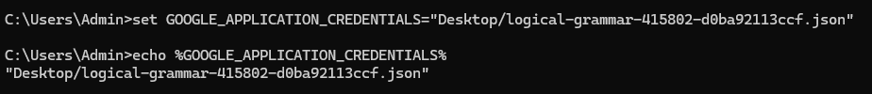

Thao tac voi gs:

* Tai thu vien

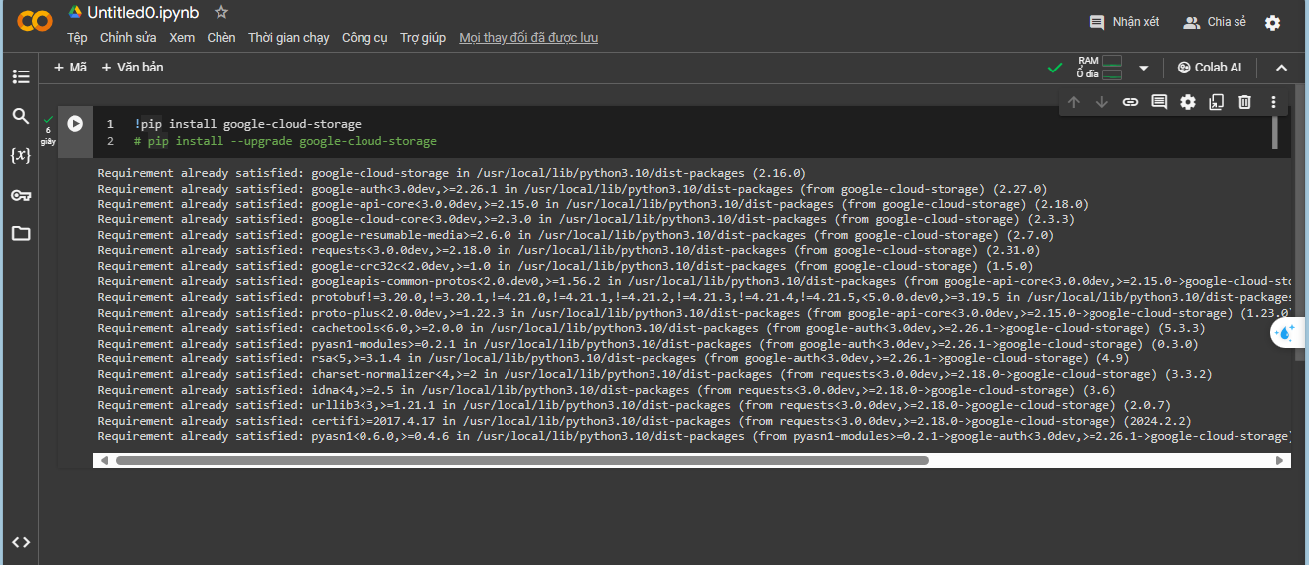

* Updata thu vien

* Chay kiem tra

* Xac thuc voi gg va chon project de su dung

* Tao mot client

* Tao bucket

* Tai tep len bucket

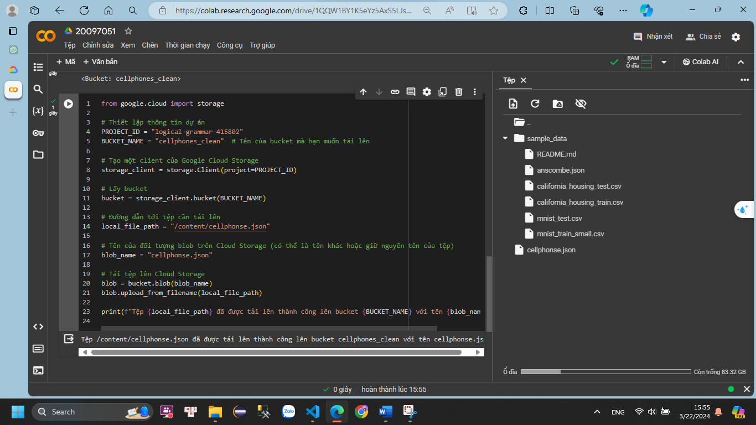

* Kiem tra

* Dowload file ve may

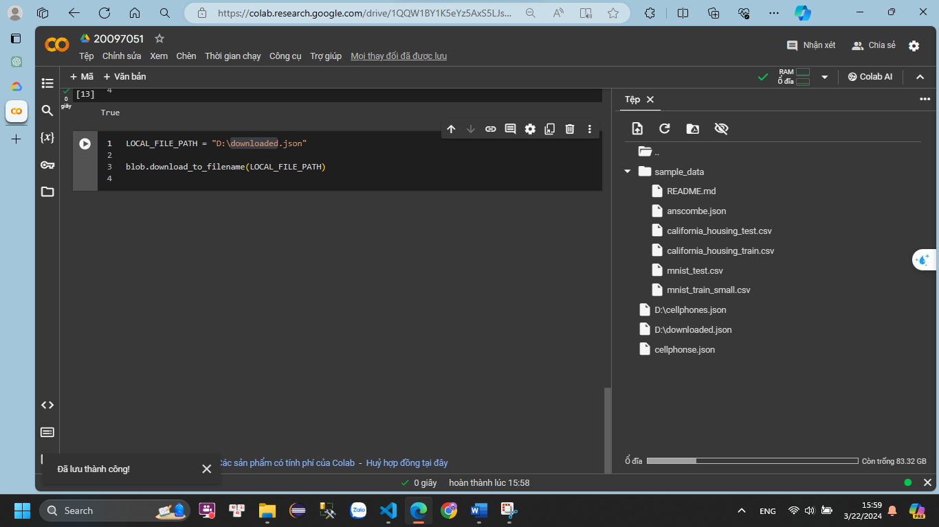

* Tai thu vien pandas va pyarrow

* Doc file json da tai ve

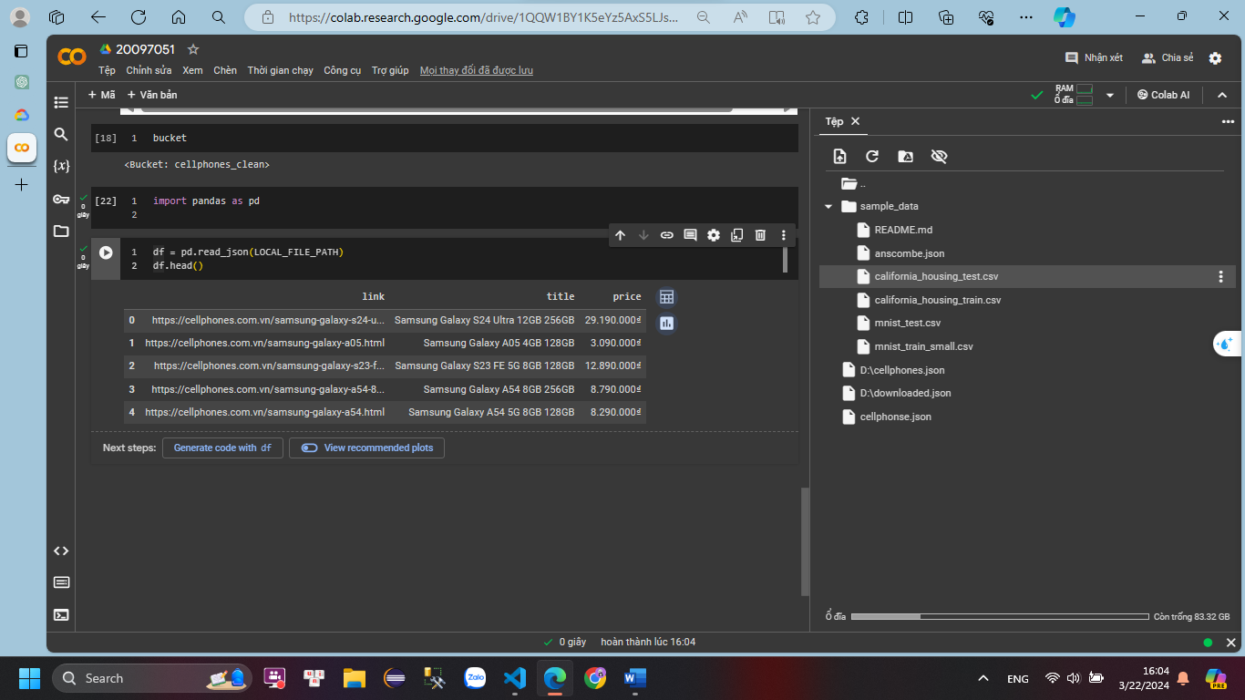

* Tai tep len bucket

