THAO TAC VOI MONGODB

* KET NOI VOI MONGODBA screenshot of a computer screen

  Description automatically generated
* Di chuyen den database va collections can tuong tac

* Xem toan bo du lieu

* Tim kiem theo id

* Tim kiem theo title

* Dem so luong document

* Them du lieu

* Xoa du lieu

* Cap nhat du lieu

* Sap xep theo price

* Tong gia tri cac san pham

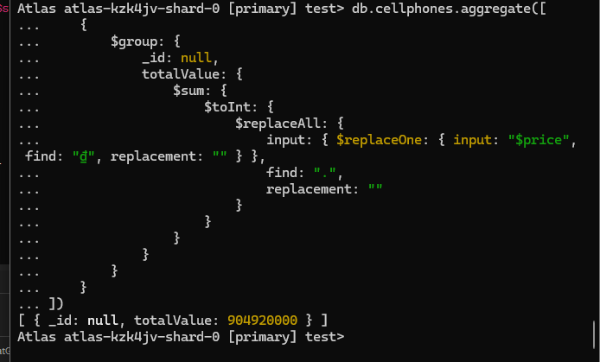

* So san pham tren 20tr

