1. Log in google cloud

1. Set project

1. Get bucket

1. Upload file to bucket

1. Use pandas to read json file

1. Convert from json to table

1. Convert from table to parquet

1. Upload parquet file to bucket

1. Create cluster

1. Use spark to read parquet file

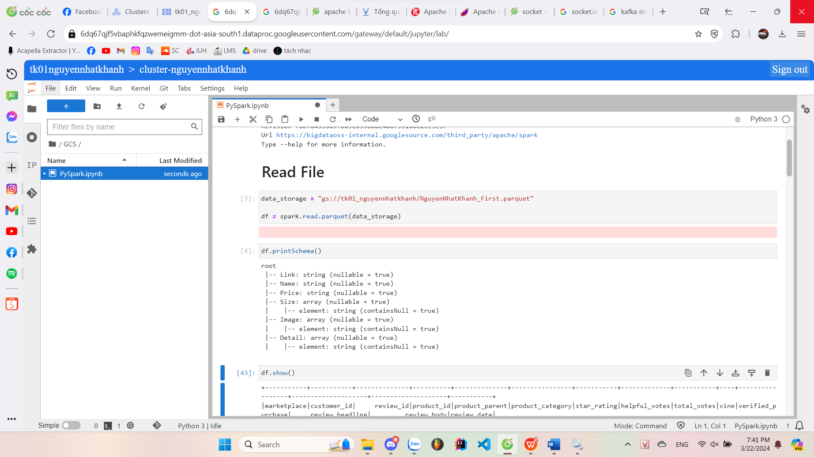

1. Some analysis query

