Cài đặt thư viện

  
xác thực tài khoản

Lấy project

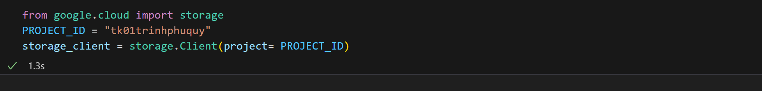

Đẩy file .json lên google cloud

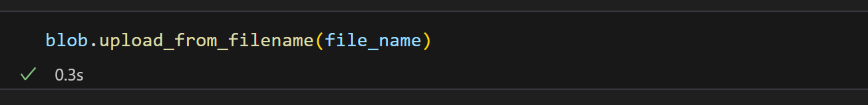

Đọc file json theo dạng parquet

Tạo file parquet từ table vừa đọc

