Init spark

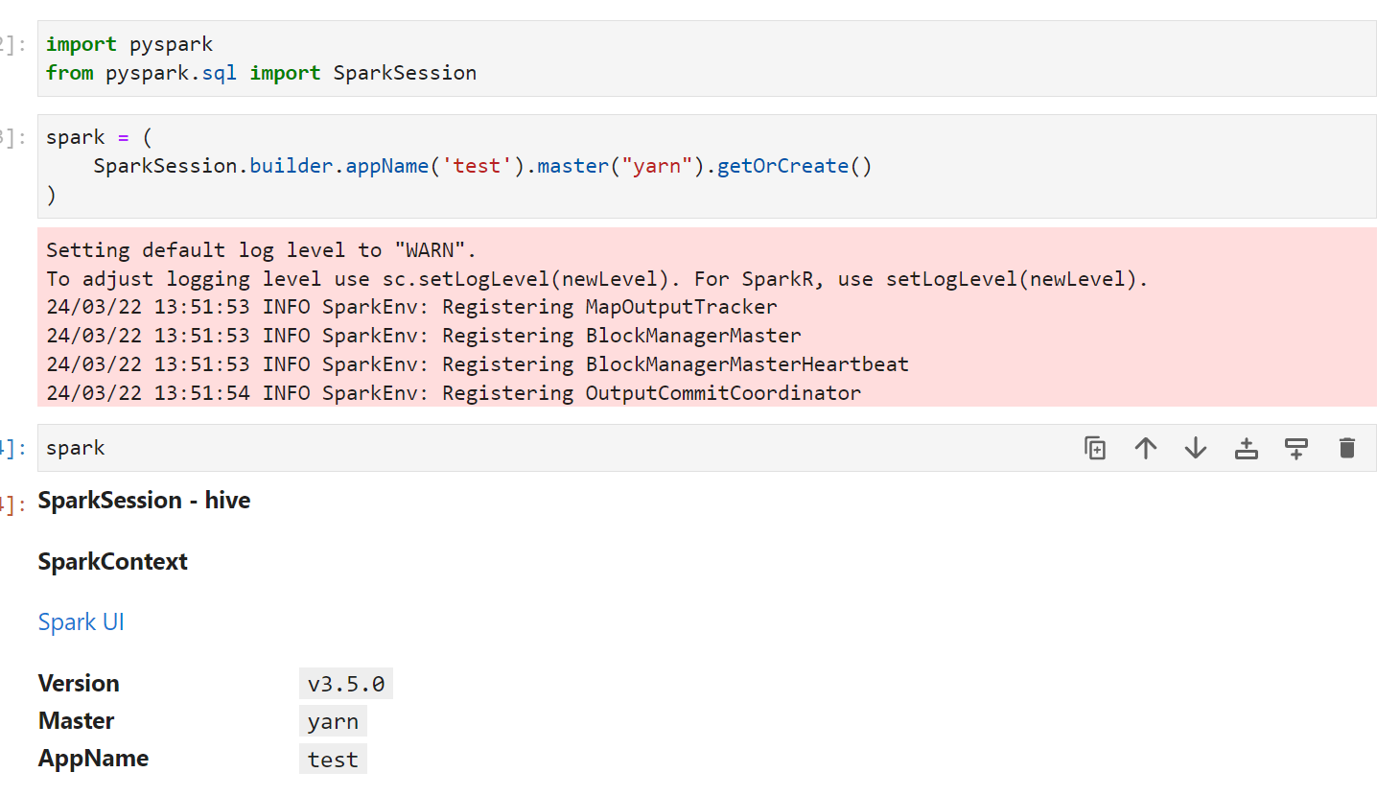

Read file

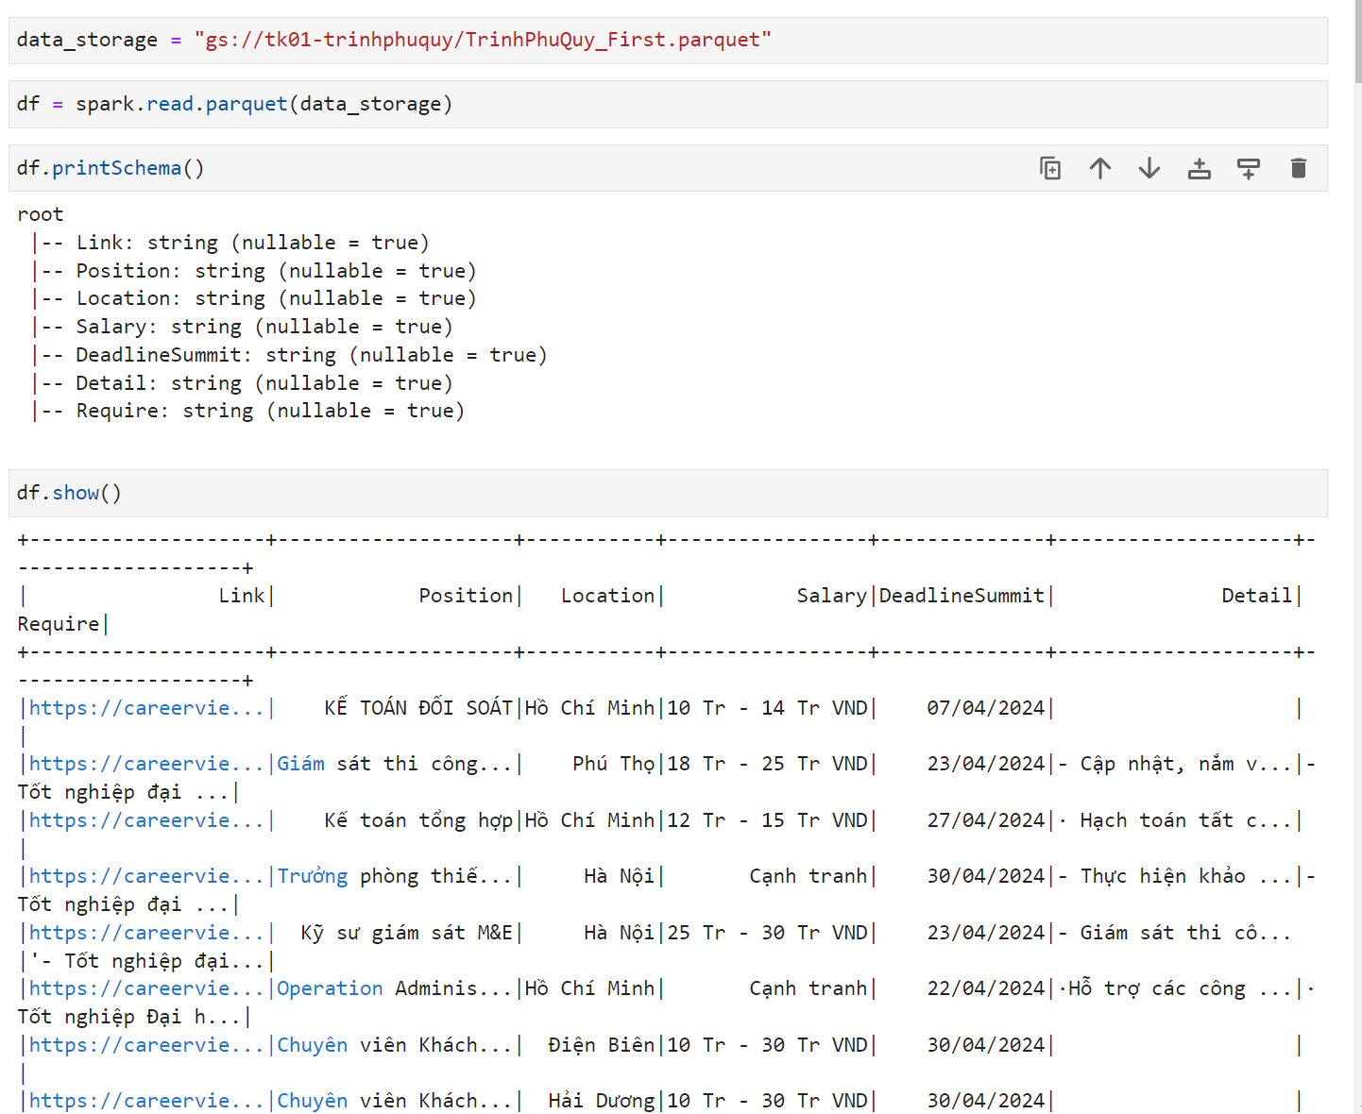

Read with schema

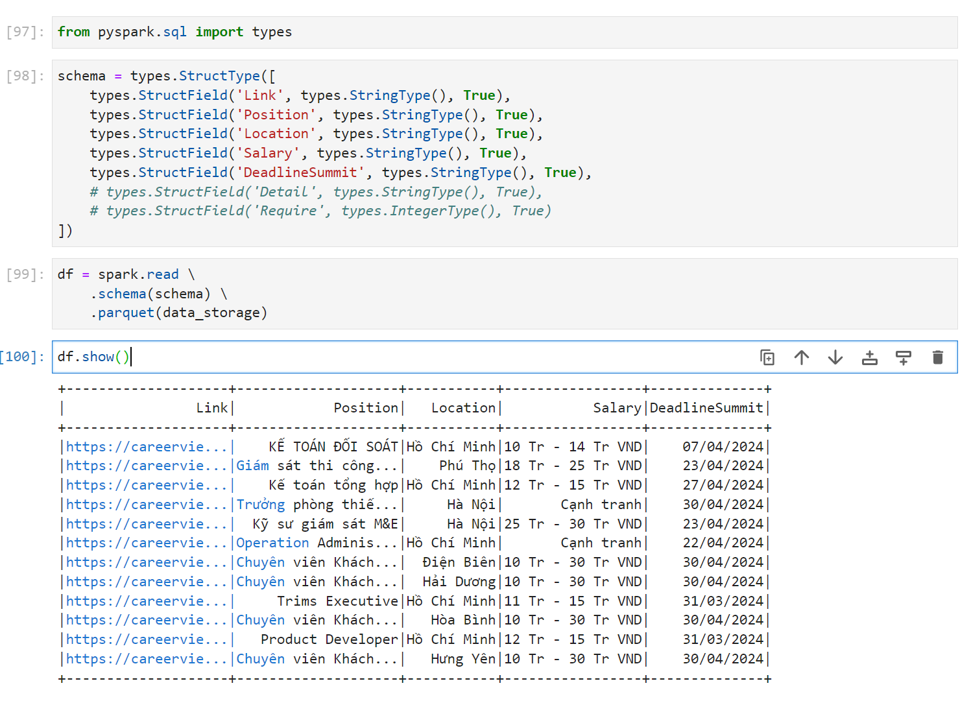

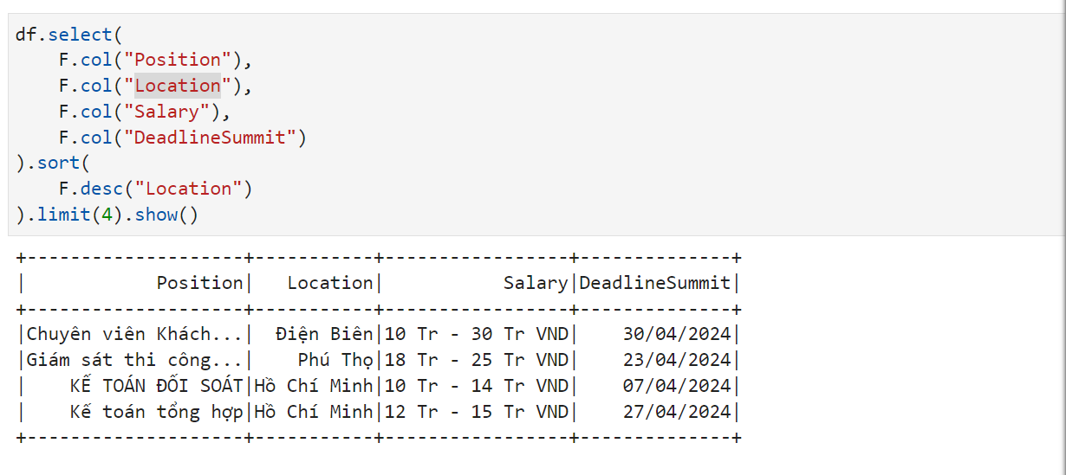Spark SQL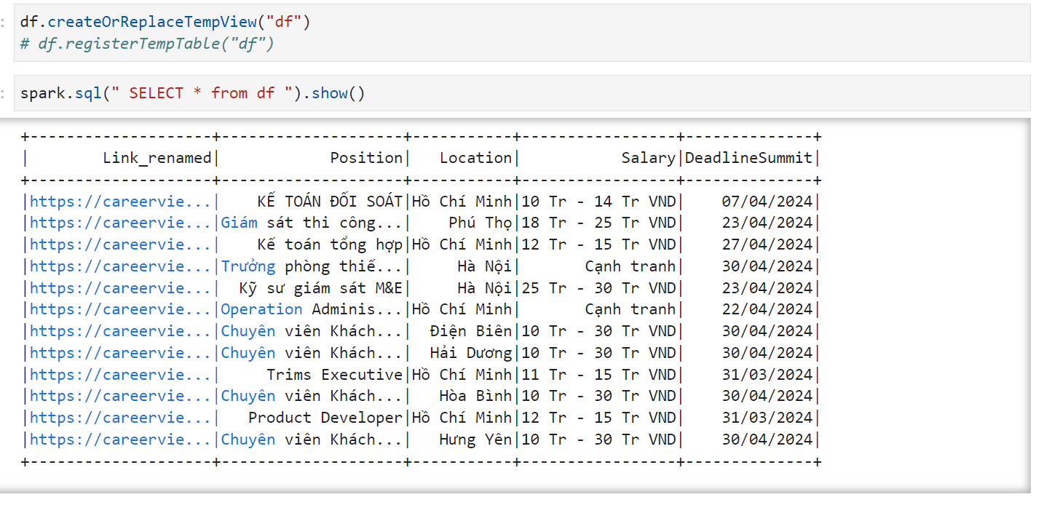

Ghi kết quả ra file parquet

