

**Software Requirements Specification**

**Nike Plus e-commerce website**

**Version: 1.0**

– DANANG, Jan 2025 –

Table of Contents

**1.DOCUMENT HISTORY** 4

**2.** **REFERENCE DOCUMENTS** 4

**3.** **DISTRIBUTION LIST AND APPROVALS** 4

4. INTRODUCTION 5

**5.** **OVERVIEW** 5

5.1 Actor 5

5.2 Use Cases 6

**5.3. System Pages Flow** 8

6. Common Functions 8

6.1 View Common Feature Authentication 8

6.1.1 Login 8

6.1.2. Sign Up 10

6.1.3 Sign Out 12

6.1.4 Forgot Password 13

6.1.5 **Change password** 15

6.2. View Common Feature as Guest and Buyer 16

6.2.1 View home page 16

**6.2.2** View sneaker details 17

6.2.3. List Products by price and ratings 18

6.2.4. List products by release date 19

6.2.5 List all Sneaker 20

6.2.6. Sneaker Review 21

6.2.7. Update Profile 22

6.2.8 View Sneaker Purchase History 24

6.3 View Common Feature as Admin 25

6.3.1 View Admin Dashboard 25

6.3.2. Add new sneaker 26

6.3.3 Delete,Update sneaker 27

6.3.4 View Sneaker Dashboard 28

6.3.5. Search Sneaker 29

6.3.6. Update/Delete Account 31

7. Appendix 32

7.1. Assumptions & Dependencies 32

7.2. Limitations & Exclusions 32

7.3. Business Rules 33

# 

# **1.DOCUMENT HISTORY**

|  |  |  |
| --- | --- | --- |
| Date | Summary of Changes | Version |
| 19/1/2025 | Create the first version of SRS | 1.0 |
|  |  |  |

# 

# **2.** **REFERENCE DOCUMENTS**

|  |  |
| --- | --- |
| Document Name | Description |
| SRS_Sample | Refer to the sample SRS |
| Use Case Diagram | Refer to how to draw Use Case diagrams |
| UML Activity diagram | Refer to how to draw Systems Pages Flow diagram |
| Instructions for using Mockups | Refer to how to sketch the interface |

# 

# **3.** **DISTRIBUTION LIST AND APPROVALS**

|  |  |
| --- | --- |
| Name | Title |
| Nguyễn Thị Hiếu | 4. Introduction |
| Đặng Văn Mích | 5. Overview |
| Lê Văn Huy | 6. Functional Description |
| Nguyễn Khánh | 7. Non-functional Requirements and Others  Tổng kết |

# 4. INTRODUCTION

**4.1. Purpose**The purpose is to build a **Nike Shoes Store Management System** with the following objectives:

* Provide all basic features to meet the needs of different user roles.
* Deliver an intuitive and user-friendly interface.
* Ensure security and access control, allowing each user type to access only their designated functionalities.

Through this project:

* Understand the implementation process of a software project following a standardized workflow.
* Develop teamwork skills to enhance the learning experience.

**4.2. Scope**The scope of the Nike Shoes Store Management System project:

* Applicable for small to medium-sized retail shoe stores.
* Aligns with the limitations and requirements of the course project.

# 

# **5.** **OVERVIEW**

## 5.1 Actor

|  |  |  |
| --- | --- | --- |
| **#** | **Actor** | **Description** |
| 1 | Admin | -Manage the entire system and content on the website.  -Have access and perform administrative functions such as adding, editing, -deleting information, users, articles, products, etc.  Ensure security, information confidentiality and resolve technical issues. |
| 2 | Guest | -The user is not logged in or does not have an account on the website.  -There is usually only access to some basic parts of the website without logging in.  -Cannot perform special functions or create content. |
| 3 | Customer | -Users have registered accounts on the website and usually have full access.  -Can perform activities such as making purchases, ordering services, posting articles, interacting with the website, etc. |

## 5.2 Use Cases

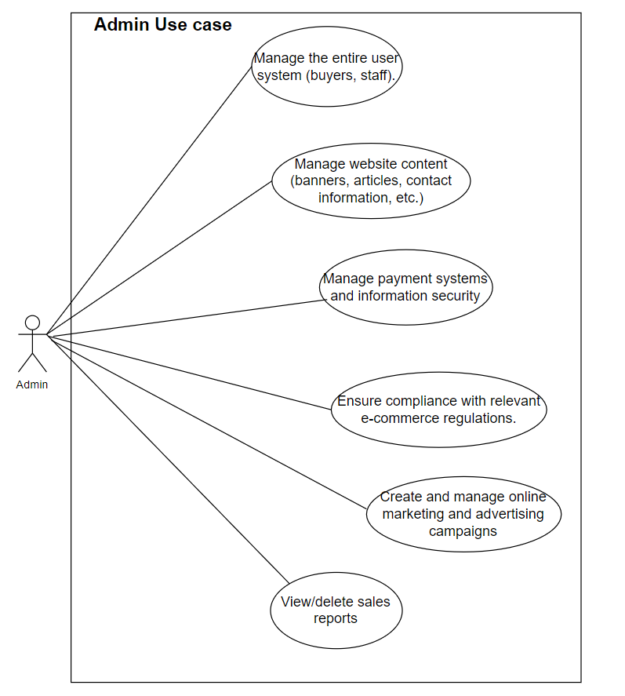

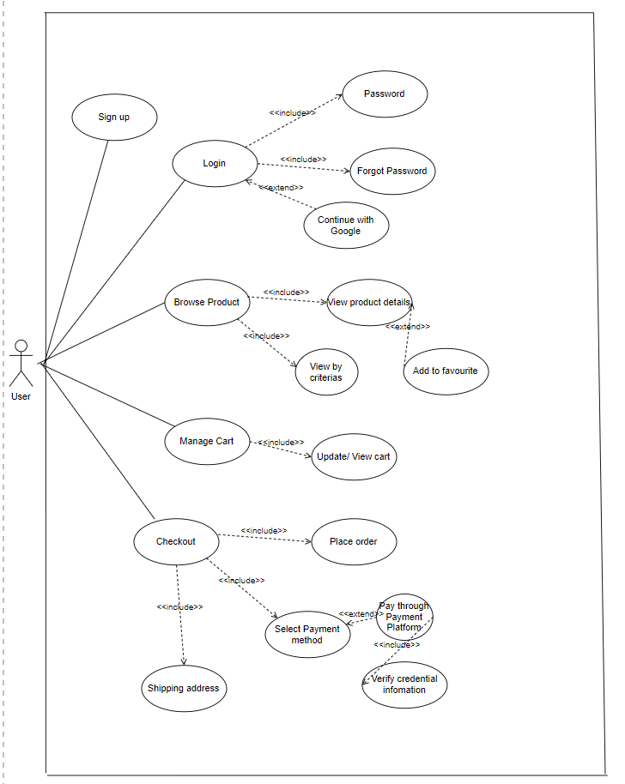

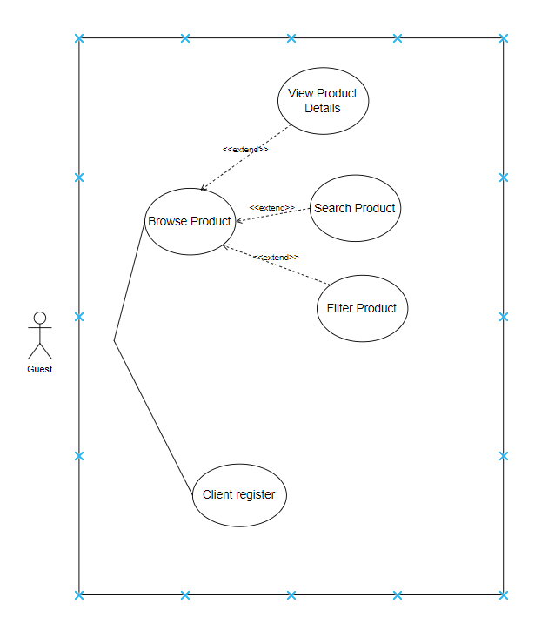

## **5.3. System Pages Flow**

# 6. Common Functions

## 6.1 View Common Feature Authentication

### 6.1.1 Login

|  |  |  |  |
| --- | --- | --- | --- |
| UC ID and Name: | **UC-2_Login** | | |
| Created By: | MichDV | Date Created: |  |
| Primary Actor: | Customer | Secondary Actors: | None |
| Trigger: | -User clicks Login button from the page header, or User accesses an authenticated feature (from a link or type the page URL directly into the address bar)  -Enter email in wrong format:  Message: "Invalid email. Please re-enter."  -Do not enter Email or password:  Message: "Email and password are required."  -Enter incorrect Email or password many times (eg 5 times):  Message: "You have entered incorrectly too many times. Your account has been temporarily locked. Please try again in 15 minutes."  Block: Yes, the system will temporarily block your account after entering it incorrectly too many times.  -System timeout time:  -Timeout: The system will automatically log out after 30 minutes of inactivity to ensure security.  -"Keep me signed in" function:  Description: If the user selects the "Keep me signed in" option, the system will maintain the user's signed in status even after closing the browser. This status will be maintained for 1 day or until the user logs out manually. | | |
| Description: | As a user, I want to be able to log into the system so that I can use the system’s authenticated features and access my personalized account. | | |
| Preconditions: | User account has been created & authorized | | |
| Postconditions: | * User logs in the system successfully * The system tracked successful login into the Activity Log | | |
| Normal Flow | **2.0 Login System**  1. User accesses the User Login screen  2. User types in the login details or choo other login options (see 2.1 and 2.2)  3. User clicks the Login button  4. System validates the login details (see 2.0.E1)  5. System allows user to access  6. System tracks user’s success login to the Activity Log  7. System accesses the Home Page (or the previous calling page if any) | | |
| Alternative Flows: | ***2.1 Google Login***  1. User chooses to login system using Google account  2. System redirects the user to the Google’s Login screen  3. User types in the Google account details and chooses to login  4. Google validates user’s login information successfully and redirect him/her back to the system  5. Return to step 5 of normal flow. | | |
| Exceptions: | ***2.0.E1 System can’t authenticate the user***  1. The Error Message screen is shown to the user  2. User cancels the logging in *=> UC stops, change to UC-1_View Home Page*  3. User clicks “Forgot Password?” link *=> change to UC-5_Reset Password*  4. User clicks “Register” link *=> change to UC-4_Register User Account* | | |
| Priority: | Must Have | | |
| Frequency of Use: |  | | |
| Business Rules: | FR1:User’s password must be encoded with MD5 hashing  FR2: User can’t be authenticated to login the system if below cases   * His/her logging-in details are incorrect * His/her account has not been verified * His/her account has been locked or blocked | | |
| Other Information: |  | | |
| Assumptions: |  | | |

## 

### 6.1.2. Sign Up

##### 

|  |  |  |  |
| --- | --- | --- | --- |
| Use Case ID: | **UC-02** | USE CASE NAME | **SIGN-UP** |
| Create By: | MichDV | Date Created: |  |
| Primary Actor: | Guest | Secondary Actor | None |
| Description | This use case describes the process of new visitors creating an account on a website, providing their personal information such as their name,email address, and a password to become registered Buyers. | | |
| Priority: | low | | |
| Trigger | The guest clicks on the "Register" link in the Sign in page or accesses the sign-up page with a link | | |
| Preconditions: | PRE-01: The guest has a valid email address  PRE-02: The guest has valid password | | |
| Post-Conditions | POST-1: gic system works stably, without error.  POST-2: The system creates a new Buyer account and assigns the guest a unique identifier upon successful verification.  POST-3: The guest can use their account to login to gic system | | |
| Basic Flow: | 1. The guest accesses the home page.  2. Click on avatar default then click the “Login” button.  3. System redirects to the sign-in page.  4. Click on “Register” .  5. Type in all the required fields needed to create an account.  6. Click on button “Create Account”.  7. Verify email with the code sent to the Buyer's email address.  8. System redirects to the sign-in page | | |
| Alternative Flow: | None | | |
| Exception: | 5a. The guest fills in invalid Buyer name or email.  5a1. The system gives an error message and informs the guest to fill in another Buyername, email, password.  5b. The guest fills in a Buyer name or email that already exists.  5b1. The system gives an error message and inform the guest to fill in another Buyername, email | | |

### 6.1.3 Sign Out

|  |  |  |  |
| --- | --- | --- | --- |
| Use Case ID: | **UC-03** | USE CASE NAME | **SIGN-OUT** |
| Create By: | MichDV | Date Created: |  |
| Primary Actor: | Buyer, , Admin | Secondary Actor | None |
| Description | This use case describes how a Buyer can sign out of their account, which clears any active cookies and logs them out of the system | | |
| Priority: | high | | |
| Trigger | The Buyer wants to log out of the gic website and clicks on the log out option. | | |
| Preconditions: | PRE-01: Buyer has logged in into gic system | | |
| Post-Conditions | POST-1: gic system works stably, without error.  POST-2: System navigates the Buyers back to home page. | | |
| Basic Flow: | 1. Buyer hovers over the avatar in the header.  2. Click on the log out option.  3. The Buyer is now no longer determined as any role but Guest.  4. The guest will be navigated back to the home page. | | |
| Alternative Flow: | None | | |
| Exception: | None | | |

##### 

### 6.1.4 Forgot Password

|  |  |  |  |
| --- | --- | --- | --- |
| Use Case ID: | **UC-04** | USE CASE NAME | **Forgot-password** |
| Create By: | MichDV | Date Created: |  |
| Primary Actor: | Buyer | Secondary Actor | None |
| Description | This use case describes how a Buyer can reset their forgotten password by verifying their email address and clicking on the password reset link sent by the system. | | |
| Priority: | medium | | |
| Trigger | The Buyer clicks on the forgot password link to be able to reset their password | | |
| Preconditions: | PRE-01: Buyer already has a valid account and valid email address. | | |
| Post-Conditions | POST-1: NikePlus system works stably, without error.  POST-2: The Buyer changed their account password successfully. | | |
| Basic Flow: | 1. Buyer access to the sign-in page.  2. Buyer clicks on the forgot password in the login screen.  3. Buyers will fill their email address in the email field.  4. The system will send a link to reset password to the  Buyer’s email address.  5. The Buyer clicks on the link in their mail and got redirected to the  reset password screen.  6. The Buyer types in the new password and clicks confirms the new  password.  7. System redirects back to the login screen. | | |
| Alternative Flow: | 3a. The Buyer fills in an invalid email address  3a1. The system gives an error message and informs the guest to fill in a valid email. | | |
| Exception: | None | | |

##### 

### 6.1.5 **Change password**

|  |  |  |  |
| --- | --- | --- | --- |
| Use Case ID: | **UC-05** | USE CASE NAME | **Change password** |
| Create By: | MichDV | Date Created: |  |
| Primary Actor: | Buyer, Admin | Secondary Actor | None |
| Description | This use case describes how a Buyer or an Admin can change their password in the system. | | |
| Priority: | high | | |
| Trigger | The Buyer or Admin wants to change their password in the gic website. | | |
| Preconditions: | Buyer or Admin is logged into the gic system. | | |
| Post-Conditions | POST-1: The password for the Buyer or Admin is successfully updated.  POST-2: The system operates stably without errors. | | |
| Basic Flow: | 1. Buyer or Admin navigates to the account settings.  2. Selects the option to change the password.  3. Enters the current password, new password, and confirms the new password.  4. Submits the changes.  5. The password is successfully updated. | | |
| Alternative Flow: | None | | |
| Exception: | None | | |

## 6.2. View Common Feature as Guest and Buyer

### 6.2.1 View home page

|  |  |  |  |
| --- | --- | --- | --- |
| Use Case ID: | **UC-06** | USE CASE NAME | **View Home Page** |
| Create By: | KhanhN | Date Created: |  |
| Primary Actor: | Guest, Buyer | Secondary Actor | None |
| Description | This use case describes how a Guest or Buyer can view the home page of the NikePlus system to access various features and information about products and services. | | |
| Priority: | Medium | | |
| Trigger | The Guest or Buyer navigates to the NikePlus system's URL. | | |
| Preconditions: | PRE-01: The NikePlus system is online and accessible. | | |
| Post-Conditions | POST-1: The Guest or Buyer views the home page with relevant content and navigation options. | | |
| Basic Flow: | 1. The Guest or Buyer opens a web browser and navigates to the NikePlus system's URL.  2. The system loads and displays the home page.  3. The Guest or Buyer views the featured products, promotions, and navigation links on the home page. | | |
| Alternative Flow: | None | | |
| Exception: | None | | |

##### 

### **6.2.2** View sneaker details

|  |  |  |  |
| --- | --- | --- | --- |
| Use Case ID: | **UC-07** | USE CASE NAME | View sneaker details |
| Create By: | KhanhN | Date Created: |  |
| Primary Actor: | Guest, Buyer | Secondary Actor | None |
| Description | This use case describes how a Guest or Buyer can list products (sneakers) based on price and ratings on the NikePlus system. | | |
| Priority: | medium | | |
| Trigger | The Guest or Buyer wants to explore products based on price and ratings criteria. | | |
| Preconditions: | PRE-01: Buyer already has a valid account and valid email address. | | |
| Post-Conditions | POST-1: Sneaker products are available in the NikePlus system.  POST-2: The Guest or Buyer views a list of products filtered based on price and ratings criteria. | | |
| Basic Flow: | 1. The Guest or Buyer navigates to the page displaying the list of sneakers.  2. The Guest or Buyer selects the option to filter products by price and ratings.  3. The system retrieves and displays a list of sneakers based on the selected criteria. | | |
| Alternative Flow: | None | | |
| Exception: | None | | |

### 

### 6.2.3. List Products by price and ratings

|  |  |  |  |
| --- | --- | --- | --- |
| Use Case ID: | **UC-08** | USE CASE NAME | **List Products by price and ratings** |
| Create By: | KhanhN | Date Created: |  |
| Primary Actor: | Guest, Buyer | Secondary Actor | None |
| Description | This use case describes how a Guest or Buyer can view the details of a specific sneaker on the NikePlus system. | | |
| Priority: | medium | | |
| Trigger | The Guest or Buyer wants to view detailed information about a specific sneaker. | | |
| Preconditions: | PRE-01: Buyer already has a valid account and valid email address.  PRE-02: Sneaker products are available in the NikePlus system. | | |
| Post-Conditions | POST-01: The Guest or Buyer views detailed information about the selected sneaker. | | |
| Basic Flow: | 1. The Guest or Buyer navigates to the page displaying the list of sneakers.  2.The Guest or Buyer selects a sneaker to view its details.  3.The system retrieves and displays the detailed information of the selected sneaker. | | |
| Alternative Flow: | AF-1: The Guest or Buyer decides to filter the list of sneakers by price and ratings before selecting a sneaker to view its details. | | |
| Exception: | EX-1: The selected sneaker is no longer available. The system displays a message indicating that the product is out of stock and suggests similar products. | | |

### 6.2.4. List products by release date

|  |  |  |  |
| --- | --- | --- | --- |
| Use Case ID: | **UC-09** | USE CASE NAME | **List Products by Release Date** |
| Create By: | KhanhN | Date Created: |  |
| Primary Actor: | Guest, Buyer | Secondary Actor | None |
| Description | This use case describes how a Guest or Buyer can view a list of products (sneakers) sorted by their release date on the NikePlus system. | | |
| Priority: | medium | | |
| Trigger | The Guest or Buyer wants to explore products based on their release dates. | | |
| Preconditions: | PRE-01: Sneaker products with release dates are available in the NikePlus system. | | |
| Post-Conditions | POST-01: The Guest or Buyer views a list of products sorted by release date. | | |
| Basic Flow: | 1. The Guest or Buyer navigates to the page displaying the list of sneakers.  2.The Guest or Buyer selects the option to sort products by release date.  3.The system retrieves and displays a list of sneakers sorted by release date. | | |
| Alternative Flow: | AF-1: The Guest or Buyer decides to filter the list of sneakers by release date before selecting a sneaker to view its details. | | |
| Exception: | None | | |

##### 

### 6.2.5 List all Sneaker

|  |  |  |  |
| --- | --- | --- | --- |
| Use Case ID: | **UC-10** | USE CASE NAME | **List all Sneaker** |
| Create By: | KhanhN | Date Created: |  |
| Primary Actor: | Buyer, Admin ,Guest | Secondary Actor | None |
| Description | This use case describes how a Buyer or an Admin can view a list of all sneakers available on the platform. | | |
| Priority: | high | | |
| Trigger | The Buyer or Admin wants to view a list of all sneakers on the gic website. | | |
| Preconditions: | PRE-01: Buyer or Admin is logged into the system. | | |
| Post-Conditions | POST-1: The list of all sneakers is displayed to the Buyer or Admin.  POST-2: The system operates stably without errors. | | |
| Basic Flow: | 1. Buyer or Admin navigates to the "Sneaker" section of the website.  2. Selects the option to view all sneakers.  3. A list of all available sneakers is displayed. | | |
| Alternative Flow: | None | | |
| Exception: | None | | |

### 6.2.6. Sneaker Review

|  |  |  |  |
| --- | --- | --- | --- |
| Use Case ID: | **UC-11** | USE CASE NAME | **Sneaker Review** |
| Create By: | HieuNT | Date Created: |  |
| Primary Actor: | Buyer | Secondary Actor | None |
| Description | This use case describes how a Buyer can write and submit a review for a specific sneaker on the NikePlus system. | | |
| Priority: | medium | | |
| Trigger | The Buyer wants to share their experience or opinion about a sneaker they purchased. | | |
| Preconditions: | PRE-01: The Buyer has purchased the sneaker they want to review.  PRE-02: The Buyer is logged in to their account on the NikePlus system. | | |
| Post-Conditions | POST-01: The Buyer's review is successfully submitted and visible to other users on the NikePlus system. | | |
| Basic Flow: | 1.The Buyer navigates to the page displaying the details of the sneaker they want to review.  2.The Buyer selects the option to write a review.  3.The Buyer writes their review, including a rating if applicable.  4.The Buyer submits the review.  5.The system verifies and publishes the review to be visible to other users. | | |
| Alternative Flow: | None | | |
| Exception: | None | | |

##### 

### 6.2.7. Update Profile

|  |  |  |  |
| --- | --- | --- | --- |
| Use Case ID: | **UC-12** | USE CASE NAME | **Update Profile** |
| Create By: | HieuNT | Date Created: |  |
| Primary Actor: | Buyer | Secondary Actor | None |
| Description | This use case describes how a Buyer can update their profile information on the NikePlus system. | | |
| Priority: | medium | | |
| Trigger | The Buyer wants to update their personal information such as name, email, or shipping address. | | |
| Preconditions: | PRE-01: Buyer already has a valid account and valid email address. | | |
| Post-Conditions | POST-1: The Buyer is logged in to their account on the NikePlus system.  POST-2: The Buyer's profile information is successfully updated in the NikePlus system. | | |
| Basic Flow: | 1. The Buyer accesses the profile or account settings section.  2. The Buyer selects the option to edit their profile.  3. The Buyer modifies the desired information such as name, email, or shipping address.  4. The Buyer saves the changes.  5. The system verifies and updates the Buyer's profile information. | | |
| Alternative Flow: | None | | |
| Exception: | None | | |

### 6.2.8 View Sneaker Purchase History

|  |  |  |  |
| --- | --- | --- | --- |
| Use Case ID: | **UC-13** | USE CASE NAME | **View Sneaker Purchase History** |
| Create By: | HieuNT | Date Created: |  |
| Primary Actor: | Buyer | Secondary Actor | None |
| Description | This use case describes how a Buyer can view their purchase history of sneakers on the NikePlus system. | | |
| Priority: | medium | | |
| Trigger | The Buyer wants to review their past purchases of sneakers. | | |
| Preconditions: | PRE-01: The Buyer is logged in to their account on the NikePlus system. | | |
| Post-Conditions | POST-1: The Buyer views their complete purchase history of sneakers. | | |
| Basic Flow: | 1. The Buyer navigates to their account dashboard.  2. The Buyer selects the option to view their purchase history.  3. The system retrieves and displays the list of sneakers the Buyer has purchased, including details such as purchase dates and order numbers. | | |
| Alternative Flow: | None | | |
| Exception: | None | | |

## 

## 6.3 View Common Feature as Admin

### 6.3.1 View Admin Dashboard

##### 

| Use Case ID: | **UC-14** | USE CASE NAME | **View Admin Dashboard** |
| --- | --- | --- | --- |
| Create By: | HuyLV | Date Created: |  |
| Primary Actor: | Admin | Secondary Actor | None |
| Description | This use case describes how an Admin can view the dashboard containing key metrics, insights, and management tools on the NikePlus system. | | |
| Priority: | medium | | |
| Trigger | The Admin wants to access performance metrics, user data, and management tools. | | |
| Preconditions: | PRE-01: The Admin is logged in to their account on the NikePlus system. | | |
| Post-Conditions | POST-1: The Admin views the dashboard containing relevant metrics, insights, and management tools. | | |
| Basic Flow: | 1. The Admin accesses the admin dashboard section.  2. The system loads and displays the admin dashboard containing key metrics such as sales, user engagement, inventory status, and various management tools. | | |
| Alternative Flow: | None | | |
| Exception: | None | | |

### 6.3.2. Add new sneaker

|  |  |  |  |
| --- | --- | --- | --- |
| Use Case ID: | **UC-15** | USE CASE NAME | **Add New Sneaker** |
| Create By: | HuyLV | Date Created: |  |
| Primary Actor: | Admin | Secondary Actor | None |
| Description | This use case describes how an Admin can add a new sneaker to the NikePlus system's inventory. | | |
| Priority: | High | | |
| Trigger | The Admin wants to add a new sneaker to the system's inventory. | | |
| Preconditions: | PRE-01: The Admin is logged in to their account on the NikePlus system. | | |
| Post-Conditions | POST-1: The new sneaker is successfully added to the NikePlus system's inventory. | | |
| Basic Flow: | 1. The Admin accesses the admin dashboard or product management section.  2. The Admin selects the option to add a new sneaker.  3. The Admin fills in the details of the new sneaker, including name, description, price, and images.  4. The Admin submits the new sneaker information.  5. The system verifies and adds the new sneaker to the inventory. | | |
| Alternative Flow: | None | | |
| Exception: | None | | |

### 6.3.3 Delete,Update sneaker

|  |  |  |  |
| --- | --- | --- | --- |
| Use Case ID: | **UC-16** | USE CASE NAME | **Delete, Update sneaker** |
| Create By: | HuyLV | Date Created: |  |
| Primary Actor: | Admin | Secondary Actor | None |
| Description | This use case describes how an Admin can delete a sneaker from the NikePlus system. | | |
| Priority: | High | | |
| Trigger | The Admin wants to remove a sneaker from the system. | | |
| Preconditions: | PRE-01: Admin has a valid account with the necessary permissions to delete products.  PRE-02: The sneaker to be deleted exists in the system. | | |
| Post-Conditions | POST-01: The sneaker is removed from the NikePlus system. | | |
| Basic Flow: | 1.The Admin logs into the NikePlus system.  2.The Admin navigates to the product management page.  3.The Admin selects the sneaker to be deleted.  4.The Admin confirms the deletion.  5.The system removes the sneaker from the database.  6.The system confirms the deletion to the Admin. | | |
| Alternative Flow: | AF-1: The Admin decides to cancel the deletion. | | |
| Exception: | EX-1: The system encounters an error while deleting the sneaker. | | |

##### 

### 6.3.4 View Sneaker Dashboard

##### 

| Use Case ID: | **UC-18** | USE CASE NAME | **View Sneaker Dashboard** |
| --- | --- | --- | --- |
| Create By: | HuyLV | Date Created: |  |
| Primary Actor: | Admin | Secondary Actor | None |
| Description | This use case describes how an Admin can view a dashboard specifically focused on sneaker-related metrics and insights on the NikePlus system. | | |
| Priority: | medium | | |
| Trigger | The Admin wants to access detailed analytics and performance metrics related to sneakers. | | |
| Preconditions: | PRE-01: The Admin is logged in to their account on the NikePlus system. | | |
| Post-Conditions | POST-1: The Admin views the sneaker dashboard containing relevant metrics and insights. | | |
| Basic Flow: | 1. The Admin accesses the admin dashboard section.  2. The Admin selects the option to view the sneaker dashboard.  3. The system loads and displays the sneaker dashboard containing metrics such as sales trends, popular models, and inventory status. | | |
| Alternative Flow: | None | | |
| Exception | None | | |

##### 

### 6.3.5. Search Sneaker

|  |  |  |  |
| --- | --- | --- | --- |
| Use Case ID: | **UC-19** | USE CASE NAME | **Search Sneaker** |
| Create By: | HieuNT | Date Created: |  |
| Primary Actor: | Admin | Secondary Actor | None |
| Description | This use case describes how an Admin can search for a specific sneaker within the NikePlus system's inventory. | | |
| Priority: | medium | | |
| Trigger | The Admin wants to find detailed information about a specific sneaker. | | |
| Preconditions: | PRE-01: The Admin is logged in to their account on the NikePlus system. | | |
| Post-Conditions | POST-1: The Admin views the detailed information of the searched sneaker. | | |
| Basic Flow: | 1. The Admin accesses the admin dashboard or product management section.  2. The Admin enters the name or any other relevant information of the sneaker they want to search for in the search bar.  3. The system retrieves and displays the detailed information of the searched sneaker. | | |
| Alternative Flow: | None | | |
| Exception: | None | | |

### 6.3.6. Update/Delete Account

|  |  |  |  |
| --- | --- | --- | --- |
| Use Case ID: | **UC-22** | USE CASE NAME | **Update/Delete Account** |
| Create By: | HuyLv | Date Created: |  |
| Primary Actor: | Admin | Secondary Actor | None |
| Description | This use case describes how an Admin can update or delete an existing user account on the NikePlus system. | | |
| Priority: | High | | |
| Trigger | The Admin wants to modify the details of an existing user account or remove it from the system. | | |
| Preconditions: | PRE-01: The Admin is logged in to their account on the NikePlus system. | | |
| Post-Conditions | POST-1: The specified user account is successfully updated or deleted from the NikePlus system. | | |
| Basic Flow: | 1. The Admin accesses the admin dashboard or user management section.  2. The Admin selects the option to view the list of existing user accounts.  3. The Admin selects the user account they want to update or delete.  4. The Admin chooses to either update the details of the user account or delete it entirely.  5. The system verifies and executes the requested action (update or delete). | | |
| Alternative Flow: | None | | |
| Exception: | None | | |

# 7. Appendix

## 7.1. Assumptions & Dependencies

Assumptions:

AS-1: The warehouse management system will always be updated and synchronized to ensure information on inventory status is accurate.

AS-2: Users will have a stable Internet connection to access and use the shoe selling website.

AS-3: Customer support staff will be available to answer questions and handle issues that arise from customers during business hours.

Dependencies:

DE-1: Shoe selling website must be able to integrate with third-party payment gateways such as PayPal, Stripe to process online payments.

DE-2: Shoe selling website needs to integrate with third-party delivery services to ensure deliveries are on time and to the right location.

DE-3: The system needs to be compatible with current web browser technologies and mobile devices to ensure the best user experience.

## 7.2. Limitations & Exclusions

LE-1: The system will not support ordering via phone or social media.

LE-2: Virtual shoe try-on function using AR (Augmented Reality) technology will not be implemented in the first version of the website.

LE-3: International delivery is not supported in the early stages of deployment, only serving domestic delivery.

LE-4: The system will not store customer credit card information to ensure security.

## 7.3. Business Rules

|  |  |  |
| --- | --- | --- |
| **ID** | **Category** | **Rule Definition** |
| BR-01 | Constraints | Orders must be delivered within the hours of 9:00 A.M. to 9:00 P.M. local time, including weekends. |
| BR-02 | Constraints | Shoes ordered must be delivered to the same address in one order. |
| BR-03 | Facts | All products in an order must be paid for using the same payment method. |
| BR-04 | Constraints | Customers can return shoes within 30 days from the date of receipt, provided the shoes are new and unused. |
| BR-05 | Constraints | Order value is calculated by the total value of the products, plus taxes and shipping fees (if any). |
| BR-06 | Computations | Order price is calculated as the sum of each food item price times the quantity of that food item ordered, plus applicable sales tax, plus a delivery charge if a meal is delivered outside the free delivery zone. |
| BR-07 | Facts | Promotional products cannot be combined with other discount codes. |

## 