MO TA DATABASE VA SO DO ERD
Du an: Website To Find Workers - Tho Tot NTU
Ngay tao tai lieu: 19/03/2026
Tai lieu nay tong hop cau truc CSDL cho cac bang nghiep vu chinh co moi quan he truc tiep trong he thong.

1. Pham vi va cach doc so do
- ERD trong tai lieu tap trung vao cac bang nghiep vu chinh dang duoc su dung.
- Cac bang he thong/phu tro khong can thiet da duoc luoc bo theo yeu cau.
- Thong tin tung bang duoc trinh bay theo chuc nang, khoa chinh, cot quan trong, quan he va rang buoc.

2. So do ERD tong quan
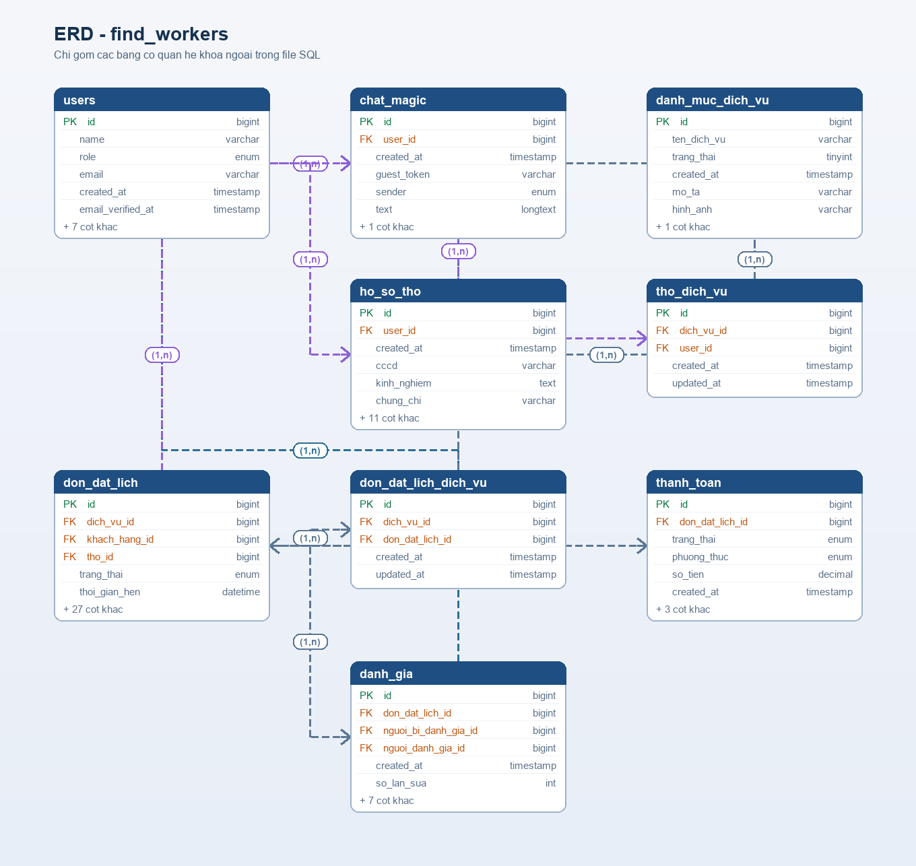
Hinh 1. So do ERD tong quan cho cac bang nghiep vu chinh trong he thong.

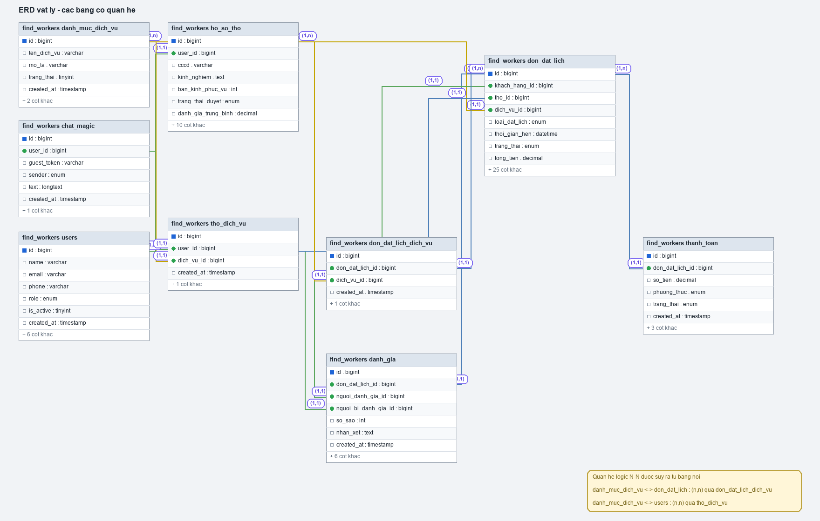
Hinh 2. So do vat ly (physical) cua cac bang nghiep vu chinh.

3. Nhom bang nghiep vu chinh

3.1. Bang users
Chuc nang: Bang nguoi dung trung tam, luu admin, khach hang va tho.
Khoa chinh: id

Noi dung | Chi tiet
Cot quan trong | - id (bigint, PK, increment)  - name, email(unique), password  - phone, address, avatar  - role (enum: admin, customer, worker)  - is_active  - created_at, updated_at
Quan he | - 1-1 voi ho_so_tho theo user_id (chi ap dung cho worker).  - 1-n voi don_dat_lich theo khach_hang_id (vai tro customer).  - 1-n voi don_dat_lich theo tho_id (vai tro worker).  - n-n voi danh_muc_dich_vu qua tho_dich_vu.
Chi muc/rang buoc | - unique(email)

3.2. Bang danh_muc_dich_vu
Chuc nang: Danh muc cac dich vu duoc cung cap trong he thong.
Khoa chinh: id

Noi dung | Chi tiet
Cot quan trong | - id (bigint, PK, increment)  - ten_dich_vu  - mo_ta  - hinh_anh  - trang_thai  - created_at, updated_at
Quan he | - n-n voi users qua tho_dich_vu.  - n-n voi don_dat_lich qua don_dat_lich_dich_vu.
Chi muc/rang buoc | - Khuyen nghi unique(ten_dich_vu) de tranh trung lap ten dich vu.

3.3. Bang ho_so_tho
Chuc nang: Ho so bo sung cho user co vai tro worker.
Khoa chinh: id

Noi dung | Chi tiet
Cot quan trong | - user_id (unique, FK -> users.id)  - cccd (unique)  - kinh_nghiem, chung_chi, bang_gia_tham_khao  - vi_do, kinh_do, ban_kinh_phuc_vu  - trang_thai_duyet  - dang_hoat_dong, trang_thai_hoat_dong  - danh_gia_trung_binh, tong_so_danh_gia  - created_at, updated_at
Quan he | - n-1 voi users theo user_id (nghiep vu 1-1 do user_id unique).
Chi muc/rang buoc | - unique(user_id)  - unique(cccd)

3.4. Bang tho_dich_vu
Chuc nang: Bang trung gian the hien ky nang dich vu cua tung worker.
Khoa chinh: id

Noi dung | Chi tiet
Cot quan trong | - user_id (FK -> users.id)  - dich_vu_id (FK -> danh_muc_dich_vu.id)  - created_at, updated_at
Quan he | - n-1 voi users theo user_id.  - n-1 voi danh_muc_dich_vu theo dich_vu_id.
Chi muc/rang buoc | - Khuyen nghi unique(user_id, dich_vu_id).

3.5. Bang don_dat_lich
Chuc nang: Bang nghiep vu trung tam luu don dat lich, tien do xu ly, chi phi va thanh toan.
Khoa chinh: id

Noi dung | Chi tiet
Cot quan trong | - khach_hang_id (FK -> users.id), tho_id (FK -> users.id)  - loai_dat_lich, ngay_hen, khung_gio_hen, thoi_gian_hen  - dia_chi, vi_do, kinh_do  - mo_ta_van_de, nguyen_nhan, giai_phap  - hinh_anh_mo_ta, video_mo_ta, hinh_anh_ket_qua, video_ket_qua  - khoang_cach, phi_di_lai, phi_linh_kien, tien_cong, tien_thue_xe, tong_tien  - phuong_thuc_thanh_toan, trang_thai_thanh_toan  - trang_thai, ly_do_huy, thoi_gian_het_han_nhan  - created_at, updated_at
Quan he | - n-1 voi users theo khach_hang_id.  - n-1 voi users theo tho_id.  - n-n voi danh_muc_dich_vu qua don_dat_lich_dich_vu.
Chi muc/rang buoc | - enum loai_dat_lich, khung_gio_hen, trang_thai, phuong_thuc_thanh_toan.

3.6. Bang don_dat_lich_dich_vu
Chuc nang: Bang trung gian luu cac dich vu nam trong mot don dat lich.
Khoa chinh: id

Noi dung | Chi tiet
Cot quan trong | - don_dat_lich_id (FK -> don_dat_lich.id)  - dich_vu_id (FK -> danh_muc_dich_vu.id)  - created_at, updated_at
Quan he | - n-1 voi don_dat_lich theo don_dat_lich_id.  - n-1 voi danh_muc_dich_vu theo dich_vu_id.
Chi muc/rang buoc | - unique(don_dat_lich_id, dich_vu_id).

4. Tong hop quan he database
- users 1-1 ho_so_tho (ap dung cho worker do user_id unique).
- users n-n danh_muc_dich_vu qua tho_dich_vu.
- users(customer) 1-n don_dat_lich theo khach_hang_id.
- users(worker) 1-n don_dat_lich theo tho_id.
- don_dat_lich n-n danh_muc_dich_vu qua don_dat_lich_dich_vu.

5. Quy tac nghiep vu quan trong
- Moi worker chi co 1 ho so_tho.
- Mot don_dat_lich co the gom nhieu dich vu.
- Trang thai don_dat_lich phai tuan thu dung luong nghiep vu.
- Tong_tien duoc tinh tu cac thanh phan chi phi trong don_dat_lich.

6. Nguon doi chieu
- DBML user cung cap (chi lay bang chinh co quan he).
- Migration/model trong project website-to-find-workers.

