MO TA DATABASE VA SO DO ERD
Du an: Website To Find Workers - Tho Tot NTU
Ngay tao tai lieu: 19/03/2026
Tai lieu nay tong hop cac bang chinh co moi quan he truc tiep trong nghiep vu dat lich tim tho. Cac bang he thong/phu tro da duoc luoc bo theo yeu cau.

1. Pham vi va cach doc so do
- Chi mo ta cac bang nghiep vu chinh co quan he trong he thong.
- Bo qua cac bang he thong/ho tro khong can thiet cho phan trinh bay do an.
- Moi bang duoc mo ta theo: chuc nang, khoa chinh, cot quan trong, quan he va rang buoc.

2. So do ERD tong quan
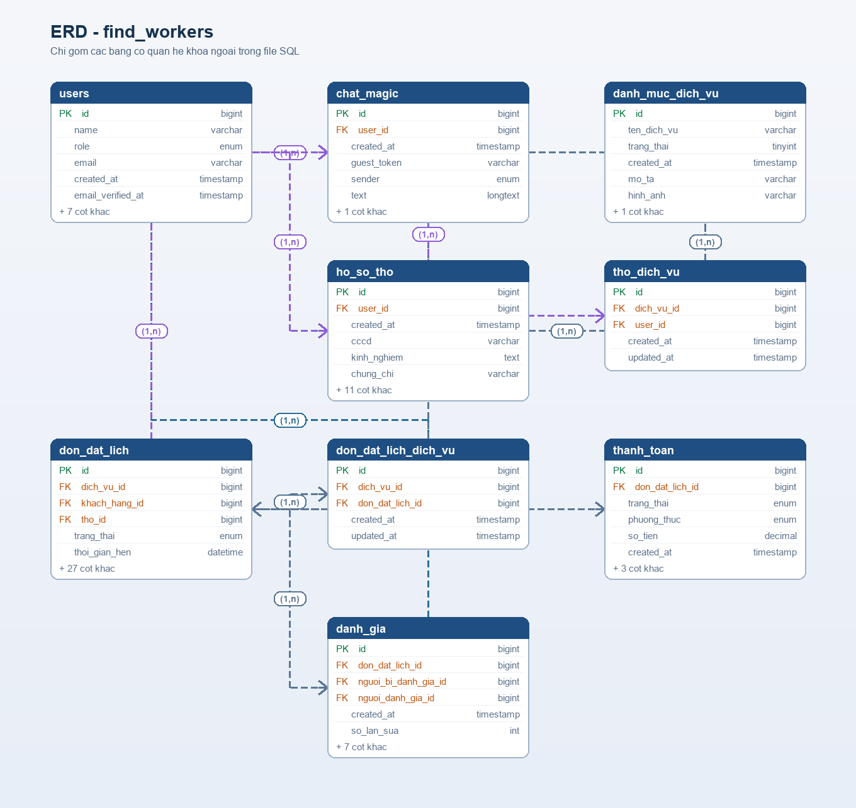
Hinh 1. So do ERD tong quan cho cac bang nghiep vu chinh trong he thong.

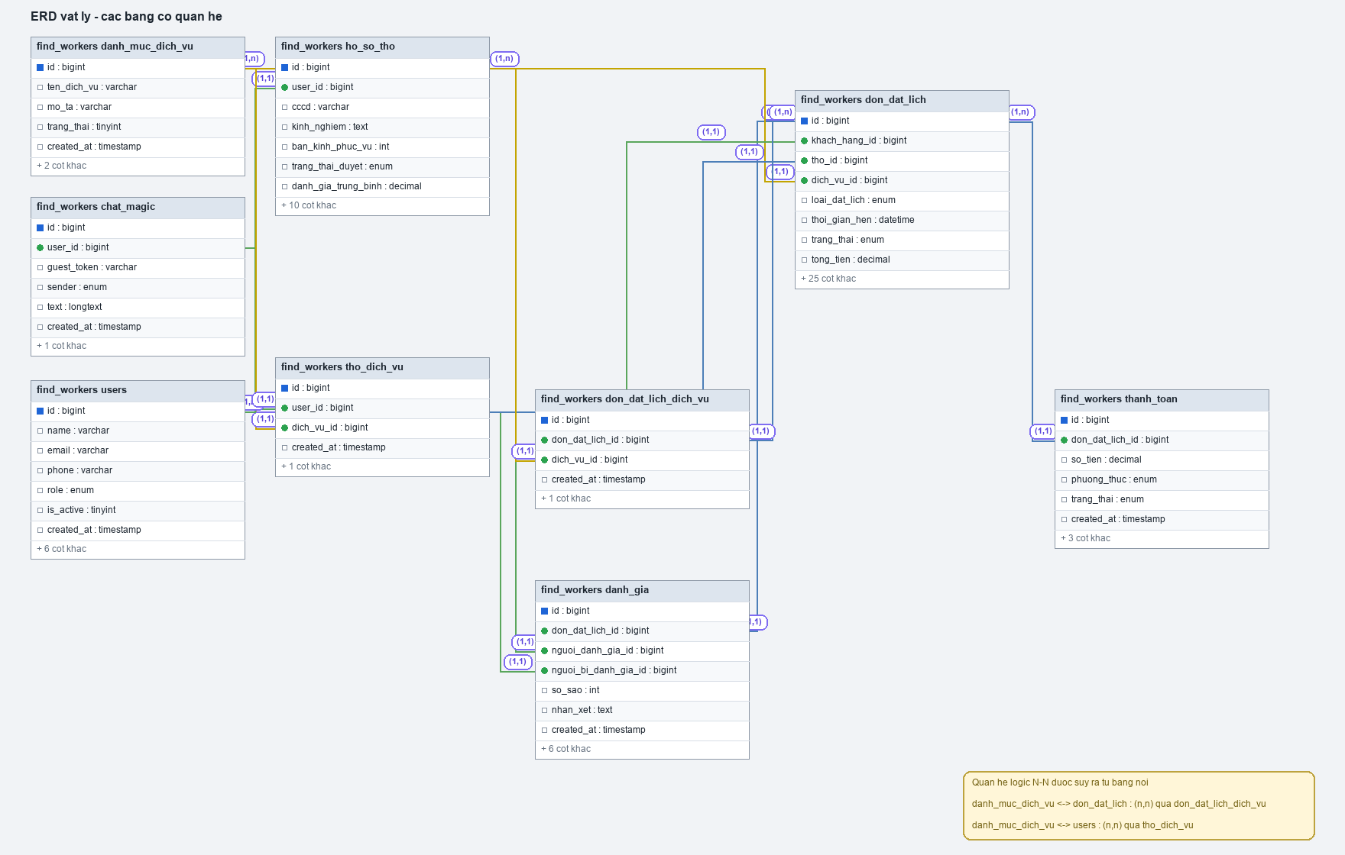
Hinh 2. So do vat ly (physical) cua cac bang chinh.

3. Nhom bang nghiep vu chinh

3.1. Bang users
Chuc nang: Bang nguoi dung trung tam, luu admin, khach hang va tho.
Khoa chinh: id

Noi dung | Chi tiet
Cot quan trong | - name, email, password  - phone, address, avatar  - role (admin/customer/worker)  - is_active
Quan he | - 1-1 voi ho_so_tho theo user_id (chi ap dung cho tho).  - 1-n voi don_dat_lich theo khach_hang_id.  - 1-n voi don_dat_lich theo tho_id.  - n-n voi danh_muc_dich_vu qua tho_dich_vu.
Chi muc/rang buoc | - unique(email)

3.2. Bang ho_so_tho
Chuc nang: Ho so bo sung cho user co vai tro tho.
Khoa chinh: id

Noi dung | Chi tiet
Cot quan trong | - user_id  - cccd  - kinh_nghiem, chung_chi, bang_gia_tham_khao  - vi_do, kinh_do  - trang_thai_duyet, dang_hoat_dong, trang_thai_hoat_dong  - danh_gia_trung_binh, tong_so_danh_gia
Quan he | - n-1 voi users theo user_id.
Chi muc/rang buoc | - unique(user_id)  - unique(cccd)

3.3. Bang danh_muc_dich_vu
Chuc nang: Danh muc cac dich vu duoc cung cap trong he thong.
Khoa chinh: id

Noi dung | Chi tiet
Cot quan trong | - ten_dich_vu  - mo_ta  - hinh_anh  - trang_thai
Quan he | - n-n voi users qua tho_dich_vu.  - n-n voi don_dat_lich qua don_dat_lich_dich_vu.
Chi muc/rang buoc | - (khuyen nghi) unique(ten_dich_vu)

3.4. Bang tho_dich_vu
Chuc nang: Bang lien ket ky nang dich vu cua tung tho.
Khoa chinh: id

Noi dung | Chi tiet
Cot quan trong | - user_id  - dich_vu_id
Quan he | - n-1 voi users theo user_id.  - n-1 voi danh_muc_dich_vu theo dich_vu_id.
Chi muc/rang buoc | - (khuyen nghi) unique(user_id, dich_vu_id)

3.5. Bang don_dat_lich
Chuc nang: Bang nghiep vu trung tam luu toan bo don dat lich va trang thai xu ly.
Khoa chinh: id

Noi dung | Chi tiet
Cot quan trong | - khach_hang_id, tho_id  - loai_dat_lich, ngay_hen, khung_gio_hen, thoi_gian_hen  - dia_chi, vi_do, kinh_do  - mo_ta_van_de, nguyen_nhan, giai_phap  - phi_di_lai, phi_linh_kien, tien_cong, tien_thue_xe, tong_tien  - phuong_thuc_thanh_toan, trang_thai_thanh_toan  - hinh_anh_mo_ta, video_mo_ta, hinh_anh_ket_qua, video_ket_qua  - trang_thai, ly_do_huy, thoi_gian_het_han_nhan
Quan he | - n-1 voi users theo khach_hang_id.  - n-1 voi users theo tho_id.  - n-n voi danh_muc_dich_vu qua don_dat_lich_dich_vu.
Chi muc/rang buoc | - enum loai_dat_lich, khung_gio_hen, trang_thai, phuong_thuc_thanh_toan

3.6. Bang don_dat_lich_dich_vu
Chuc nang: Bang lien ket dich vu trong tung don dat lich.
Khoa chinh: id

Noi dung | Chi tiet
Cot quan trong | - don_dat_lich_id  - dich_vu_id
Quan he | - n-1 voi don_dat_lich theo don_dat_lich_id.  - n-1 voi danh_muc_dich_vu theo dich_vu_id.
Chi muc/rang buoc | - unique(don_dat_lich_id, dich_vu_id)

4. Tong hop quan he database
- users 1-1 ho_so_tho (voi worker)
- users n-n danh_muc_dich_vu qua tho_dich_vu
- users(customer) 1-n don_dat_lich (khach_hang_id)
- users(worker) 1-n don_dat_lich (tho_id)
- don_dat_lich n-n danh_muc_dich_vu qua don_dat_lich_dich_vu

5. Quy tac nghiep vu quan trong
- Moi worker chi co 1 ho so_tho (rang buoc unique user_id).
- Mot don_dat_lich co the gom nhieu dich vu qua bang trung gian don_dat_lich_dich_vu.
- Trang thai don_dat_lich phai di theo luong nghiep vu, tranh nhay coc trang thai.
- Tong_tien duoc tong hop tu phi_di_lai + phi_linh_kien + tien_cong + tien_thue_xe.

6. Nguon doi chieu
- DBML do nguoi dung cung cap (cac bang chinh co quan he).
- Migration va model thuc te trong du an website-to-find-workers.

