MO TA DATABASE VA SO DO ERD
Du an: Website To Find Workers - Tho Tot NTU
Ngay tao tai lieu: 16/03/2026
Tai lieu nay tong hop cau truc database hien tai cua du an, mo ta y nghia tung bang, cac khoa chinh, khoa ngoai, cac quan he giua bang va nhung ghi chu nghiep vu quan trong. No dong thoi phan biet ro giua bang dang hoat dong, bang he thong va bang legacy da bi loai bo.

1. Pham vi va cach doc so do
- ERD trong tai lieu tap trung vao cac bang nghiep vu chinh dang duoc su dung.
- Cac bang he thong cua Laravel duoc liet ke rieng de tai lieu day du.
- Quan he 1-1 cua thanh_toan va danh_gia duoc mo ta theo nghiep vu hien tai.
- Cac bang bai_dang, hinh_anh_bai_dang, bao_gia da bi drop va chi duoc nhac o phan legacy.

2. So do ERD tong quan
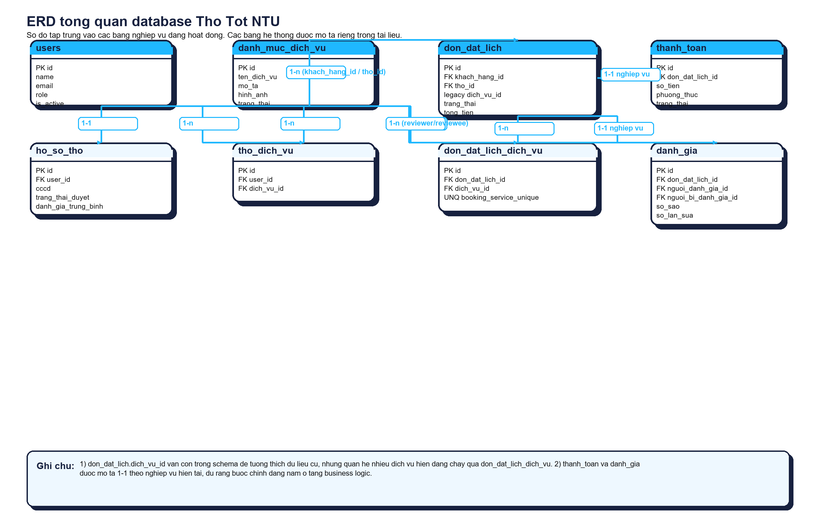
Hinh 1. So do ERD tong quan cho cac bang nghiep vu chinh trong he thong.

3. Nhom bang nghiep vu chinh

3.1. Bang users
Chuc nang: Bang nguoi dung trung tam, luu admin, khach hang va tho.
Khoa chinh: id
Noi dung | Chi tiet
Cot quan trong | - name, email, password  - phone, address, avatar  - role (admin/customer/worker)  - is_active
Quan he | - 1-1 voi ho_so_tho theo user_id (chi ap dung cho tho).  - 1-n voi don_dat_lich theo khach_hang_id.  - 1-n voi don_dat_lich theo tho_id.  - n-n voi danh_muc_dich_vu qua tho_dich_vu.  - 1-n voi danh_gia o 2 vai tro: nguoi_danh_gia va nguoi_bi_danh_gia.  - 1-n voi chat_magic theo user_id.  - 1-n voi app_settings theo updated_by ve mat nghiep vu.
Ghi chu | - Bang trung tam cua he thong.  - Role dang luu truc tiep bang enum trong users; bang roles hien khong duoc dung de rang buoc.

3.2. Bang ho_so_tho
Chuc nang: Ho so bo sung cho user co vai tro tho.
Khoa chinh: id
Noi dung | Chi tiet
Cot quan trong | - user_id  - cccd  - kinh_nghiem, chung_chi, bang_gia_tham_khao  - vi_do, kinh_do  - trang_thai_duyet, dang_hoat_dong, trang_thai_hoat_dong  - danh_gia_trung_binh, tong_so_danh_gia
Quan he | - n-1 voi users theo user_id.
Ghi chu | - Thuc te nghiep vu la 1 user worker co 1 ho so tho.  - Diem danh gia trung binh va tong so danh gia duoc cap nhat tu bang danh_gia.

3.3. Bang danh_muc_dich_vu
Chuc nang: Danh muc cac dich vu sua chua/bao tri ma he thong cung cap.
Khoa chinh: id
Noi dung | Chi tiet
Cot quan trong | - ten_dich_vu  - mo_ta  - hinh_anh  - trang_thai
Quan he | - n-n voi users qua tho_dich_vu.  - n-n voi don_dat_lich qua don_dat_lich_dich_vu.
Ghi chu | - don_dat_lich.dich_vu_id van con ton tai de tuong thich du lieu cu.  - Quan he nghiep vu chinh hien nay la qua bang pivot don_dat_lich_dich_vu.

3.4. Bang tho_dich_vu
Chuc nang: Bang trung gian gan ky nang dich vu cho tho.
Khoa chinh: id
Noi dung | Chi tiet
Cot quan trong | - user_id  - dich_vu_id
Quan he | - n-1 voi users theo user_id.  - n-1 voi danh_muc_dich_vu theo dich_vu_id.
Ghi chu | - The hien quan he n-n giua tho va dich vu.

3.5. Bang don_dat_lich
Chuc nang: Bang giao dich chinh cua he thong, luu yeu cau dat lich sua chua.
Khoa chinh: id
Noi dung | Chi tiet
Cot quan trong | - khach_hang_id, tho_id  - dich_vu_id (legacy/compatibility)  - loai_dat_lich, ngay_hen, khung_gio_hen, thoi_gian_hen  - dia_chi, vi_do, kinh_do  - mo_ta_van_de, nguyen_nhan, giai_phap  - phi_di_lai, phi_linh_kien, tien_cong, tien_thue_xe, tong_tien  - phuong_thuc_thanh_toan, trang_thai_thanh_toan  - hinh_anh_mo_ta, video_mo_ta, hinh_anh_ket_qua, video_ket_qua  - trang_thai, ly_do_huy, thoi_gian_het_han_nhan
Quan he | - n-1 voi users theo khach_hang_id.  - n-1 voi users theo tho_id.  - n-n voi danh_muc_dich_vu qua don_dat_lich_dich_vu.  - 1-1 theo nghiep vu voi thanh_toan.  - 1-1 theo nghiep vu voi danh_gia.
Ghi chu | - Moi don co the gom nhieu dich vu.  - thanh_toan va danh_gia dang duoc ep boi business logic, khong chi bang database constraint.

3.6. Bang don_dat_lich_dich_vu
Chuc nang: Bang pivot gan nhieu dich vu vao mot don dat lich.
Khoa chinh: id
Noi dung | Chi tiet
Cot quan trong | - don_dat_lich_id  - dich_vu_id  - unique(don_dat_lich_id, dich_vu_id)
Quan he | - n-1 voi don_dat_lich theo don_dat_lich_id.  - n-1 voi danh_muc_dich_vu theo dich_vu_id.
Ghi chu | - Bang nay la can cu chinh de mo ta quan he nhieu dich vu trong moi don.

3.7. Bang thanh_toan
Chuc nang: Luu thong tin giao dich thanh toan cua don dat lich.
Khoa chinh: id
Noi dung | Chi tiet
Cot quan trong | - don_dat_lich_id  - so_tien  - phuong_thuc (cash/vnpay/momo/zalopay)  - ma_giao_dich  - trang_thai (pending/success/failed)  - thong_tin_extra
Quan he | - n-1 voi don_dat_lich theo don_dat_lich_id.
Ghi chu | - Theo nghiep vu moi don chi thanh toan thanh cong 1 lan.  - Code hien chong lap thanh toan success trong PaymentController::processSuccessPayment().

3.8. Bang danh_gia
Chuc nang: Danh gia cua khach hang sau khi don hoan tat.
Khoa chinh: id
Noi dung | Chi tiet
Cot quan trong | - don_dat_lich_id  - nguoi_danh_gia_id  - nguoi_bi_danh_gia_id  - so_sao, nhan_xet  - chuyen_mon, thai_do, dung_gio, gia_ca  - so_lan_sua
Quan he | - n-1 voi don_dat_lich theo don_dat_lich_id.  - n-1 voi users theo nguoi_danh_gia_id.  - n-1 voi users theo nguoi_bi_danh_gia_id.
Ghi chu | - Theo nghiep vu moi don chi co 1 danh gia.  - Danh gia duoc sua toi da 1 lan thong qua cot so_lan_sua.

3.9. Bang otp_codes
Chuc nang: Luu ma OTP xac thuc tam thoi theo email.
Khoa chinh: id
Noi dung | Chi tiet
Cot quan trong | - email  - code  - expires_at
Quan he | - Khong co khoa ngoai truc tiep.
Ghi chu | - Dung trong dang ky, quen mat khau va xac minh email.

3.10. Bang personal_access_tokens
Chuc nang: Token dang nhap API cua Laravel Sanctum.
Khoa chinh: id
Noi dung | Chi tiet
Cot quan trong | - tokenable_type, tokenable_id  - name, token  - abilities, last_used_at, expires_at
Quan he | - Quan he da hinh voi thuc the xac thuc, chu yeu la users.
Ghi chu | - Bang ha tang xac thuc API.

3.11. Bang chat_magic
Chuc nang: Luu hoi thoai AI/assistant soul phia ung dung.
Khoa chinh: id
Noi dung | Chi tiet
Cot quan trong | - user_id  - guest_token  - sender  - message  - meta  - created_at
Quan he | - n-1 voi users theo user_id (nullable).
Ghi chu | - Cho phep ca khach chua dang nhap thong qua guest_token.

3.12. Bang chat_messages
Chuc nang: Bang du phong cho chat message, hien chi co id va timestamps.
Khoa chinh: id
Noi dung | Chi tiet
Cot quan trong | - created_at  - updated_at
Quan he | - Chua co khoa ngoai/nghiep vu ro rang trong migration hien tai.
Ghi chu | - Can xem lai neu du an mo rong module chat theo huong rieng.

3.13. Bang app_settings
Chuc nang: Cau hinh he thong dang key-value.
Khoa chinh: id
Noi dung | Chi tiet
Cot quan trong | - key  - value (json)  - updated_by
Quan he | - updated_by tham chieu nghiep vu den users, nhung migration hien khong dat foreign key.
Ghi chu | - Dung de luu cau hinh assistant soul va cac cai dat dong.

3.14. Bang roles
Chuc nang: Bang du phong vai tro, hien migration chi tao id va timestamps.
Khoa chinh: id
Noi dung | Chi tiet
Cot quan trong | - created_at  - updated_at
Quan he | - Khong co quan he thuc te trong schema hien tai.
Ghi chu | - He thong hien dang dung users.role thay vi foreign key sang bang roles.

4. Bang he thong va xac thuc
Day la cac bang phuc vu ha tang Laravel, xac thuc, queue va cache. Chung khong dong vai tro truc tiep trong ERD nghiep vu, nhung van la mot phan cua database hien tai.
- password_reset_tokens: Luu token dat lai mat khau.
- sessions: Session web cua Laravel.
- cache: Du lieu cache key-value.
- cache_locks: Khoa cache.
- tien_trinh_nen: Queue jobs.
- lo_tien_trinh_tien: Queue job batches.
- tien_trinh_that_bai: Failed jobs.

5. Bang legacy da bi loai bo
Mot so bang duoc tao o giai doan dau cua du an nhung da bi drop bang migration 2026_03_05_035000. Cac bang nay khong con la mot phan cua schema hien tai.
- bai_dang: Bang dang bai tim tho theo mo hinh cu. Da bi drop.
- hinh_anh_bai_dang: Anh cua bai_dang. Da bi drop.
- bao_gia: Bao gia tu tho cho bai dang. Da bi drop.

6. Tong hop quan he database
- users -> ho_so_tho: 1-1
- users -> don_dat_lich (khach_hang_id): 1-n
- users -> don_dat_lich (tho_id): 1-n
- users <-> danh_muc_dich_vu qua tho_dich_vu: n-n
- don_dat_lich <-> danh_muc_dich_vu qua don_dat_lich_dich_vu: n-n
- don_dat_lich -> thanh_toan: 1-1 theo nghiep vu
- don_dat_lich -> danh_gia: 1-1 theo nghiep vu
- danh_gia -> users (nguoi_danh_gia_id / nguoi_bi_danh_gia_id): n-1
- chat_magic -> users: n-1, nullable
- app_settings -> users(updated_by): lien ket nghiep vu, migration chua dat foreign key

7. Quy tac nghiep vu quan trong
- Mot don dat lich co the gom nhieu dich vu. Bang pivot chinh la don_dat_lich_dich_vu.
- Cot don_dat_lich.dich_vu_id van con ton tai de phuc vu du lieu cu va tuong thich code.
- Mot don chi duoc thanh toan thanh cong 1 lan theo business logic trong PaymentController.
- Mot don chi co 1 danh gia; danh gia nay co the sua toi da 1 lan thong qua cot so_lan_sua.
- Khach hang la chu don; tho co the duoc gan truoc hoac nhan viec sau.
- Phi di lai, phi linh kien, tien cong va tien thue xe hop thanh tong_tien cua don.

8. Van de ky thuat can luu y
- Bang roles hien la bang placeholder; he thong thuc te dang dung users.role.
- Bang chat_messages hien chi co id va timestamps, chua co du lieu nghiep vu ro rang.
- app_settings.updated_by hien chua co foreign key trong migration.
- Neu muon rang buoc chat hon, co the bo sung unique constraint cho thanh_toan(don_dat_lich_id) va danh_gia(don_dat_lich_id) neu muon ep 1-1 ngay o tang database.

9. Nguon doi chieu
- database/migrations/0001_01_01_000000_create_users_table.php
- database/migrations/2026_02_22_130802_create_ho_so_tho_table.php
- database/migrations/2026_02_22_130747_create_danh_muc_dich_vu_table.php
- database/migrations/2026_02_22_130841_create_don_dat_lich_table.php
- database/migrations/2026_02_22_130842_create_danh_gia_table.php
- database/migrations/2026_03_05_090636_create_thanh_toan_table.php
- database/migrations/2026_03_14_000001_create_don_dat_lich_dich_vu_table.php
- app/Http/Controllers/Api/PaymentController.php
- app/Http/Controllers/Api/DanhGiaController.php
- app/Http/Controllers/Api/DonDatLichController.php

Phu luc A. Danh sach bang hien co
Loai | Bang | Ghi chu
Nghiep vu/ho tro | app_settings | Dang ton tai
Nghiep vu/ho tro | chat_magic | Dang ton tai
Nghiep vu/ho tro | chat_messages | Dang ton tai
Nghiep vu/ho tro | danh_gia | Dang ton tai
Nghiep vu/ho tro | danh_muc_dich_vu | Dang ton tai
Nghiep vu/ho tro | don_dat_lich | Dang ton tai
Nghiep vu/ho tro | don_dat_lich_dich_vu | Dang ton tai
Nghiep vu/ho tro | ho_so_tho | Dang ton tai
Nghiep vu/ho tro | otp_codes | Dang ton tai
Nghiep vu/ho tro | personal_access_tokens | Dang ton tai
Nghiep vu/ho tro | roles | Dang ton tai
Nghiep vu/ho tro | thanh_toan | Dang ton tai
Nghiep vu/ho tro | tho_dich_vu | Dang ton tai
Nghiep vu/ho tro | users | Dang ton tai
He thong | password_reset_tokens | Luu token dat lai mat khau.
He thong | sessions | Session web cua Laravel.
He thong | cache | Du lieu cache key-value.
He thong | cache_locks | Khoa cache.
He thong | tien_trinh_nen | Queue jobs.
He thong | lo_tien_trinh_tien | Queue job batches.
He thong | tien_trinh_that_bai | Failed jobs.
Legacy | bai_dang | Bang dang bai tim tho theo mo hinh cu. Da bi drop.
Legacy | hinh_anh_bai_dang | Anh cua bai_dang. Da bi drop.
Legacy | bao_gia | Bao gia tu tho cho bai dang. Da bi drop.

