Lab1

Step 1: Create a local git repositoryStep

Step 3: Add a file to the staging environment

Step 4: Create a commit



Step 5: Create a new branch



Step 6: Create a new repository on GitHub

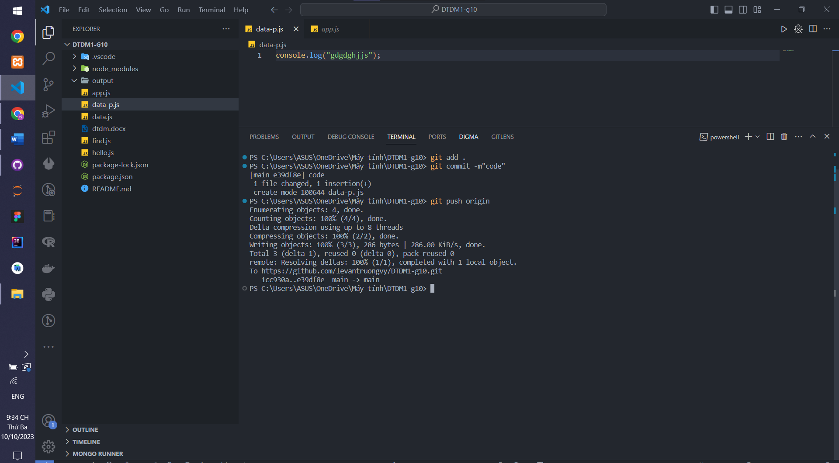

Step 7: Push a branch to GitHub

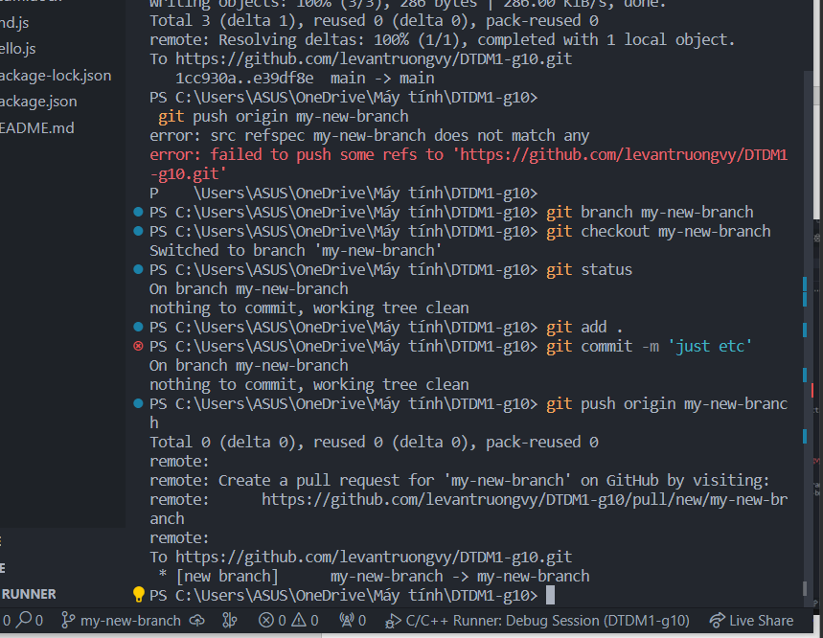Step 8: Create a pull request (PR)

Step 10: Get changes on GitHub back to your computer

Lab2