1-Week Task

Please try to use the following listed software/tech.

The following are just recommendations and you are free to use any framework/language

* ASP.NET 3.5 framework
* Visual Studio 2013
  + Pro version is free for anyone with a .edu id – [www.dreamspark.com](http://www.dreamspark.com)
  + You can choose to use the Express version which can be downloaded from <http://www.visualstudio.com/en-us/products/visual-studio-express-vs.aspx>
* Databases
  + You can download and use SQL Server 2008/2012/2014
    - All full versions are free for anyone with .edu email id
    - You can use the SQL Express which comes with Visual Studio

Recommendations (These are just suggestions, you are free to use your own ideas)

* Feel free to use <UpdatePanel> in ASP.NET for easier AJAX
* GridView wherever necessary
* A simple CSS. For ex: - <https://www.cco.purdue.edu/asp/aspnet/GradSurvey/>
* jQuery and online sources

Note: - Please refrain from references to online libraries as we can’t keep track of them. You are free to download the entire reference and use it.

Compatibility

We will test your work on IE8 and above, Chrome, Firefox, Safari (Even tablets)

Restrictions:

You may not discuss or collaborate with anyone else within the office. You are to not talk to friends and ask for help. This is a solo task, no one else is making this. Take pride in it! You may search online and look for assistance there if needed.

Please attempt to complete the as much of this task within the given span as you, there will be no extensions. At the end of the week your work **must** be submitted! If you are unable to do a certain part, or are struggling, move on and come back later if needed.

**TASK**

You will be making an online counseling appointment request system. There are 3 roles in the application namely counselor, student, admin. All the roles should be validated using passwords stored in a database. The passwords can be stored in the database in clear text or hash. Bonus points for hashing -> MD5/SHA1/SHA2.

All 3 of them share a common login screen. Depending on the role the next page should vary.

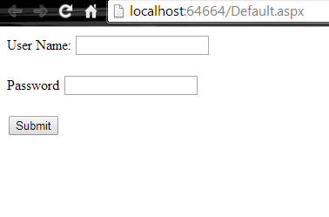

**Student Page**:

The student should be able to select a date and time for the appointment. If the box is checked there should be a textbox displayed without a page reload being shown to the user.

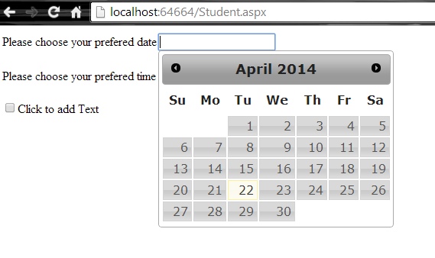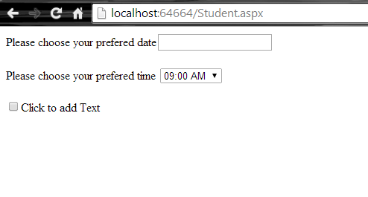

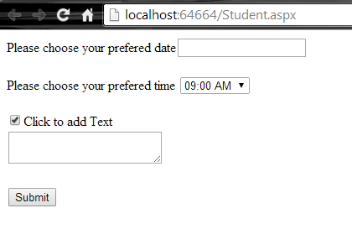

On submission the data should be stored to the database.

**Counselor Page:**

The counselor after validation should be able to accept an appointment.

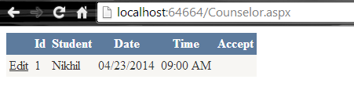

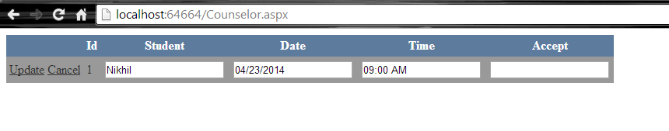

**Admin Page:**

The admin should be able to see the database in a page. He should not be able to edit any of the values.

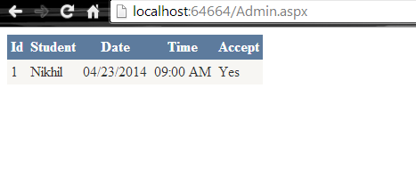

It would be great if the admin page could feature an autocomplete search textbox on student names. It should deal with real data from your database.

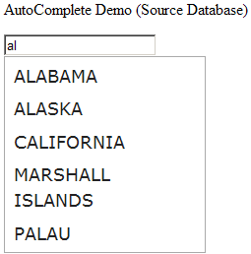

*Illustrative purpose only.

NOTE: -

The above screenshots are samples. You can replicate them with all features specified or choose to make your own. The above examples are without explicit CSS but your project should contain CSS.

**Database Design Specifications: -**

* Assume you have a list of student names and PUIDs in a table dbo.student
* Assume you have a list of counselor names and unique IDs in a table dbo.counselor
* Each appointment should be logged in a table for example dbo.appointment
* Dbo.appointment table should have references to dbo.student and dbo.counselor – meaning there should not be any repetition of names. You are free to assign foreign keys, references etc
* The admin interface should display data by performing complex queries like joins or SQL nested query.
* You are free to fill any appropriate data in dbo.student and dbo.counselor.

**Submission: -**

You can capture screenshots and email them to us along with project with entire code. Be sure to zip your project folder.