Determining the Vertebral Column Condition Based on Biomechanical Measurements

The vertebral column, also known as the spine, makes up the central axis of skeleton system in all vertebrates (Kayalioglu, 2009).

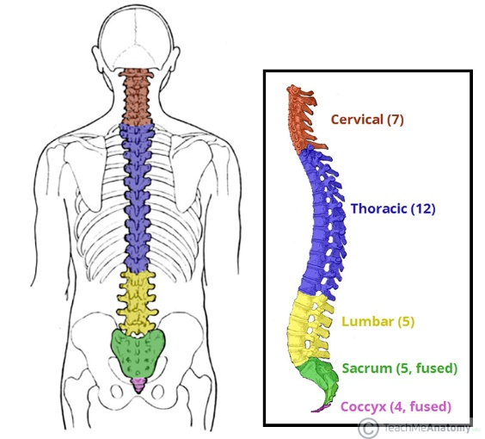

Figure 1 - The vertebral column regions (teachmeanatomy.com 2020)

In this study I aimed to build a classification model based on the data set built by Dr. Henrique da Mota (Da Mota, Barreto, & Ajalmar, 2011).

In the dataset, each patient is represented by six biomechanical attributes of the spine; pelvic incidence, pelvic tilt, lumbar lordosis angle, sacral slope, pelvic radius and grade of spondylolisthesis.

Each patient is also classified in 2 different ways. The first classification distinguishes patient's condition as Normal or Abnormal. Second classification details abnormal condition and distinguishes the class of patient as either Normal, Disk Hernia or Spondylolisthesis.

During the model building phase, we’ll build six different classification models from the ScikitLearn library for both the 2-condition and 3-condition classification and evaluate the performance of the models.

After model evaluation, we’ll also inspect which attributes seem to contribute the most to the patient’s condition.

# References

Da Mota, H., Barreto, G., & Ajalmar, N. (2011). Vertebral Column. *UCI Machine Learning Repository.*

Kayalioglu, G. (2009). Chapter 3 - The Vertebral Column and Spinal Meninges. *The Spinal Cord* (s. 17-36). içinde Academic Press. doi:https://doi.org/10.1016/B978-0-12-374247-6.50007-9