**Installation Guide for Robot Dependencies**

**Install MATLAB**

Install MATLAB 2023a. Start at this [link.](https://www.mathworks.com/academia/tah-portal/university-of-texas-at-el-paso-40735445.html) Click on the “sign in to get started” button which will take you to the UTEP single sign on. After logging in you’ll be prompted to create a mathworks account, eventually you’ll get to a downloads page which should automatically select the appropriate installer for your computer:

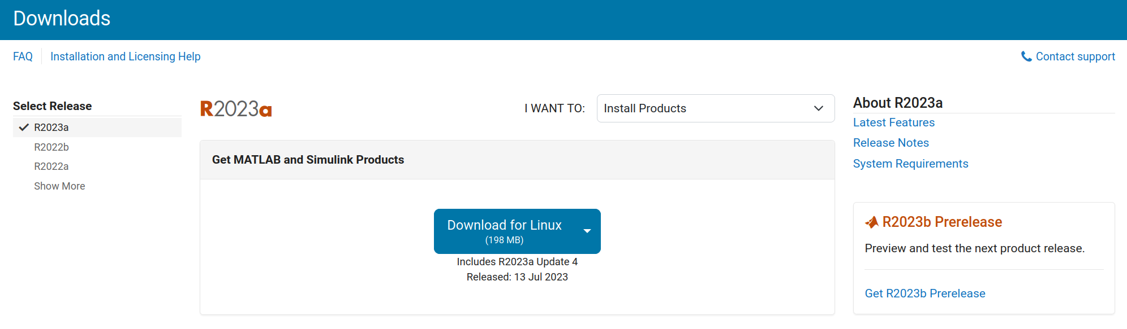

Download the installer and go through the installation process. When prompted to select products to install, make sure you select the “ROS toolbox” and “aerospace toolbox.”

**Install python**

Version 3.9, [available here](https://www.python.org/downloads/release/python-390/).

Install with default options, at the end of install if prompted to remove the windows path length limitation, select “yes”

Open matlab and run

>> pyenv('Version','3.9)

**Verify**

Open MATLAB and the “simulator.m” file from blackboard. Click “Run” in the matlab editor. If prompted to “change directory” or “add to path” select “change directory” (if you get this prompt this is almost always what you want).

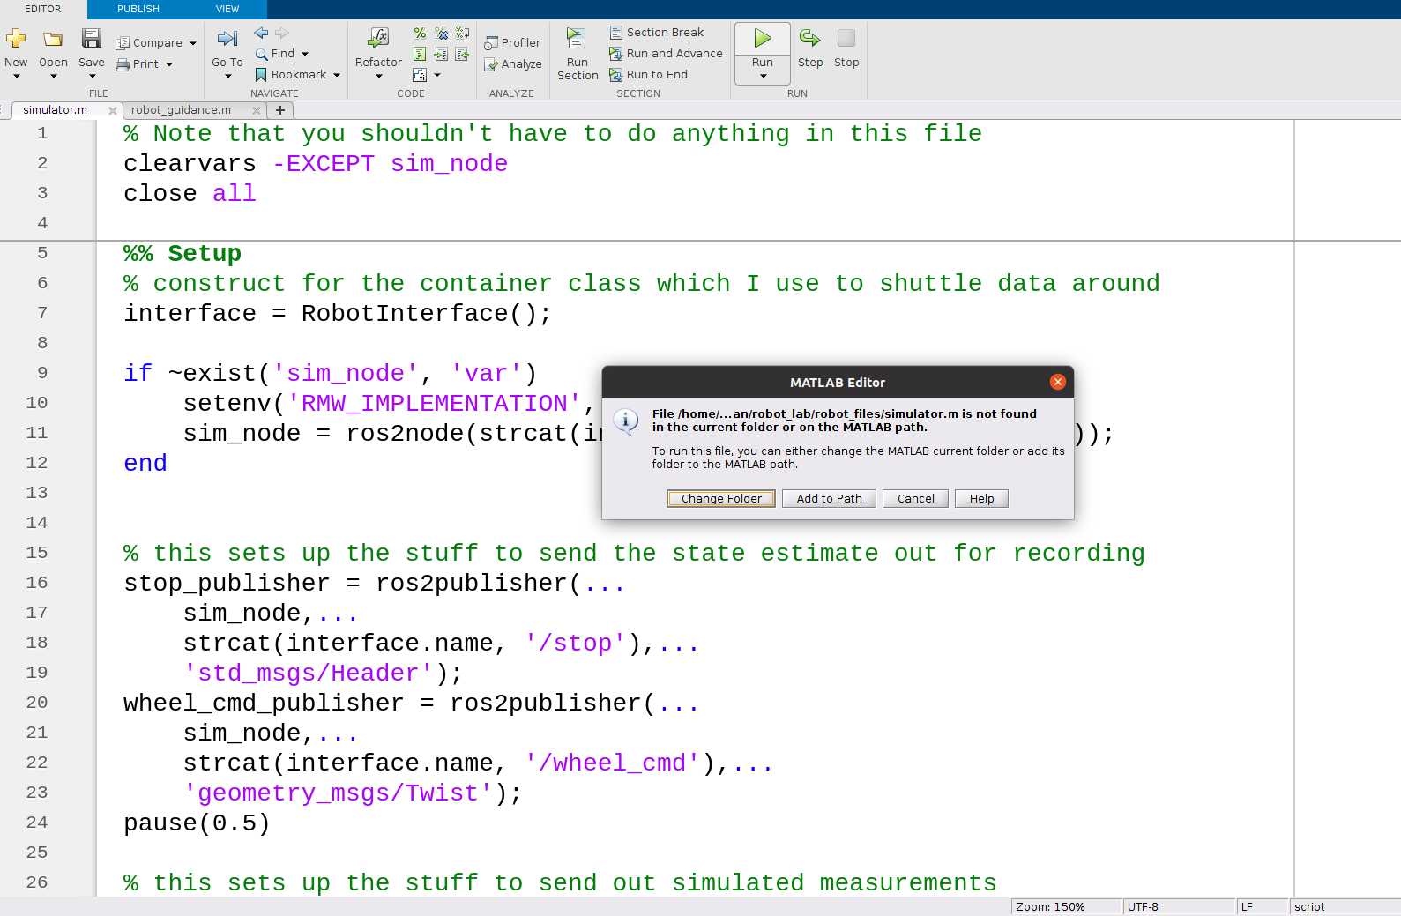

You should see a window pop up showing a robot randomly drive down a hallway. Magenta dots on the hallway indicate laser scan locations. It should continue until the robot hits a wall.

**ADDITIONAL INSTRUCTIONS – ONLY IF YOU ALREADY HAVE MATLAB INSTALLED**

**Install MATLAB ros toolbox**

In the “home” pane of matlab click “Add-Ons”

This will bring up the “add on explorer” search for “ros” and select the “ROS toolbox”

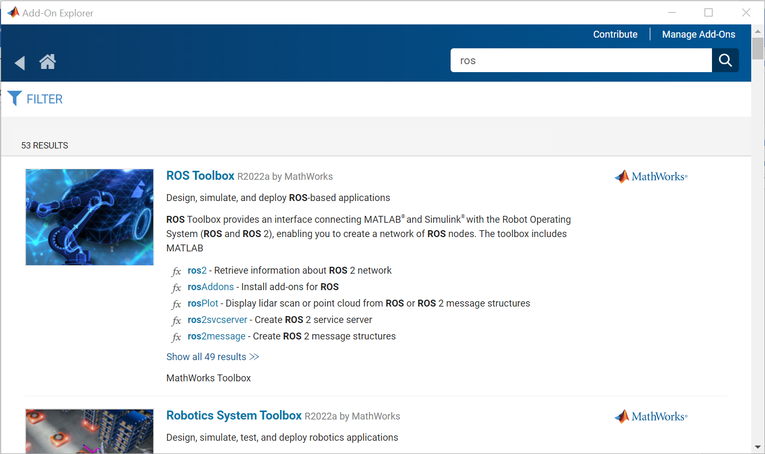

Click on it, click “sign in to install” and follow the prompts to install the toolbox

**Install Aerospace Toolbox**

Open the add on explorer again and search for “aerospace”, click on the aerospace toolbox and follow the same process to install it.