The Biography of Vincent Henin - Vhenin

I was born in Etterbeek (Brussels), on a beautiful Sunday in May 1979, the twentieth to be precise. My sign is Taurus, for the ones interested in astrology. After a short stay in Brussels, I grew up in the beautiful region of Walloon Brabant, about twenty kilometres south of the Belgian capital.

It’s in the cities Ottignies and Louvain-la-neuve that I spent most of my time. Since I was thirteen I went to comic classes, given by Jean-François Di Giorgio (Munro, Shane, Samouraï, Mygala,…) and Jean-luc Cornette (Les Enfants Terribles, Alexandre Pompidou...) in the comics museum, where I myself would be giving summer classes a while later. Then Jean-François asked me to join a higher group in the cultural centre “Espace Bernier” in Waterloo. It was here that I met Frédéric Genêt (“Samuraï”), and Cédric Van Erweghe (alias Hervan), who I would introduce to Jacques Martin years later. Hervan draws the series “Le dernier des Schoënfeld” with the tandem Barrat-Bartoll for the scenario. It was also with the members of this studio that I created the biggest comic book page in the world (the record is without a doubt broken since then, but it remains an exceptional experience). An unforgettable experience recorded by the Guinness Book of Records!

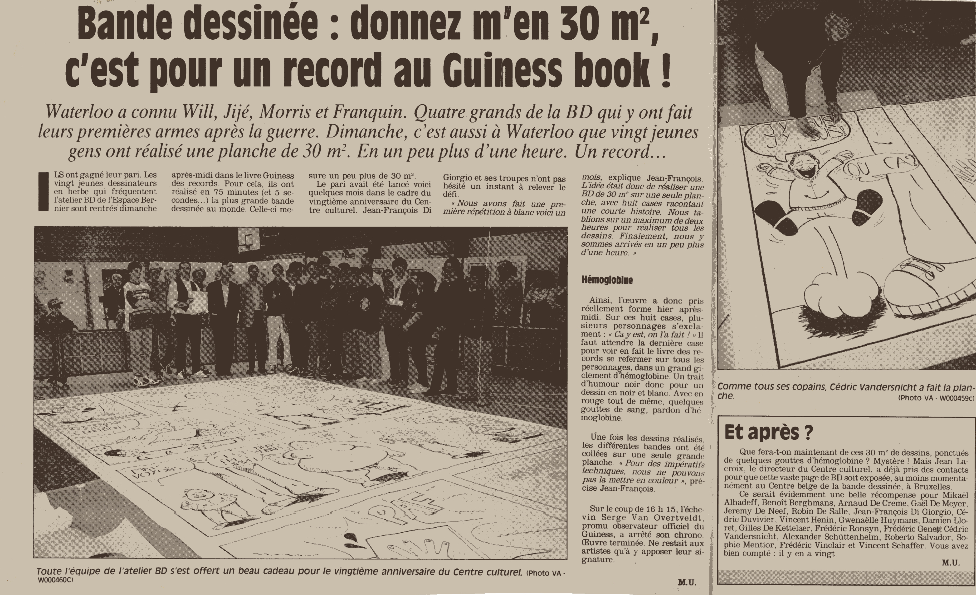 | 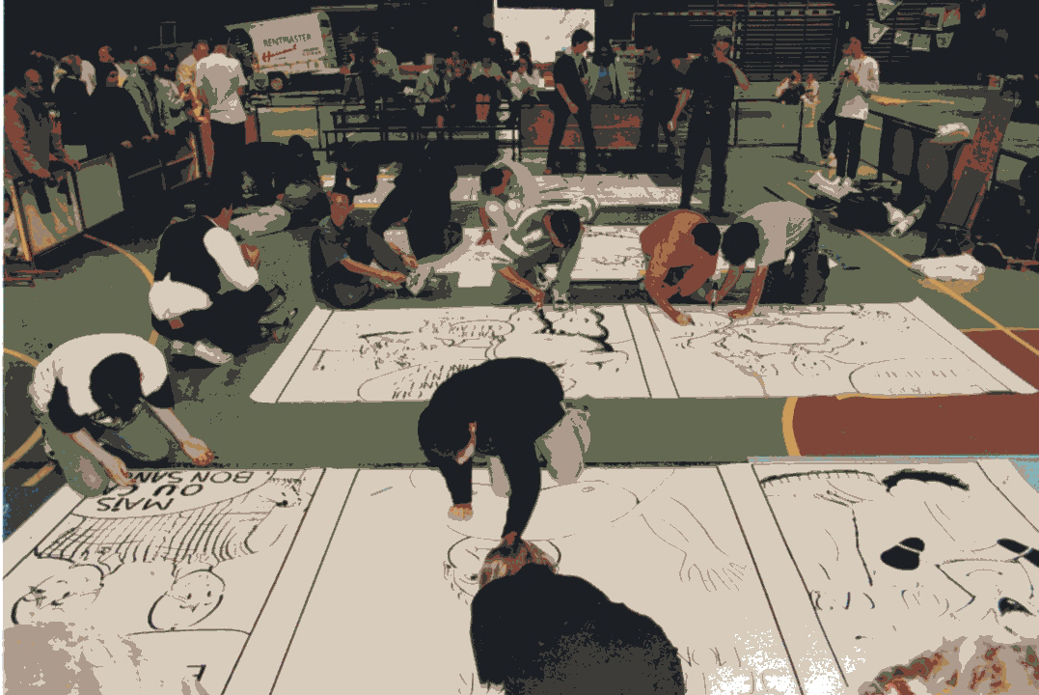
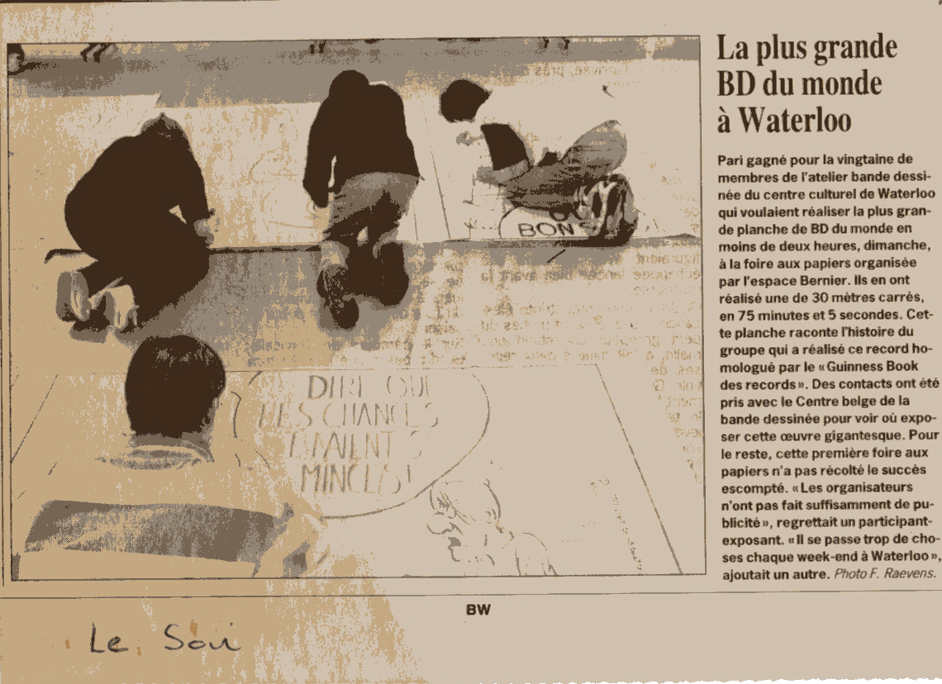 | 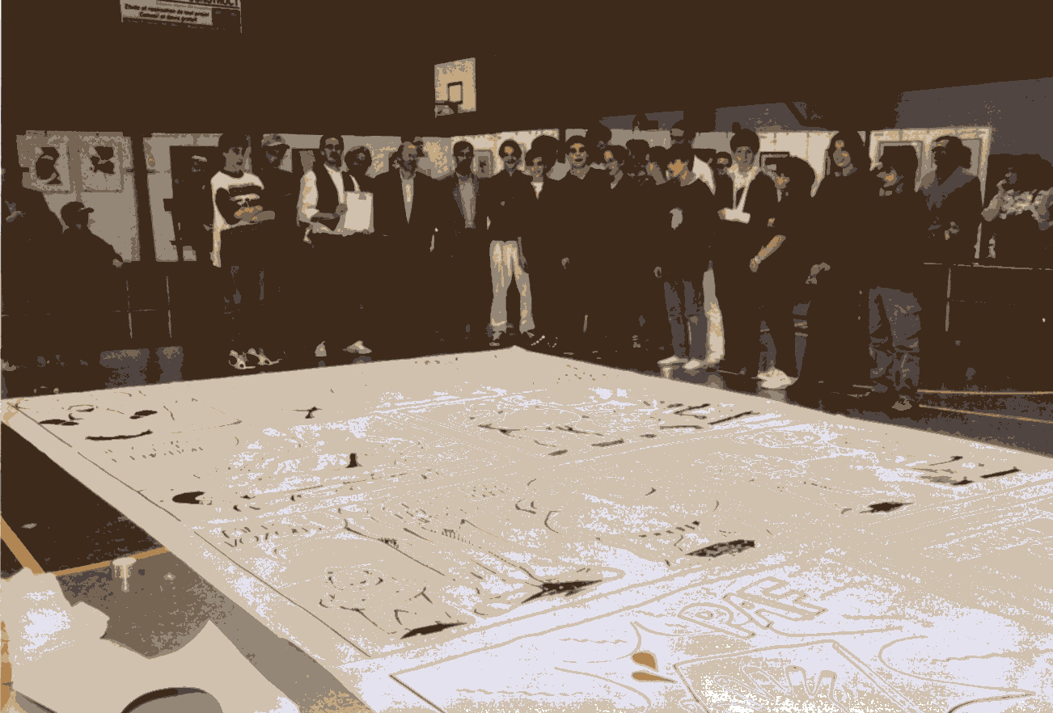

After an ordinary education at the Martin V high school in Louvain-la-Neuve, I met the wife of Jacques Martin (Alix, Lefranc) during a wine-tasting. Bacchus did his work and I got to meet the great master Jacques Martin. He proposes me to help with several little assignments like colouring, backgrounds, lettering,… After a few months of cooperation, the master suggests to resume a project which failed a few years before; Les Voyages d’Alix (The journeys of Alex – Carthage). I just celebrated my 19th spring. A real challenge!

Other albums followed; Jérusalem (Jerusalem), Pétra (Petra) and Lutèce (Lutetia) (please see bibliography at the end of this biography). I was also given the chance to work with Christophe Simon on several projects: l’odyssée d’Alix (1) (The odyssee of Alex), l’odyssée d’Alix (2) (The odyssee of Alex (2)), Orion – Le Pharaon (Orion – The pharaoh), Lefranc – La Colonne (Lefranc – The column).

Comics don’t always feed their creator. And with about 5000 new releases each year, it’s definitely not always easy to catch the eye. Despite the good sales figures of my books and “Le Prix De l’Avenir 2002” (Rising Talent Award 2002) presented by “La Chambre Belge des Experts en Bande Dessinée” (The Belgian Chambre of Comics Experts) which I received for the comic Jerusalem, I decide to go studying again in September 2003. It was a way to safeguard my future but I also craved to extend my horizons. So I studied infography at l’Institut Saint Luc de Bruxelles (Saint Gilles) where I graduate in 2006 with a diploma in Infography-Visual and Plastic arts.

My last comic book “Les Voyages d'Alix – Lutèce”, in partnership with Jacques Martin-Casterman, is released in May 2006. Then, a lot of things -personal as well as non-personal- came inbetween, and kept me away from Comics world, which I regret. I hope I will collaborate again with Casterman Press. The doors are, of course, still wide-open...

A few Comics Strip projects with other publishers were nearly achieved though but each time something untimely came to interrupt the ongoing project: publisher bankrupcy, deceiving promises, disagreements... and I had to begin every thing from scratch again.

I tried not to lose heart and I will achieve several commissioned works between 2006 and today; illustrations, logo's, websites for:

- Apis Consulting
- Miss V hats
- « Le Conseil de la Jeunesse de la Communauté française de Belgique »
- Pragmacom
- The painter Eric Migom
- « Une Zine à rêves »
- European Commission
- Etc,

Thanks to these works I got myself hired, in 2008, as a trainer/webmaster and interface designer for a company outsourcing for the European Commission in Brussels.

Back to a stable financial situation, I launch a new Comic book project with the character Roger Roger, a lumpish with easy-going looks non-hero. This project draws the attention of the scenarist Tarek, and comic book publisher, Tartamudo. Tarek proposes me to undertake the drawings of « Blateman & Bobine », a story for children and pre-teenagers. A new adventure for me, definitely ! Release scheduled for December 2015.

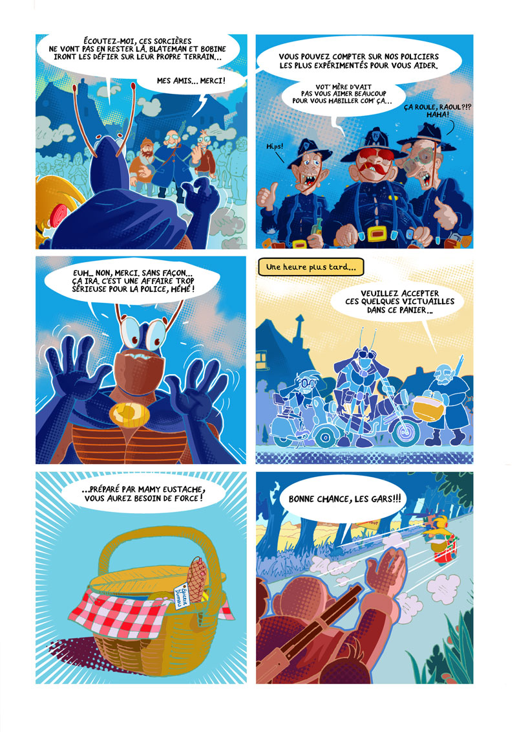 | 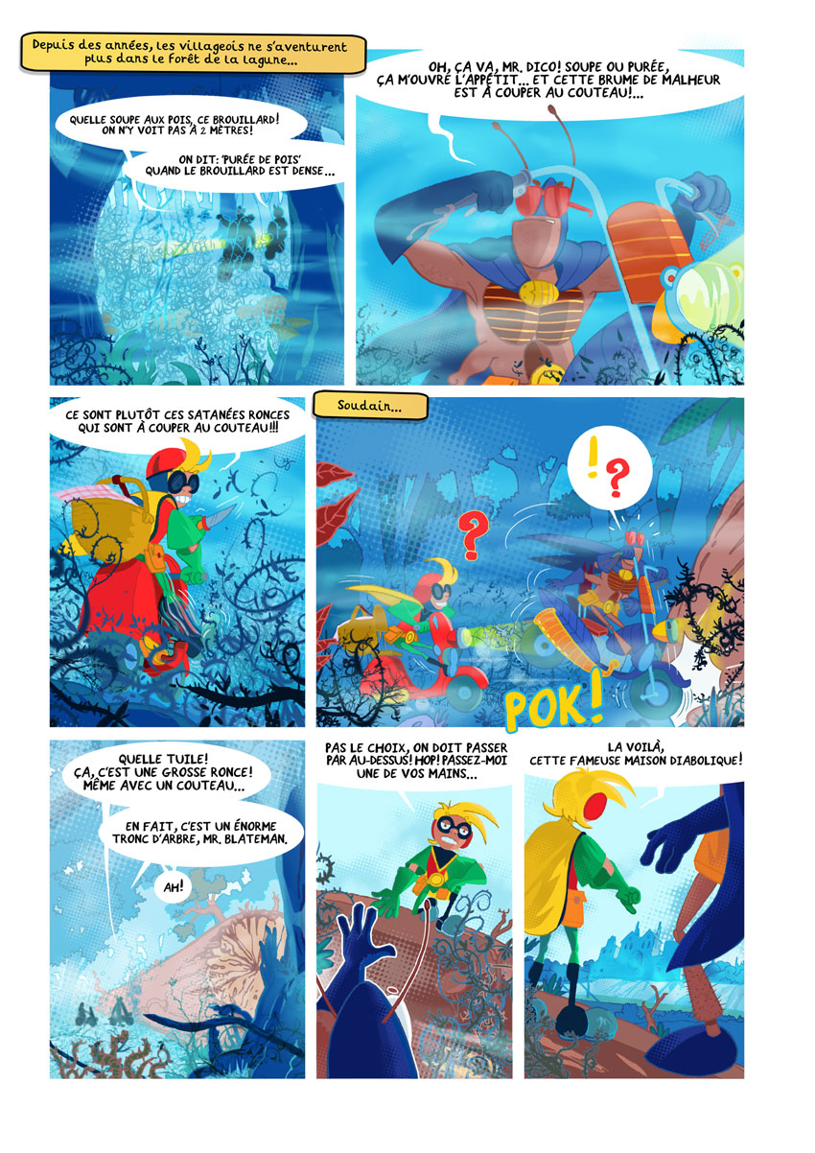
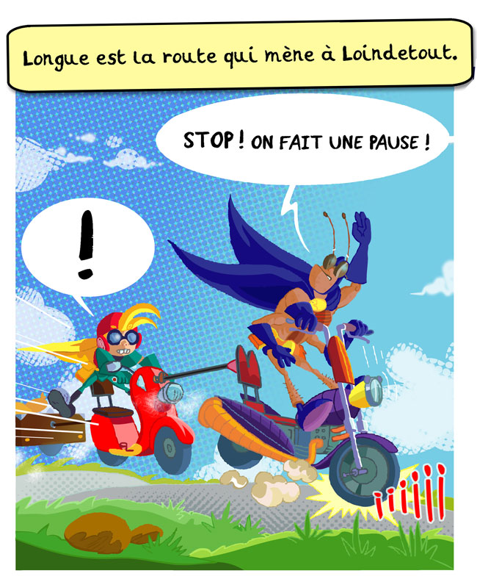 | 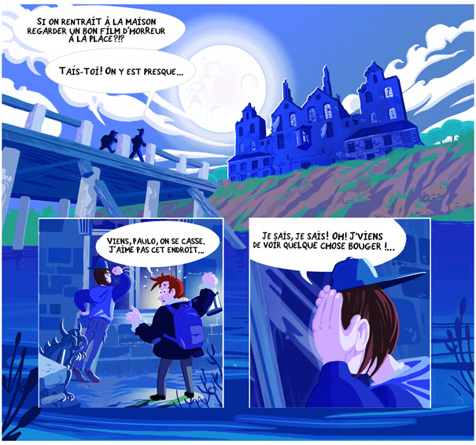

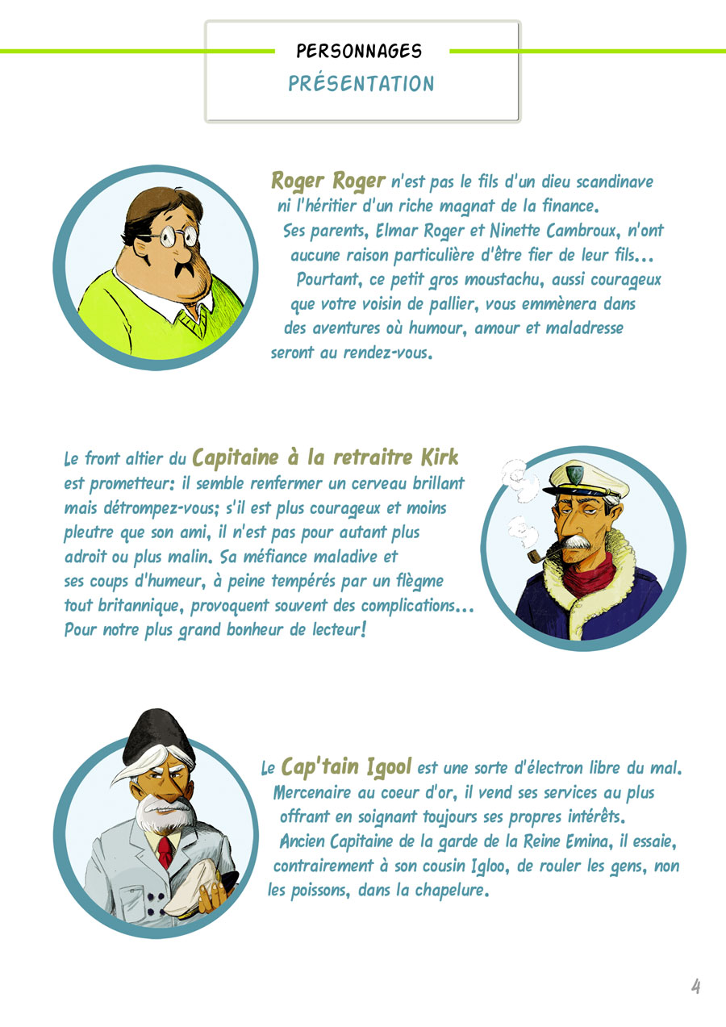 | 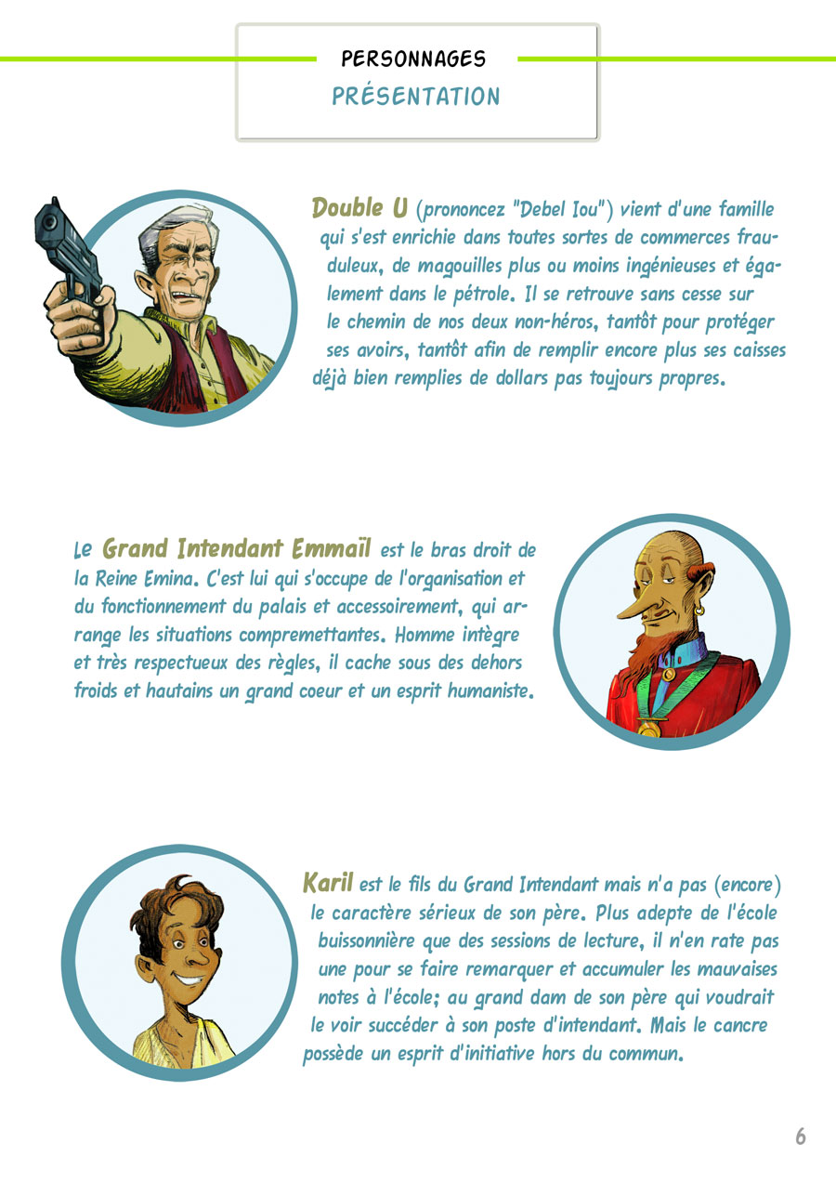
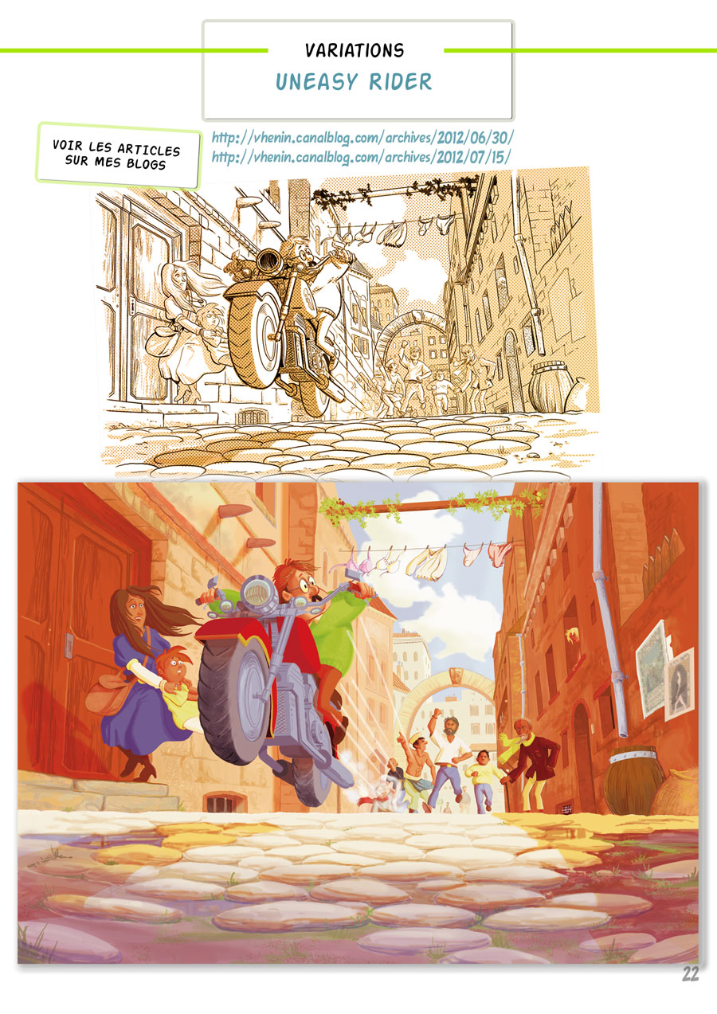 | 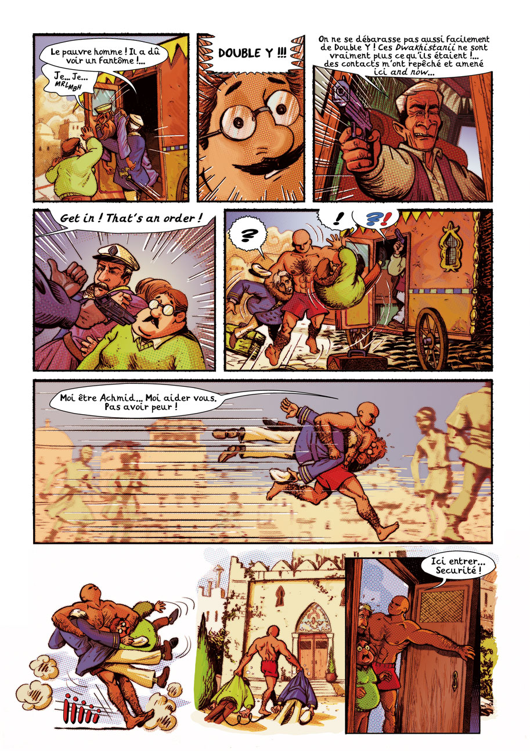

Bibliography

The journeys of Alex - “Les Voyages d'Alix” (with Jacques Martin):
- Carthage, Casterman Press
- Jérusalem (Jerusalem), Casterman Press
- Pétra (Petra), Casterman Press
- Lutèce (Lutetia), Casterman Press

“Blateman & Bobine” (with Tarek):
-#1 - “Loindetout”, Tartamudo editions (only in french at the moment)
upcoming: 2 - Goudacity
Blog and sites
http://www.vincent-henin.be/
http://www.vhenin.be/
http://vhenin.canalblog.com/
https://blatemanetbobine.wordpress.com/

YouTube
The channel of Vhenin :
https://www.youtube.com/channel/UCFgRf_TU8ES5LJNMaKOr8Eg/videos
URL of the biography :
http://www.vhenin.be/fichiers/bio_site_vhenin_en_web.pdf/

Photos

Please respect copyrights. Thanks!

Photos taken by photograph Leila Khemissi
https://www.facebook.com/pages/Leila-K-Photographer/186352108044694

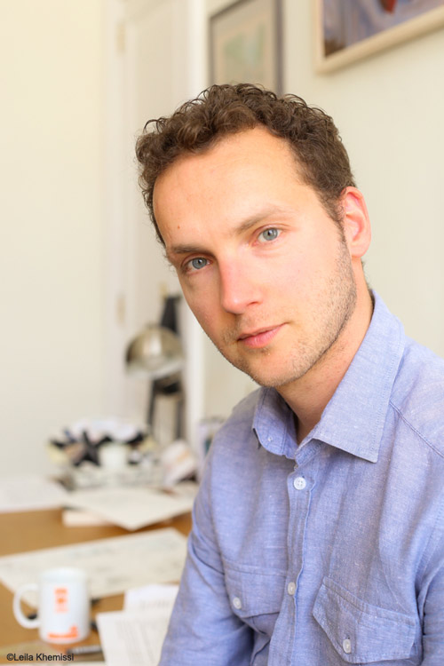 | 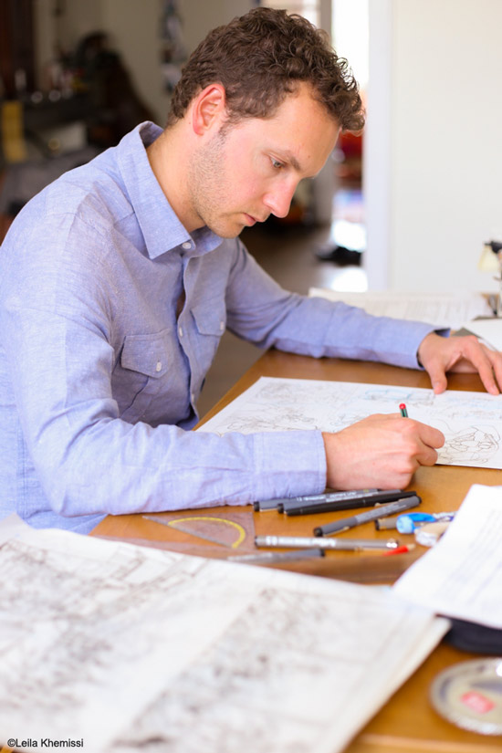 | 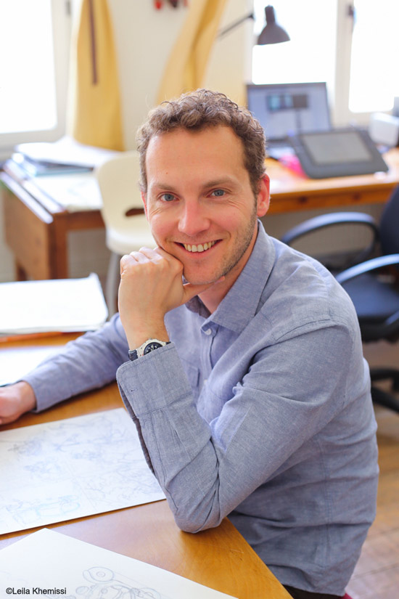
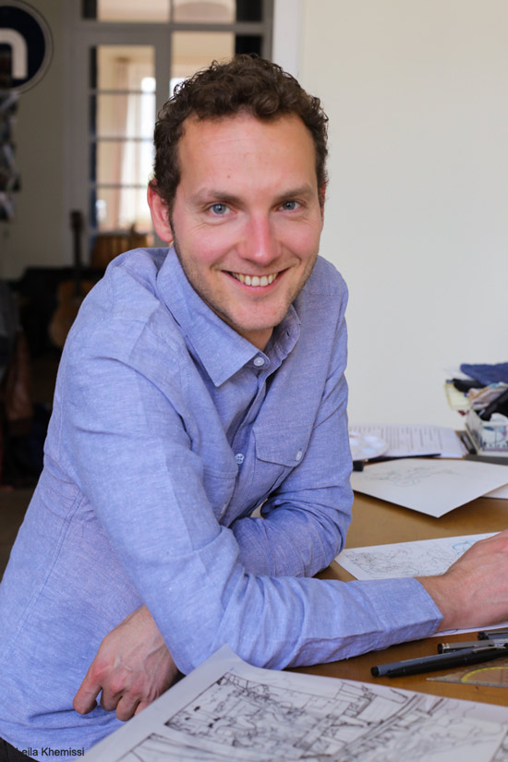 | 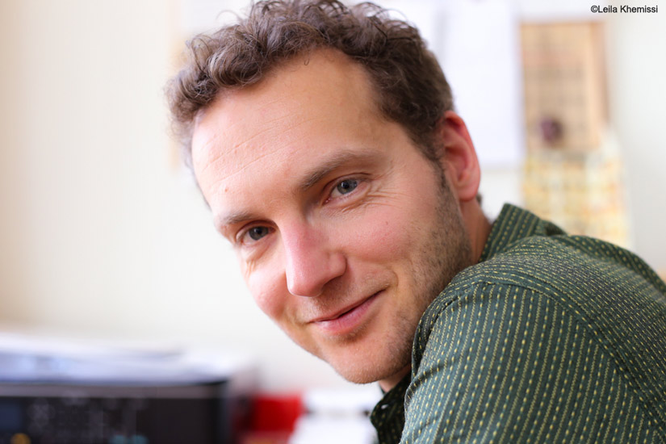 | 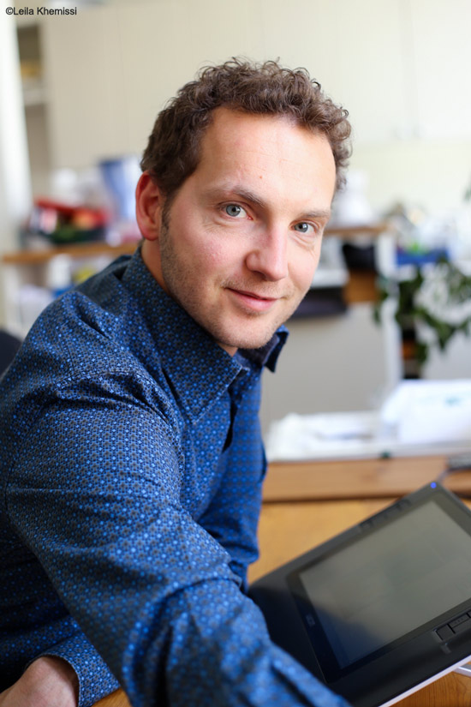
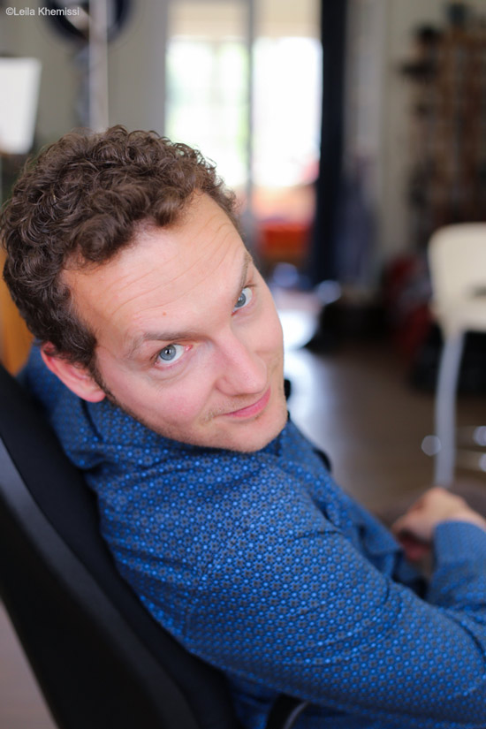 | 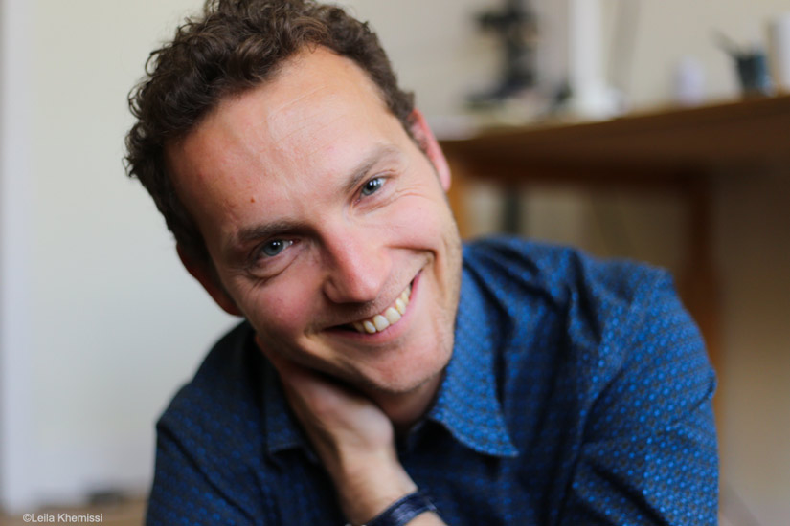 | 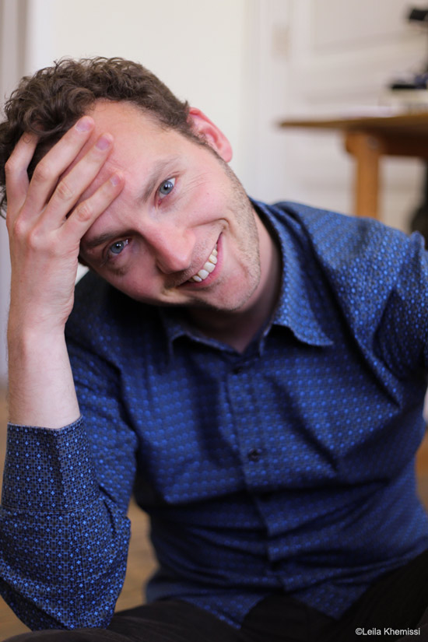

Please contact me for higher resolution pictures. Thanks !
http://www.vhenin.be/#contact

