YUV INTERNSHIP — WEEK 1
PLANETS & MOONS
Data Acquisition, Cleaning & Preprocessing
A Physics-Based Data Science Case Study

1. Introduction & Dataset
This project demonstrates a complete Week 1 data-science workflow using the Kaggle “Planets & Moons” dataset. The selected planets.csv file contains physical and orbital properties such as diameter, mass, eccentricity, semi-major axis, surface gravity, orbital period, rotation period and number of satellites. The dataset is well suited to a Physics background because the variables have direct scientific meaning.

2. Objectives
- Acquire and load the planetary dataset using Python.
- Explore its structure, variables and data types.
- Check missing values, duplicates and statistical outliers.
- Apply physics-based validation and appropriate preprocessing.
- Create scientific visualizations and prepare clean data for further analysis.

3. Data Acquisition & Initial Exploration
The dataset was downloaded from Kaggle using KaggleHub and loaded with Pandas. Initial inspection was performed using df.head() and df.info().
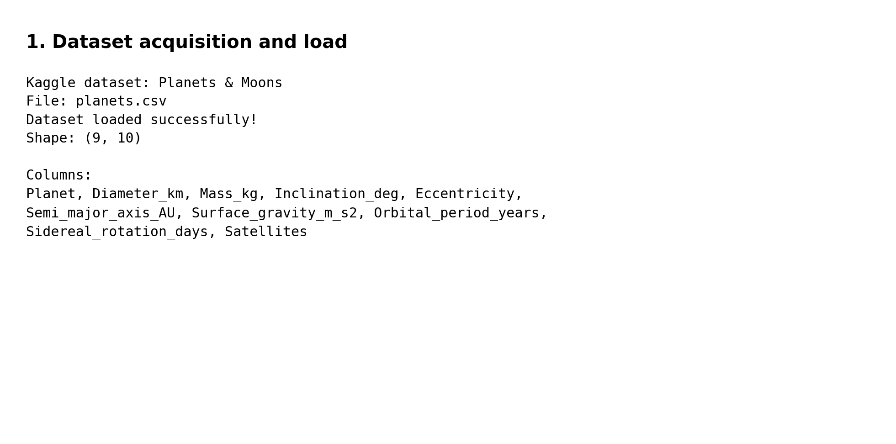
Figure 1. Dataset acquisition and successful loading of planets.csv.
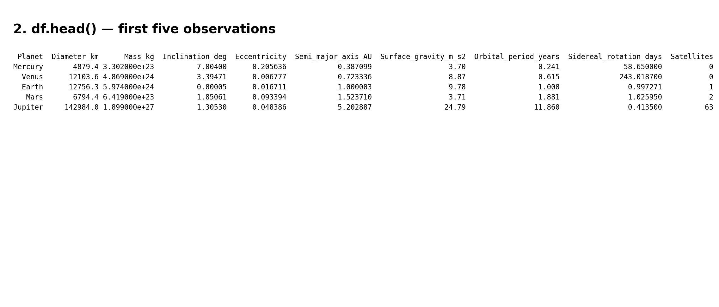
Figure 2. First five observations displayed using df.head().
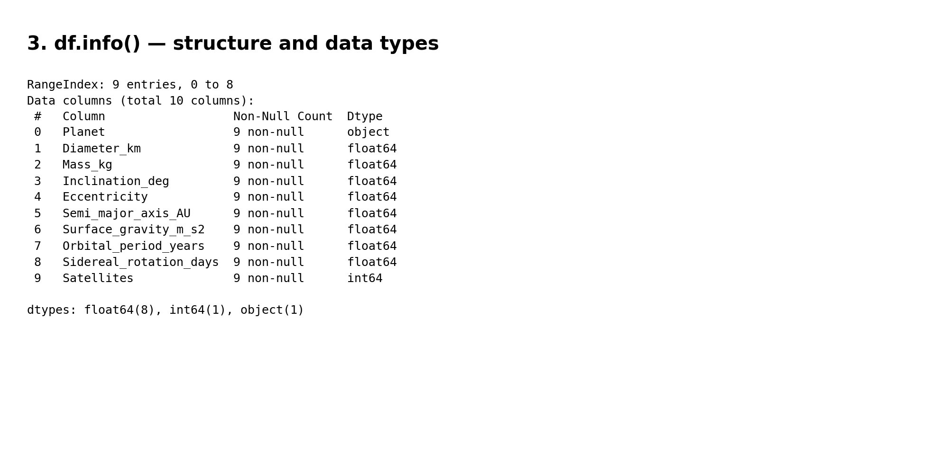
Figure 3. Dataset structure and data types obtained using df.info().

4. Data Quality Assessment
Data quality was assessed through missing-value, duplicate, outlier and physical-validity checks. The selected planetary records contain no missing values in the source table and no duplicate rows. Numerical variables were screened using the IQR rule. Importantly, an IQR outlier is not automatically an error: large differences between planets can be physically meaningful.
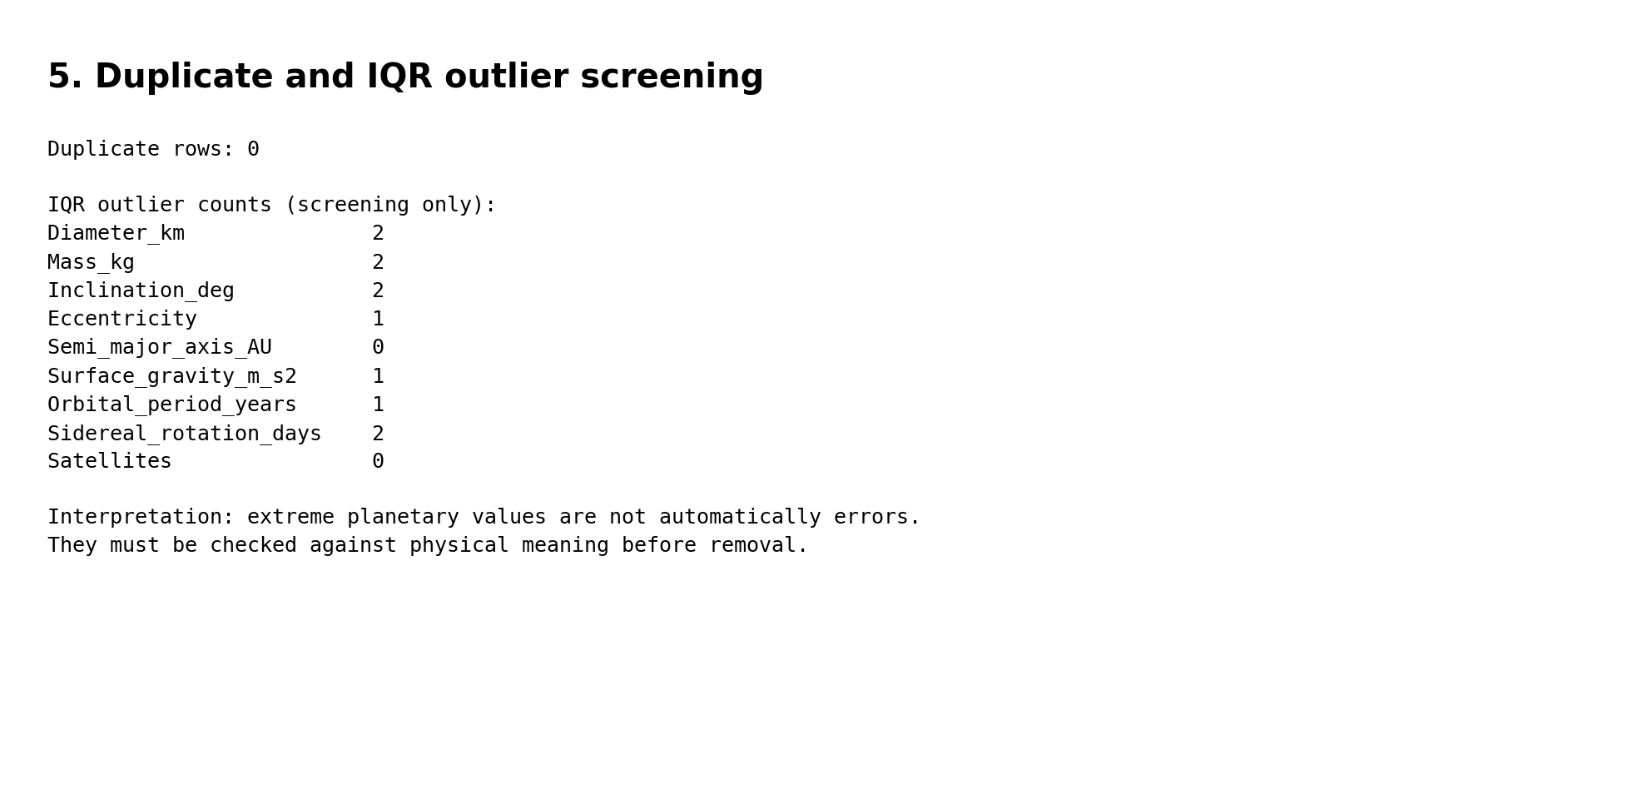
Figure 4. Duplicate check and IQR-based outlier screening.
Physics-based validation was also applied. Quantities such as mass, diameter, surface gravity, orbital period and semi-major axis should be positive. This domain knowledge helps distinguish potentially invalid records from genuine extreme planetary values.

5. Data Preprocessing
Column names were standardized to a consistent machine-readable format. Duplicate records, if present, were removed. Numerical features were standardized with Scikit-learn's StandardScaler for potential future statistical or machine-learning analysis. The original physical units were retained in a separate cleaned dataset so that scientific interpretation is not lost.
Generated outputs:
- planets_cleaned.csv
- planets_preprocessed_scaled.csv
- planet_outlier_summary.csv

6. Scientific Visual Analysis
Three focused visualizations were selected to connect the data analysis directly with planetary physics.
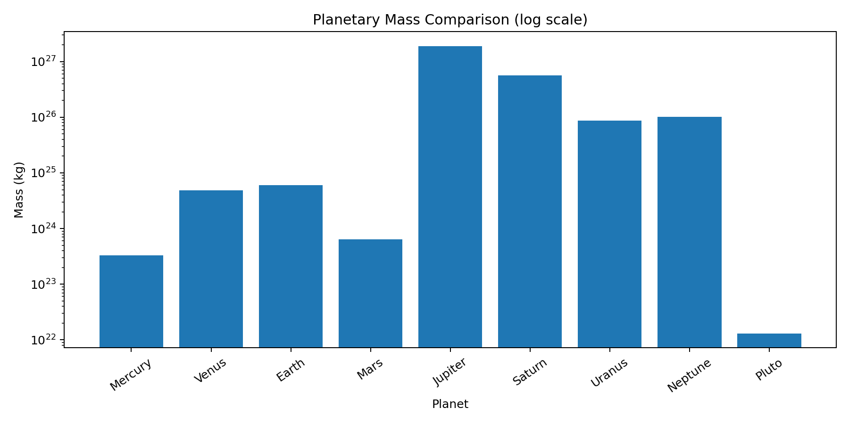
Figure 5. Planetary mass comparison on a logarithmic scale.
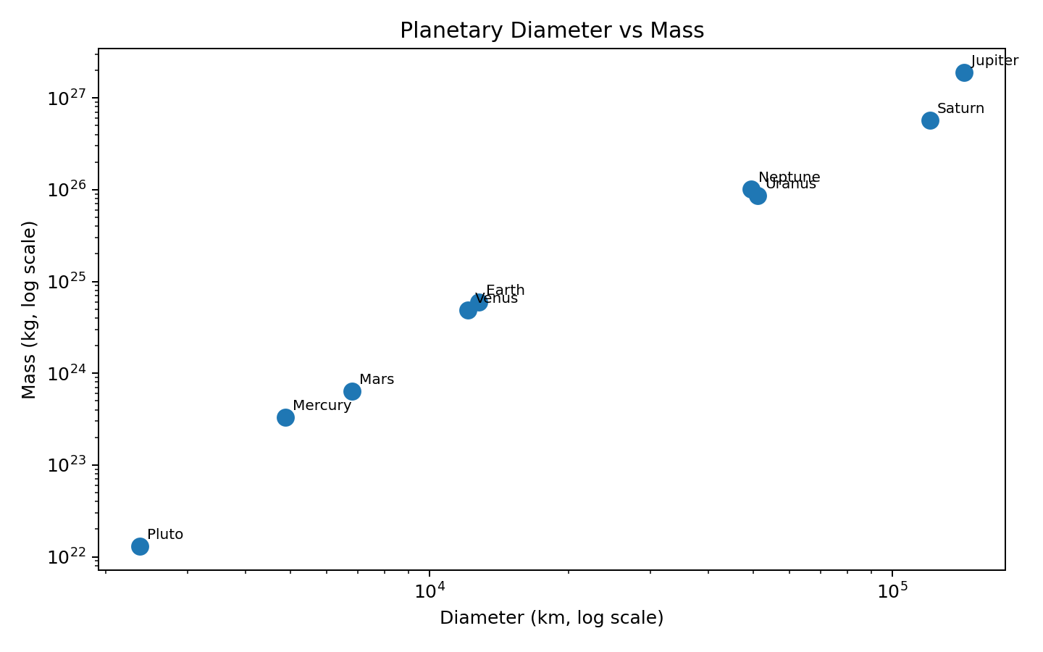
Figure 6. Relationship between planetary diameter and mass.
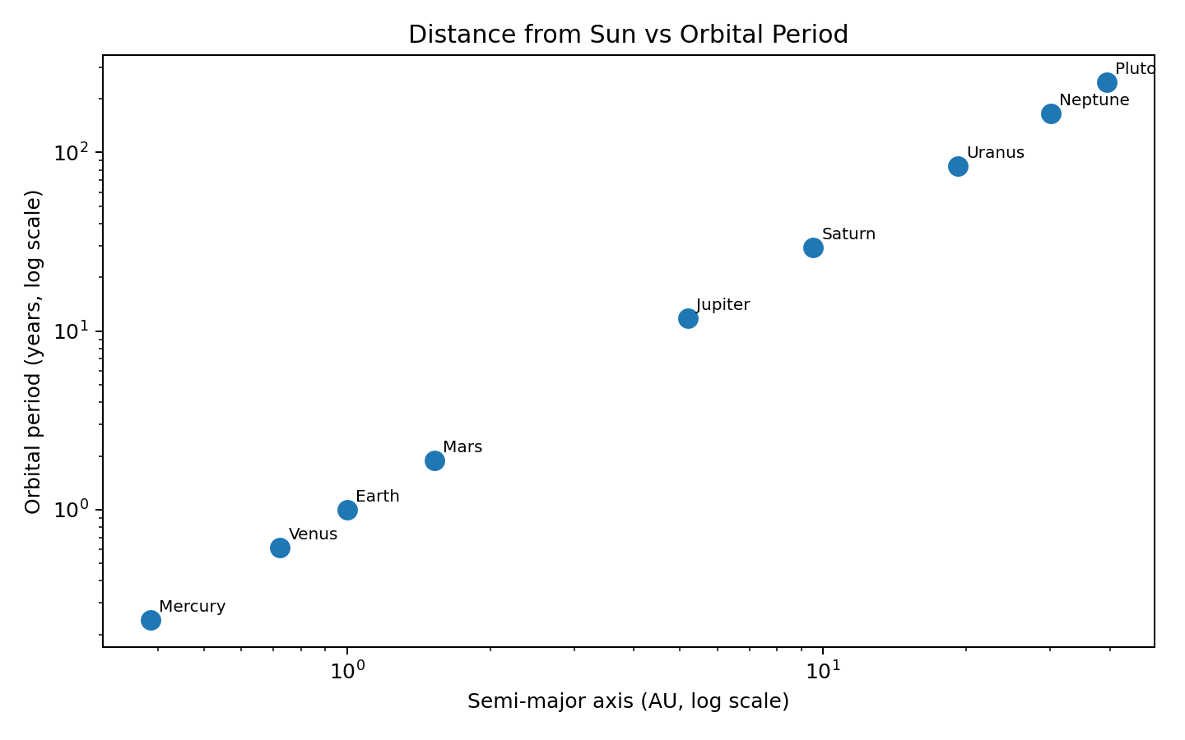
Figure 7. Semi-major axis versus orbital period.
The mass comparison highlights the large range of planetary masses. The diameter–mass plot shows a strong physical relationship while also reflecting differences in planetary composition and density. The orbital plot demonstrates that planets farther from the Sun generally have much longer orbital periods, providing a direct connection to orbital mechanics.

7. Challenges & Solutions
Challenge | Solution
Different feature scales | Retain physical units for interpretation and create a standardized copy.
Extreme planetary values | Use IQR for screening and physics for interpretation rather than automatic deletion.
Reproducibility | Keep the raw/source data unchanged and save separate processed outputs.

8. Conclusion
The Planets & Moons dataset provides a compact and scientifically meaningful example of data acquisition, cleaning and preprocessing. The workflow combines statistical checks with Physics-based reasoning, ensuring that genuine planetary extremes are not incorrectly treated as errors. The cleaned and standardized datasets are now suitable for further analysis in subsequent internship work.

9. References
1. Kaggle — “Planets & Moons,” dataset by Joakim Arvidsson; NASA JPL planetary data identified as the source.
2. Python documentation and standard library references for Pandas, NumPy, Matplotlib, Seaborn and Scikit-learn.

