Yuva Intern (NSDC) – Data Science Internship
Week 2 Task: Exploratory Data Analysis and Visualization
Dataset: Star Type Classification (Kaggle)
Name: Yasir
GitHub: github.com/levi-Akkk/yuva-intern-data-science

1. Objective
This report covers Week 2 of the internship: performing exploratory data analysis (EDA) and visualization on the Star Type Classification dataset (240 stars, 6 classes). It builds on the Week 1 cleaning work, and following the Week 1 feedback, specific figures are quoted for every observation and a short section is added on how the earlier preprocessing affected this week's results.

2. Dataset Overview
The dataset has 240 rows and 7 columns: Temperature, Luminosity (L), Radius (R), Absolute Magnitude (A_M), Color, Spectral Class, and Type. df.info() showed 240 non-null values in all 7 columns — no missing data. Data types: 3 float64 columns (L, R, A_M), 2 int64 columns (Temperature, Type), 2 string columns (Color, Spectral_Class).
df['star_type'].value_counts() confirmed the classes are perfectly balanced — 40 records in each of the 6 types (0 to 5), for a total of 240. This is shown below.
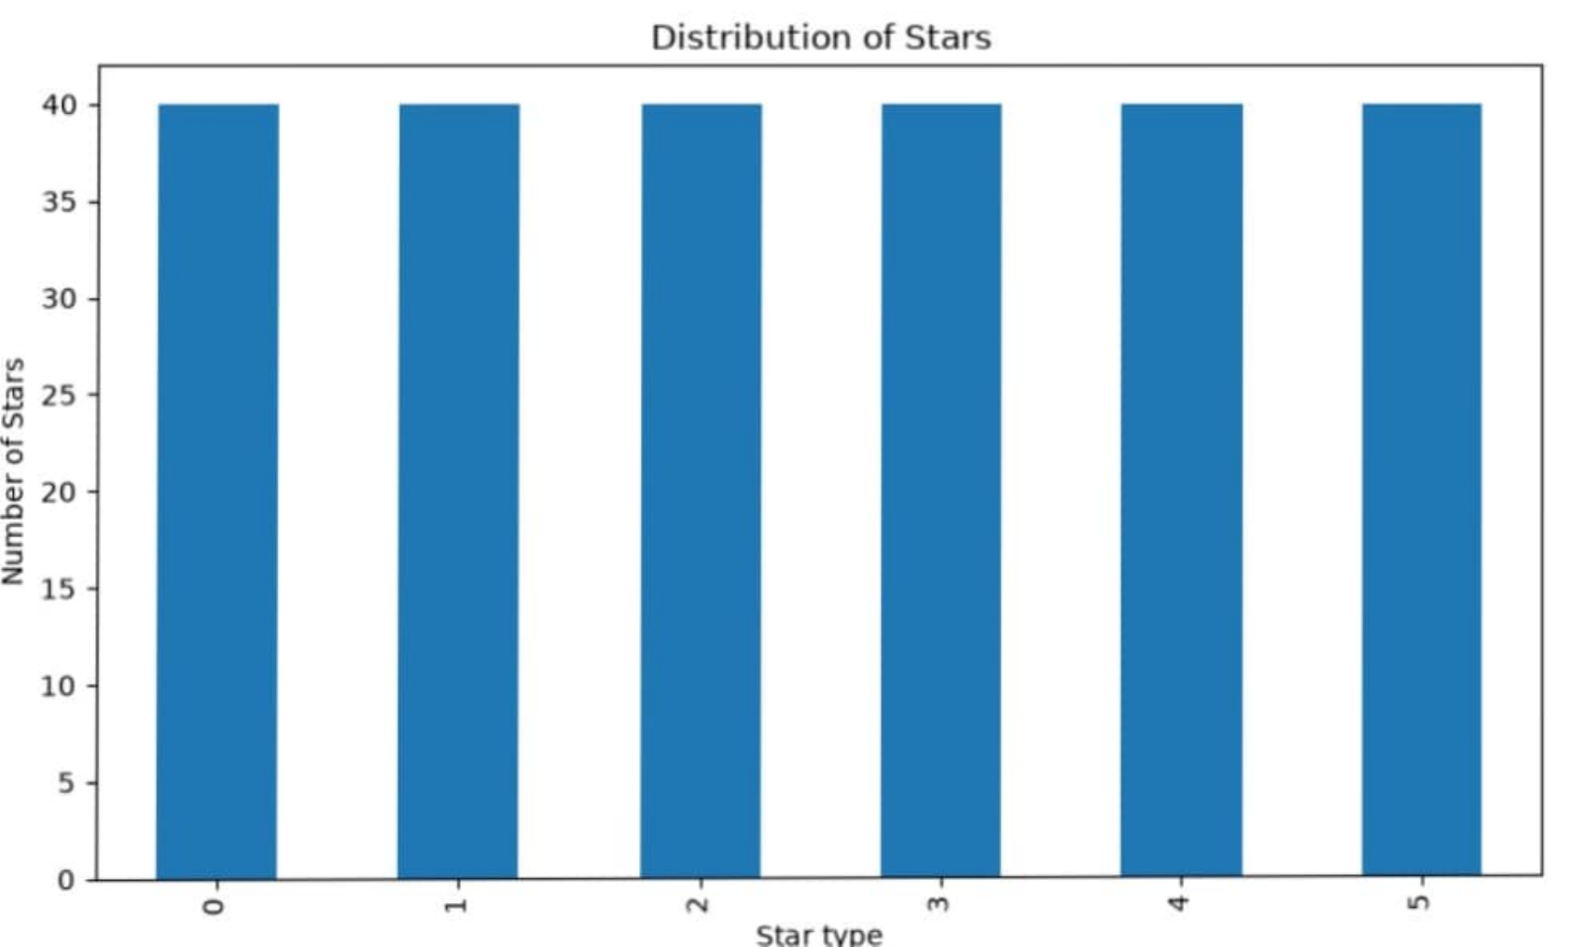
Fig. 1 — Distribution of Stars by Type (40 records in every class)

3. Temperature Analysis
Statistic | Value
Minimum | 1,939 K
Maximum | 40,000 K
Mean | 10,497.46 K
Median | 5,776.00 K
The mean (10,497.46 K) is almost double the median (5,776.00 K), which points to a right-skewed distribution. The histogram below confirms this: well over 100 of the 240 stars fall below 5,000 K, and the remaining stars are spread thinly across a long tail up to 40,000 K.
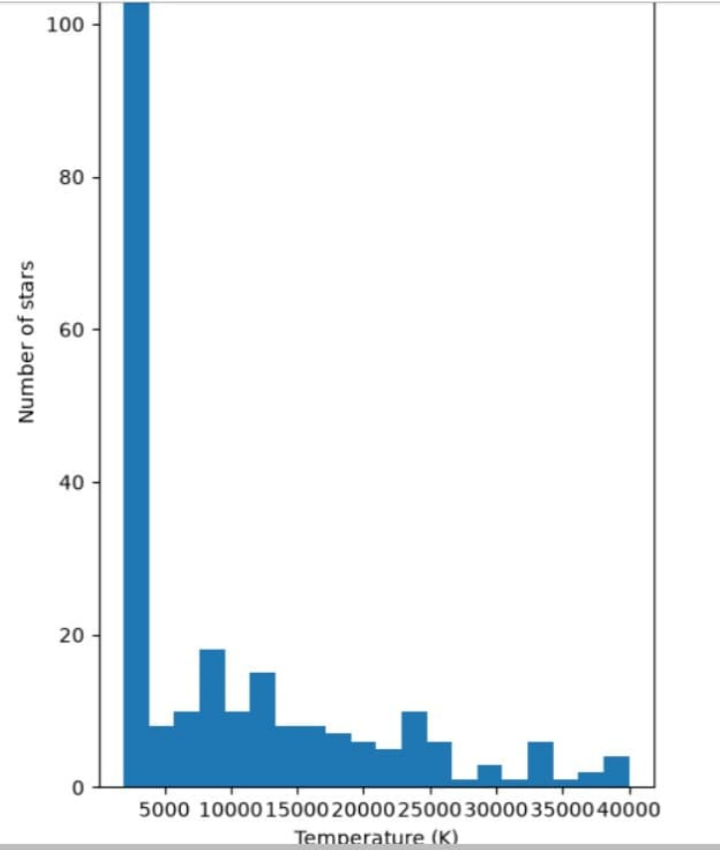
Fig. 2 — Distribution of Stellar Temperature (20 bins)

4. Relationships Between Variables
Temperature vs Luminosity
On a log scale, Temperature vs Luminosity does not form one straight trend — it splits into a few separate bands. One dense group of cool, low-luminosity stars sits below ~5,000 K (luminosity around 10⁻⁴ to 10⁰ L/L☉), while a separate high-luminosity band (10⁴–10⁶ L/L☉) runs across almost the whole temperature range. This second band is the giant/supergiant/hypergiant stars, which stay bright regardless of temperature.
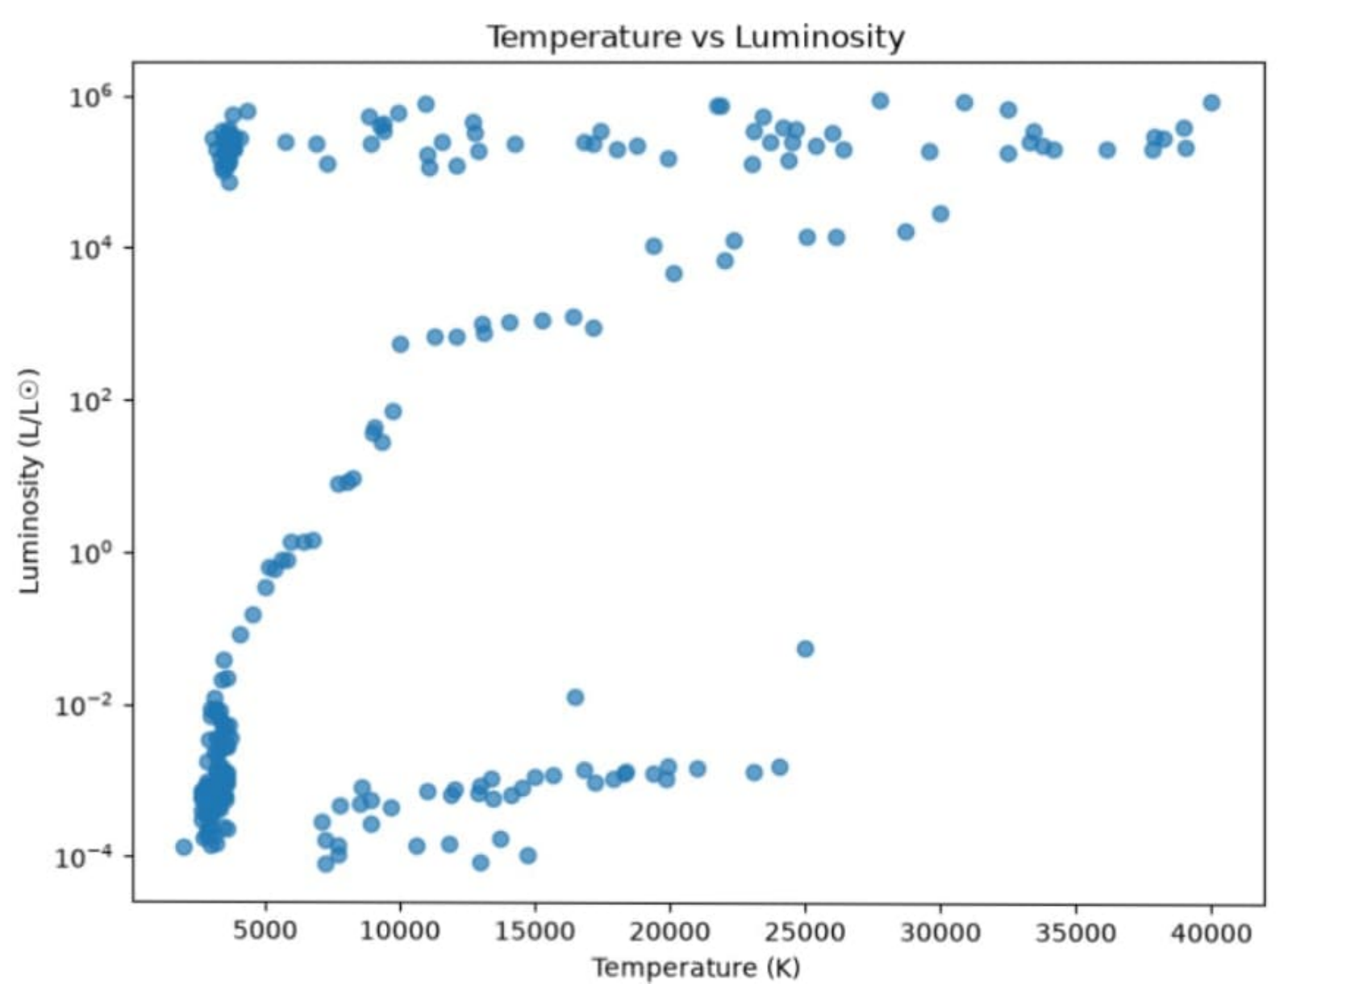
Fig. 3 — Temperature vs Luminosity (log scale)
Radius vs Luminosity
Radius vs Luminosity (log-log) shows a much cleaner positive trend: as radius goes up, luminosity goes up sharply too. Two low-radius clusters (R < 1 R☉) sit at the bottom with low luminosity, and a separate cluster near R ≈ 10³ R☉ sits at the top with luminosity around 10⁵–10⁶ L/L☉ — these are the hypergiants.
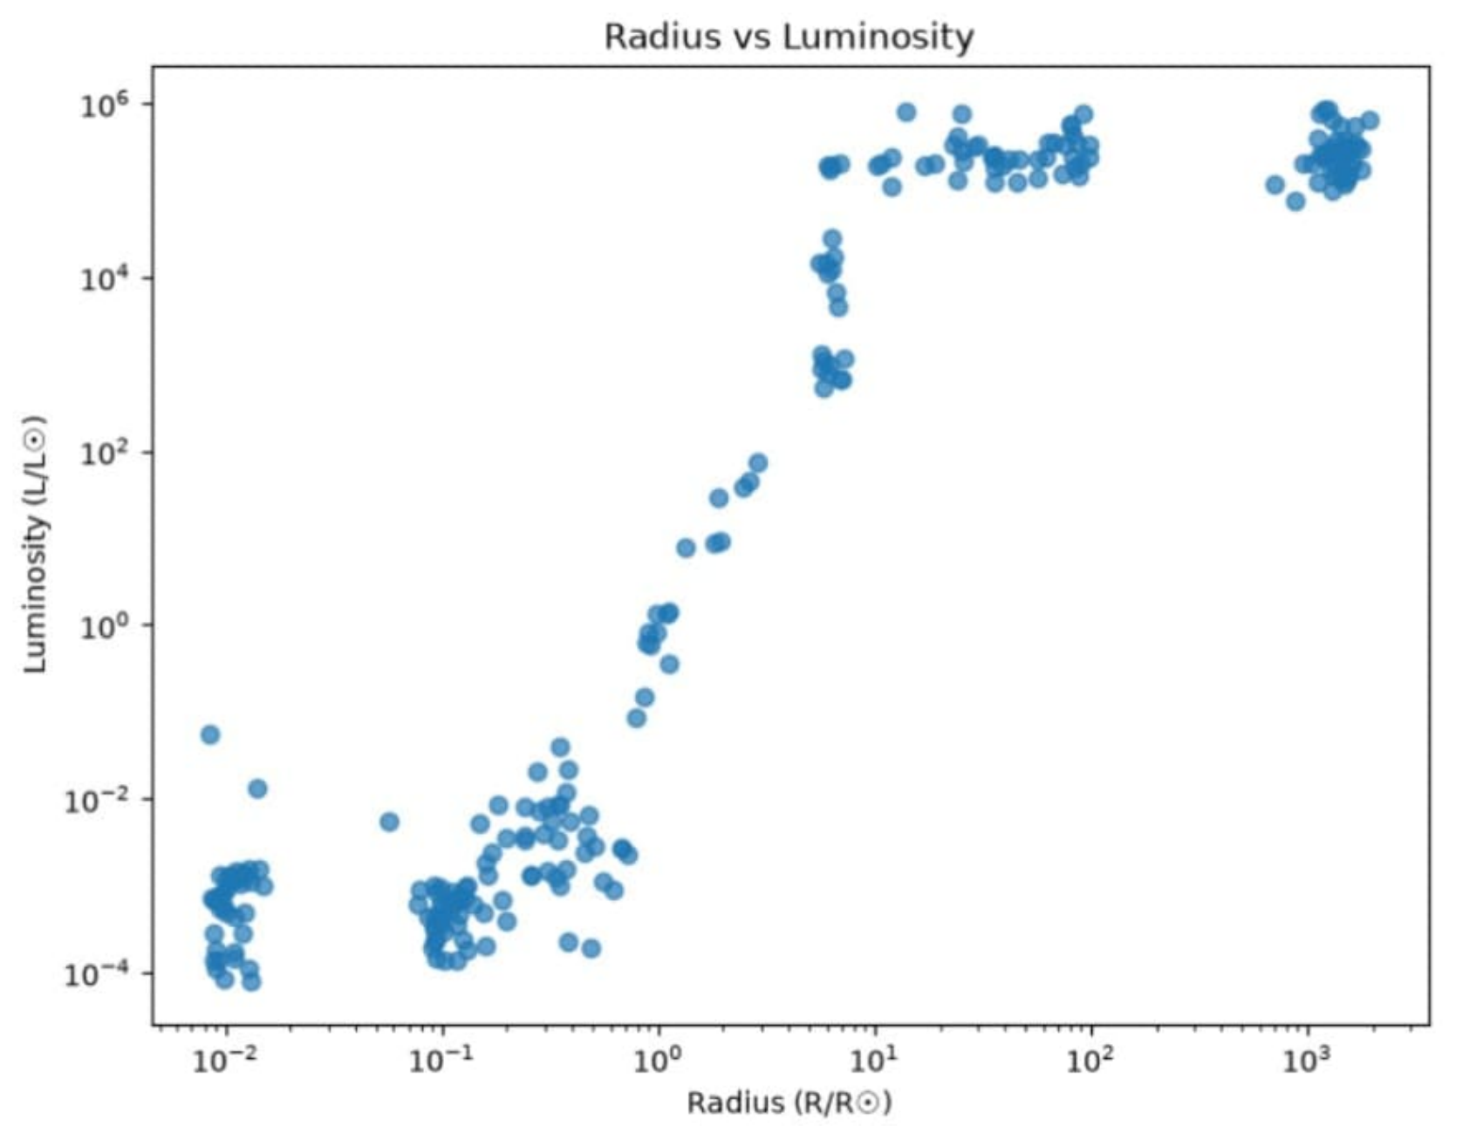
Fig. 4 — Radius vs Luminosity (log-log scale)

5. Star Type Comparison and Correlations
Grouping Temperature by Type (boxplot) shows Types 0 and 1 (Brown/Red Dwarfs) sit low and tight, under about 5,000 K with almost no spread. Types 2–5 spread much wider, with medians roughly 10,000–15,000 K and maximums up to ~40,000 K — so Temperature alone separates dwarfs from the rest, though it does not cleanly separate Types 2–5 from each other.
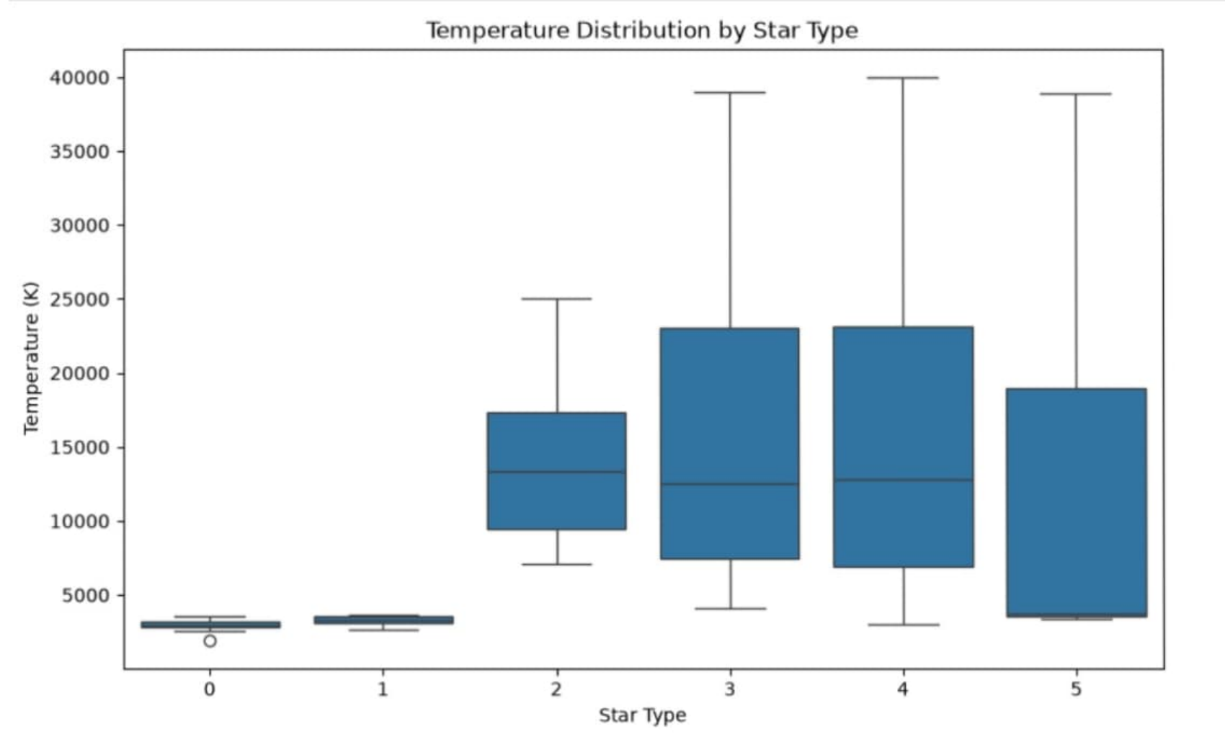
Fig. 5 — Temperature Distribution by Star Type
The correlation matrix across Temperature, Luminosity, Radius and Magnitude gives the numbers behind these patterns:
 | Temp | Luminosity | Radius | Magnitude
Temperature | 1.00 | 0.39 | 0.06 | -0.42
Luminosity | 0.39 | 1.00 | 0.53 | -0.69
Radius | 0.06 | 0.53 | 1.00 | -0.61
Magnitude | -0.42 | -0.69 | -0.61 | 1.00
Luminosity and Magnitude are the most strongly related (-0.69, negative because a brighter star has a lower magnitude value). Luminosity and Radius are moderately correlated (0.53). Radius and Temperature are almost independent (0.06) — a star's size does not really predict its surface temperature by itself.
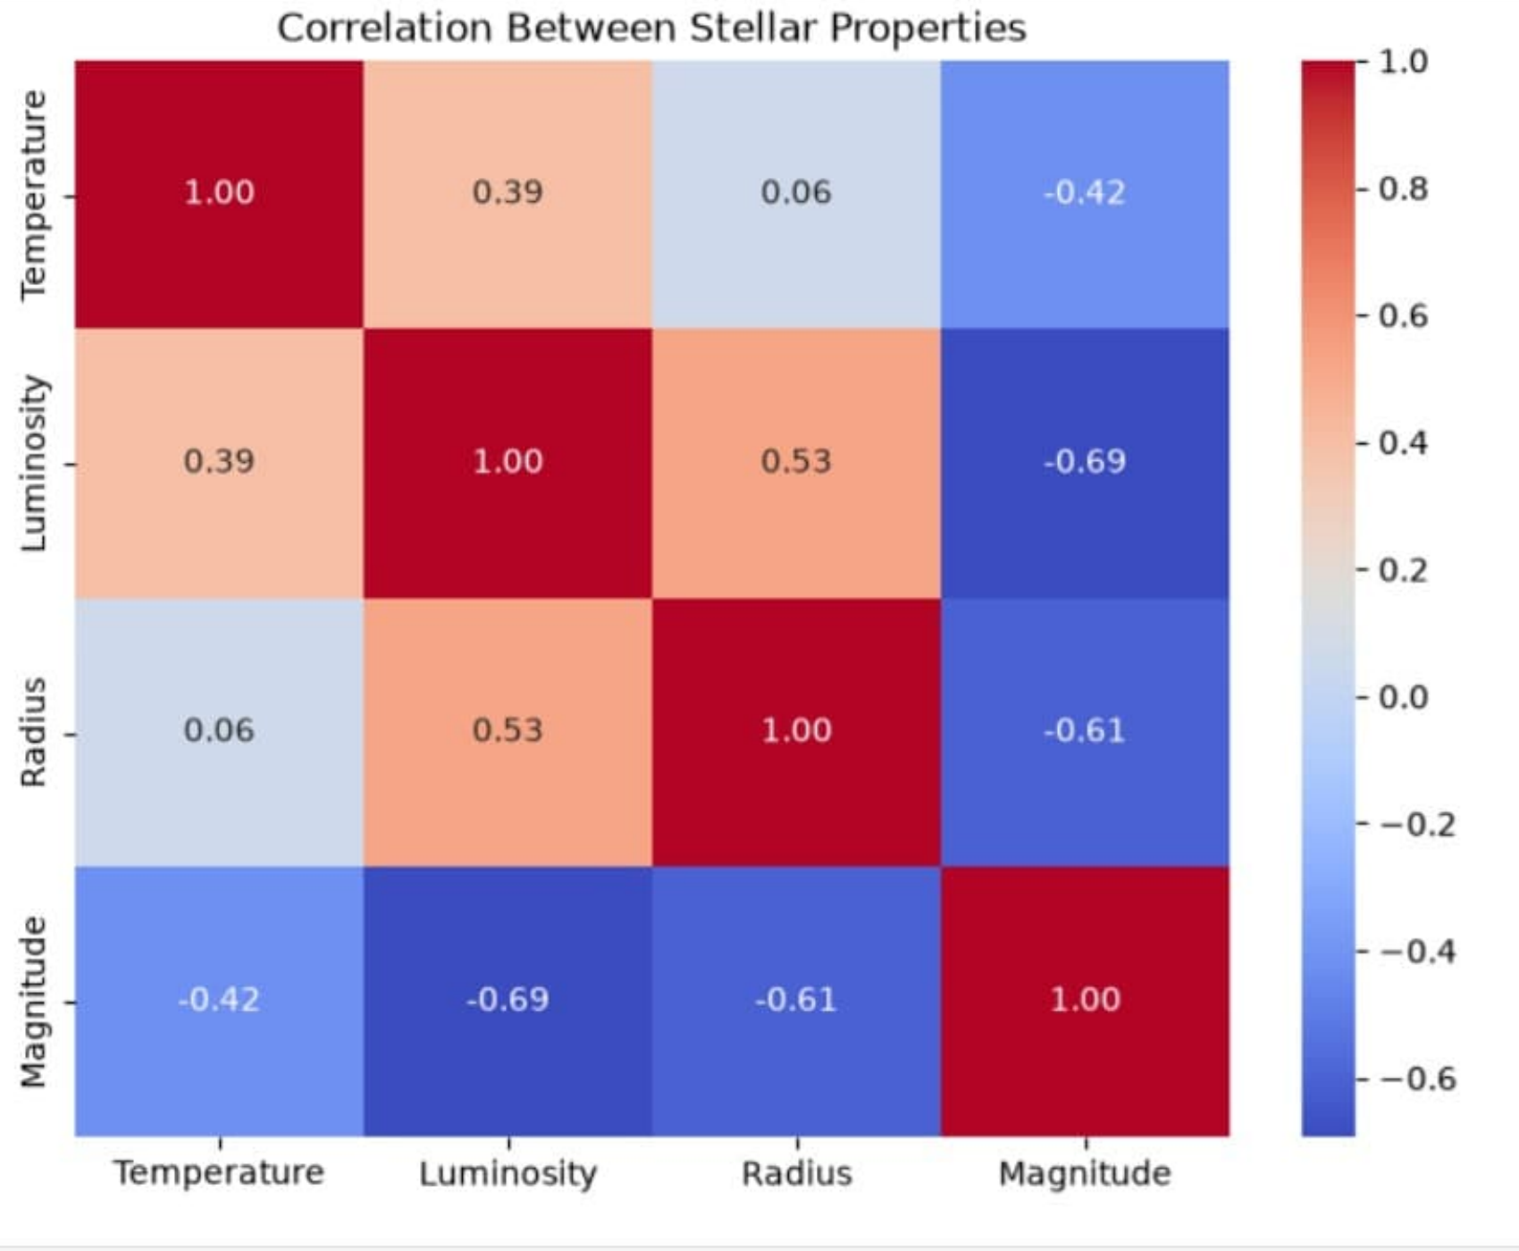
Fig. 6 — Heatmap of Correlation Between Stellar Properties

6. Outliers and Extreme Values
An IQR check was run on Luminosity: Q1 and Q3 were used to get IQR = Q3 − Q1, and an upper limit of Q3 + 1.5×IQR = 495,124.99. This flagged 12 stars (5% of the dataset) above the limit. These are not data errors — they line up with the high-luminosity hypergiant band seen in Figures 3 and 4, so they were kept rather than removed.
A few specific records stand out. The hottest star has Temperature = 40,000 K, Luminosity = 813,000 L/L☉, Radius = 14.0 R☉. The most luminous star has Luminosity = 849,420 L/L☉ at Temperature = 27,739 K. The largest star by radius (1,948.5 R☉) is actually cooler than the other two (32,489 K) — a good example of a red supergiant, and further evidence that Radius and Temperature are not tightly linked (correlation of just 0.06).

7. Effect of Week 1 Preprocessing on This Analysis
The Week 1 evaluator asked for more discussion on how preprocessing affects later analysis. Concretely, in this notebook:
- Zero missing values (all 240 rows non-null, confirmed in df.info()) meant the mean/median temperature and the correlation values above did not need any imputation and are not skewed by dropped or filled-in rows.
- Confirming the classes were balanced (40 per type) before analysis meant the boxplot in Fig. 5 and any type-wise comparison is fair — no type is over-represented, so differences between boxes reflect the data and not sample-size bias.
- Correct column types (float64 for L, R, A_M and int64 for Temperature) meant operations like .mean(), .median() and .corr() ran on true numeric data instead of strings, avoiding silent calculation errors.
- Because the cleaned data was already validated, the 12 luminosity outliers found in Section 6 could be confidently read as real hypergiant stars rather than bad entries, and were kept in the analysis instead of being dropped.

8. Conclusion
The Star Type dataset is clean (no missing values) and perfectly balanced (40 stars per type). Temperature is right-skewed (mean 10,497.46 K vs median 5,776.00 K), and Luminosity, Radius and Magnitude are clearly related to each other — most strongly Luminosity and Magnitude (-0.69) — while Radius and Temperature are nearly independent (0.06). The IQR check found 12 legitimate high-luminosity outliers rather than errors. Overall, the reliable preprocessing from Week 1 is what made all of these numbers trustworthy this week.

