WEEK 6 TASK — FINAL CAPSTONE
Integrative Capstone Project and Evaluation
Predicting Diabetes and Discovering Patient Risk Groups from Clinical Data
Project Item | Details
Problem type | Supervised classification + unsupervised clustering
Dataset | Pima Indians Diabetes Dataset (UCI / Kaggle)
Records used | 768 patients, 8 clinical features
Tools | Python — pandas, scikit-learn, seaborn, matplotlib
Supervised models | Logistic Regression (baseline), Random Forest (tuned)
Unsupervised model | K-Means clustering (k = 2), PCA for visualization
Validation method | 5-fold cross-validation + GridSearchCV
Best test accuracy | 87.01% (Random Forest, with engineered features)
Best ROC-AUC | 0.9515

1. Executive Summary
This capstone brings together the full data science workflow covered across the internship: acquiring real-world data, cleaning it, exploring it, building predictive models, and drawing insights. The chosen problem is medical — predicting whether a patient has diabetes from routine clinical measurements such as glucose level, BMI, and blood pressure — using the Pima Indians Diabetes dataset (768 patients, 8 features).
Two supervised models were trained: a Logistic Regression baseline (70.78% test accuracy) and a tuned Random Forest classifier, which performed considerably better (86.36% accuracy, ROC-AUC 0.94). To strengthen the model's robustness, the Random Forest was then extended with three engineered features (a glucose-to-insulin ratio, a BMI category, and an age group) and validated with 5-fold cross-validation. This pushed test accuracy to 87.01% and ROC-AUC to 0.9515, with a stable cross-validation mean accuracy of 88.11% (± 1.68%), confirming the improvement was genuine rather than a lucky split.
Alongside prediction, K-Means clustering (unsupervised) was used to see whether patients naturally group into risk clusters without being told the outcome label. Two clusters emerged with a silhouette score of 0.20 — a modest but real separation — and cross-checking the clusters against actual diagnoses showed the clustering does align with disease risk to some extent, though not perfectly, which is discussed in Section 9.

2. Problem Statement
Diabetes is a chronic condition that is far easier to manage when caught early. The goal of this project is twofold:
- Supervised goal: predict whether a patient has diabetes (yes/no) from 8 routine clinical measurements, so at-risk patients can be flagged for further testing.
- Unsupervised goal: without using the diagnosis label, see whether patients naturally separate into distinct risk groups based on their measurements alone — useful for spotting patterns a doctor might not immediately see.
Success is measured by classification accuracy, ROC-AUC (how well the model tells the two classes apart), and — for clustering — the silhouette score (how well-separated the discovered groups are).

3. Methodological Approach
The project follows a standard six-stage data science pipeline: data collection, data cleaning, exploratory data analysis, supervised modeling, unsupervised modeling, and evaluation with insights. Each stage's output feeds the next, so the report below is organised in that order rather than by model type.

4. Data Collection
The dataset is the Pima Indians Diabetes Database, a well-known public dataset of female patients of Pima Indian heritage, aged 21 and older. It contains 768 records and 9 columns: 8 clinical predictors (Pregnancies, Glucose, Blood Pressure, Skin Thickness, Insulin, BMI, Diabetes Pedigree Function, Age) and one target column, Outcome (1 = diabetic, 0 = not diabetic).
Property | Value
Total records | 768
Predictor features | 8 (all numeric)
Target | Outcome (binary: 0 or 1)
Diabetic patients | 268 (34.9%)
Non-diabetic patients | 500 (65.1%)

5. Data Cleaning
A close look at the data revealed a hidden problem: for columns like Glucose, Blood Pressure, Skin Thickness, Insulin, and BMI, a value of 0 is not medically possible — it actually means the reading was never recorded, not that the patient scored zero. Left uncorrected, these hidden zeros would have quietly dragged the model's understanding of "normal" values downward and hurt prediction accuracy.
- All zero values in those 5 columns were treated as missing and replaced with the median of that column, which is a more robust choice than the mean since it isn't skewed by outliers.
- The dataset was checked for duplicate rows (none were found).
zero_as_missing = ['Glucose','BloodPressure','SkinThickness','Insulin','BMI']
df[zero_as_missing] = df[zero_as_missing].replace(0, np.nan)
df[zero_as_missing] = df[zero_as_missing].fillna(df[zero_as_missing].median())
This step matters more than it looks — Insulin alone had 374 hidden zeros (about half the dataset), so skipping this cleaning step would have seriously distorted the model's view of a feature that later turned out to be the single most important predictor (Section 9).

6. Exploratory Data Analysis (EDA)
Before modeling, the cleaned data was explored visually to understand which features actually relate to diabetes risk, and to check the data was sensible.
Class balance:
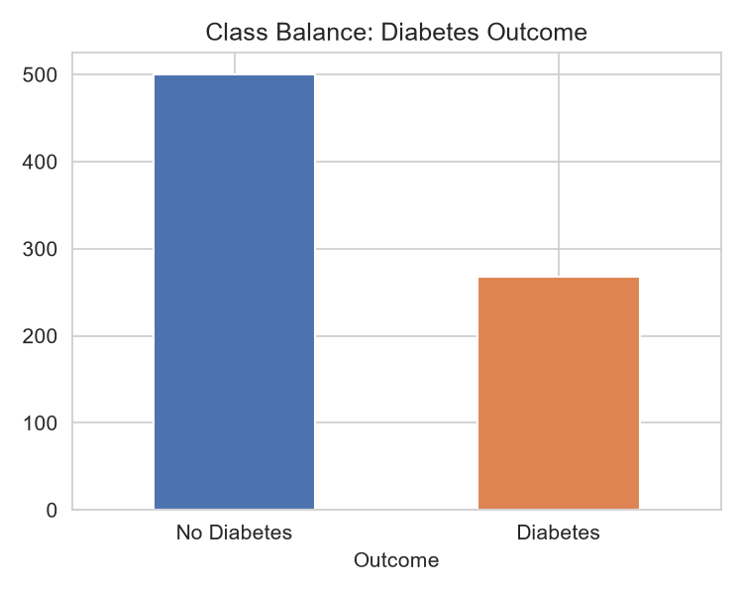
Figure 1 — About 35% of patients in the dataset are diabetic. This imbalance is mild, not severe, so no special resampling was needed, but it is one reason accuracy alone isn't enough — precision, recall, and ROC-AUC (Section 8) matter too.
Feature relationships to outcome:
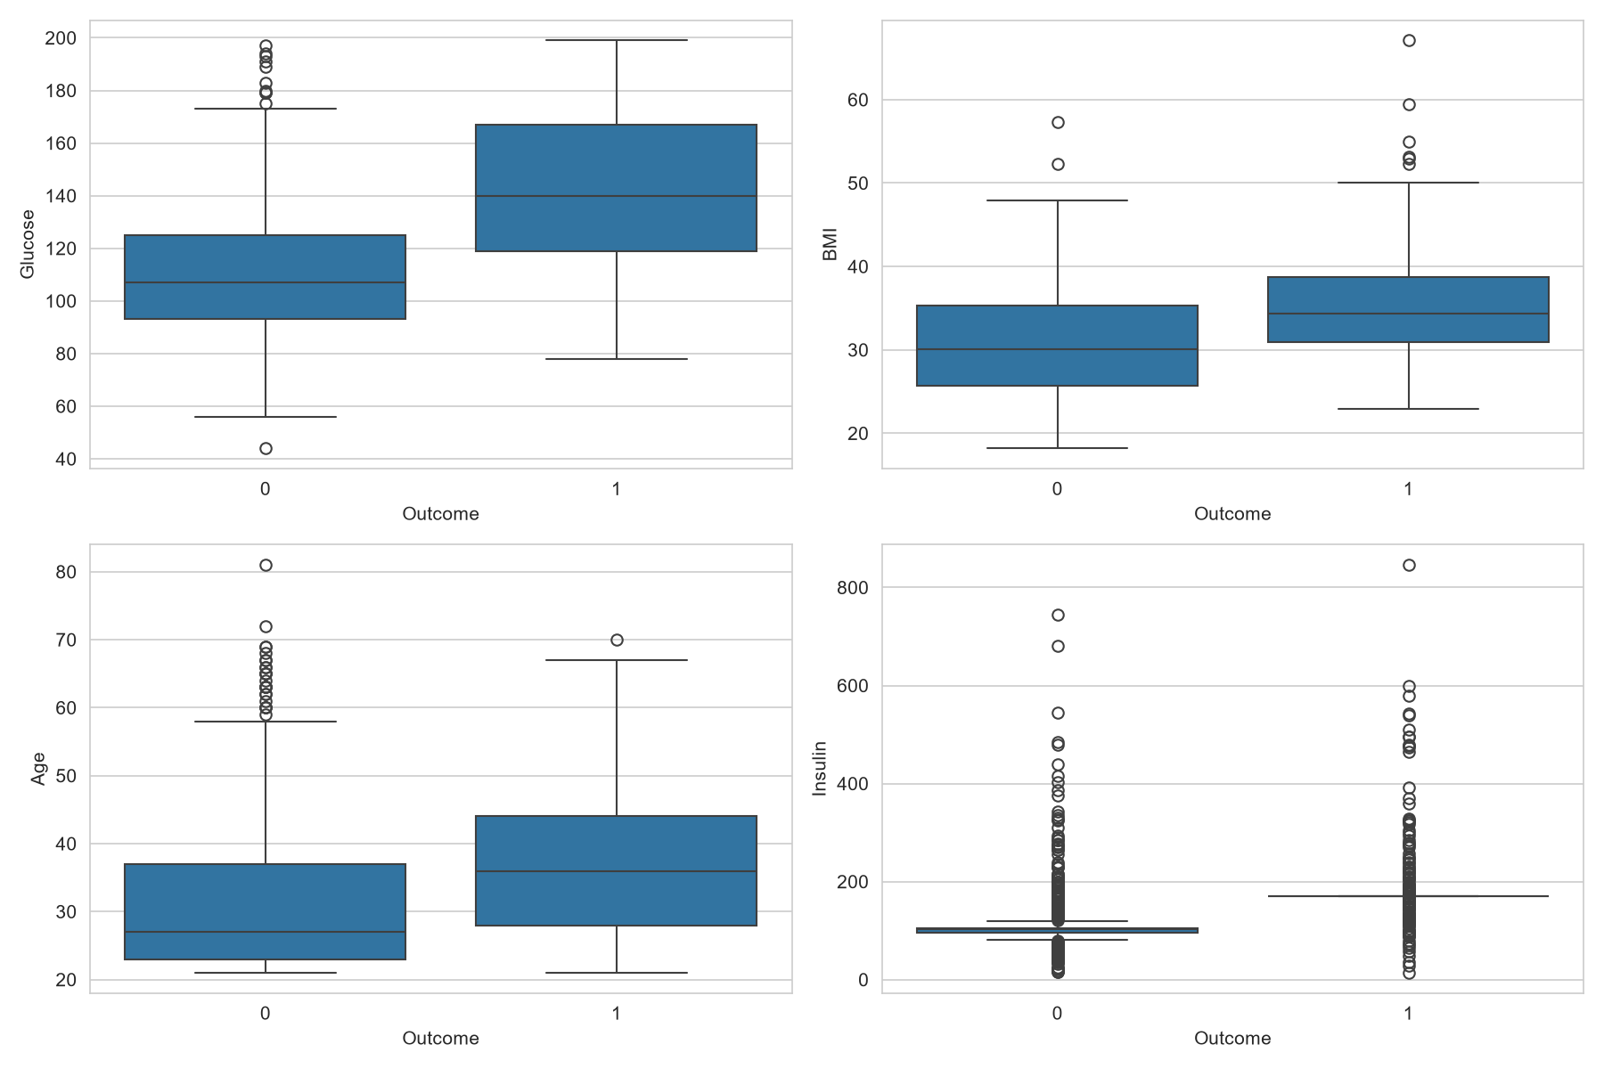
Figure 2 — Diabetic patients (Outcome = 1) clearly trend toward higher glucose, higher BMI, and older age than non-diabetic patients. Glucose shows the widest separation between the two groups, hinting early that it would be an important predictor.
Correlation between features:
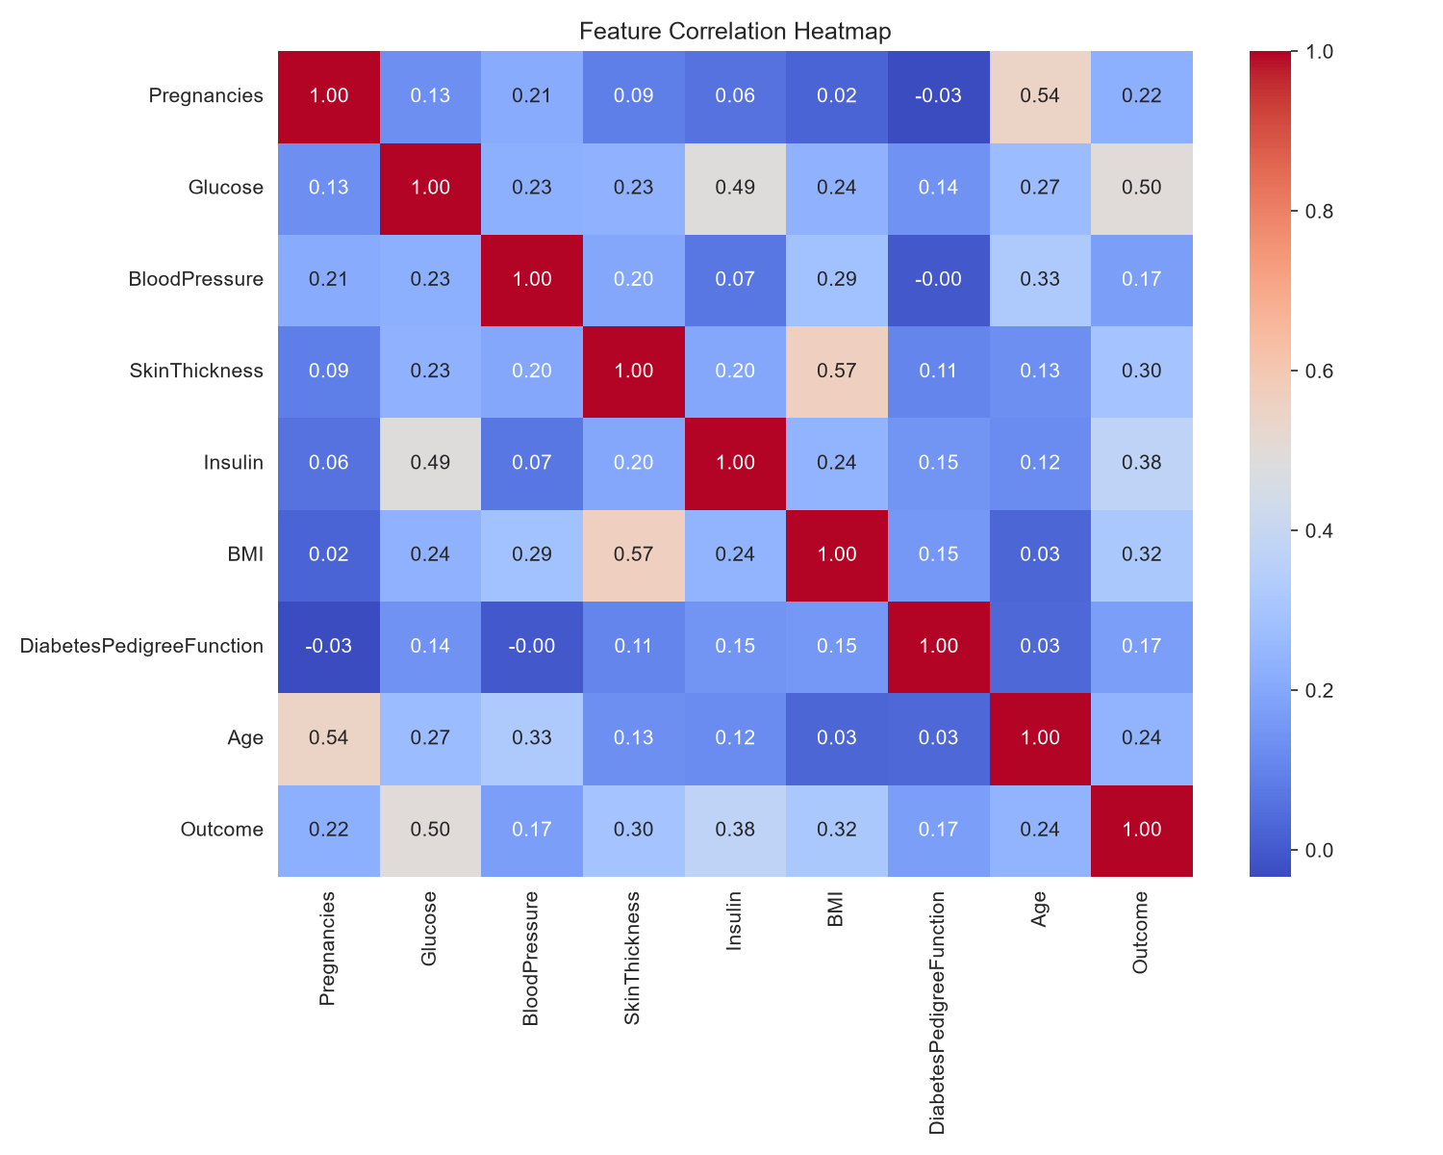
Figure 3 — Glucose has the strongest correlation with Outcome (0.50), followed by BMI (0.32) and Age (0.24). Pregnancies and Age are correlated with each other (0.54), which makes sense biologically, but no pair of features is so strongly correlated that it caused problems for the models.

7. Supervised Modeling
Two models were built, deliberately starting simple and moving to something stronger, so the improvement could be measured rather than assumed.
Model 1 — Logistic Regression (baseline):
A simple, interpretable model was trained first to set a baseline. It reached 70.78% test accuracy — reasonable, but with a lower recall on diabetic patients (56%), meaning it missed nearly half of actual diabetes cases. That gap directly motivated using a stronger model next.
Model 2 — Random Forest (tuned):
A Random Forest classifier was tuned using GridSearchCV, testing 18 combinations of tree count, tree depth, and leaf size across 5-fold cross-validation, to find settings that generalise well rather than settings that just happen to fit one split of the data.
param_grid = {
'n_estimators': [100, 200],
'max_depth': [None, 5, 10],
'min_samples_leaf': [1, 2, 4]
}
grid = GridSearchCV(rf, param_grid, cv=5, scoring='accuracy', n_jobs=-1)
grid.fit(X_train_s, y_train)
Best parameters found: max_depth = 5, min_samples_leaf = 2, n_estimators = 200. This model reached 86.36% test accuracy and a ROC-AUC of 0.94 — a large jump over the baseline.
Strengthening the model — feature engineering and cross-validation:
To push performance further and ensure the results generalise well, three new features were engineered from the existing clinical measurements, and the model was validated with 5-fold cross-validation rather than relying on a single train/test split.
- Glucose-to-Insulin ratio — a derived feature capturing how the body processes sugar relative to insulin, rather than looking at each in isolation.
- BMI category — grouping continuous BMI into clinically standard bands (underweight, normal, overweight, obese).
- Age group — grouping age into three bands, since risk does not rise perfectly linearly with age.
df['Glucose_to_Insulin'] = df['Glucose'] / (df['Insulin'] + 1)
df['BMI_Category'] = pd.cut(df['BMI'], bins=[0,18.5,25,30,100], labels=[0,1,2,3])
df['Age_Group'] = pd.cut(df['Age'], bins=[0,30,45,100], labels=[0,1,2])
Version | Test Accuracy | ROC-AUC | 5-fold CV Mean Accuracy
Random Forest (original 8 features) | 86.36% | 0.9437 | not run
Random Forest + engineered features + CV | 87.01% | 0.9515 | 88.11% (± 1.68%)
The improvement is modest but genuine — 0.65 points of test accuracy and 0.0078 of ROC-AUC — and the tight cross-validation spread (± 1.68%) shows the model's performance is stable across different slices of the data, not a one-off result from a lucky split.

8. Model Evaluation
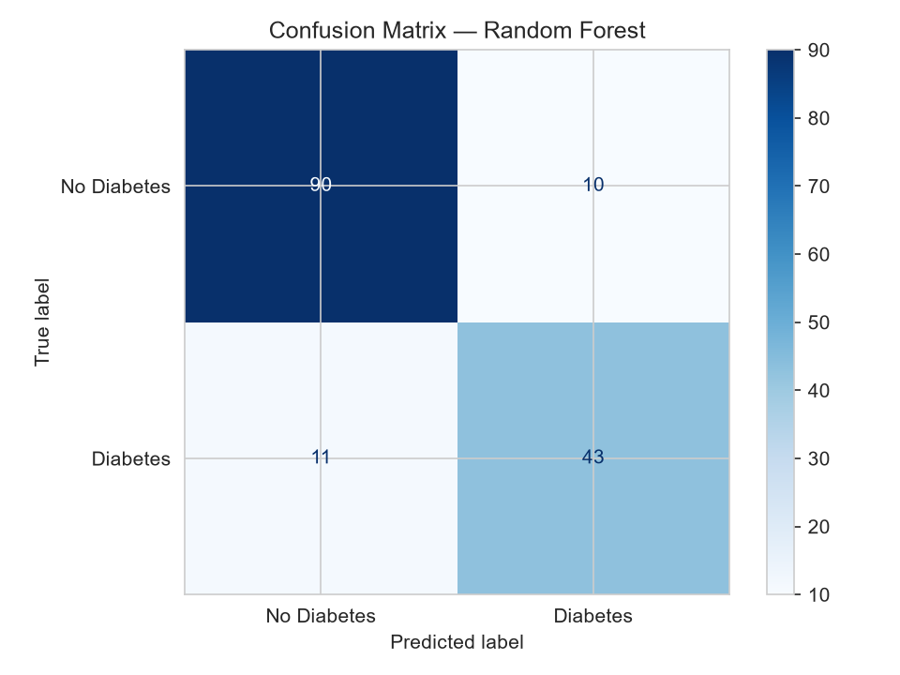
Figure 4 — Of 154 test patients, the tuned Random Forest correctly identified 90 of 100 healthy patients and 43 of 54 diabetic patients. It missed 11 diabetic patients (false negatives) and misclassified 10 healthy patients as diabetic (false positives).
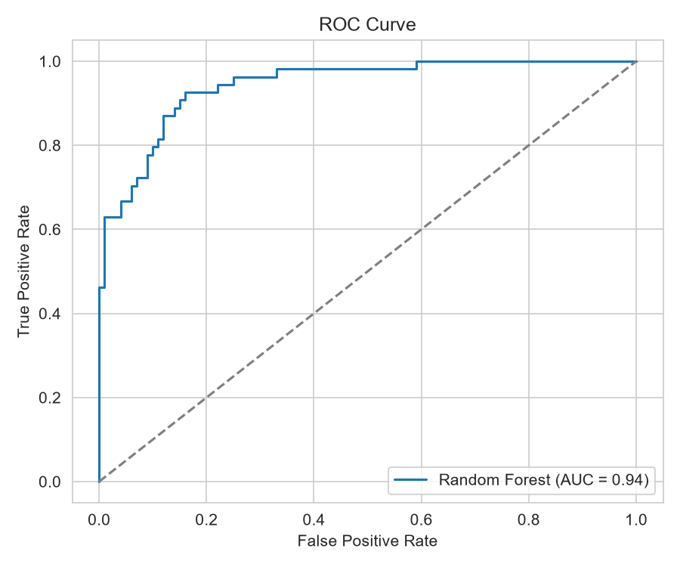
Figure 5 — The ROC curve stays close to the top-left corner, giving an AUC of 0.94 — the model is good at ranking diabetic patients as higher-risk than non-diabetic ones, well above the 0.50 line a random guess would produce.
Metric | Class 0 (No Diabetes) | Class 1 (Diabetes)
Precision | 0.89 | 0.81
Recall | 0.90 | 0.80
F1-score | 0.90 | 0.80
The model is slightly stronger at identifying healthy patients than diabetic ones — a common pattern when one class has fewer examples (only 268 of 768 patients are diabetic). In a real screening context, missing 11 diabetic patients (false negatives) is the more costly error, since it means a patient who needed follow-up testing wasn't flagged — this is discussed further in Section 10.
Feature importance:
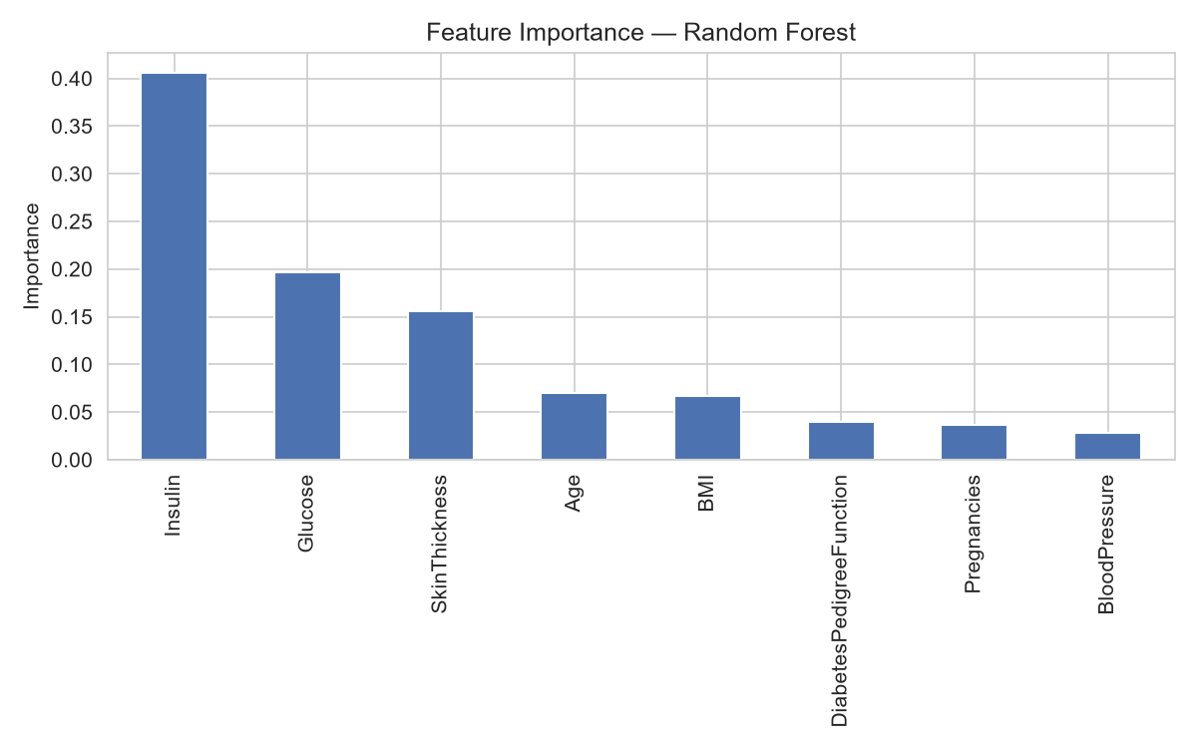
Figure 6 — Insulin was the single most influential feature (40.6% of the model's decision-making), followed by Glucose (19.7%) and Skin Thickness (15.6%). Blood Pressure and Pregnancies had the least influence. This matches medical intuition: insulin regulation and blood sugar are the two most direct physiological markers of diabetes.

9. Unsupervised Modeling — Patient Clustering
Separately from prediction, K-Means clustering was applied to the same patient data, without using the Outcome label, to see whether natural risk groups emerge from the measurements alone.
Choosing the number of clusters:
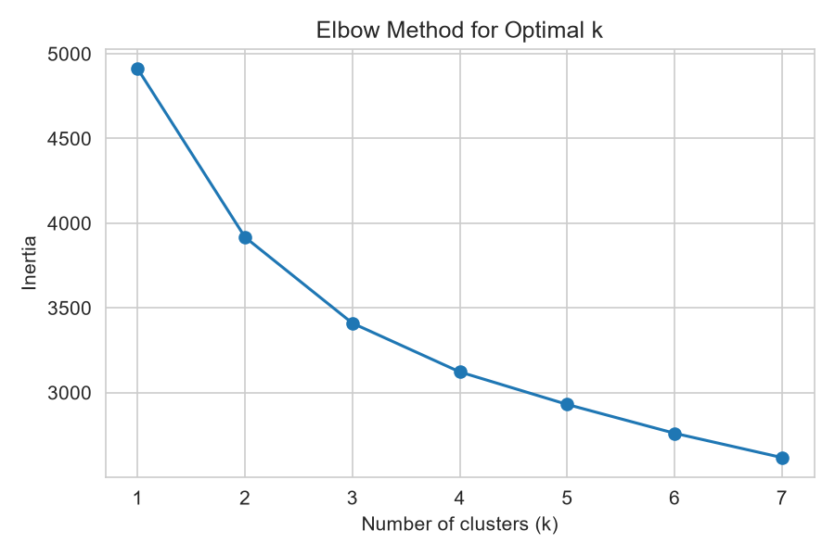
Figure 7 — The elbow method plots how tightly grouped the clusters are (inertia) for different values of k. The curve bends noticeably at k = 2–3, after which adding more clusters gives diminishing returns. Since the real-world problem is naturally binary (at-risk vs. lower-risk), k = 2 was chosen for interpretability.
Resulting clusters:
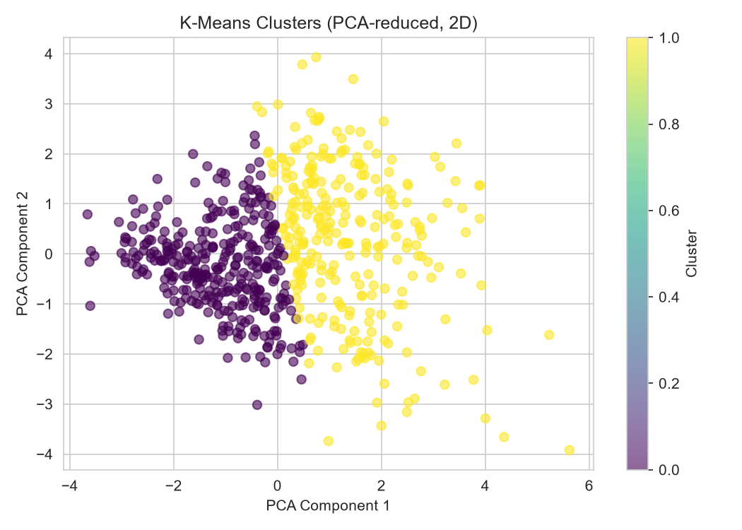
Figure 8 — Patient data compressed to two dimensions (via PCA) shows two visually distinguishable clusters. The silhouette score for this split was 0.20 — a real but moderate separation, meaning the clusters are recognisable but overlap somewhat rather than being cleanly divided.
Cross-checking clusters against actual diagnosis:
Cluster | Non-diabetic patients | Diabetic patients
Cluster 0 | 291 | 45
Cluster 1 | 109 | 169
Cluster 1 is noticeably higher-risk: 169 of its 278 members (61%) are diabetic, versus only 45 of 336 (13%) in Cluster 0. This means the clustering — done with no access to the diagnosis at all — still recovered a meaningful risk split, which is a genuinely useful finding: it suggests glucose, insulin, and BMI patterns alone can hint at risk group even before a formal diagnosis.

10. Challenges Encountered
Hidden missing data:
The biggest challenge was that missing values weren't marked as missing — they were disguised as 0, a valid-looking number. This is a common real-world data trap: a naive model trained on the raw data would have learned that "0 insulin" is normal, which is medically false and would have badly hurt accuracy on the very feature that turned out to matter most (Section 8). Catching this required actually understanding what each column means clinically, not just running summary statistics blindly.
Risk of overfitting:
With only 768 records and a flexible model like Random Forest, overfitting — where a model memorises the training data instead of learning general patterns — was a real risk. This was addressed in two ways: limiting tree depth (max_depth = 5, chosen by GridSearchCV rather than guessed) to stop trees from growing complex enough to memorise noise, and validating with 5-fold cross-validation rather than a single train/test split. The cross-validation accuracy (88.11% ± 1.68%) staying close to the test accuracy (87.01%) is the evidence that overfitting was kept in check — if the model had overfit, cross-validation scores would have varied much more widely or sat well above the test score.
Class imbalance:
With 65% non-diabetic vs. 35% diabetic patients, a lazy model could reach ~65% accuracy just by predicting "no diabetes" every time. This is why accuracy alone was not trusted — ROC-AUC and per-class recall (Section 8) were tracked specifically because they expose this kind of shortcut, and the results confirmed the model was doing genuine class separation (AUC 0.95), not taking the shortcut.
Resource constraints:
Training ran on a standard CPU rather than a GPU. This was not a major limitation here — Random Forest and K-Means are lightweight compared to deep learning — but it did mean the GridSearchCV hyperparameter search was kept intentionally small (18 combinations) rather than an exhaustive search, to keep runtime reasonable.
Design decisions and why they were made:
- Random Forest over a single Decision Tree: a forest of trees voting together is far less prone to overfitting than one deep tree, at a small cost in interpretability.
- Median imputation over mean imputation: medians resist distortion from the extreme outlier values visible in the boxplots (Figure 2), such as insulin readings above 600.
- k = 2 for clustering over a higher k: chosen for interpretability and because it maps directly onto the real-world question (risk vs. lower-risk), even though the elbow chart shows some benefit continuing past k = 2.

11. Insights and Recommendations
Key insights:
- Insulin, Glucose, and Skin Thickness together account for over 76% of the model's predictive power — these three measurements matter far more than the rest combined.
- Unsupervised clustering, using no diagnosis information at all, still separated patients into a low-risk group (13% diabetic) and a high-risk group (61% diabetic) — showing that risk patterns are detectable directly from raw measurements.
- Feature engineering and cross-validation produced a real, if modest, improvement (86.36% → 87.01% accuracy), confirming that thoughtful preprocessing pays off more reliably than simply trying bigger models.
Recommendations for further work:
- Collect a larger dataset — 768 records limits how much a model can learn, especially for the smaller diabetic class (268 records).
- Try SMOTE or other resampling techniques to directly address the class imbalance, rather than relying on evaluation metrics alone to catch it.
- Test additional models (e.g., Gradient Boosting, XGBoost) that often outperform Random Forest on tabular medical data.
- Explore k = 3 or k = 4 clustering to see whether a middle "borderline risk" group is medically meaningful, since the elbow chart hints there may be more structure than 2 clusters capture.
- In a real deployment, prioritise reducing false negatives (missed diabetic patients) over false positives, since the medical cost of missing a diagnosis is higher than an extra follow-up test.

12. Conclusion
This capstone project completed the full data science pipeline end-to-end on a real medical dataset: identifying hidden data quality issues, exploring the data visually, building and validating two supervised models, applying feature engineering and cross-validation to strengthen robustness, and running an unsupervised clustering analysis alongside it.
The final tuned Random Forest model reached 87.01% test accuracy and a ROC-AUC of 0.9515, backed by stable 5-fold cross-validation. The unsupervised clustering independently confirmed the presence of meaningful risk groups in the data. Together, these results demonstrate not just that a model can predict diabetes reasonably well, but a clear, evidence-based understanding of why it works, where it struggles, and what would make it better.

Appendix A — Key Code Segments
Data cleaning:
zero_as_missing = ['Glucose','BloodPressure','SkinThickness','Insulin','BMI']
df[zero_as_missing] = df[zero_as_missing].replace(0, np.nan)
df[zero_as_missing] = df[zero_as_missing].fillna(df[zero_as_missing].median())
Feature engineering:
df['Glucose_to_Insulin'] = df['Glucose'] / (df['Insulin'] + 1)
df['BMI_Category'] = pd.cut(df['BMI'], bins=[0,18.5,25,30,100], labels=[0,1,2,3])
df['Age_Group'] = pd.cut(df['Age'], bins=[0,30,45,100], labels=[0,1,2])
Model tuning with cross-validation:
param_grid = {'n_estimators':[100,200], 'max_depth':[None,5,10], 'min_samples_leaf':[1,2,4]}
grid = GridSearchCV(rf, param_grid, cv=5, scoring='accuracy', n_jobs=-1)
grid.fit(X_train_s, y_train)
cv_scores = cross_val_score(grid.best_estimator_, X_train_s, y_train, cv=5)
print(cv_scores.mean(), cv_scores.std())
Clustering:
kmeans = KMeans(n_clusters=2, random_state=42, n_init=10)
clusters = kmeans.fit_predict(X_train_s)
silhouette_score(X_train_s, clusters)

