WEEK 5 TASK
Deep Learning Application in Data Science
MNIST Handwritten Digit Classification using TensorFlow
Project Item | Details
Problem type | Supervised multi-class classification
Dataset | MNIST handwritten digits
Framework | TensorFlow / Keras
Model | Fully Connected Neural Network (Dense ANN)
Training samples | 60,000 images
Test samples | 10,000 images
Image size | 28 × 28 grayscale pixels
Training setup | 5 epochs, batch size 32
Final test accuracy | 91.46%

1. Executive Summary
This project trains a neural network to recognise handwritten digits from the MNIST dataset. It is a supervised, 10-class classification problem: every 28 × 28 grayscale image belongs to one digit, 0 through 9. Pixel values were normalised, labels were one-hot encoded, and a fully connected (Dense) network was trained using TensorFlow/Keras.
The network has one hidden layer of 128 ReLU neurons and a 10-neuron Softmax output layer. It was trained with the Adam optimizer and categorical cross-entropy loss for 5 epochs. Training accuracy rose from 71.55% (epoch 1) to 91.10% (epoch 5), and the model reached 91.46% accuracy on the unseen test set, with a test loss of 0.2970.
The result confirms that even a small, simple network can learn useful patterns from image data. Its main strengths are simplicity, fast training, and a solid baseline accuracy. Its main limitations are the lack of a validation split, minimal hyperparameter tuning, and the use of a Dense network rather than a Convolutional Neural Network (CNN), which is generally better suited to images.

2. Objective
Build and evaluate a neural network that classifies handwritten digit images into the correct class (0–9).
- Task: supervised multi-class classification
- Input: 28 × 28 grayscale image of a handwritten digit
- Output: one of 10 classes (0–9)
- Success measure: high test accuracy with low test loss
- Practical goal: demonstrate the full deep learning workflow, from data loading to evaluation

3. Dataset and Preprocessing
The project uses the standard MNIST dataset, loaded through tf.keras.datasets.mnist: 60,000 training images and 10,000 test images, each 28 × 28 pixels and grayscale. A quick visual check of the first 10 training images confirmed the labels matched the images before training began.
Property | Observed in notebook
Training shape | (60000, 28, 28)
Test shape | (10000, 28, 28)
Image dimensions | 28 × 28
Image type | Grayscale
Number of classes | 10 (digits 0–9)

Two preprocessing steps were applied before training:
- Normalisation: pixel values were divided by 255, rescaling them from 0–255 to 0–1, which makes training more stable.
- One-hot encoding: digit labels (0–9) were converted into 10-value vectors to match the Softmax output layer.
x_train = x_train / 255.0
x_test = x_test / 255.0
y_train = to_categorical(y_train, 10)
y_test = to_categorical(y_test, 10)

4. Model Architecture
A fully connected feed-forward network was used as a simple baseline:
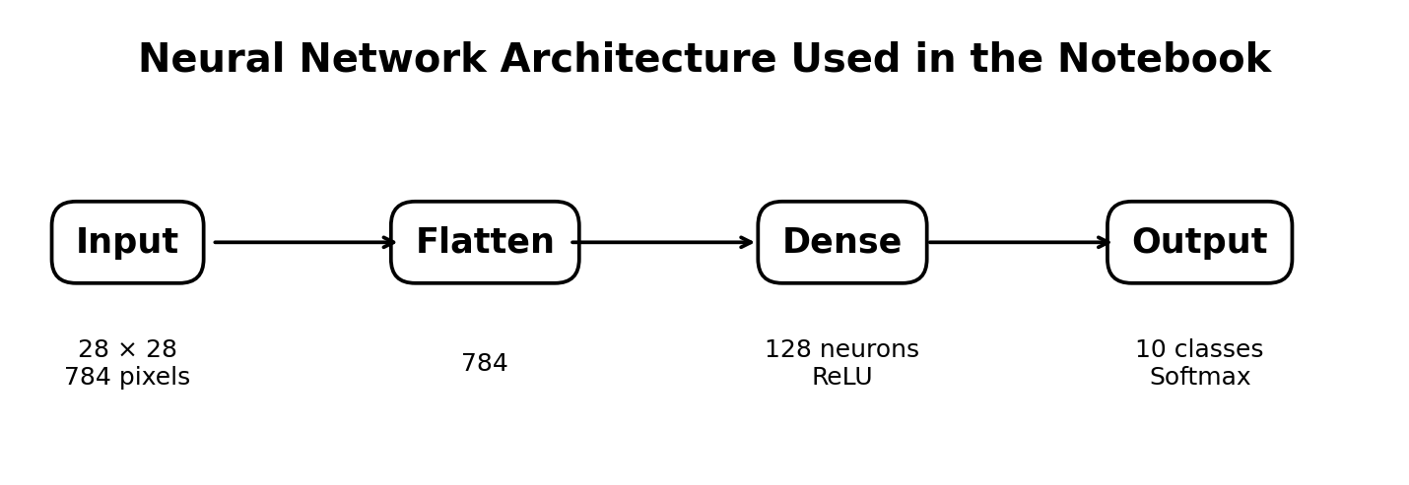
Layer | Configuration | Purpose
Input | 28 × 28 | Receives the grayscale digit image
Flatten | 784 values | Converts the image matrix into a vector
Dense | 128 neurons, ReLU | Learns non-linear digit patterns
Output | 10 neurons, Softmax | Predicts a probability for each digit 0–9
Approximate trainable parameters: 101,770. This is a small model, so it is fast to train and does not need much compute.
model = Sequential([
Flatten(input_shape=(28, 28)),
Dense(128, activation='relu'),
Dense(10, activation='softmax')
])

5. Training Setup
Setting | Choice | Reason
Optimizer | Adam | Adaptive, strong general-purpose baseline
Loss | Categorical cross-entropy | Suitable for one-hot encoded, multi-class labels
Metric | Accuracy | Easy to interpret for digit classification
Epochs | 5 | Short training run used in the submitted notebook
Batch size | 32 | Common mini-batch size, stable updates
Activation | ReLU + Softmax | Non-linear hidden learning + class probabilities

model.compile(
optimizer='adam',
loss='categorical_crossentropy',
metrics=['accuracy'])
model.fit(x_train, y_train, epochs=5, batch_size=32)

6. Training Results
Epoch | Training Accuracy | Training Loss
1 | 71.55% | 1.1540
2 | 87.46% | 0.4779
3 | 89.66% | 0.3762
4 | 90.54% | 0.3353
5 | 91.10% | 0.3117
Accuracy improved every epoch, with the biggest jump between epochs 1 and 2. Gains became smaller after that, suggesting the model was approaching what this simple architecture could achieve within five epochs.

7. Evaluation on Test Data
test_loss, test_acc = model.evaluate(x_test, y_test)
print(f"Test accuracy: {test_acc:.4f}")
Metric | Result | Interpretation
Final training accuracy | 91.10% | About 91 of 100 training examples classified correctly
Test accuracy | 91.46% | Good baseline performance on unseen data
Test loss | 0.2970 | Reasonably confident predictions overall
Test error rate | 8.54% | About 8.54% of test predictions were wrong
Test accuracy (91.46%) is slightly higher than training accuracy (91.10%), a gap of 0.36 points. This alone does not indicate overfitting — but since no validation set was used, overfitting cannot be checked as rigorously as it could with validation curves. A confusion matrix and per-class precision, recall, and F1-score would be a useful next step to see which digits are most often confused.

8. Practical Uses
Digit recognition is a classic computer-vision task and a good introduction to automated document understanding. A model like this can support reading numeric fields on forms, basic OCR pipelines, document digitisation, and teaching demonstrations of image recognition.
MNIST itself is mainly a benchmark, not a production dataset. Good MNIST performance does not guarantee good performance on real-world handwriting, scanned documents, or varied image quality — before any real deployment, the model would need testing on representative real-world data.

9. Strengths and Limitations
Strengths
- Simple architecture — easy to understand and reproduce
- Correct preprocessing for pixel inputs and categorical labels
- Adam + ReLU + Softmax + cross-entropy is a sensible, well-tested baseline combination
- Training accuracy improved consistently across all five epochs
- Final test accuracy of 91.46% shows the network learned meaningful digit patterns
Limitations
- A Dense network ignores image spatial structure — a CNN is normally stronger for images
- Only 5 epochs were used; further training could improve results
- No validation set, which limits proper overfitting checks
- No confusion matrix or per-class metrics generated
- No systematic hyperparameter search was performed
- GPU was unavailable in the notebook's environment; training ran on CPU

10. Recommended Improvements
- Replace the Dense baseline with a small CNN (Conv2D + MaxPooling layers)
- Add a validation split and track training vs. validation accuracy/loss
- Add a confusion matrix plus per-digit precision, recall, and F1-score
- Tune learning rate, hidden units, batch size, and epoch count
- Use EarlyStopping to avoid unnecessary training once validation performance plateaus
- Check class counts and per-class error rates during EDA
- Test the final model on a more realistic handwriting dataset before considering deployment

11. Conclusion
This Week 5 project demonstrates a complete supervised deep learning workflow: loading, inspecting, normalising, and preparing the MNIST dataset, then training a compact fully connected network with Adam and categorical cross-entropy.
The model reached 91.10% training accuracy and 91.46% test accuracy, with a test loss of 0.2970. These results make it a solid baseline, and the report highlights clear next steps — a CNN architecture, a validation split, and per-class evaluation — to improve it further.

Appendix A — Key Code Segments
Imports:
import tensorflow as tf
from tensorflow.keras.models import Sequential
from tensorflow.keras.layers import Dense, Flatten
from tensorflow.keras.utils import to_categorical
import matplotlib.pyplot as plt
Dataset loading:
(x_train, y_train), (x_test, y_test) = tf.keras.datasets.mnist.load_data()
print(f"Training data shape is {x_train.shape}")
print(f"Test data shape is {x_test.shape}")
Model definition:
model = Sequential([
Flatten(input_shape=(28, 28)),
Dense(128, activation='relu'),
Dense(10, activation='softmax')
])
Compile, train, evaluate:
model.compile(
optimizer='adam',
loss='categorical_crossentropy',
metrics=['accuracy'])
model.fit(x_train, y_train, epochs=5, batch_size=32)
test_loss, test_acc = model.evaluate(x_test, y_test)
print(f"Test accuracy: {test_acc:.4f}")

