WEEK 4 — SUPERVISED LEARNING
Predicting Median House Value with Random Forest
Regression Modeling Report — Yasir Arafat
Item | Result
Dataset | housing.csv — 20,640 rows, 10 columns
Train / test split | 16,512 / 4,128 rows (80/20, stratified by income)
Target | median_house_value
Final model | Random Forest Regressor
Test RMSE | $47,198
Test MAE | $30,929
Test R² | 0.829

Based on housing.csv, main.py, output.csv and input_-_Copy.csv, and written to address the Week 3 feedback.

1. Objective
This task builds a model that predicts a district's median house value from its income, location and housing data. The goal is a working model plus a clear, honest report on how well it performs and where it struggles.

2. Dataset and Problem Type
This is a supervised regression problem: the data includes the correct answer (median_house_value) for every row, and the target is a continuous number, not a category. That combination — labeled data plus a continuous target — is what rules out both unsupervised methods (like clustering) and classification models, and points directly to a regression algorithm.
Item | Result
Rows | 20,640
Numerical predictors | 8 (location, age, rooms, bedrooms, population, households, income)
Categorical predictor | ocean_proximity (5 categories)
Missing values | 207 rows missing total_bedrooms (about 1% of the data)

3. Exploratory Data Analysis (EDA)
Before building the model, the data was checked for scale, missing values and outliers.
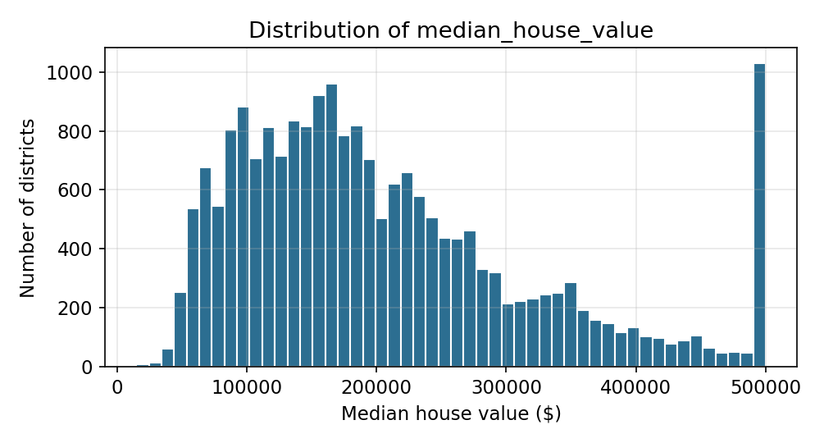
Figure 1. Most districts are valued under $350,000. Values are capped at $500,001, so that bar is artificially tall.
ocean_proximity category | Number of districts
<1H OCEAN | 9,136
INLAND | 6,551
NEAR OCEAN | 2,658
NEAR BAY | 2,290
ISLAND | 5

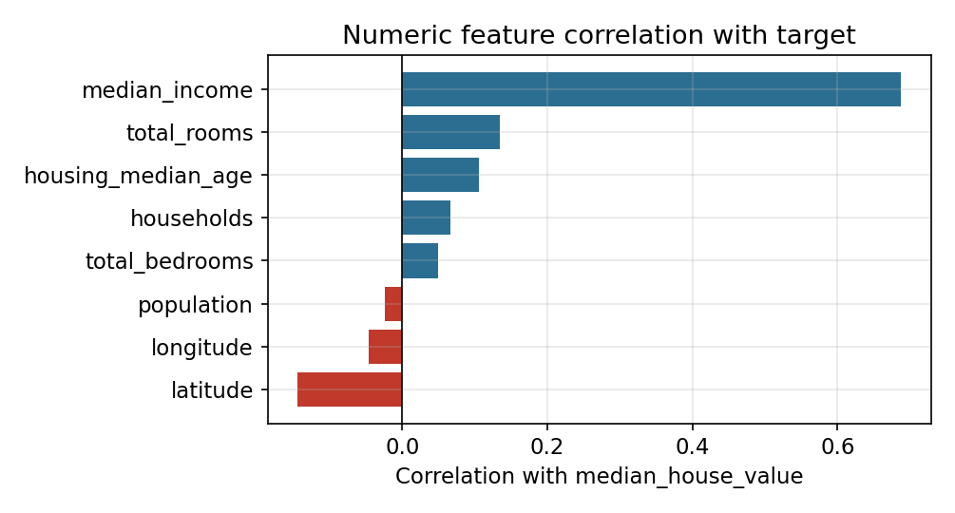
Figure 2. median_income has by far the strongest straight-line relationship with house value.
Two things follow from this: (1) total_bedrooms needs its missing values filled in, and (2) since median_income correlates strongly but not perfectly, a model that can also use location and housing details — not income alone — should do better.

3.1 Summary statistics
A quick look at the spread of the numeric columns explains why scaling is needed before training: these columns sit on very different scales, from single digits to the tens of thousands.
Column | Mean | Median | Min | Max
median_income (x $10,000) | 3.9 | 3.5 | 0.5 | 15.0
total_rooms | 2,636 | 2,127 | 2 | 39,320
total_bedrooms | 538 | 435 | 1 | 6,445
population | 1,426 | 1,166 | 3 | 35,682
households | 500 | 409 | 1 | 6,082
housing_median_age (years) | 28.6 | 29 | 1 | 52

A few columns (total_rooms, population) have maximums far above their median, which points to a small number of unusually large districts rather than a data error. Standardizing the numeric features (Section 4) prevents these large-scale columns from dominating the model just because their raw numbers are bigger.

4. Data Preparation
Two preprocessing steps were applied, one for numbers and one for the location category, then combined:
- Numeric columns — fill missing values with the median, then rescale so every column is on a comparable scale.
- ocean_proximity — convert to one-hot columns (one 0/1 column per category), since the categories have no natural order.
num_pipeline = Pipeline([
("imputer", SimpleImputer(strategy="median")),
("scalar", StandardScaler())
])
cat_pipeline = Pipeline([
("onehot", OneHotEncoder(handle_unknown="ignore"))
])
full_pipeline = ColumnTransformer([
("num", num_pipeline, num_attribs),
("cat", cat_pipeline, cat_attribs)
])
The data was then split 80/20 using StratifiedShuffleSplit on income bands, so both the training set (16,512 rows) and the test set (4,128 rows) have a similar income mix. The income-band column itself is dropped before training — it only controls the split.

5. Model Selection
Three models were trained on the same prepared data so their results are directly comparable.
Model | RMSE | MAE | R²
Linear Regression | $67,347 | $49,776 | 0.652
Decision Tree | $69,204 | $43,503 | 0.633
Random Forest | $47,198 | $30,929 | 0.829

Random Forest was chosen because house prices depend on several factors acting together — income, location, housing age — not just one. A linear model can only fit straight-line effects, and a single Decision Tree tends to overfit. Random Forest combines many trees and handles both problems, and it clearly wins here: about 30% lower RMSE than Linear Regression.

6. Model Training
The final model is trained on the prepared training data, then saved with joblib so it can be reused without retraining.
model = RandomForestRegressor(random_state=42)
model.fit(housing_prepared, housing_labels)
joblib.dump(model, "model.pk1")
joblib.dump(pipeline, "pipeline.pk1")
Saving both files together matters: the pipeline remembers the exact median values and category list it learned from the training data, so any future input — including the held-out test rows — gets the same treatment the training data got, instead of being transformed slightly differently.

7. Evaluation Metrics
All numbers below come directly from the 4,128 prediction/actual pairs in output.csv.
Metric | Result | In plain terms
RMSE | $47,198 | Typical error, but large mistakes count extra
MAE | $30,929 | Typical error in dollars, all mistakes weighted equally
R² | 0.829 | The model explains 83% of the price differences between districts
Within ±10% | 45.6% | Just under half of predictions are very close to correct
Within ±20% | 71.6% | About 7 in 10 predictions are reasonably close

No single metric tells the whole story: R² alone would hide how large individual mistakes can be, so RMSE and MAE are reported alongside it.

8. Prediction Performance
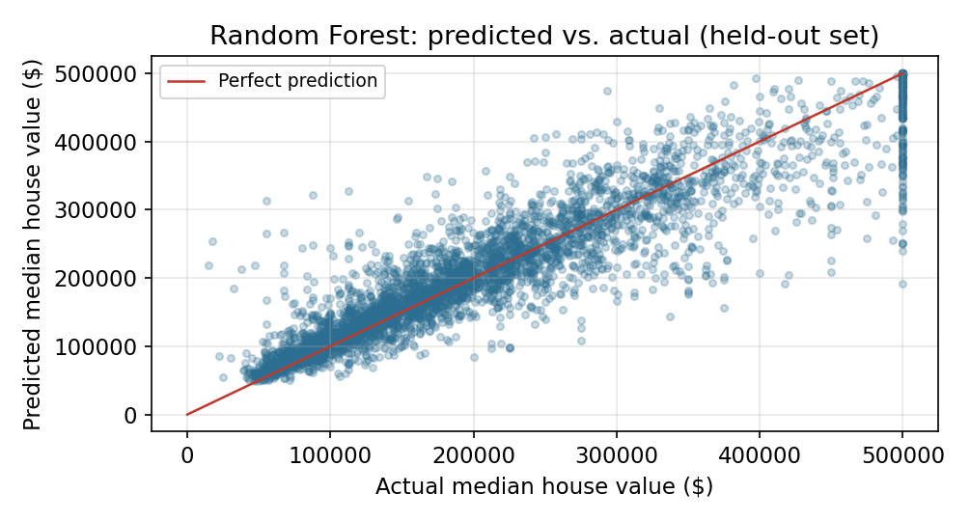
Figure 3. Predicted vs. actual values. Points on the red line are perfect predictions.
Most points sit close to the diagonal line, meaning the model is usually in the right range. The scatter widens for expensive districts, so high-value homes are the hardest to price accurately.

9. Distribution of Prediction Errors
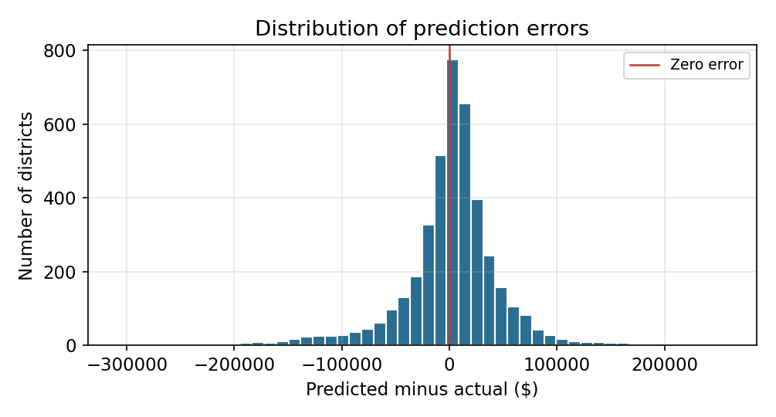
Figure 5. How far off each prediction was (predicted minus actual). A value of 0 would be a perfect prediction.
Most errors cluster tightly around zero, which matches the earlier mean signed error of about $1,291 — the model is not consistently biased high or low. The spread is roughly symmetric but has a long tail on both sides: a small number of districts are off by well over $100,000 in either direction. These tail cases are what push RMSE noticeably above MAE (Section 7), and they line up with the specific examples in Section 13.

10. Feature Importance
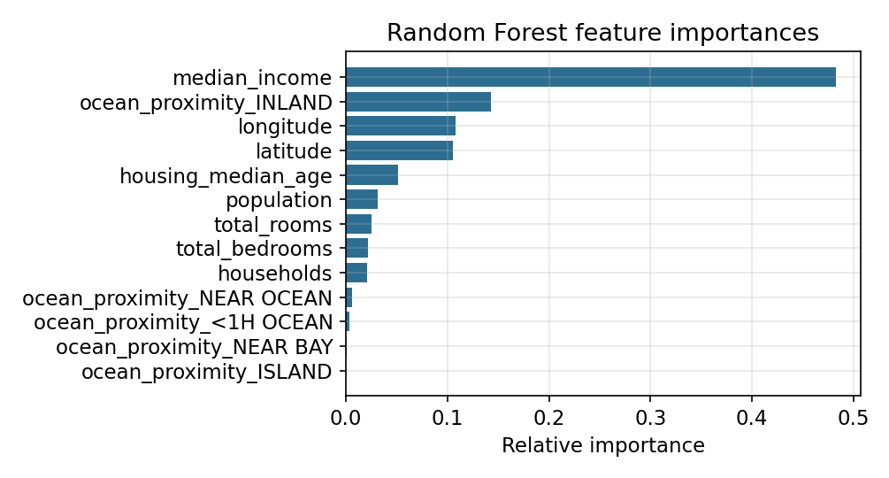
Figure 4. What the Random Forest relies on most when making a prediction.
median_income matters most by a wide margin. Location — the INLAND category, plus longitude and latitude — comes next. Simple counts like total_rooms matter far less on their own.

11. Error by Location
Category | Districts | Average error (MAE)
<1H OCEAN | 1,859 | $32,172
INLAND | 1,289 | $22,846
NEAR BAY | 443 | $35,219
NEAR OCEAN | 534 | $42,081
ISLAND | 3 | $115,877 (too few rows to trust)

INLAND districts — generally the cheaper, more uniform homes — are predicted most accurately. NEAR OCEAN districts have the highest error among the larger groups, likely because coastal pricing varies more (view, exact distance to water, etc.) than the available features capture.

12. What This Means in Practice
A buyer, seller or agent could use this model to get a quick, rough estimate of a district's typical house value — useful for an initial screening, not a final price. Given the ±10%/±20% figures above, the model is reasonably reliable for typical, mid-priced INLAND and suburban districts, and least reliable for expensive coastal areas, where a single large miss (see Section 13) could mislead a decision. In a real product, predictions for these harder categories should come with a wider confidence range or a manual review step, rather than being shown as a single precise number.

A worked example
Take one <1H OCEAN district from the test set: median_income of about $45,900, 3,239 total rooms and 612 households. The model predicted $408,649; the actual value was $337,000 — an over-prediction of $71,649, or about 21%. This falls outside the ±20% band, so it is one of the less reliable predictions rather than a typical one. It illustrates a general pattern: districts with above-average income but only middling housing stock are harder to price precisely, because the model has seen many combinations of income and housing size but not this exact one as often.

13. Large Prediction Errors — Examples
Case | Predicted | Actual | Error
Largest over-prediction | $312,667 | $55,000 | $257,667
Largest under-prediction | $192,052 | $500,001 | $307,949

These two cases show why RMSE is higher than MAE: a few very large misses pull it up even though most predictions are much closer. The under-prediction case sits right at the $500,001 data cap, so the true value may be even higher than recorded.

14. Validation: Done vs. Still Needed
The model was checked on a single, reproducible 80/20 split, which is a valid first check but only tells us about one particular split of the data.
Cross-validation was imported but never run — main.py imports cross_val_score but never calls it. The next step should be 5-fold cross-validation on the training data, which shows whether performance stays consistent across different splits rather than relying on one lucky (or unlucky) split.
Cross-validation works by splitting the training data into 5 equal parts, training on 4 of them and testing on the 5th, and repeating this 5 times so every part is used for testing once. The result is 5 RMSE values instead of one, and their spread shows how much the model's performance depends on which rows happened to end up in the test set.

15. Week 3 Feedback — How This Report Responds
Week 3 feedback | Response in this report
More detailed EDA | Section 3 adds missing-value count, category sizes and correlation, each with a plain-English takeaway.
Business / research implications | Section 12 explains who could use the model and where its predictions should be trusted less.
Explore alternative techniques | Section 5 compares Linear Regression, Decision Tree and Random Forest side by side.
Clarify silhouette score | Explained directly below.

Silhouette score, in plain terms — Silhouette score checks how well a data point fits inside the group it has been placed in during clustering (unsupervised learning). It is not a regression metric, so it cannot and should not be used to judge this model.
This project is regression, not clustering, so silhouette score does not apply here — there are no clusters for it to measure. It would only become relevant if districts were later grouped into market segments, for example with k-means. That would be a separate, optional analysis (see item 6 in Section 16), not part of predicting a price.

16. Strengths, Limitations and Next Steps

Strengths
- One shared pipeline for training and prediction, so no mismatch between the two.
- Missing values are filled in rather than dropped.
- Categorical location data is one-hot encoded correctly.
- Stratified split keeps training and test data realistic.
- Random Forest clearly beats both simpler models tested.

Limitations
- No real cross-validation yet, only one train/test split.
- No engineered features (e.g. rooms per household).
- Harder to explain than a linear model.
- Large errors remain for expensive, coastal districts.
- ISLAND category has too few rows (3 in the test set) to trust its error number.
- output.csv and the model code use different column names for the prediction — should be made consistent.

Next steps
Priority | Action | Why
1 | Add 5-fold cross-validation | Confirms the result isn't due to one lucky split
2 | Add rooms/household, bedrooms/room, population/household features | Gives the model more direct signal
3 | Tune Random Forest settings (e.g. number of trees) | May lower RMSE/MAE further
4 | Check errors by income band and price range | Finds exactly where the model struggles
5 | Use consistent column names for predictions | Easier to check and reuse results
6 | Optional: cluster districts and check with silhouette score | A separate way to find market segments

17. Conclusion
The Random Forest model predicts median house value with an RMSE of $47,198, an MAE of $30,929 and an R² of 0.829 on 4,128 held-out districts — clearly better than Linear Regression or a single Decision Tree on the same data. Income and location drive most of its predictions. It is a solid baseline, best trusted for typical mid-priced districts and used more cautiously for expensive coastal ones. Cross-validation, a few engineered features and hyperparameter tuning are the clearest ways to improve it further.

18. Project Files
File | Purpose
housing.csv | Original dataset (20,640 rows)
main.py | Training, preprocessing and inference code
input_-_Copy.csv | Saved copy of the held-out test rows
output.csv | Predictions and actual values used for evaluation
model.pk1 / pipeline.pk1 | Saved trained model and preprocessing pipeline
Tools used: Python, pandas, NumPy, scikit-learn, joblib.

Appendix A: Full Training and Inference Code (main.py)
Included in full for reference, as requested by the task brief. This is the exact code supplied with the project; the walkthrough in earlier sections explains each part in context.
import os
import joblib
import pandas as pd
import numpy as np
from sklearn.model_selection import StratifiedShuffleSplit
from sklearn.pipeline import Pipeline
from sklearn.compose import ColumnTransformer
from sklearn.impute import SimpleImputer
from sklearn.preprocessing import StandardScaler, OneHotEncoder
from sklearn.linear_model import LinearRegression
from sklearn.tree import DecisionTreeRegressor
from sklearn.ensemble import RandomForestRegressor
from sklearn.metrics import root_mean_squared_error
from sklearn.model_selection import cross_val_score
MODEL_FILE = "model.pk1"
PIPELINE_FILE = "pipeline.pk1"
def build_pipeline(num_attribs, cat_attribs):
num_pipeline = Pipeline([
("imputer", SimpleImputer(strategy="median")),
("scalar", StandardScaler())
])
cat_pipeline = Pipeline([
("onehot", OneHotEncoder(handle_unknown="ignore"))
])
full_pipeline = ColumnTransformer([
("num", num_pipeline, num_attribs),
("cat", cat_pipeline, cat_attribs)
])
return full_pipeline
if not os.path.exists("input.csv"):
# TRAINING PHASE
housing = pd.read_csv("housing.csv")
housing["income_cat"] = pd.cut(housing["median_income"],
bins=[0.0, 1.5, 3.0, 4.5, 6.0, np.inf],
labels=[1, 2, 3, 4, 5])
split = StratifiedShuffleSplit(n_splits=1, test_size=0.2, random_state=42)
for train_index, test_index in split.split(housing, housing["income_cat"]):
housing.loc[test_index].drop("income_cat", axis=1).to_csv("input.csv", index=False)
housing = housing.loc[train_index].drop("income_cat", axis=1)
housing_labels = housing["median_house_value"].copy()
housing_features = housing.drop("median_house_value", axis=1)
num_attribs = housing_features.drop("ocean_proximity", axis=1).columns.tolist()
cat_attribs = ["ocean_proximity"]
pipeline = build_pipeline(num_attribs, cat_attribs)
housing_prepared = pipeline.fit_transform(housing_features)
model = RandomForestRegressor(random_state=42)
model.fit(housing_prepared, housing_labels)
joblib.dump(model, MODEL_FILE)
joblib.dump(pipeline, PIPELINE_FILE)
print("Model trained and saved.")
else:
# INFERENCE PHASE
model = joblib.load(MODEL_FILE)
pipeline = joblib.load(PIPELINE_FILE)
input_data = pd.read_csv("input.csv")
transformed_input = pipeline.transform(input_data)
predictions = model.predict(transformed_input)
input_data["median_house_value"] = predictions
input_data.to_csv("output.csv", index=False)
print("Inference complete. Results saved to output.csv")

