PRODUCT CHANGE REQUEST

Chat NoControl UI/UX Change Request
  - Mobile polish, passphrase feedback, QR exports, appearance settings, and LAN testing
Project: Chat NoControl
Requested: 13 July 2026
Status: Implementation-ready requirements brief
Scope: User interface, interaction behavior, local settings, and development server access
Out of scope: PPX object formats and cryptographic suite changes, except removal of the passphrase minimum
Product intent: Make the app feel like a polished, Apple-inspired mobile product: clear, compact, direct, customizable, and easy to use. Keep it local-first, bilingual, accessible, and honest about risk.

Change map
- Vault and identity: 1, 9, and 11 - passphrase freedom, QR PNG export, and a faster mobile unlock path.
- Mobile shell and appearance: 3, 4, 5, 8, and 10 - icons, branding, denser layout, settings, themes, and selectable accent colors.
- Text entry and clipboard: 6 and 7 - an explicit Paste action and inputs that look unmistakably editable.
- Content and test access: 2 and 12 - remove the beta banner and expose the local test server to the LAN.

Shared rules
- All new copy and behavior must ship in English and German with the same meaning.
- Icons must retain accessible names, visible focus, and non-color active states.
- No setting, clipboard action, QR export, font, or visual asset may require a remote service.
- Private recovery and private vault warnings remain prominent even though the generic beta banner is removed.
- This change request overrides the current one-accent visual rule where it conflicts with the selectable accent requirement below.

A. Vault and identity

1. Allow any non-empty vault passphrase and show estimated bits
Required change: Remove the 12-byte minimum from vault creation, remembered-vault unlock, and private-vault file or QR import. Keep the existing 256 UTF-8-byte maximum. Replace the minimum-length error with a live, local-only estimated-strength counter that warns without blocking.
Security wording: The displayed bit count is an estimate of guess resistance, not a guarantee of real entropy or of the vault's total security. The KDF parameters and encrypted vault format do not change.

Acceptance criteria
- A passphrase such as "1234" can be used to save a vault. It remains visibly red and weak, but the Save action stays available.
- Empty input is still invalid. Input above 256 UTF-8 bytes remains blocked with a clear error.
- The counter updates after every keystroke and paste and uses copy such as "Estimated strength: 13 bits - Weak".
- Color bands are red below 50 bits, orange from 50 through 99 bits, and green from 100 bits upward.
- A text label or icon accompanies the color so strength is never communicated by color alone.
- The estimator runs entirely on the device, is deterministic, penalizes obvious repetition or common sequences, and never logs, stores, or transmits the passphrase.
- Tests cover empty, "1234", the 49/50-bit boundary, the 99/100-bit boundary, multi-byte characters, 256 bytes, and 257 bytes.
Affected areas: vault crypto validation; identity creation; remembered-vault unlock; private file and QR import; EN/DE strings; unit, E2E, and accessibility tests.

9. Make public-contact and private-vault QR codes downloadable as PNG
Required change: Add an obvious Save QR as PNG action beside each generated QR code. This is separate from the existing download of the structured .ppxcontact or .ppxvault file.

Acceptance criteria
- The user's own public contact card has a visible "Save contact QR as PNG" button directly below or beside the QR.
- The private vault card has a visible "Save private vault QR as PNG" button directly below or beside the QR.
- Public filenames are sanitized and descriptive, for example chat-nocontrol-alice-contact-qr.png. The private filename is chat-nocontrol-private-vault-qr.png.
- The exported image has a white quiet zone, crisp square pixels, and enough resolution to scan from another phone or from a printed page.
- A public PNG identifies the pseudonym and public-contact purpose. A private PNG visibly says that it is a private identity vault and must not be shared.
- The existing structured-file download remains available with a distinct label and icon, so users understand the two export formats.
- Automated tests download both PNGs, verify their MIME type and filename, and decode the saved QR payload back to the original PPXC or PPXV data.
Affected areas: public contact export card; private export card; QR renderer; local blob download helper; EN/DE copy; QR and E2E tests.

11. On mobile, unlock by paste and continue directly to Encrypt
Required change: Shorten the remembered-vault flow on mobile. Pasting into the vault passphrase field submits the unlock automatically. Any successful mobile unlock lands on Encrypt instead of first showing the unlocked Identity page.

Acceptance criteria
- The behavior applies only to the remembered-vault passphrase field at mobile breakpoints. It does not auto-submit ordinary text fields.
- A non-empty paste event starts one unlock attempt after the pasted value has been committed.
- On success, announce "Identity unlocked. Opening Encrypt." to assistive technology and navigate directly to Encrypt without briefly flashing identity details.
- On failure, remain on Identity, show the normal unlock error, keep the route stable, and allow another attempt.
- Manual typing still provides an explicit Unlock button. A successful button-based unlock on mobile also lands on Encrypt.
- Desktop keeps its current post-unlock Identity view unless changed separately.
- Rapid paste, cancellation, and component unmount cannot start duplicate jobs or leave secret material owned by the old screen.
Affected areas: remembered-vault unlock component; route navigation; mobile breakpoint behavior; live region; cancellation and zeroization tests.

B. Mobile shell, settings, and visual system

3. Use icon-only mobile navigation and replace the NC letter badge
Required change: On mobile, replace the visible bottom-navigation text labels with a consistent icon set. Replace the current NC letter badge with an original, professionally designed vector mark rather than letters inside a rounded square.

Acceptance criteria
- Encrypt, Decrypt, Contacts, Identity, and Help use recognizable 24px SVG icons with a consistent stroke weight and optical size.
- No text labels are visible in the mobile bottom bar, but every destination keeps an aria-label and accessible name in English and German.
- The active route is shown through at least two cues, such as a filled surface plus icon emphasis, and not by color alone.
- Touch targets are at least 44x44 CSS pixels and the bar preserves safe-area padding.
- Desktop navigation may retain visible labels where the extra context improves scanning.
- The new brand mark contains no plain "NC" lettering, works at 20px through app-icon sizes, and has light, dark, monochrome, maskable, favicon, and manifest variants.
- The logo and navigation icons are bundled locally as SVG or equivalent vector assets and do not imitate Apple trademarks or system app icons.
Affected areas: top bar; mobile bottom navigation; SVG icon components; app icon, favicon, and web manifest assets; shell and accessibility tests.

4. Use mobile space for controls instead of empty margins and nested cards
Required change: Reduce unused space on phone screens and make the task controls larger. The mobile layout should feel like a native one-column screen, not a small desktop card floating inside several padded containers.

Acceptance criteria
- Use about 12-16px horizontal screen padding on common 360-430px phones, with primary panels and controls filling the available width.
- Remove redundant screen-level cards, dashed outer containers, and repeated nested borders when they do not communicate a distinct state or security boundary.
- Keep normal vertical gaps around 12-24px instead of using empty height to center or isolate small controls.
- Primary text areas, file controls, buttons, and content previews become larger and easier to use; interactive targets remain at least 44px high.
- Content receives enough bottom padding that the fixed navigation bar never covers the final control or result.
- The Decrypt and Contacts screens shown in Appendix A visibly use more of the 382px viewport and no longer contain narrow controls surrounded by a large void.
- At 200% zoom and down to 320 CSS pixels, content reflows without horizontal scrolling, clipping, or hidden actions.
Affected areas: mobile shell CSS; flow panels; drop areas; contact import; fixed bottom navigation spacing; mobile and zoom visual tests.

5. Move the English/German selector into Settings
Required change: Create a dedicated Settings page and move the language selector out of the always-visible top bar. The top bar should remain calm and focused on branding, lock state, and access to settings.

Acceptance criteria
- A clearly labeled gear button opens Settings while the identity is locked or unlocked.
- Settings contains a Language section with English and Deutsch choices and the current selection visibly marked.
- Changing the language updates the interface immediately, updates the document lang attribute, and persists using the existing local settings store.
- The language control is removed from the normal top bar on mobile and desktop.
- On first use, the existing browser-locale behavior remains the default until the user makes a choice.
- Settings is fully keyboard operable and has an accessible page title, route name, back behavior, and localized control names.
Affected areas: routes; top bar; new Settings screen; settings storage schema; i18n; shell, storage, and accessibility tests.

8. Provide complete Light, Dark, and System themes
Required change: Turn the existing system-color behavior into an explicit appearance setting that applies to the entire interface. Users can choose System, Light, or Dark from Settings.

Acceptance criteria
- System is the default and follows operating-system changes while the app is open. Light and Dark override the system preference.
- The selection persists locally and is applied before first meaningful paint where practical, avoiding a flash of the wrong theme.
- Every screen and state is themed, including dialogs, menus, banners, text areas, file inputs, focus rings, QR cards, output panels, and disabled controls.
- QR codes always preserve a high-contrast light quiet zone even when the surrounding card is dark.
- All theme combinations meet WCAG 2.2 AA for text, interactive controls, and focus indicators.
- Theme choice and accent choice are independent settings.
Affected areas: semantic CSS tokens; Settings; boot-time preference loading; system preference listener; theme, visual regression, and accessibility tests.

10. Polish the visual language and add selectable accent colors
Required change: Refine the full interface toward a calm, Apple-inspired web aesthetic: better proportion, typography, depth, and color relationships, without copying Apple assets. Add multiple accessible accent options to Settings.
Design boundary: Describe the result as Apple-inspired, not as Apple UI, Liquid Glass, or Apple-endorsed. The product must keep its own brand and local-first character.

Acceptance criteria
- Use the existing system font stack, restrained frosted material only where it helps hierarchy, thin separators, subtle shadows, and a consistent radius scale instead of making every control a pill.
- Use full pills only for compact actions. Text areas, file inputs, form buttons, and navigation surfaces use fitted 10-16px radii.
- Offer at least these accent presets: Blue (default), Indigo, Purple, Teal, Pink, Orange, and Graphite. Each preset has tested light and dark tokens.
- Accent choice updates interactive emphasis, selection, and focus styling immediately and persists locally.
- Danger red, warning amber, and success green remain semantic and are not replaced by the chosen accent.
- Motion remains subtle, normally 180-240ms, and becomes immediate when reduced motion is requested.
- Update the visual specification and screenshots so documentation matches the new multi-accent system and denser mobile layout.
Affected areas: design tokens and CSS; Settings; controls and navigation; app icon system; apple visual specification; visual and accessibility tests.

C. Text entry and clipboard

6. Add a user-triggered Paste button where the browser allows it
Required change: Place an explicit Paste button next to the main text-paste areas, at minimum Encrypt plaintext and Decrypt encrypted item. Use the Clipboard API only after the user presses the button.
Browser limitation: Programmatic clipboard reading generally requires HTTPS or localhost, a user gesture, and browser permission. Manual paste must always remain available.

Acceptance criteria
- The button uses a paste icon plus a visible or accessible "Paste" label and is placed beside the related text field, not far below the form.
- Clipboard text is read only after an explicit click or tap. The app never reads the clipboard on load, focus, route change, or a timer.
- On supported secure contexts, the pasted text appears in the field and normal validation or routing runs.
- If the API is unsupported, denied, or blocked by browser policy, the field remains usable and a short message explains that the user can paste manually.
- A failed clipboard read never clears existing field content.
- The feature works with keyboard and screen readers and has matching English and German copy.
Affected areas: Encrypt and Decrypt text flows; optional reusable paste control; clipboard permissions handling; i18n; unit, E2E, and accessibility tests.

7. Make paste areas look like real typing areas
Required change: Redesign the text entry section so it is immediately recognizable as an editable text area. Do not present the main typing surface as a rounded pill inside a large dashed drop-zone card.

Acceptance criteria
- Use a conventional textarea with a persistent label, visible border, clear caret, selected-text styling, and a 10-12px radius.
- The empty field provides a useful prompt but does not rely on placeholder text as its only label.
- On mobile, the primary textarea is full width and roughly 160-240px tall depending on the flow, with a drag handle only when it adds value.
- File selection or drag-and-drop remains available as a clearly separate secondary control or tab, not as a border around the entire text form.
- Focus, invalid, read-only, disabled, filled, and success states remain visually distinct in light and dark themes.
- The same input pattern is reused across equivalent paste/import areas so Contacts and Decrypt do not look like unrelated components.
Affected areas: shared text field and textarea primitives; Encrypt, Decrypt, and Contacts import layouts; CSS; mobile and accessibility tests.

D. Content and development access

2. Remove the generic public-beta warning banner
Required change: Remove the Help-screen sentence "Public beta software. Stable security is not claimed." and its German equivalent. Do not replace it with another equally prominent generic beta banner.

Acceptance criteria
- The English sentence and German "Öffentliche Beta-Software. Stabile Sicherheit wird nicht zugesichert." are not shown anywhere in the user interface.
- The dedicated beta-warning visual block is removed from Help and does not leave an empty gap.
- Specific security limitations in About/Help remain available, and private recovery or private vault warnings are unchanged.
- Technical release-status documentation may keep factual beta status unless a separate documentation change requests its removal.
- EN/DE content tests confirm the banner key and rendered warning are gone without weakening unrelated warnings.
Affected areas: Help flow; EN/DE message catalog; beta-warning CSS; content parity and UI tests.

12. Make the local development/test server reachable on the LAN
Required change: Provide a documented project command that binds the Vite development or test server to all local interfaces so the app can be opened from a phone or another computer on the same network.
Network safety: Do not expose the development server to the public internet. LAN access may require a local firewall rule that is outside the application itself.

Acceptance criteria
- The standard LAN test command binds to 0.0.0.0, for example through Vite's --host 0.0.0.0 option, while preserving a clear localhost option when needed.
- Startup output shows both the local URL and a usable network URL such as http://192.168.x.x:5173/.
- A second device on the same LAN can load the app, navigate the mobile UI, and use non-secure-context-compatible features.
- Documentation explains that clipboard read, camera, service worker, and other secure-context APIs may require HTTPS or localhost and can behave differently over plain LAN HTTP.
- The LAN binding is for development/testing only and does not change the static production hosting contract or expose a backend.
- The command and port work with the existing Playwright and local QA workflow, with no external network requests from the app.
Affected areas: package scripts or Vite configuration; README/development documentation; test-server startup; mobile device QA checklist.

Definition of done
Release gate: The work is done only when the behavior is implemented, the documents and bilingual copy agree, and the updated mobile UI has been visually verified on real phone-sized viewports in both themes.

Required verification matrix
- Viewports: 320px reflow, 360x800, 382x830, 390x844, a modern tablet width, and 1440x900 desktop.
- Themes: System, Light, and Dark; all accent presets receive contrast checks, with representative visual snapshots for every preset.
- Languages: Every changed flow is exercised in English and German, including accessible names and error/live-region copy.
- Input: Keyboard typing, manual paste, Paste button success, permission denial, unsupported browser, drag/drop, and file picker.
- Vault: Weak passphrase save and unlock, bit thresholds, maximum length, wrong passphrase, rapid paste, cancellation, and secret cleanup.
- QR: Public and private PNG download, filename, MIME type, decode round trip, dark-theme quiet zone, and scan from a second device.
- Accessibility: Keyboard-only use, visible focus, screen-reader names, color-independent status, reduced motion, and 200% zoom.
- Network: Start the LAN command, open the network URL from another device, record secure-context limitations, and confirm no unintended external requests.

Documentation updates
- Update product, UX/content, accessibility/i18n, visual, implementation, testing, user-guide, and local-development documents where these requirements conflict with current rules.
- Keep the detailed security limitations and private-material warnings intact while removing only the requested generic beta banner from the UI.
- Capture new mobile screenshots after implementation so the old narrow-card layouts are no longer presented as the intended result.

Appendix A. Current mobile UI evidence
The supplied screenshots show the current dark mobile layout at approximately 382px wide and support the requested density, navigation, input, language-control, and visual-polish changes.

Figure 1. Decrypt screen
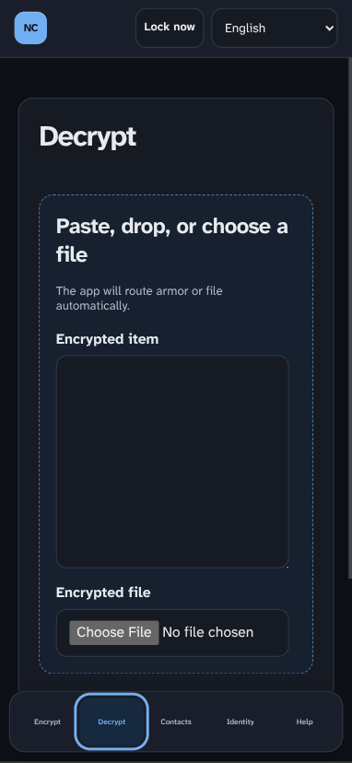
Current mobile Decrypt screen. The main task is constrained by nested rounded containers, while the bottom navigation uses very small text labels.

Observed issues tied to this request
- The text area does not immediately read as the main place to type or paste.
- The dashed outer drop area and inner input create unnecessary visual layers.
- The language selector occupies permanent top-bar space that belongs in Settings.
- The bottom navigation labels are tiny; icon-only destinations can be larger and clearer.
- The task controls use less width than the phone can comfortably provide.

Figure 2. Contacts screen
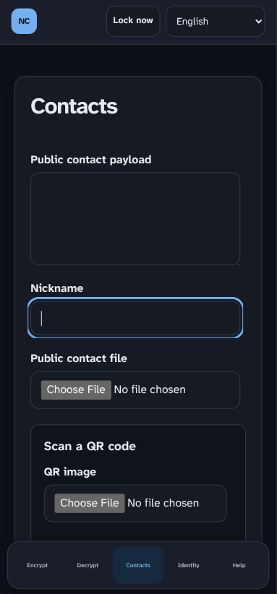
Current mobile Contacts screen. Usable fields are narrow and stacked inside several bordered regions, leaving the page visually sparse despite the amount of work required.

Observed issues tied to this request
- The public payload and file controls look small compared with the available width.
- Nested borders and generous gaps make the form feel longer without making it easier to use.
- The bottom navigation and top language selector repeat the same mobile shell issues as Decrypt.
- A common full-width textarea and import-control pattern would make Contacts and Decrypt feel like one product.

