1 Pmu Release Source Description
If you put your code package in D\|Elephant , you will find all the release source of pmu at
D \Elephant\src\lld\pmu\mcu and
1: Both tools keil uVision2 and DoCD Keil package 2.27 are need to install to build compiler
Environment
2: the mcu source code path:
Elephant\src\lld\pmu\mcu\mcu_src
3: you must build your mcu project to the path:
Elephant\src\lld\pmu\mcu\keil_prj
4: you will Transform mcu.hex to ali_pmu_bin_xx.h with PMU.bat at the path:
Elephant\src\lld\pmu\mcu\keil_prj
pmu_bin_xx.h are different according to different project,for example your ic is
M35XX, ali_pmu_bin_xx.h is ali_pmu_bin_35.h
5：you can debug for your pannle code at the path:
Elephant\src\lld\pmu\mcu\mcu_debug
Build Mcu development Environment
(1): install tools for compiler mcu code
Step 1:
Get the keil uVision2 install package
Step 2:
Install it with setup\Setup.exe ,the pictures for the Process of install as bellow.
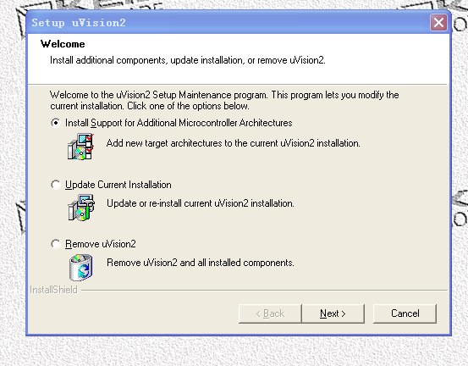

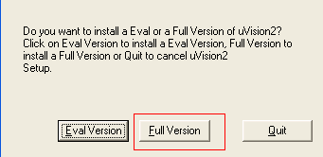

You should chose Full Version
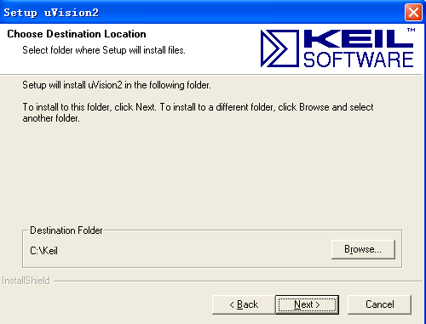

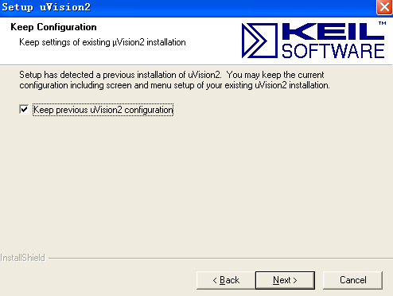

c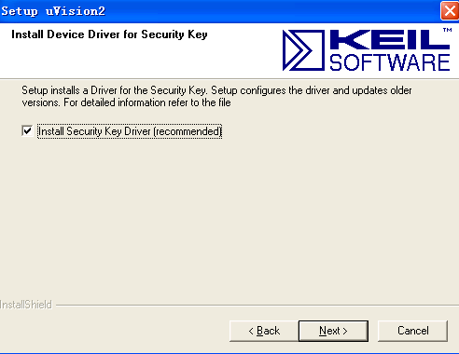
continue to click next until the end, when it is success，you will see keil uVision2 at desktop

Step 3:
Get the DoCD Keil package 2.27
Step 4:
Install it with \SOFTWARE\Keil_uVision\SOFTWARE\Keil_uVision \ DoCDKeil-setup.exe,
You should continue to click next until the end.

(2) Build a project to development mcu code
Step 1:
Open keil uVision2 on your desktop,you will see
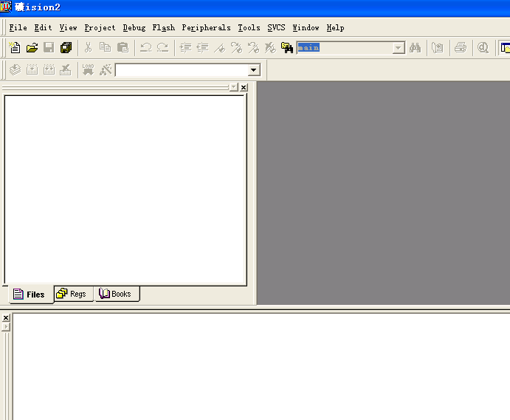
Step 2:
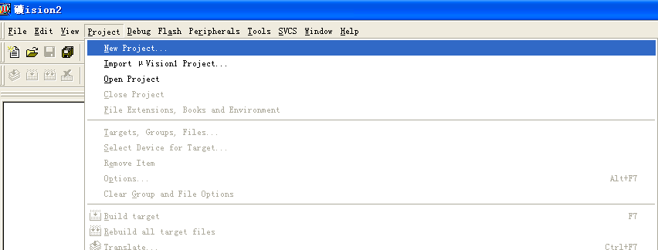
Step 3:
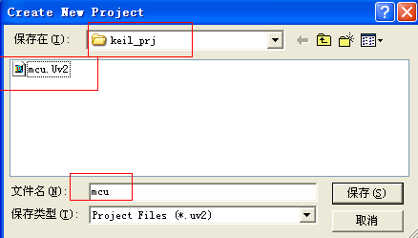
1: You should write mcu to the bank
2: You should choose Elephant\src\lld\pmu\mcu\keil_prj to the path

Step 4:
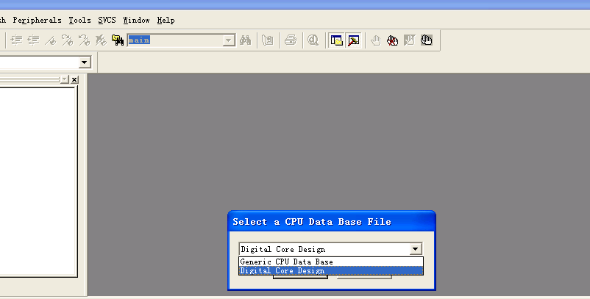
Step 5:
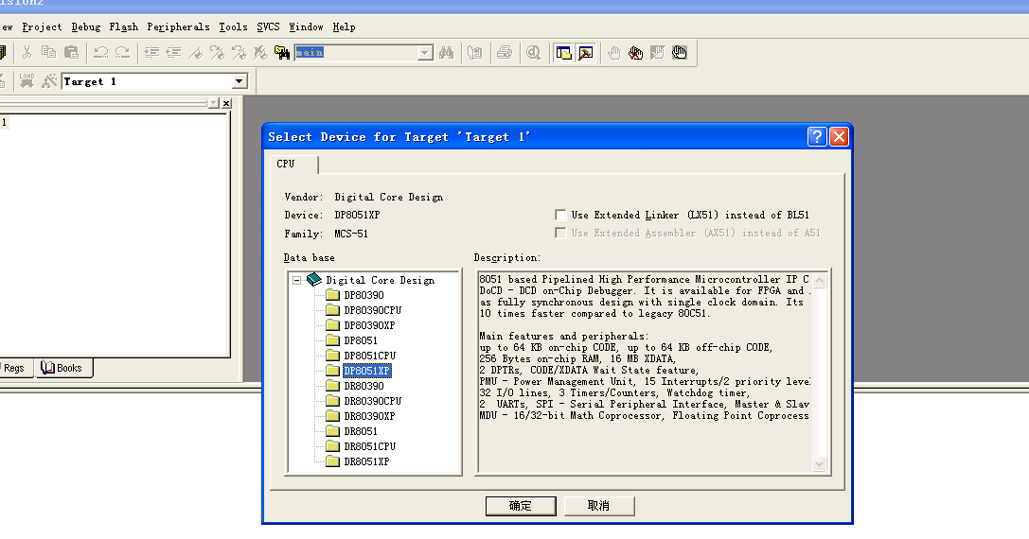
Step 6:
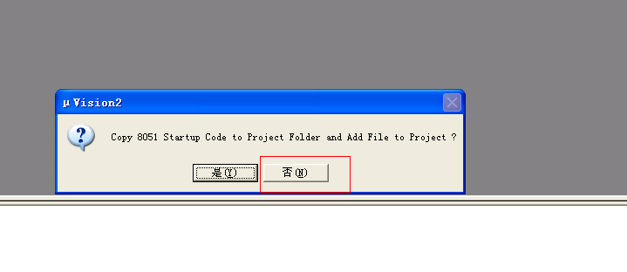
Step 6:
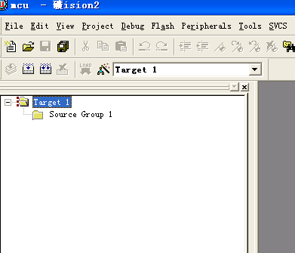

Step 7:
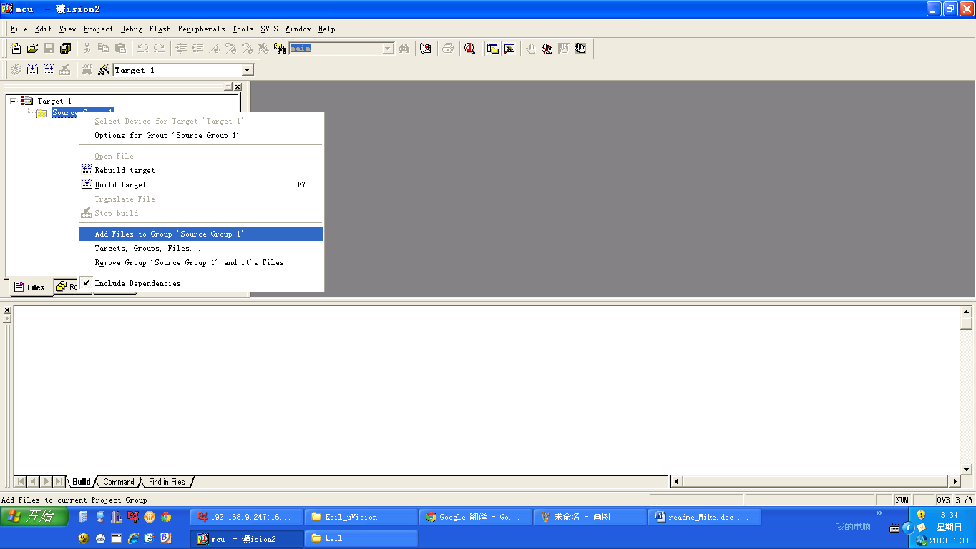
Step 8:
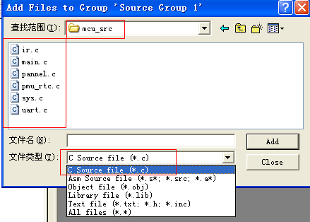
Add ir.c main.c pannel.c pmu_rtc.c sys.c and uart.c (src\lld\pmu\mcu\mcu_src) to the project
Step 9:
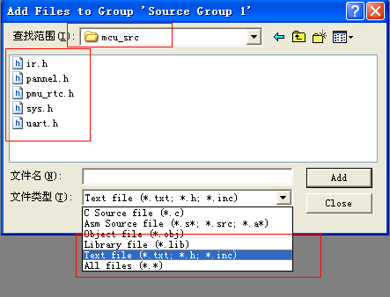

Add ir.h pannel.h pmu_rtc.h sys.h uart.h (\src\lld\pmu\mcu\mcu_src) to the project

Step 10:
you should press the red ring to config the targe for compile
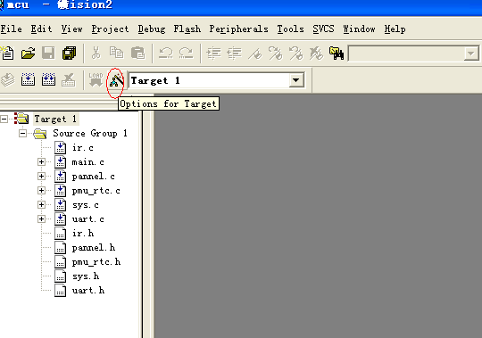
Step 11:
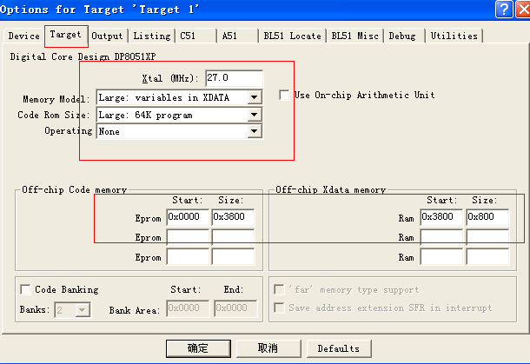
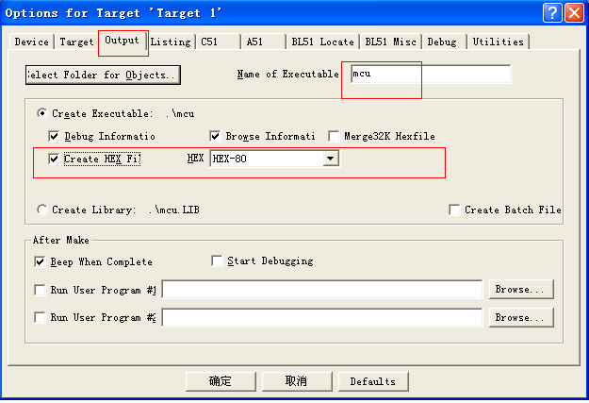
If you set same the environment as the pictures above. You can continue to compiler for it as the picture below
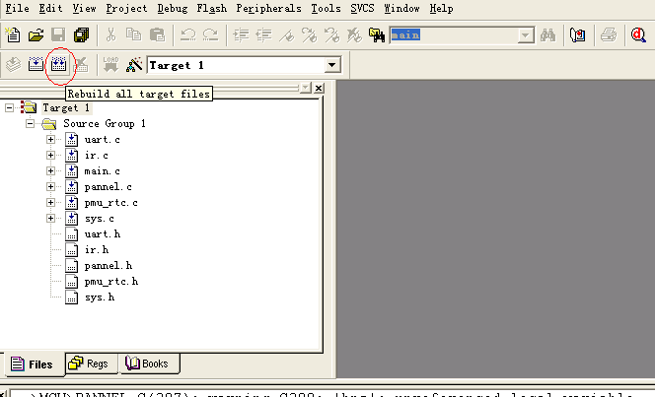
If you are success for compiling the code ,you will see the picture below
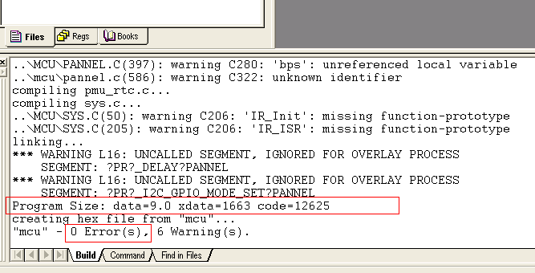
you will ses mcu.hex at : Elephant\src\lld\pmu\mcu\keil_prj, so you are success to compiler to mcu code and get mcu.hex
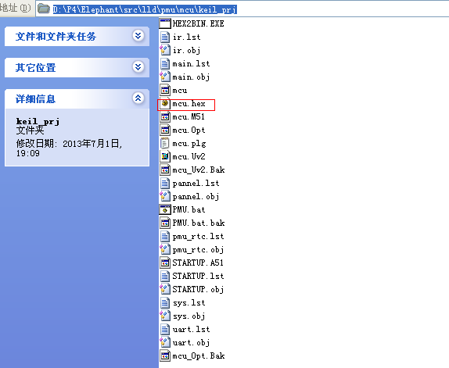
Step 12：
Go to the path: \Elephant\src\lld\pmu\mcu\keil_prj to run the Script to generate ali_pmu_bin_xx.h
( pmu_bin_xx.h are different according to different project,for example your ic is
M35XX, ali_pmu_bin_xx.h is ali_pmu_bin_35.h
)
For example:
- cd Elephant\src\lld\pmu\mcu\keil_prj
- For WIN7 ./ PMU_WIN7.bat
1:You should modify PMU_WIN7.bat accoding to different project,please Reference readme (src\lld\pmu\mcu\keil_prj\readme)
2: run the PMU_WIN7.bat ,If you success , you will see Elephant\src\lld\pmu\mcu\ keil_prj\ali_pmu_bin_35.h (if your project is M3503 arccoding the step 1)
and prj\app\demo\combo\sabbat_dual\ali_pmu_bin.h

For XP please use as follow method:
1. cd Elephant\src\lld\pmu\mcu\keil_prj
./PMU_XP.bat -> generate the muc.txt
2,if your project is M3503 Copy the Content of mcu.txt and the replace the content for array variable that in src\lld\pmu\mcu\ keil_prj\ali_pmu_bin_35.h (If ali_pmu_bin_35.h not exist, please create it ) .

For example, mcu.txt is
0x01,0x2,0x03,0x04,
0x05,0x06,0x07,0x08
0x09,0x0a,0x0b,0x0c,
You should change the ali_pmu_bin_35.h like this:
unsigned char g_ali_pmu_bin []=
{
0x01,0x2,0x03,0x04,
0x05,0x06,0x07,0x08
0x09,0x0a,0x0b,0x0c,
};

- compiler the systerm soltware and burning it to your board
make path config_3503 new ddk product_7z

make sure src\lld\pmu\mcu\ ali_pmu_bin_35.h
have copy to prj\app\demo\combo\sabbat_dual\ ali_pmu_bin.h
and prj\app\demo\combo\sabbat_dual\power.c have compile to new power.o

because prj\app\demo\combo\sabbat_dual\power.c will use prj\app\demo\combo\sabbat_dual\ ali_pmu_bin.h

2 how to modify pannel.c
Because your panne maybe different from ali demo board, so you should modify
Elephant\src\lld\pmu\mcu\mcu_src\pannel.c , please make sure only to modify pannel.c and
do not modify anyother files (include pannel.h,do not modify it).

(1)
You must implement 4 functions as bellow. Don’t change the archetype of them, make them the same archetype as the pannel.h that we provide to you, because we will call the four function
in sys.c

(2)
When you implement your pannel.c , you must include head files like below, and don’t change it.
Pannel.c
#include <dp8051xp.h>
#include <stdio.h>
#include <intrins.h>
#include "sys.h"
#include "pannel.h"
#include "uart.h"

(3)
For M35XX mcu has 3 pin can use as gpio to operate.
You can use four gpio api and three maro about mcu gpio pin to operater mcu gpio in your pannel.c

Three Mcu Gpio pin marco

. Marco
For M3503 you can use marco as below
XPMU_GPIO_0 XPMU_GPIO_1 XPMU_CEC
For M3821 you can use marco as below
XPMU_GPIO_0
XPMU_GPIO_1
XPMU_GPIO_2
XPMU_GPIO_3
XPMU_GPIO_4
XPMU_GPIO1_0
XPMU1_CEC

marco mens mcu pin

GPIO API
void hal_mcu_gpio_en(pos);
void hal_mcu_gpio_disable_en();
UINT8 hal_gpio_bit_get(pos);
void hal_gpio_bit_set(pos,val);
void hal_gpio_bit_dir_set(pos,val);
(1)
/*
para: pos :input val :input
function type: void
function: set gpio direction
*/

hal_gpio_bit_dir_set(pos,val)

(2)
/*
para:pos :input val :input
function type:void
function: set gpio output val
*/
hal_gpio_bit_set(pos,val)
(3)
/*
para: pos :input
function type: unsigned char
function: get the input value for gpio pin
*/
hal_gpio_bit_get(pos)
(4)
/*
para: void
function type: void
function: enable mcu pin for gpio function
*/
hal_mcu_gpio_en()
Example to opearate mcu pin
hal_mcu_gpio_en()

This function is use to enable mcu_pin to gpio function
When you want to opearate gpio , you must enable gpio first .if you enable it, this mcu pin will always work as gpio pin. So you only need call HAL_MCU_GPIO_EN() for one time at the init panel step;
Example ALi demo:
void pannel_init()
{
hal_mcu_gpio_en(); // enale all the mcu_pin to gpio function
}

When you want to make XPMU_GPIO_0 output high Level
Step 1:
// set xpmu_gpio_0 to output mode
hal_gpio_bit_dir_set(XPMU_GPIO_0, 1)
Step 2:
// set xpmu_gpio to output high level
hal_gpio_bit_set (XPMU_GPIO_0, l)
If you want to make XPMU_GPIO_0 output low Level
Step 1:
// set xpmu_gpio to output mode
hal_gpio_bit_dir_set(XPMU_GPIO_0, 1)
Step 2:
// set xpmu_gpio to output low level
hal_gpio_bit_set(XPMU_GPIO_0, 0)
When you want to read the gpio XPMU_GPIO_1 input value
Step 1:
// set xpmu_gpio_1 to input mode
hal_gpio_bit_dir_set(XPMU_GPIO_1, 0)
Step 2:
// read the input value,
Unsigned char val;
Val = hal_gpio_bit_get(pos)
If val is 1 means input to this gpio pin is high level, or the input is low level

You should open different marc in sys.h, for example ,your project is M3503 you must open marc
Like this
#define PMU_MCU_M3503 1
//#define PMU_MCU_M3821 1
//#define PMU_MCU_DEBUG 1

Now you should implement four function in your panel.c for your pannel as bellow
(1)void pannel_init()
(2)void show_pannel(enum SHOW_TYPE show_type,pRTC_TIMER rtc);
(3)char pannel_scan();

pannel_init()
You will do some init step that you want, but you should awalys enable gpio first.
For example:
Panel_init()
{
// must call it firs
hal_mcu_gpio_en(SYS_I2C_SDA); //enable sda gpio
hal_mcu_gpio_en(SYS_I2C_SCL); //enable scl gpio

/** do what you want to do, according to your board*/
……………..
…………….
……………..
}

void show_pannel(enum SHOW_TYPE show_type,pRTC_TIMER rtc);
Para : show_type input
rtc input
function：It is used to show off, time.or noting on your board

for example : ali demo implement it like this
void show_pannel(enum SHOW_TYPE show_type,pRTC_TIMER rtc)
{

if(show_type ==SHOW_BANK)
show_bank(); //use to show nothing , you must implement it in your panel.c
else if(show_type ==SHOW_TIME)
show_time(rtc); //use to show time , you must implement it in your panel.c
else
show_off(); //use to show OFF , you must implement it in your panel.c
}

INT8 pannel_scan()
Para: void
Function type ; char , it will return -1 or 0
If return is -1, means you do nor scan your panel key , or you get the key
Ali demo code implement like this

INT8 pannel_scan()
{
UINT8 pan_key;
i2c_gpio_read(KEY_ADDR,&pan_key,1);
if(pan_key == PANNEL_KEY)
return SUCCESS;
else
return ERROR ;
}

3 how to debug pannel.c

If you want to debug, you should open marco PANNEL_DEBUG in panel.h. (you can modify pannel.h if you want to debug)
How to debug pmu code
(1)
1 You can only debug your panel code with the tools in Elephant\src\lld\pmu\mcu\mcu_debug
- When you want to debug panel code ,you should open the marco in \src\lld\pmu\mcu\mcu_src\sys.h
Open macro #define PMU_MCU_DEBUG 1

but you must add Little debug infor , or the code size will too large to compiler success. When you modify the pannle.c, you should compiler the mcu code again to generat mcu.hex to Elephant\src\lld\pmu\mcu\keil_prj,
then you only need to make step below
step1: cd Elephant\src\lld\pmu\mcu\keil_prj
step2 ./ PMU.bat
- When you finsh step1 and step2 you can use wingdb to download Elephant\src\lld\pmu\mcu\mcu_debug \pmu_debug.ini. And run it.for ali demo code
You will see the following information or your uart terminal (set uart terminal Baud Rate to 9600bps)

For M3503 ali_demo , you can see pritnf message below
"enter stdby\n" sys.c
pan_key=0x2e , pannel.c ( you can also add your printf
message to check wether success to
scan your board pannel key)
for ali demo ,if we presss pannel key ,we will see
pannel exit standby , which means we get the key and exit standby mode

4; when you finsh debug , you should close macro // #define PMU_MCU_DEBUG 1
And the compiler all the process again.

