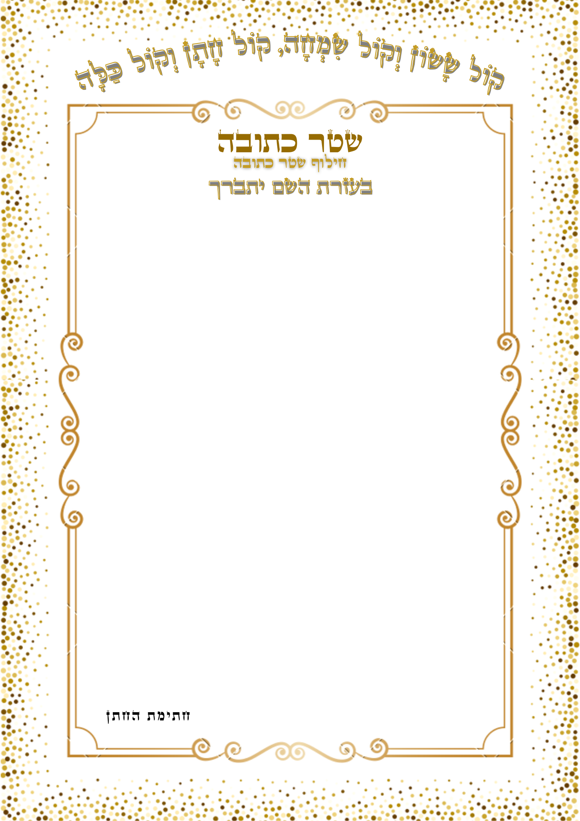
${text}
${neoum}
${fin}

