Lab2:

Q1:

Ls:

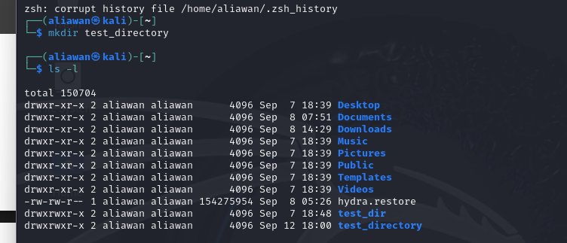

Cd and pwd:

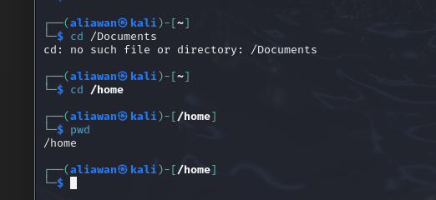

Rmdir:

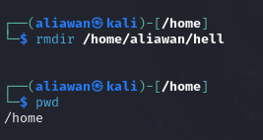

Rm:

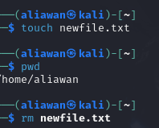

Cp: copy a directory into new one and rename

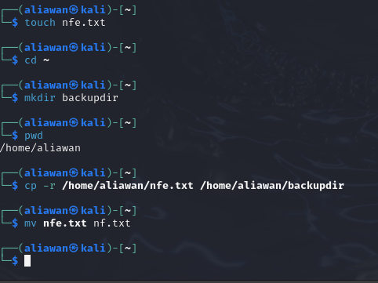

Ques2:

Top:

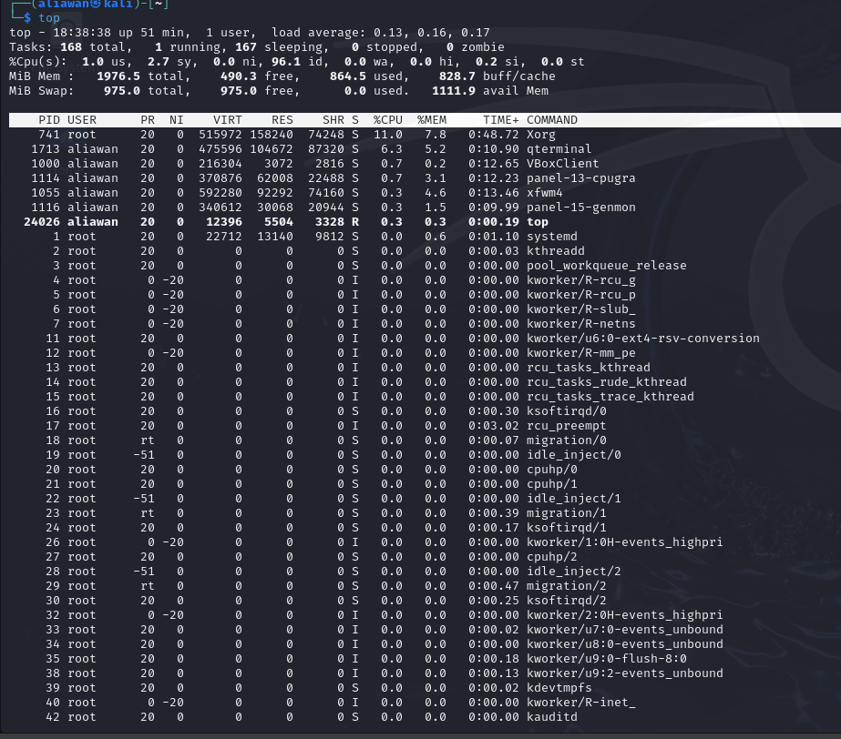

Ps:

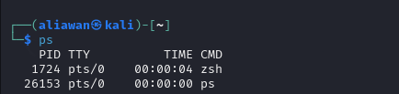

Kill: using signal id and SIGTERM

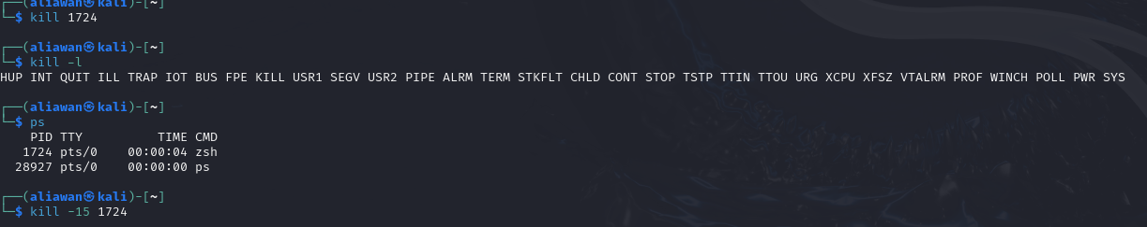

Chmod using 400 and 700 and ls -l:

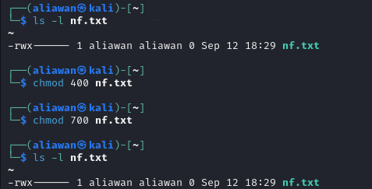

Ifconfig:

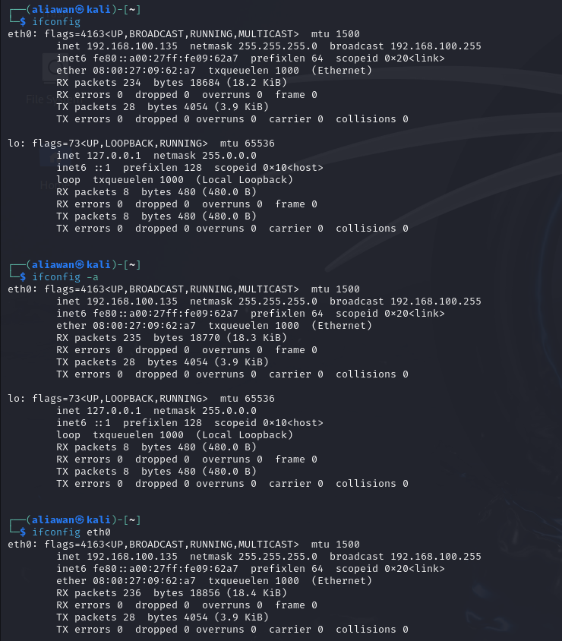

Route:

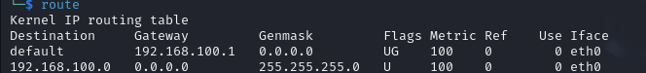

Ss:



Weget

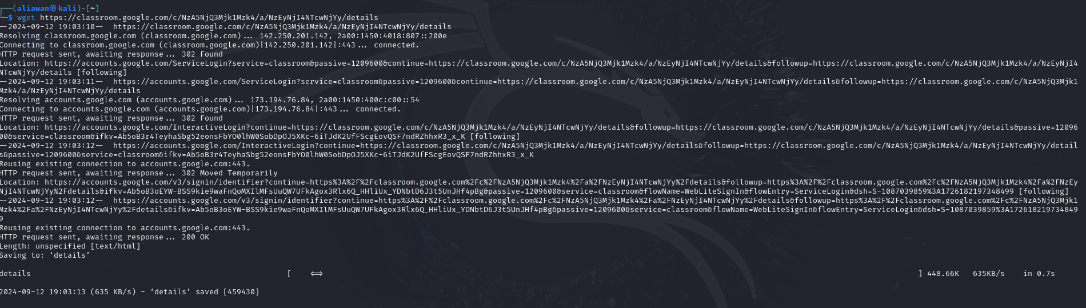

Traceroute:

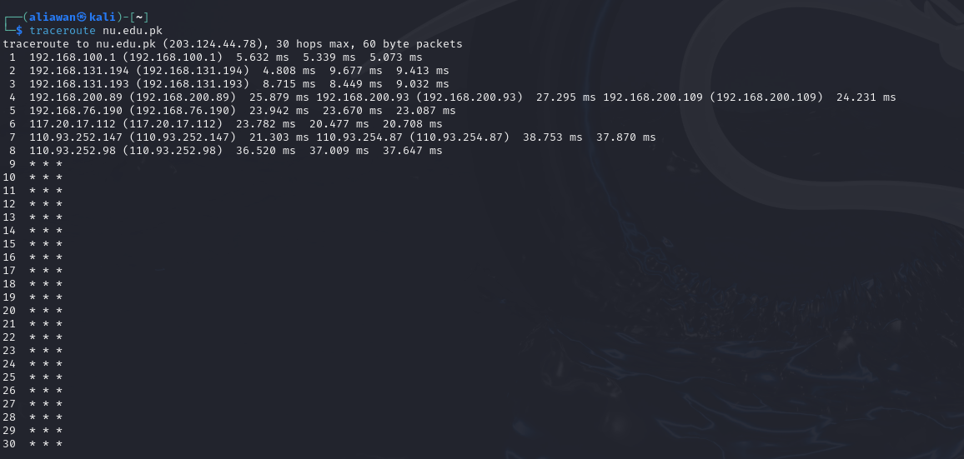

Nslookup:

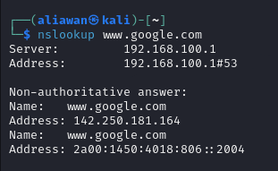

Host:

Q3 : ping and sending 4 packets

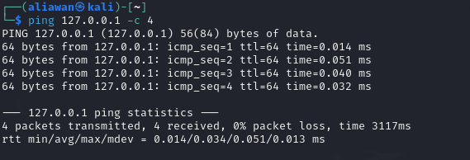

Ping with local gateway network :

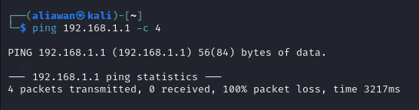

Ping with Google DNS server:

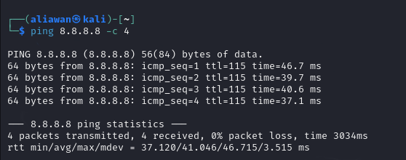

Ping with website: Google ,Github and Flex

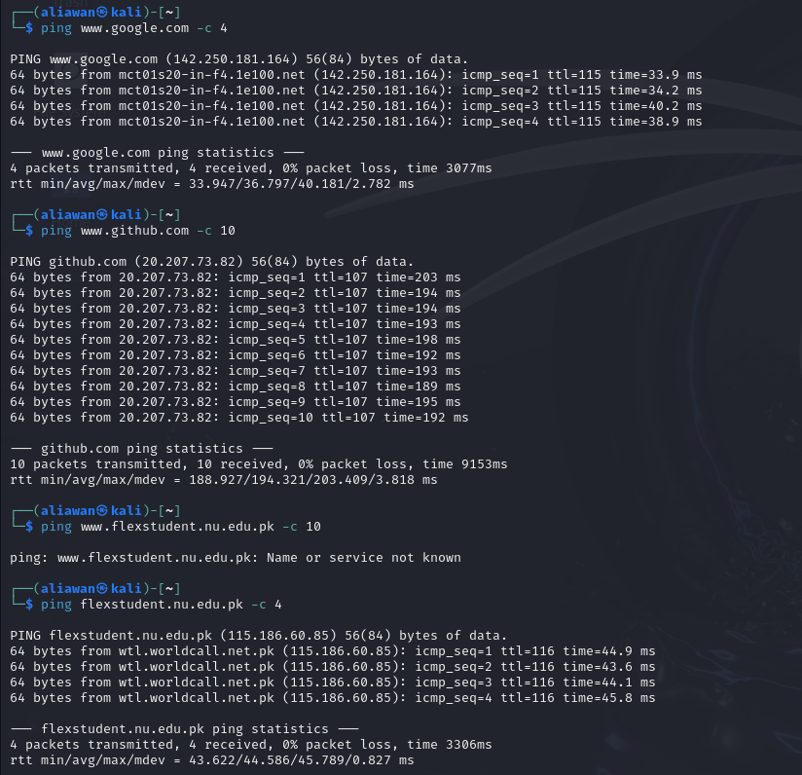

Que4:

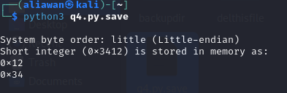

Q5:

