|  |  |  |
| --- | --- | --- |
| a boy is enjoying loud music, dancing and enjoying life | 5 |  |
| a young man in dancing | 5 |  |
| dancing well | 5 |  |
| dancing with a boy | 5 |  |
| happy boy | 5 |  |
| music playing | 5 |  |
| the boy is dancing excitedly with loud and crazy music | 5 |  |
| the boy is dancing on music | 5 |  |
| the young man and dancing to the music | 5 |  |



Item 1 Targeted

Item 1 Untargeted

|  |  |  |
| --- | --- | --- |
| exercising to music | 5 |  |
| the boy is jiving | 5 |  |

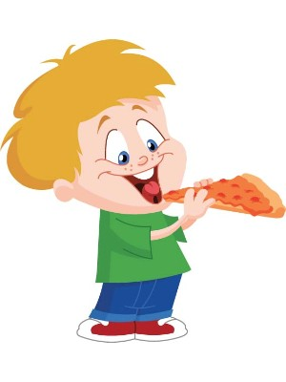

Item 2 Targeted

|  |  |  |
| --- | --- | --- |
| a short boy is going to eat a pepperoni pizza | 5 |  |
| he's having lunch | 5 |  |
| the boy is eating lunch | 5 |  |
| the child is enjoying a snack | 5 |  |
| the boy is eating pepperoni pizza | 5 |  |
| eating lunch | 5 |  |
| this young man is enjoying his cheese pizza | 5 |  |
| he's scarfing down a pizza | 5 |  |
| the kid is eating a slice of meatball pizza | 5 |  |
| the boy is about to take a bite from a slice of plain pizza | 5 |  |

Item 2 Untargeted

|  |  |  |
| --- | --- | --- |
| the boy is eating for pizza | 5 |  |
| a boy is going to eat a big pizza | 5 |  |
| the boy is preparing to eat a pepperoni pizza | 5 |  |
| he is eating lunch | 5 |  |
| child is eating lunch | 5 |  |
| a child is eating a slice of pepperoni pizza | 5 |  |
| a small boy is happily munching on a slice of pepperoni pie | 5 |  |
| at lunch time the boy ate a slice of pizza | 5 |  |
| a slice of pizza is going to be a meal for a boy | 5 |  |
| pepperoni pizza makes the boy smile | 5 |  |
| a toddler is enjoying a slice of pizza | 5 |  |
| the little boy decided to eat pizza for lunch | 5 |  |
| a young boy has a big appetite | 5 |  |

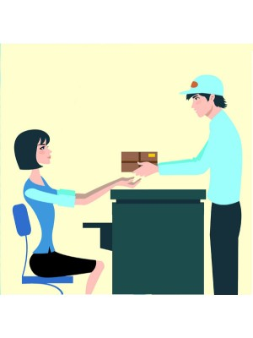

Item 3 Targeted

|  |  |  |
| --- | --- | --- |
| the man is handing a package to his client | 5 |  |
| the poster officer is giving a package to a woman | 5 |  |
| the man is putting the package to the woman | 5 |  |
| the postman is giving a package to the lady | 5 |  |
| the mailman is delivering a package to the receptionist | 5 |  |

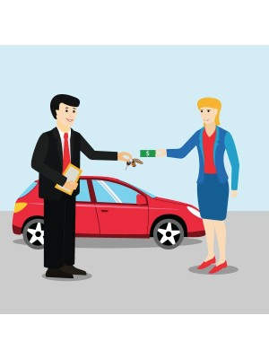

Item 14 Untargeted

|  |  |  |
| --- | --- | --- |
| the woman pay money for the man and take back to her car's key, | 5 |  |
| the woman is paying the waiter for parking her car, | 5 |  |
| a women buying a car, | 5 |  |
| a women buying a new car and exchange cash for the keys, | 5 |  |
| the sales man is handing the women her new car keys, | 5 |  |
| car purchase, | 5 |  |

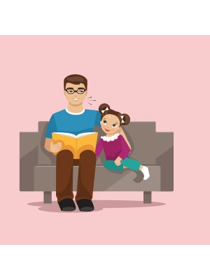

Item 26 Untargeted

|  |  |
| --- | --- |
| the father is telling the story | 5 |
| the father is reading the story to his daughter | 5 |
| a father is reading a book for his daughter | 5 |
| father is reading his daughter a story | 5 |
| the girl is reading a book with her father | 5 |
| the man is reading a story book for his daughter in the sofa | 5 |
| little girl's father is telling the story to make the girl sleep | 5 |
| a father is reading a book to his daughter | 5 |
| dad is talking a story to the daughter | 5 |
| the man is reading a book for a girl who is around by one of his arms | 5 |
| a father is telling story to his daughter | 5 |
| the father is telling a story to his daughter | 5 |
| the man is telling stories to his daughter | 5 |
| father is reading a story book to is daughter | 5 |
| a father is telling a story to his daughter | 5 |
| a father is telling stories to his sweet daughter | 5 |
| the father is reading stories to his daughter | 5 |
| the father is reading a story to a girl | 5 |
| the father is reading a story to his daughter | 5 |
| a father is reading a book to his young daughter on the sofa | 5 |
| the man is reading to his daughter | 5 |
| a father is reading a story to his daughter | 5 |
| dad is telling a story to his daughter | 5 |
| the father is telling stories to his daughter | 5 |
| a father is telling stories to his daughter | 5 |
| the father is telling a story to his little girl | 5 |
| the man is describing a book for his daughter | 5 |
| a father is telling a story from a book to a girl | 5 |
| the father is telling stories to his kid | 5 |
| a dad is reading a book with his daughter | 5 |
| father is telling his daughter the stories | 5 |
| the father is telling a story for the girl | 5 |
| the father is talking a story to the girl | 5 |
| the father is reading book to his daughter | 5 |
| a father is telling story to his girl | 5 |
| a father is telling a story to his daughter on a sofa | 5 |
| the father is telling the story to the girl | 5 |
| the girl is listening to the old man for a story | 5 |
| the man is telling his daughter stories | 5 |
| the father is reading a book to his daughter | 5 |
| a man is telling a story for his daughter | 5 |
| the girl's father is telling a interesting story to her | 5 |
| a dad reads to his daughter | 5 |
| the father reads a story to his child | 5 |
| a father reads to his daughter | 5 |
| a daughter listens to her father as he reads | 5 |
| the dad is reading a book to the girl | 5 |
| the girl is listening to her dad read a book | 5 |
| the dad is reading a story to his daughter | 5 |
| the father is reading to his daughter | 5 |
| the girl is enjoying the story her father is reading to her | 5 |
| a father is reading to his daughter | 5 |
| the man is reading a bed time story | 5 |
| a father is reading his daughter a story | 5 |
| a dad is reading to his daughter | 5 |
| dad is reading a story to his daughter | 5 |
| the dad is reading his daughter a story | 5 |
| the dad is reading a story | 5 |
| the daughter is so happy | 5 |
| a man reads a story to his daughter | 5 |
| daddy is narrating a story to his daughter | 5 |
| the daughter is enjoying the story being narraed by her dad | 5 |
| the little girls father is reading her a book | 5 |
| the little girl is enjoying storytime with her dad | 5 |
| the man is reading book to his daughter | 5 |
| the girl is listening to a story from her father | 5 |
| a child is listening to her father read aloud from a book | 5 |
| a father is reading a story to his child | 5 |
| a child is listening to her father read a story | 5 |
| dad has the task of reading to his young daughter, who is happy with the story | 5 |
| dad finds he enjoys reading to his daughter because he does dot get the chance to be close to her when they are on vacation | 5 |
| the dad is reading too his daughter | 5 |
| the daughter is listening to her dad reading the story | 5 |
| the little girl is excited to sit next to her dad while he reads her a story | 5 |
| a father reads a story to his daughter | 5 |
| the little girl enjoys a story from her dad | 5 |
| dad is reading his daughter a story | 5 |
| the girl is enjoying the story her dad is reading to her | 5 |
| daddy is reading a story to his daughter | 5 |
| the young girl looks so happy to be beside her dad as he reads to her | 5 |
| the dad is reading to his daughter | 5 |
| the older brother reads to his little sister | 5 |
| the younger sister is spending time with her brother | 5 |
| the girl's father is reading her a book | 5 |
| the girl is enjoying bonding time with her dad | 5 |
| a parent is reading a story to a child | 5 |
| a child is listening to a story read by a parent | 5 |
| father is reading to his daughter | 5 |
| father reads story to daughter | 5 |
| a man reads to his child | 5 |
| father and daughter are reading a book together | 5 |
| father reads a book to child | 5 |
| a child is about to read a book with father | 5 |
| reading story | 5 |
| the man is reading a story to his daughter | 5 |
| the girl is listening to her dad read her a story | 5 |
| dad is reading the book to his daughter | 5 |

Get general impressions from Annotator 2:

What was easy? What was hard? Were guidelines clear? Etc.

Re: Father/daughter, pepperoni, etc.:

We’re getting into degrees of verifiability. We’re making assumptions each time we annotate—how do we know the figures are not robots?

Father/daughter – couch implies a home, reading a storybook is a familial activity, arm around girl also implies familial relationship. If we accept father/daughter, we need to expand guidelines… if evidence points to relationship, it may be considered verifiable (?)

One factor: if multiple respondents agree on an inference, that may add weight to the decision that it is verifiable. If multiple respondents give different ideas (pepperoni, sausage, cheese…) it may not be a verifiable inference.

Holistic layer of annotation?

Likert scale

Crowd sourcing?

LREC 2018, due 9/25 – huge conference… half paper for submission, full paper later.

Maybe COLING? Or NAACL?

LREC, COLING, NAACL – from highest to lowest rate of acceptance

Current focus for a paper would be: what makes a good description of a picture?

Discuss with Sandra: venues for my current work?

Revise timeline and send to Markus this week.