OUTPUT

|  |  |
| --- | --- |
| Index | Final Output |
| 0 | 0004-000c-0004-0022-0007-0006-000d-0009-0009-0002-0008-000d-0002-000f-0010-0003 |
| 1 | 0017-002d-0043-0016-0007-0006-0004-0001-0012-0038-000d-000c-0003-0005-0007-0009 |
| 2 | 001b-0039-0047-0038-000e-000c-0011-000a-001b-003a-0015-0019-0005-0014-0017-000c |
| 3 | 0017-002d-0043-0016-0007-0006-0004-0001-0012-0038-000d-000c-0003-0005-0007-0009 |
| 4 | 0017-0007-0012-0003-002d-0006-0038-0005-0043-0004-000d-0007-0016-0001-000c-0009 |
| 5 | 0000-0000-0000-0000-0000-0000-0000-0000-0000-0000-0000-0000-0000-0000-0000-0000 |
| 6 | 0000-0000-0000-0000-0000-0000-0000-0000-0000-0000-0000-0000-0000-0000-0000-0000 |
| 7 | 0000-0000-0000-0000-0000-0000-0000-0000-0000-0000-0000-0000-0000-0000-0000-0000 |

|  |  |  |  |  |  |  |
| --- | --- | --- | --- | --- | --- | --- |
| XXXX | XX | XXXXXXXX | X | XXXXXXXX | X | XXXXXXXX |
| OP | Reg/Mem | Addr | Reg/Mem | Addr | Reg/Mem | Addr/Scalar |

basic explanation of module control, 1. put info and control on busses 2. EN = 1 3. on flag, EN = 0 4. back to one for next step 5. if no next step, get new opcode and reset busses

Instruction: ***To set instructions, Edit opMem.mem file with up to 8 instructions, following the below formula***

Exceptions:  
Stop; 000000000000000000000000000000000000000  
Scalar; Reg/Mem not used for scalar

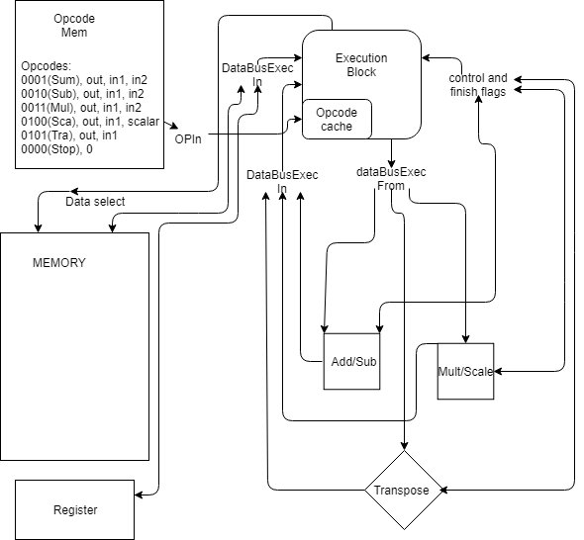Transpose; second Reg/Mem and Addr/Scalar not used