|  |  |
| --- | --- |
| Sikking bv |  |
|  | **OFFERTE** |

|  |
| --- |
| Flex-Zipper |
| Harmonielaan 1 |
| 3438 ED Nieuwegein |

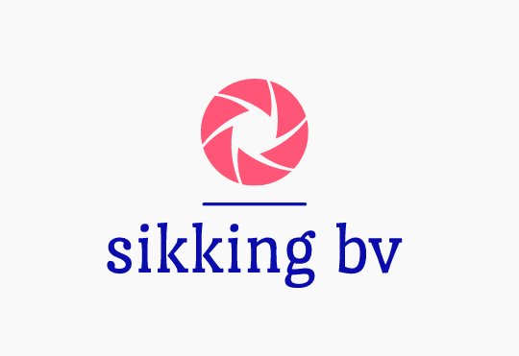

|  |  |
| --- | --- |
| **Offertedatum:** | **17-05-2021** |
| **Geldig t/m:** | **25-05-2021** |
| **Offertenummer:** | 12544 |

|  |  |  |  |  |
| --- | --- | --- | --- | --- |
| **Aantal** | **Omschrijving** | **Stuksprijs** | **BTW** | **Bedrag excl. BTW** |
| 40 | loonkosten | 50 | 2 | 2000,00 |
| 5 | Apparatuur kosten | 40 | 2 | 200,00 |
| 1 | Administratie kosten | 11 | 0 | 11 |
|  |  |  |  |  |
|  |  |  |  |  |

|  |  |  |  |  |  |
| --- | --- | --- | --- | --- | --- |
| BTW | BTW% | Grondslag | BTW bedrag | Totaal excl. BTW | 2200,00 |
| 0 | 0% | 0,00 | 0,00 | Totaal BTW | 462,00 |
| 1 | 6% | 0,00 | 0,00 |  |  |
| 2 | 21% | 0.00 | 462.00 | **Te betalen** | **€ 2673.00** |

**Voor akkoord:**

- - - - - - - - - - - - - - - - - - - - - - - - - - - - - - - - - handtekening en naam

|  |  |  |  |  |
| --- | --- | --- | --- | --- |
| Sikking bv | T: | 0184 - 601665 | KvK nr: | 943654363456 |
| Van Der Heydenstraat 5 | M: | **06 15473096** | Btw nr: | 6921420 |
| 2967 EL langerak | E: | info@sikkingbv.nl | Rek nr: | ING |