Step 1: Create a new Queue Connection Factory

Open folder bin of glassfish

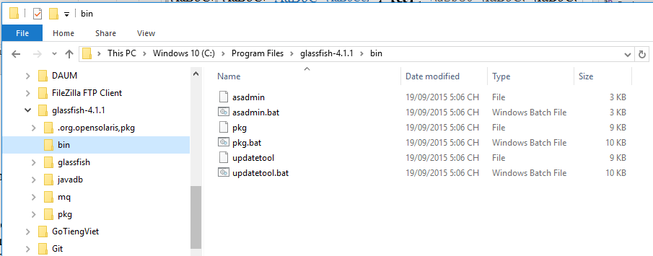

Run

asadmin.bat

Run command:

create-jms-resource --restype javax.jms.QueueConnectionFactory --description "connection factory for durable subscriptions" --property ClientId=MyID jms/EmailQueueConnectionFactory

Step 2: Config Email Sender

Open class GmailServiceImpl.java in MyUser_JAVA

Change user, password email sender.

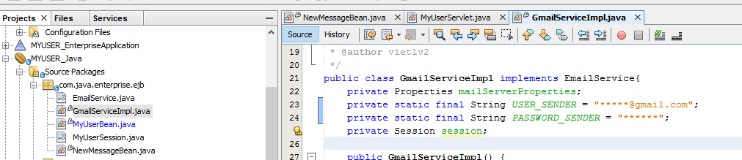

Enable IMAP on Gmail

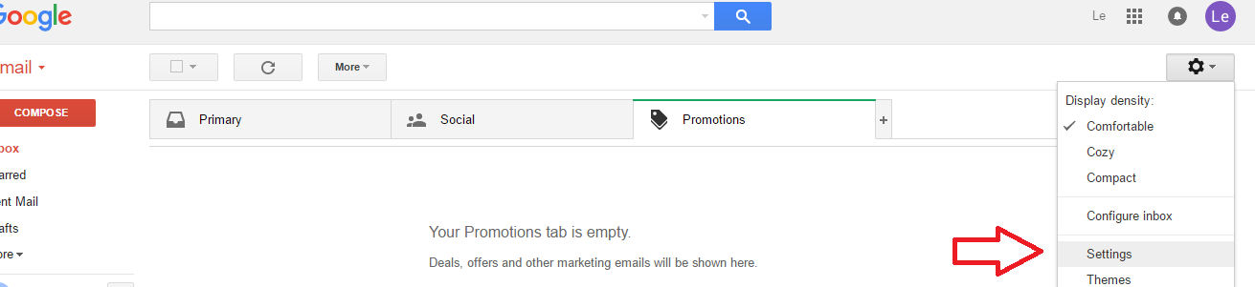

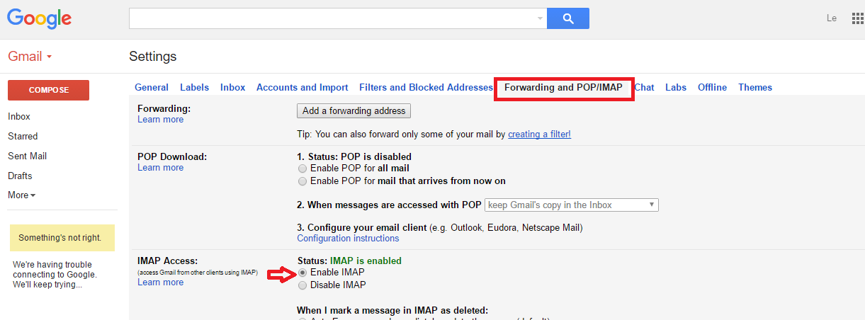

Step 3: Clean and build MYUSER_Java

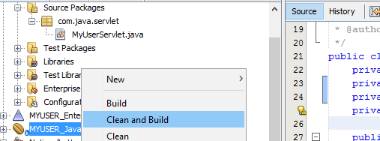

Step 4: Run MYUSER_ClientApplication