**FPT ACADEMY INTERNATIONAL**

**FPT - APTECH COMPUTER EDUCATION**

**Center Name: ACE-HCMC-2-FPT.**

**Address: 590 Cach Mang Thang 8, District 3, Ho Chi Minh City, Viet Nam.**

**Artistry Social Network**

**Design Document**

|  |  |  |
| --- | --- | --- |
| **Supervisor:** | Mr. Truong Thanh Trung | |
| **Semester:** | 4 | |
| **Batch No:** | T1.2206.E1 | |
| **Group No:** | 2 | |
| **Order:** | **Full name** | **Roll No.** |
| 1. | Le Viet Dong | Student 1390589 |
| 2. | Tran Thu Huy | Student 1387816 |
| 3. | Huynh Tan Phuoc | Student 1387826 |
| 4. | Nguyen Nhat Minh | Student 1390586 |
| 5. | Cao Tien Nam | Student 1387832 |

This is to certify that

|  |  |
| --- | --- |
| **Mr.** | **LE VIET DONG** |
| **Mr.** | **TRAN THU HUY** |
| **Mr.** | **HUYNH TAN PHUOC** |
| **Mr.** | **NGUYEN NHAT MINH** |
| **Mr.** | **CAO TIEN NAM** |

Have successfully Designed & Developed

|  |  |  |
| --- | --- | --- |
|  |  |  |
| **MY IMAGE** | | |

Submitted by:

|  |
| --- |
| **Mr. TRUONG THANH TRUNG** |

Date Of Issue:

10 - May -2023

Authorized Signature:

|  |  |
| --- | --- |
| **Mr** | **LE VIET DONG** |

**TABLE OF CONTENTS**

TABLE OF CONTENTS

I. Introduction 2

II. Problem Definition 3

1. Non-functional Requirement Specifications 4

2. System Requirement Specifications 4

a. Server Requirement: 4

b. Client requirements: 4

c. Development Software: 5

d. Technology: 5

REVIEW 2 6

Architecture & Design of the Project 7

1.Presentation Tier 7

2.Business Logic Tier 7

3.Data Access Tier 7

Algorithms – Data Flowchart 8

1.Symbols generates 8

2.Login (all users) 8

3.Logout (all users) 9

4. Upload Image 9

9

5. Add To Cart 10

6. Checkout 11

Use Case Diagram 12

1.User: 12

2.Admin: 13

13

REVIEW 3 14

Database Design Diagram 18

18

GUI Design 19

Login 19

User 20

**REVIEW** **1**

**ACKNOWLEDGEMENT**

First and foremost, we extend our heartfelt gratitude to our esteemed instructor, Mr. Truong Thanh Trung. Throughout the project's duration, he consistently and passionately instilled a sense of curiosity and enthusiasm for research, learning, and teaching. Without his unwavering guidance and support, the completion of this project would have been an insurmountable task. Therefore, we wholeheartedly appreciate your dedication and mentorship, Mr. Trung.

Next, the collaborative efforts of our team members were instrumental in the successful execution and completion of this project. Despite encountering numerous challenges along the way, we persevered through hard work, unwavering commitment, and the strong bond of camaraderie among us. Ultimately, we achieved our goals through collective effort.

Finally, we would like to express our gratitude to Aptech's eProject team, who provided us with a remarkable opportunity to apply our theoretical knowledge in a practical setting. This hands-on experience is invaluable as it equips us with essential skills for our future careers.

.

## I. Introduction

The IT industry today demands continuous learning, skill enhancement, and the practical application of concepts in a rapidly changing environment. However, the constraints of busy schedules, geographical distances, and limited availability of suitable time slots often hinder the practical application of these concepts. Hence, there is a pressing need to explore alternative methods of implementation, such as a phased approach.

These challenges are particularly pertinent to our students. Their demanding schedules make it challenging to keep pace with the ever-evolving technology landscape, especially in the field of IT education, where advancements occur rapidly. Fortunately, technology comes to our rescue in such circumstances.

With a commitment to leveraging technology in our training model, Aptech has embarked on a journey to revolutionize how our students learn and apply concepts by providing them with a live and synchronous eProject learning environment. This innovative approach aims to bridge the gap between theoretical knowledge and practical implementation, empowering our students for success in the dynamic IT industry.

## II. Problem Definition

In today's digital age, the photography and modeling industry lacks a comprehensive platform that effectively connects photographers, studios, makeup artists, models, and individuals seeking their services. Traditional methods of finding and booking these professionals are often inefficient, time-consuming, and lack transparency. As a result, both service providers and customers face challenges in establishing connections and managing bookings seamlessly.

Introducing "ArtistrySocialNetwork":

" ArtistrySocialNetwork " is poised to address these pressing issues by revolutionizing the way photography and modeling professionals interact and collaborate. ArtistrySocialNetwork is envisioned as an innovative web application designed to facilitate seamless communication, collaboration, and booking management within the photography and modeling community.

With ArtistrySocialNetwork, we envision a future where finding and booking photography and modeling services is as simple as a few clicks. Our platform is not just a tool; it's a catalyst for positive change within the industry. Join us on this exciting journey as we redefine the way professionals connect, collaborate, and create unforgettable moments together. ArtistrySocialNetwork - Where Creativity Meets Connectivity.

### Non-functional Requirement Specifications

* Good using Interface and Experience.
* Clean code, secure and easily scalable
* Try hard to improve the performance.
* Try this website to run on all browsers.
* Try to limit bugs on this website.

### System Requirement Specifications

### Server Requirement:

* Hardware:
* Component CPU:
  + Processor type:
  + Core-I3 processor or faster
  + Processor speed: Recommended: 2.0 GHz or faster
* OS:
  + Microsoft Windows XP or higher with IIS
* Memory (RAM):
  + Minimum: 512MB
  + Recommended: 2GB or more
* Hard Drive:
  + Minimum: 200 MB
  + Recommended: 50 GB or more
  + Maximum: Operating system maximum
* Software:
* Spring boot 3, Nextjs 14, Flutter
* RDBMS: MySql, MongoDB

### Client requirements:

* Hardware:
* Component CPU:
  + Processor type:
  + Core-I3 processor or faster
  + Processor speed: Recommended: 2.0 GHz or faster
* OS:
  + Microsoft Windows XP or MacOS …
* Memory (RAM):
  + Minimum: 512MB
  + Recommended: 2GB or more
* Hard Drive:
  + Minimum: 512MB
  + Recommended: 1 GB or more
* Software:
* Web Browser: Microsoft Edge, Mozilla Firefox, Chrome

### Development Software:

* **Development Software:**
* WebStorm
* IntelliJ.
* Microsoft Visual Code

### Technology:

* Server: Microservice, Spring boot, MongoDB, MySQL, Websocket, Elastic Search, Eh Cache
* Client: NextJs 14, Flutter

# REVIEW 2

# Architecture & Design of the Project

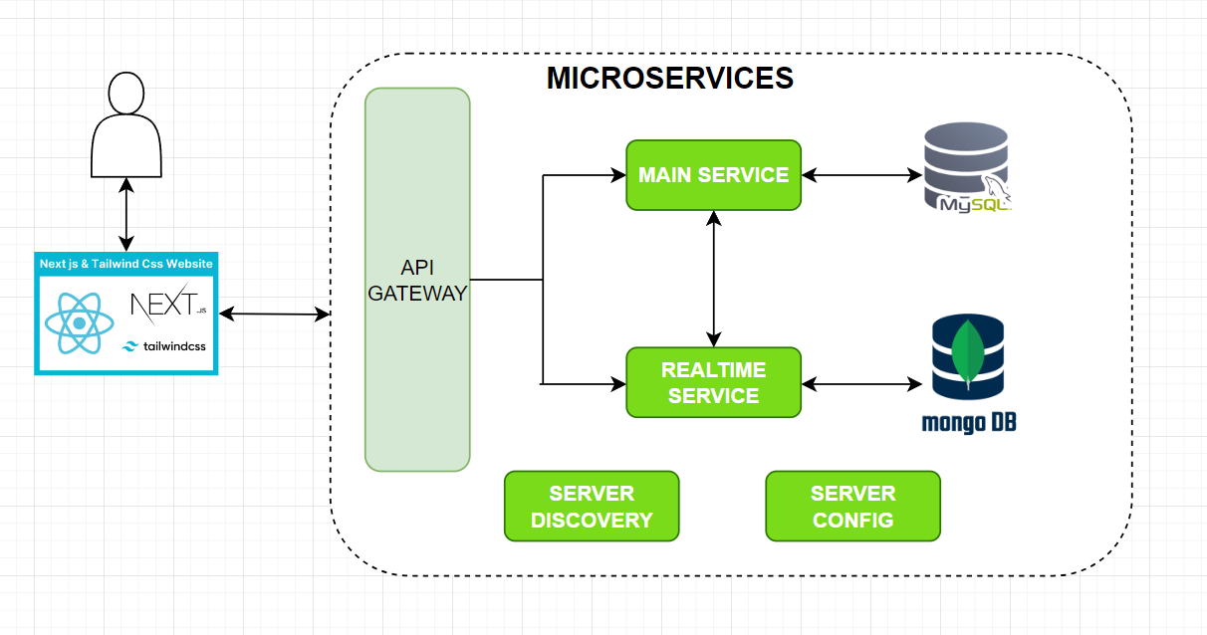

## 1.Presentation Tier

* + - * This is the tier in which the users interact with applications. Presentation Tier contains View used to receive a request and response to User.
      * Technology: NextJs 13, Html, Css, Tailwind

## 2.Business Logic Tier

* + - * Is mainly working as the bridge between Data Tier and Presentation Tier. All the Data passes through the Business Tier before passing to the Presentation Tier.
      * Technology: Microservices, Spring boot, Websocket, Elastic Search

## 3.Data Access Tier

* + - * This is basically the server which stores all the application’s data. Data tier contents Database Tables, Database Views and other means of storing Application’s data.
      * Technology: My SQL, MongoDB

# Algorithms – Data Flowchart

## 1.Symbols generates

### 

## 2.Login (all users)

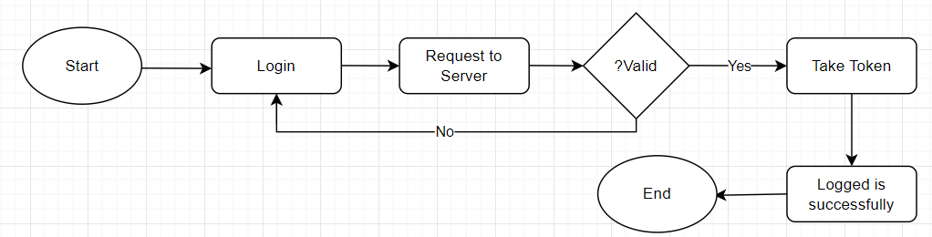

## 3.Logout (all users)

## 4. Booking

## 5. Searching

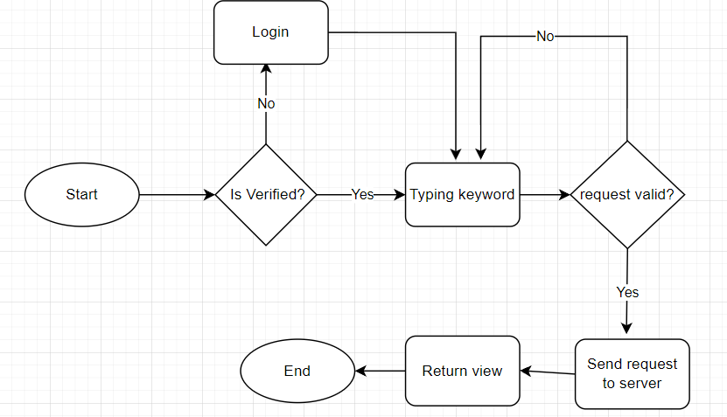

## 6. Checkout

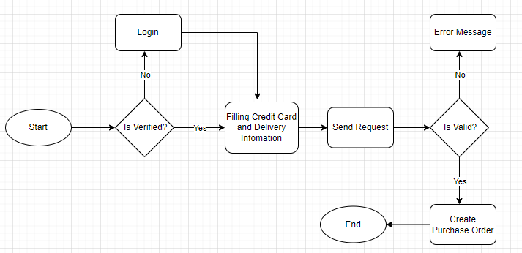

## 

## 

## 

## 

## 

# Use Case Diagram

## 1. User and provider

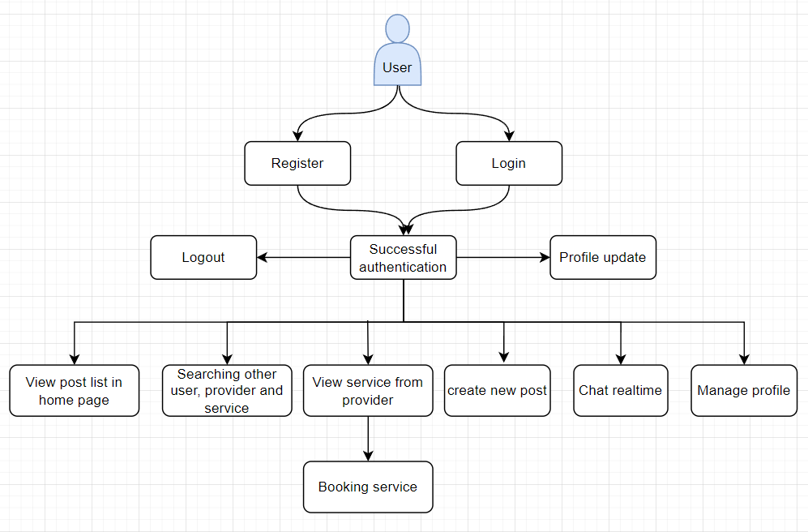

## 2. Only provider:

