**FPT ACADEMY INTERNATIONAL**

**FPT - APTECH COMPUTER EDUCATION**

**Center Name: ACE-HCMC-2-FPT.**

**Address: 590 Cach Mang Thang 8, District 3, Ho Chi Minh City, Viet Nam.**

My Image

**Design Document**

|  |  |  |
| --- | --- | --- |
| **Supervisor:** | Mr. Truong Thanh Trung | |
| **Semester:** | 3 | |
| **Batch No:** | T1.2206.E1 | |
| **Group No:** | 2 | |
| **Order:** | **Full name** | **Roll No.** |
| 1. | Le Viet Dong | Student 1390589 |
| 2. | Tran Thu Huy | Student 1387816 |
| 3. | Huynh Tan Phuoc | Student 1387826 |
| 4. | Nguyen Nhat Minh | Student 1390586 |
| 5. | Cao Tien Nam | Student 1387832 |

This is to certify that

|  |  |
| --- | --- |
| **Mr.** | **LE VIET DONG** |
| **Mr.** | **TRAN THU HUY** |
| **Mr.** | **HUYNH TAN PHUOC** |
| **Mr.** | **NGUYEN NHAT MINH** |
| **Mr.** | **CAO TIEN NAM** |

Have successfully Designed & Developed

|  |  |  |
| --- | --- | --- |
|  |  |  |
| **MY IMAGE** | | |

Submitted by:

|  |
| --- |
| **Mr. TRUONG THANH TRUNG** |

Date Of Issue:

10 - May -2023

Authorized Signature:

|  |  |
| --- | --- |
| **Mr** | **LE VIET DONG** |

**TABLE OF CONTENTS**

TABLE OF CONTENTS

I. Introduction 2

II. Problem Definition 3

2. Non-functional Requirement Specifications 5

3. System Requirement Specifications 6

**3.1 Server Requirement:** 6

**3.2 Client requirements:** 7

**3.3 Development Software:** 7

**3.4 Technology:** 7

REVIEW 2 8

Architecture & Design of the Project 9

1.Presentation Tier 9

2.Business Logic Tier 9

3.Data Access Tier 9

Algorithms – Data Flowchart 10

1.Symbols generates 10

2.Login (all users) 10

3.Logout (all users) 11

4. Upload Image 11

11

5. Add To Cart 12

6. Checkout 13

Use Case Diagram 14

1.User: 14

2.Admin: 15

15

REVIEW 3 16

Database Design Diagram 18

18

GUI Design 19

Login 19

User 20

**REVIEW** **1**

**ACKNOWLEDGEMENT**

First and foremost, we extend our heartfelt gratitude to our esteemed instructor, Mr. Truong Thanh Trung. Throughout the project's duration, he consistently and passionately instilled a sense of curiosity and enthusiasm for research, learning, and teaching. Without his unwavering guidance and support, the completion of this project would have been an insurmountable task. Therefore, we wholeheartedly appreciate your dedication and mentorship, Mr. Trung.

Next, the collaborative efforts of our team members were instrumental in the successful execution and completion of this project. Despite encountering numerous challenges along the way, we persevered through hard work, unwavering commitment, and the strong bond of camaraderie among us. Ultimately, we achieved our goals through collective effort.

Finally, we would like to express our gratitude to Aptech's eProject team, who provided us with a remarkable opportunity to apply our theoretical knowledge in a practical setting. This hands-on experience is invaluable as it equips us with essential skills for our future careers.

.

## I. Introduction

The IT industry today demands continuous learning, skill enhancement, and the practical application of concepts in a rapidly changing environment. However, the constraints of busy schedules, geographical distances, and limited availability of suitable time slots often hinder the practical application of these concepts. Hence, there is a pressing need to explore alternative methods of implementation, such as a phased approach.

These challenges are particularly pertinent to our students. Their demanding schedules make it challenging to keep pace with the ever-evolving technology landscape, especially in the field of IT education, where advancements occur rapidly. Fortunately, technology comes to our rescue in such circumstances.

With a commitment to leveraging technology in our training model, Aptech has embarked on a journey to revolutionize how our students learn and apply concepts by providing them with a live and synchronous eProject learning environment. This innovative approach aims to bridge the gap between theoretical knowledge and practical implementation, empowering our students for success in the dynamic IT industry.

## II. Problem Definition

My Image is a group dedicated to the development of an online platform. This platform aims to enable users to upload their photographs and seamlessly place orders for physical prints.

"MyImage" intends to create a user-friendly web application that facilitates the selection, printing, and ordering of digital photographs stored on a user's desktop. Users often possess a collection of digital photographs that they wish to have in printed form. To address this need, the application will allow users to specify the location of the image files on their computer, select the specific photos for printing, and choose the desired print sizes.

The central challenge lies in the efficient integration of various functions within the platform:

* File Management: The application must effectively manage user-uploaded image files, ensuring they are accessible for selection and processing.
* Price Calculation: It should dynamically retrieve price information from a database for different print sizes and display the total cost to the user based on their selections.
* Payment Processing: The platform needs to securely handle payment information, including credit card details or other payment methods chosen by users.
* Order Processing: Upon successful payment, the application should upload selected photos to a server and generate purchase orders in the database, ensuring data accuracy and security.
* User Experience: Ensuring a smooth and intuitive user experience throughout the process is vital for user satisfaction and platform success.

|  |  |  |
| --- | --- | --- |
| **Function** | **End User** | **Admin** |
| **Personal page** | - Personal information can be edited and updated | - Admin just change password or email |
| **Home page** | - View and choose template image for printing | - Select management functions like:   * User * Teamplate Image * Feedback * Revenue statistics |
| **Upload Page** | - User can choose image for template or no template |  |
| **MyImage Page** | - Users can view all uploaded images  - Choose printing size, paper quality and product quantity |  |
| **Cart Page** | - User can view,update quantity of product that be created befor |  |
| **Checkout Page** | - Filling delivery information  - Select a payment method | - Access the appointment management page. |
| **Template Detail** | - View details of template like imgae, price, print size,..  - View review of the template |  |
| **Register** | - Visit Register Page.  - Filling in customer account information.  - Customer Account created. |  |
| **Sitemap** | - Visit Sitemap Page at footer.  - Can view the page sitemap. | None |
| **Contact us** | - Visit Contact Page.  - Can view contact information. |  |

### 2. Non-functional Requirement Specifications

* Good using Interface and Experience.
* Clean code, secure and easily scalable
* Try hard to improve the performance.
* Try this website to run on all browsers.
* Try to limit bugs on this website.

### 3. System Requirement Specifications

**3.1 Server Requirement:**

* Hardware:
* Component CPU:
  + Processor type:
  + Core-I3 processor or faster
  + Processor speed: Recommended: 2.0 GHz or faster
* OS:
  + Microsoft Windows XP or higher with IIS
* Memory (RAM):
  + Minimum: 512MB
  + Recommended: 2GB or more
* Hard Drive:
  + Minimum: 200 MB
  + Recommended: 50 GB or more
  + Maximum: Operating system maximum
* Software:
* ASP.NET Core Version .NET Core 7.0
* RDBMS SQL Server

**3.2 Client requirements:**

* Hardware:
* Component CPU:
  + Processor type:
  + Core-I3 processor or faster
  + Processor speed: Recommended: 2.0 GHz or faster
* OS:
  + Microsoft Windows XP or MacOS …
* Memory (RAM):
  + Minimum: 512MB
  + Recommended: 2GB or more
* Hard Drive:
  + Minimum: 512MB
  + Recommended: 1 GB or more
* Software:
* Web Browser: Microsoft Edge, Mozilla Firefox, Chrome

**3.3 Development Software:**

* Microsoft SQL server Management Studio
* Microsoft Visual Studio 2022.
* Microsoft Visual Code

**3.4 Technology:**

* Server: ASP.Net Core 7.0, Entity Framework Core 6.0.7
* Client: ReactJS

# REVIEW 2

# Architecture & Design of the Project

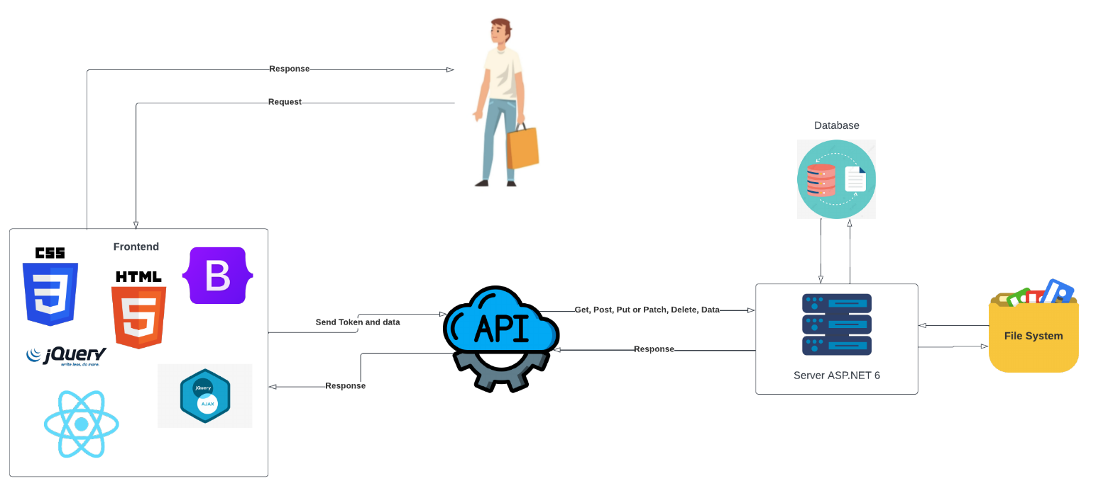

## 1.Presentation Tier

* + - * This is the tier in which the users interact with applications. Presentation Tier contains Model, View, Controller used to receive a request and response to User.
      * Technology: ASP.NET CORE 7 WEB API MVC, HTML, CSS, JS, REACTJS, Azure

## 2.Business Logic Tier

* + - * Is mainly working as the bridge between Data Tier and Presentation Tier. All the Data passes through the Business Tier before passing to the Presentation Tier.
      * Technology: OOP, ASP.NET CORE API

## 3.Data Access Tier

* + - * This is basically the server which stores all the application’s data. Data tier contents Database Tables, Database Views and other means of storing Application’s data.
      * Technology: SQL Server

# Algorithms – Data Flowchart

## 1.Symbols generates

### 

## 2.Login (all users)

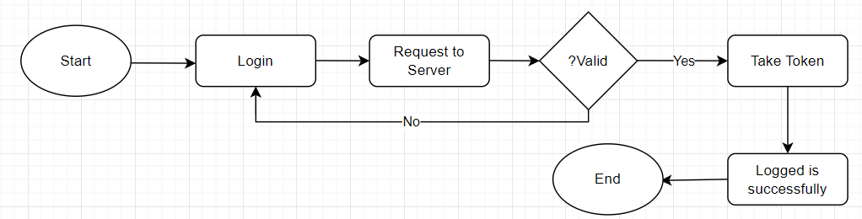

## 3.Logout (all users)

## 4. Upload Image

## 

## 5. Add To Cart

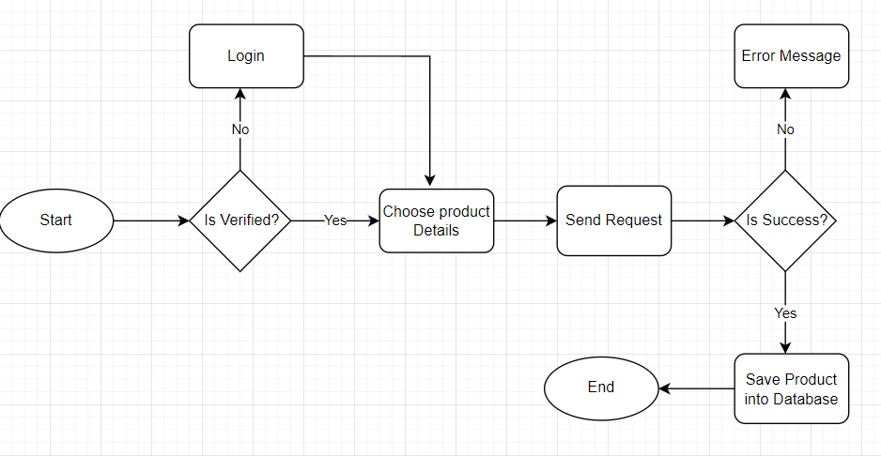

### 

## 6. Checkout

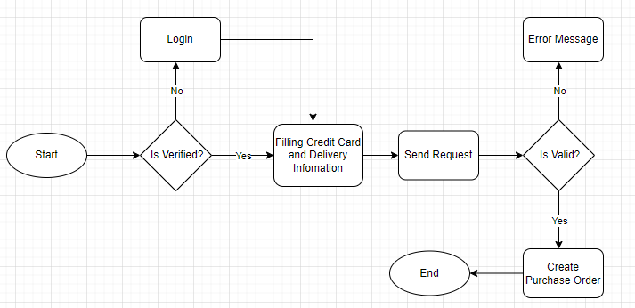

## 

## 

## 

## 

## 

# Use Case Diagram

## 1.User:

## 

## 2.Admin:

## 

## 

# 

# REVIEW 3

# Database Design Diagram

## 

## 

# GUI Design

## Login

#### 

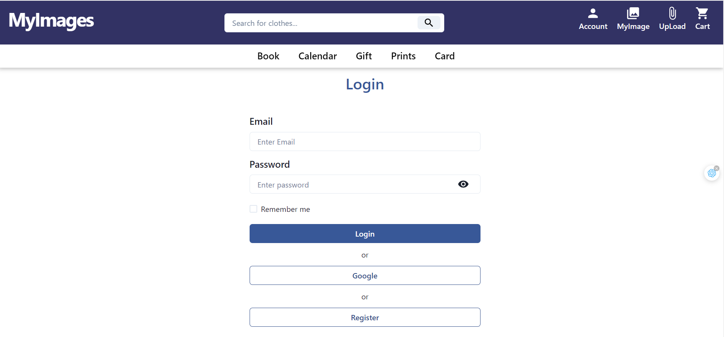

* User can login with Google account or register a account

## User

#### Home page

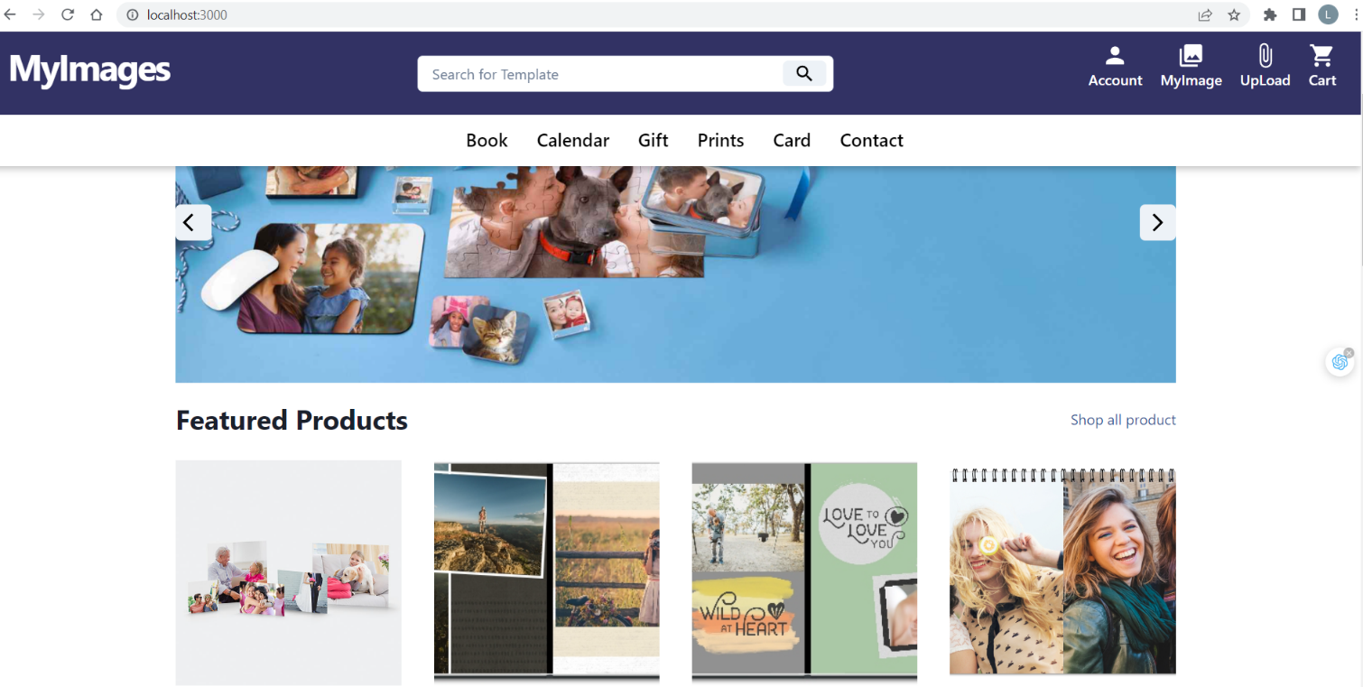

* Home page show all template
* User can choose template then upload images or simple upload with no template when click on Upload button in NavBar

#### Template Page

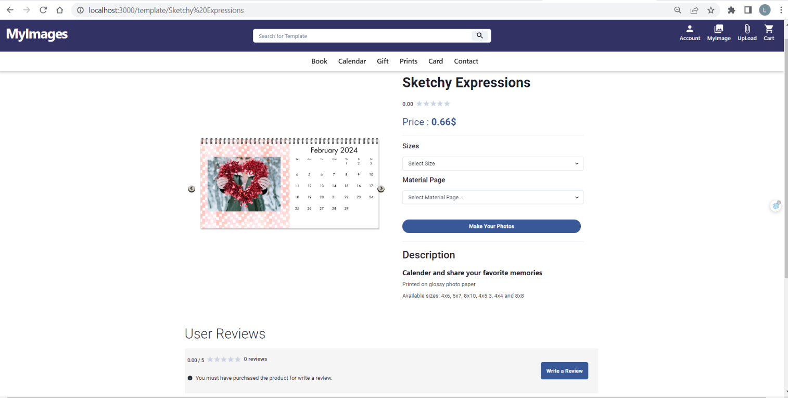

- User can view template details , review of template

- Click on “Make this Photos” to open Upload popup

- A review can only be written if the user has purchased a product with this template (order status "Received").   
- Users can choose options to view basic pricing.

#### Upload Popup

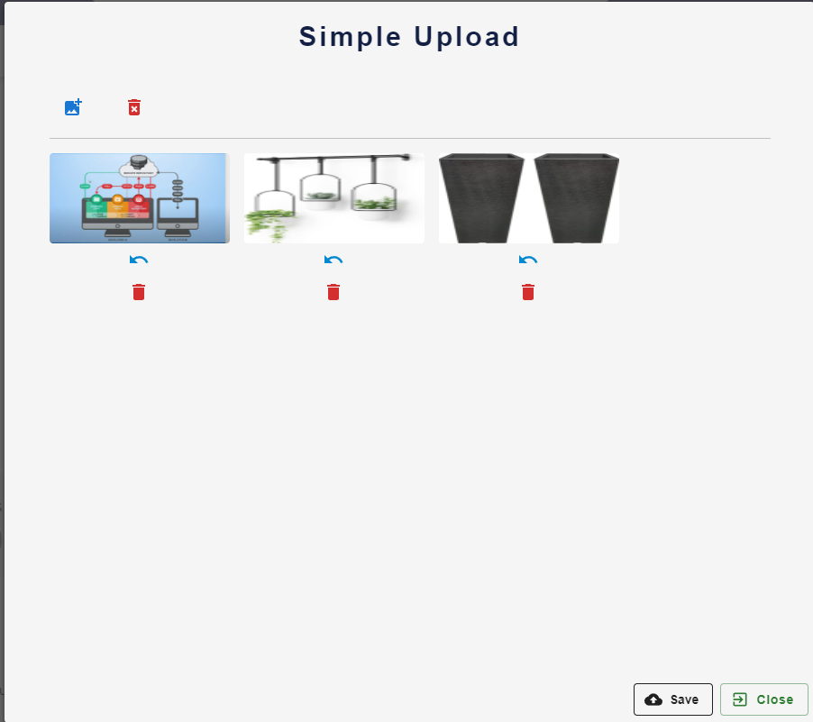

* This is a popup that user can open when click on “Upload” button in Navbar or click on “Make your Photos” in template page.
* User can upload files that is images with extensions like .png and .jpg or .jpeg

#### My Images Page

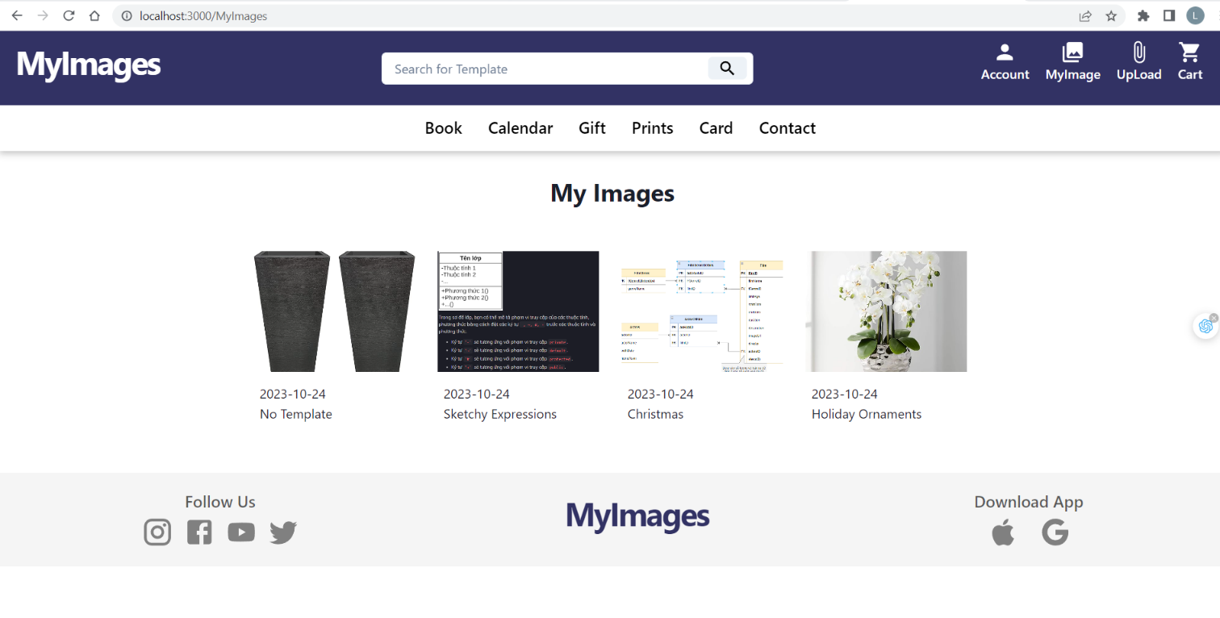

* User can view all imges that they uploaded
* User can delete template
* User can choose a template and custom details then add to cart

#### Add to Cart Popup

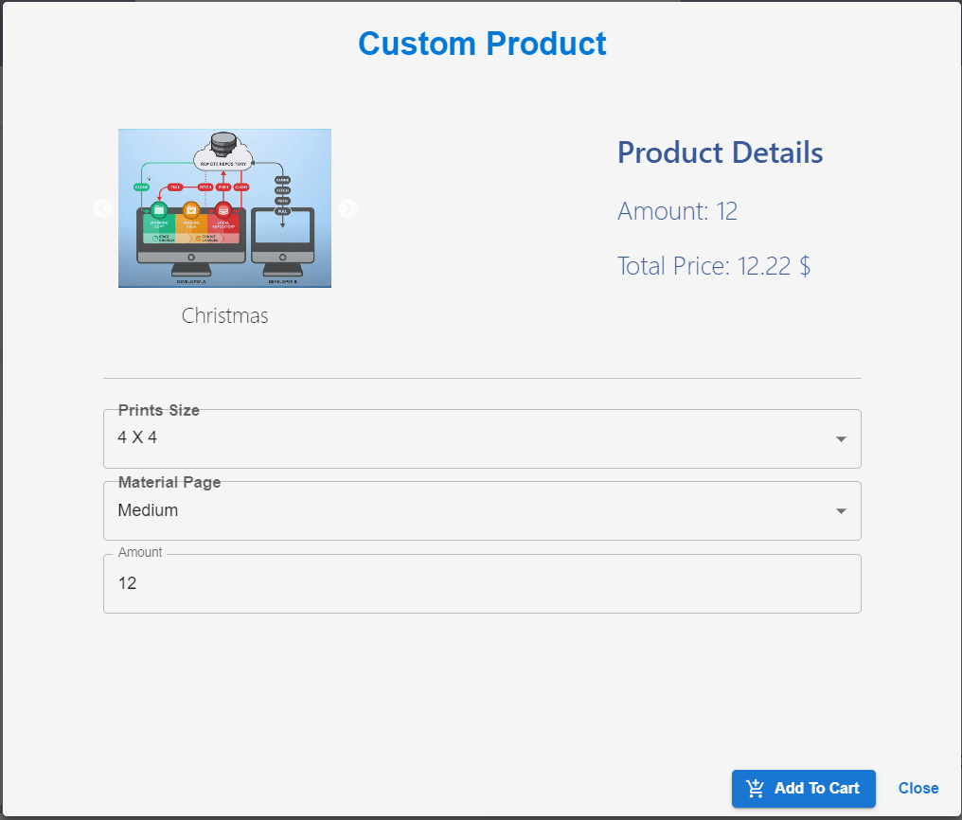

* Users select product details and click the "Add to Cart" button to save the product to the shopping cart.
* Users can add multiple products with different options to the same template.

#### Add to Cart Page for Simple Prints

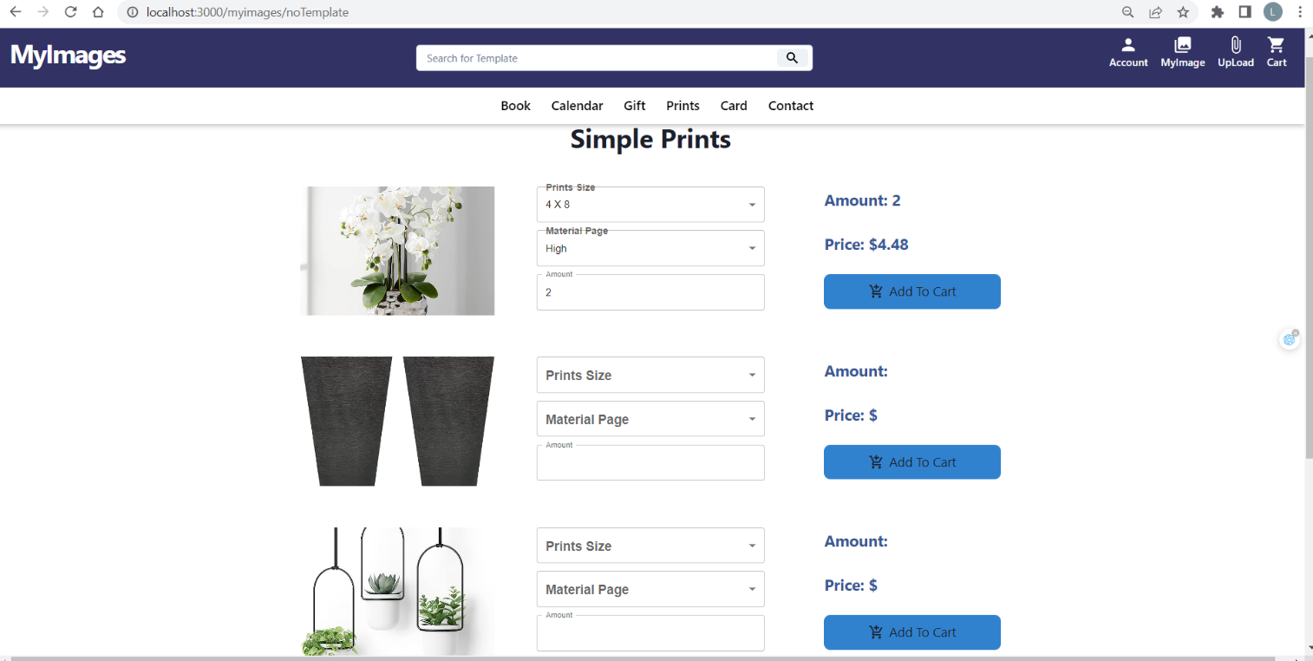

* This page is exclusively for simple prints, where users can add options for each image.
* Users select detailed information for each image and click the "Add to Cart" button to save the product to the shopping cart.
* Users can add multiple products with different options to the same image.

#### Cart Page

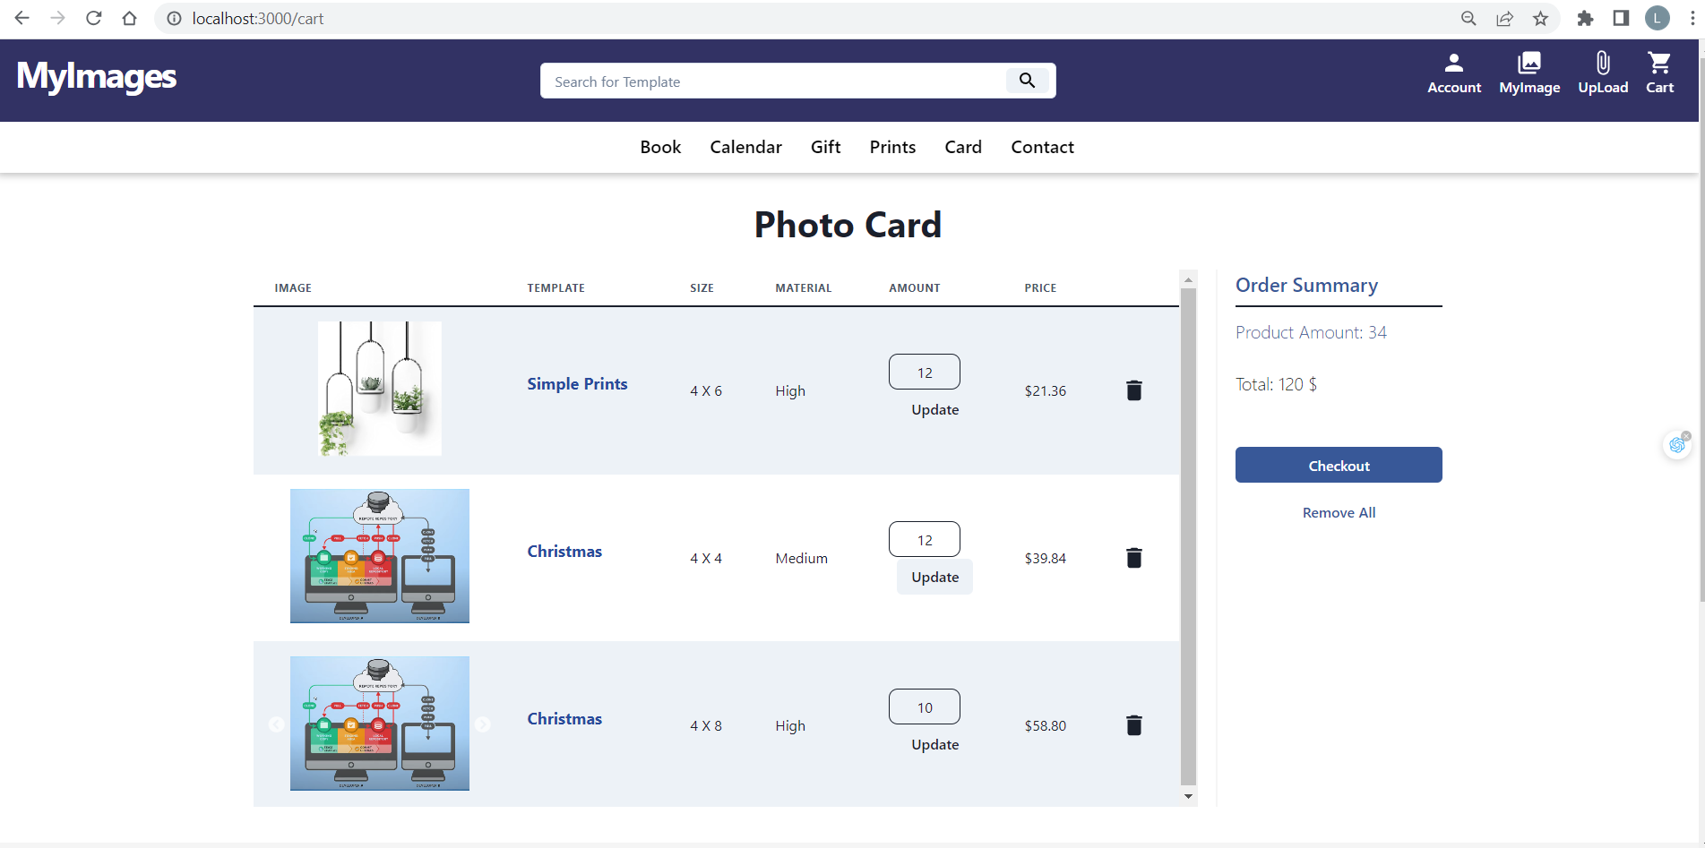

* Users can view the products that have been added to the shopping cart.
* The quantity of each product can be changed by clicking the "Update" button.
* Click on the delete icon to remove a product from the shopping cart.

#### Personal Information Pages

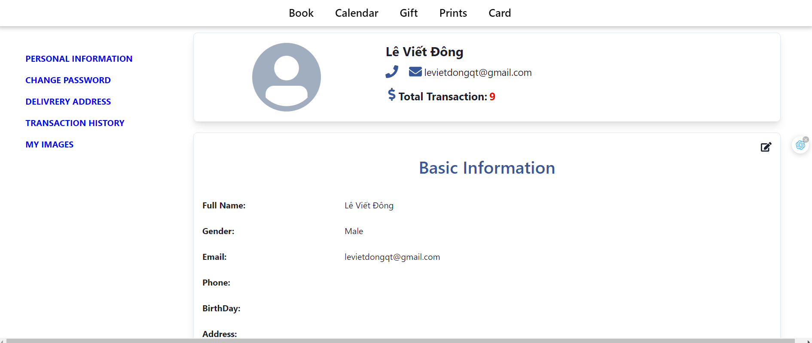

* User can view and update personal information

#### History Order

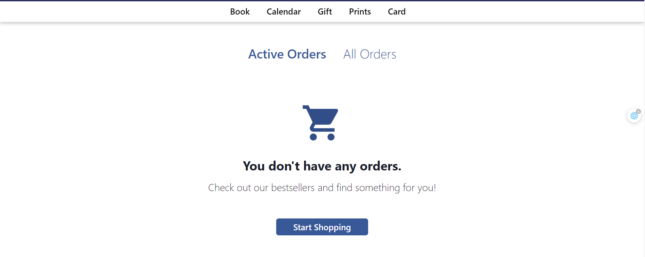

* User can view history order
* Users can cancel orders in the "Order Placed" status.
* Users can confirm receipt of the order when it's in the "To Ship" status and can also review the templates in that order.

#### Choose details for product

* User can choose size, amount and view price for the product

#### Cart

* User can view product in cart and just update amount in here

#### Register

