Process Report

WHAT THIS NEEDS TO INCLUDE:
group communication, task allocation, progress tracking and milestones

Organisational Structure

The structure of our group was largely influenced by our scrum approach to completing tasks. Scrum management largely revolves around rapid production of small-term tasks that are constantly adjusted according to the current project situation (ref ?). Completion of many small tasks as a whole is relatively counterproductive, with many ideas bottlenecking in a feud for proving one ideas merits over its alternatives. Alternatively, one approach is to constrain the decisions of each task to a smaller group of two to four members, allowing for more constructive and efficient decision-making. This division can be further exaggerated to form a hierarchy of teams, each with more finite tasks they are working to accomplish. The figure below demonstrates one possible organisation:

How subdivisions, or branching, of task allocation was decided required particular knowledge of each group members capabilities and interests, and the global concepts that define the project we are trying to complete as a group. A clear division is to separate hardware and software, as both areas can accomplish tasks largely without the reliance of the opposite being completed. Hardware was further decomposed into electronics and robot design and software decomposed into communication/firmware, strategy, and vision. This design decision largely evolved from individual member's preferences, as well as sensible pairings (e.g. members working on electronics would most likely be working on firmware and robot design) which were discussed in the first week as follows: (NOTE: in bold are the groups assigned to the members of the ones they were interested in. These do not take into account

Member: | Adam | Jin Hong | LeviH | Elijah | LeviF | Siim | Luca
Interests | Electronics, Robot Design | Electronics, Strategy, Robot Design, Communication/Firmware | Robot Design | Robot Design, Strategy, Vision | Strategy, Vision, Robot Design | Strategy, Vision | Strategy, Vision, Robot Design

The above

Structure:

(Make this into a tree describing the hierarchy of sub teams with sub tasks. Each team determines their individual tasks and then writes those goals/milestones on the Trello. Task completion is kept in check by other teams and by the product manager who checks in on each sub team. Product manager defines general goals the team will strive to.)
- Product
  - Hardware
    - Electronics
    - Robot Design
  - Software
    - Vision
    - Strategy
    - Communication/Software/Firmware
  - Management

A further breakdown of the sub teams and a summary of its work is below: (NOTE: list format is for note-taking only)

- Hardware:
* Electronics:

- Software:
* Vision:
+ Pre-processing:
- (proof of concept)
- Max-Pooling
- Decrease image ratio to speed up pooling
* Strategy:
+ Machine Learning:
- (proof of concept)
- Reinforcement Neural Networks
  - 3 NNs for each task (drive, shoot, defend) and a master NN
+ Deterministic:
- (proof of concept)

* Communication/Software/Firmware:

- Management:
* Final Product:

- Assignment of tasks:

- Assessment of task completion:

Communication Mechanism (Interaction between members)

* include evidence for decisions made in the communication

So far, the three main channels of communication between members of the group have been a facebook group chat, the project management web site Trello and regular group meetings. Each of these is used for a different purpose as described below.

The Facebook chat is used for discussing and sharing ideas with each other. The ideas we discussed would be noted down on Trello. We also used it to gather members to work and organise own meeting in the forrest hill.

As mentioned above, the group was divided into two sub-groups – hardware and software. Each of these was then divided again into more specific areas and each group member was assigned to one or more areas. We created a board in Trello for each area. Members of each area use their Trello board to log current goals and their deadlines and the tasks that must be undertaken to accomplish them.

At the weekly group meetings, members of each area share with the group the progress they have made since the last meeting, and whether they have met their deadlines listed on Trello. By presenting their progress to the team, it is ensured that each group remains accountable. Also, it ensures that each member gets a good idea of the overall progress the group has made.

'democracy'

Risk Assessment

Future Problem : we can not lose!!! we must goal!!!
Over-Powering the Motor : Directly connecting battery to the motor and this may cause over-powering the motor and damage the motor
Damage of the RF stick: As the RF stick plug into the PC, this may create a chance of bending the RF stick

Milestone/Plan

- Week 0 (18th – 24th):
  - Create Facebook group for communication
  - Organise Trello for tracking progress and managing
  - Got the equipment and looked at it and tried to get electronics working
    - Set up robot communication and Arduino
    - Test motors
    - Started design analysis
  - Research into previous RoboCup designs concerning drive systems, kickers, etc.
    - Analysis of a good approach
  - Meeting #1:
    - Determine organisational structure and who will be working in which sub-teams
    - Created goal to have Fred robot and its software completed and driving for the 29th of January. This would give us 3 buffer days to test the system. Building Fred's system gives us a rough idea of how everything works together and we can start from this general perspective to break down the individual tasks and improve them.
- Week 1 (25th – 31st):
  - Focus was on building a robot and not on software development because Fred's codebase was functioning.
  - FRED 1.0 made on the 25th and driving the same day:
    - Analysis:
      - driving is horrible, would keep spinning and wouldn't move any dedicated point/area
      - NOTE: come up with numerical stuff
      - No grabber or kicker, this is important to WIN the friendly and get a all 5 points
  - DIAGONAL 1.0 on the 26th:
    - Reason: Fred's chassis does not allow for room to place a grabber and kicker that is not a crappy propeller
    - Design is based on rotating the wheel layout by 45dgs to open up the front of the robot and add a kicker. To do this we must use omni wheels to allow for diagonal driving. This would also require editing Fred's code (which isn't hard)
    - The focus of this design was to create a modular robot that was easy to customise and edit (e.g. add new kickers, grabbers, etc.)
      - Kickers:
        - Rubber band shooter: it is built following the classic idea of the bow and arrow. A motor drives pulling the rubber band backward and this provides strength to hit the ball once releases the rubber band..
        - Spinner w/ Grabber: A wheel is directly drived by a motor with gearing mechanism. A grabber would use to hold the ball in a stationary position and the wheel spinner would spin the ball to turn as fast as the wheel turns in a opposite direction. Once the grabber is up, the ball would move forward with the peak speed.
    - Testing:
      - Originally the robot wasn't strong enough to move with raw motor power. We added gearing first from 1:2, then 1:3 to increase the strength, this proportionally decreased the speed. The robot was able to drive, but not fast.
      - The largest portion of the weight was in the centre of the chassis, this caused the wheels to bend outward on the robot because it lacked structural support. This was another factor that slowed down the driving and made it erratic. We attempted to fix this but instead scrapped the design.
  - 2 NEW DEISGNS on 27th/28th
    - Divided the team into two, to come up with two different designs to prove which was a better approach: a Fred-style robot with weaker grey motors or improve the diagonal robot by using the more powerful white/orange motors
    - FRED – NEW 1.1 on 27th/28th:
      - The problem with Fred was that its chassis was too wide. We decided to move the motors inwards to make room in front of the wheels for a kicker/grabber
    - DIAGONAL 1.1 on 27th/28th:
      - We tried to build a stronger structural support in this version and the wheels were not bending outward
  - Both new designs of Robots still kept spining
    - We found out that this problem due to the power that sent from the server to the robot. For the original Fred, they were using a motor multiplexer board and sending power that was between [-255,255]. However, for our robot, we did not use the multiplexer board and the arduino board only accepted between [-100,100], this caused the motors drived over-power.
    - It was too late for us to figure out this problem and had no time to investigate and improve the vision system and strategy.
- Week 2 (1st – 7th):
  - Discuss the reason why we would fail to win a game on First Friendly Match
    - Vision System is not well detected the robot in the match
    - Strategy is out of idea
    - Spinner w/ Grabber is not powerful enough to spin the ball toward in a fast speed and hardly to grab a ball with the Fred strategy
  - Discuss the Improvment of the Vision System and start to build a new one

- Week 3 (8th – 14th):

- ….

Contingency Planning (Future Planning)

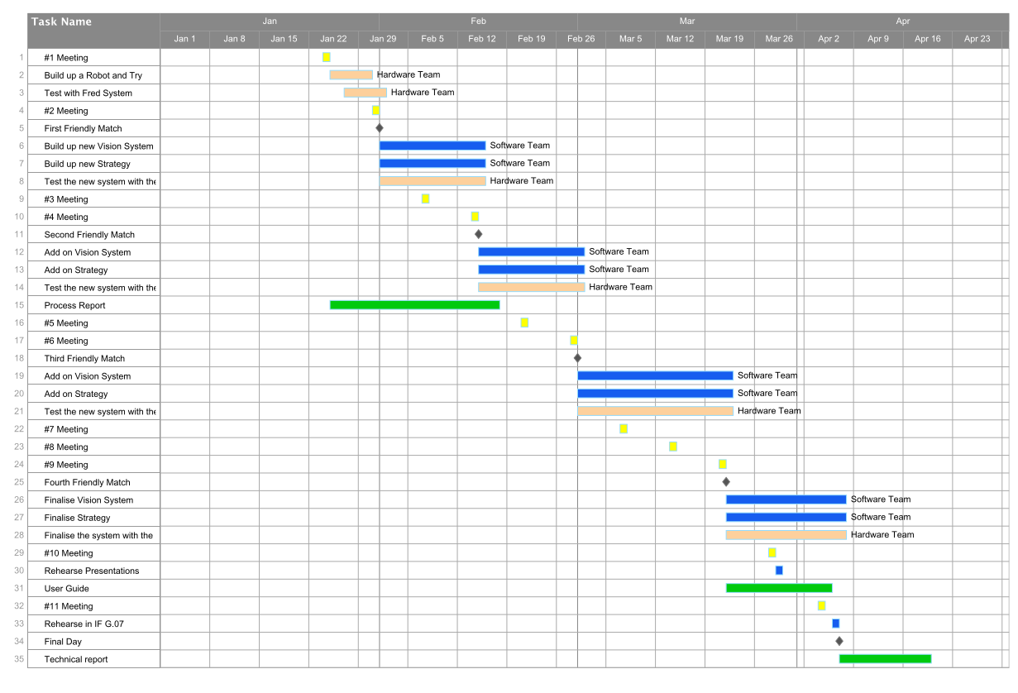
The yellow represents the weekly regular meeting
The pink represents the stuff that should be done by the hardware team
The grey represents each friendly match
The blue represens the development process of the vision system and strategy after each friendly match
The green represents the reports' progress

* how we will deal with new problems
Software
As we have been using control version system, we would get back to the lastest working version and investigate what is wrong with the new version of the software and debug it.

Hardware
Try to detect which part of the component is wrong and test it with some simple and effective tests (e.g. drive a motor with just a forward command). After confirming the problem, approach to Gary for exchanging a working component.

* outline of how we tried one organisation system at first and it didn't work, and so we chose to change the system after testing it during the first two weeks.

