Process Report

WHAT THIS NEEDS TO INCLUDE:
group communication, task allocation, progress tracking and milestones

Organisational Structure

The structure of our group was largely influenced by our scrum approach to completing tasks. Scrum management largely revolves around rapid production of small-term tasks that are constantly adjusted according to the current project situation (ref ?). Completion of many small tasks as a whole is relatively counterproductive, with many ideas bottlenecking in a feud for proving one ideas merits over its alternatives. Alternatively, one approach is to constrain the decisions of each task to a smaller group of two to four members, allowing for more constructive and efficient decision-making. This division can be further exaggerated to form a hierarchy of teams, each with more finite tasks they are working to accomplish. The figure below demonstrates one possible organisation:

How subdivisions, or branching, of task allocation was decided required particular knowledge of each group members capabilities and interests, and the global concepts that define the project we are trying to complete as a group. A clear division is to separate hardware and software, as both areas can accomplish tasks largely without the reliance of the opposite being completed. Hardware was further decomposed into electronics and robot design and software decomposed into communication/firmware, strategy, and vision. This design decision largely evolved from individual member's preferences, as well as sensible pairings (e.g. members working on electronics would most likely be working on firmware and robot design) which were discussed in the first week as follows: (NOTE: in bold are the assigned groups of those that members were interested in. These do not take into account the groups members were not interested in.)

Member: | Adam | Jin Hong | LeviH | Elijah | LeviF | Siim | Luca
Interests | Electronics, Robot Design | Electronics, Strategy, Robot Design, Communication/Firmware | Robot Design | Robot Design, Strategy, Vision | Strategy, Vision,  Manager, Robot Design | Strategy, Vision | Strategy, Vision, Robot Design

Following this division-of-labour, we then employed the agile-development process of Scrum.

What is Scrum?

(rTODO: ref. https://www.codeproject.com/articles/4798/what-is-scrum)

Scrum meetings revolve around three critical questions that each member of the group must discuss/present to the other members:

- What have you accomplished since the last meeting?
- Are there any obstacles in the way of meeting your goal?
- What will you accomplish before the next meeting?

Adjustments to the overall project are made dynamically each week, allowing for a more organic development process. Because the requirements for building a robot and its accompanying software change as our team learns more about the task, it is important that we do not resist these changes but willingly adapt to the demands.
The size of out team (8 members) makes it ideal for a scrum organisation. It is rarely possible to conclude a perfect team structure by the first or second week and alterations are inevitably necessary. Our first scrum system defined sub-teams (i.e. Electronics, Robot Design, Vision, etc.) to “self-scrum” and track progress between its 2-3 members. Laziness, and a general lack of liability and communication caused this structure to inevitably collapse and become a mess of random, insensible notes with no clear direction. The key aspect of the scrum concept had been lost: collectively as a group describing goals met and goals to be met in short sprints – this makes all team members accountable for one another's progress. During our third meeting in week three, the scrum system was reorganised so that the sprints would take place during the meeting. Each member would, in-turn, discuss the answer the three critical questions outlined above. To avoid wasting time, constraints were added to each section of the meeting. The new outline is defined below:

MEETING PLAN (as of Feb. 7th)
What we do in this section | How long this section will take
1. Questions for James: any pressing questions for James concerning the game, robot parts, etc. that are not about the plan/sprint. | 5-10 min
2. Outline the new meeting model: describe the scrum/sprint approach to the team if it is the first week, otherwise, each week re-clarify what the approach of the meeting is. | 5 min
3. Circle Time (sprint) and discussion of 3 critical questions: incrementally, go around in the circle and give each member a chance to discuss the 3 critical (sprint) questions, as described above. At the end of this, each member should have their goals written down for next week's meeting. | 30-60 min (approx. 5-10mins per member)
4. Discussion/Planning of big ideas: where does the team see itself in the future? What are the big concepts and when are we imaging these will be done? We do not discuss individual goals. | 5-10 min
5. Open Discussion: end the meeting with general discussion or any essential points; only if necessary. | 5 min

- Hardware:
* Electronics:

- Software:
* Vision:
+ Pre-processing:
- (proof of concept)
- Max-Pooling
- Decrease image ratio to speed up pooling
* Strategy:
+ Machine Learning:
- (proof of concept)
- Reinforcement Neural Networks
  - 3 NNs for each task (drive, shoot, defend) and a master NN
+ Deterministic:
- (proof of concept)

* Communication/Software/Firmware:

- Management:
* Final Product:

- Assignment of tasks:

- Assessment of task completion:

Communication Mechanism (Interaction between members)

* include evidence for decisions made in the communication

When determining external channels of communication, three essential aspects were analysed for various communication systems: accessibility/Usability - “can all members use this?”, features - “does the medium complement the organisation style of our group?”, and accountability - “by using this, will it make all group members accountable for knowing the most recent information and dates?”. An outline of the possible systems is described below based on group discussion (our decision is in red):

Communication Channel | Accessibility/Usability | Features | Accountability | Overall Score
Email | All members have this. 10/10 | Slow; Convoluted archiving of messages and media. 4/10 | No accountability 0/10 | 14/30
Slack | Not everyone has it nor is familiar with it. Largely computer-use only. 5/10 | Fast; Able to create sub-groups for different teams; Archives all data. 10/10 | Less accountable for messages because it is largely a web-app. 7/10 | 22/30
Facebook Messenger | All members have this. 10/10 | Fast; Archives all messages and media; Easy phone use. 9/10 | All members are held accountable for seeing messages. 10/10 | 29/30
WhatsApp | All members have this. 10/10 | Fast; Archives all messages and media; Easy phone use 9/10 | Less accountable for seeing messages (because no record of when the member was recently online) 8/10 | 27/30
Text | All members have this. 10/10 | Fast; No archive of group messages; Unreliable. 5/10 | No accountability 0/10 | 15/30

After establishing that Facebook Messenger suited the requirements of an external communication system, we had to define a local area to share and distribute work in an organised manner that complemented the scrum-style of out team. For a code repository we chose Git-hub - the obvious choices were Git-hub or Bit-bucket, and a decision largely depended on which of the two was the more popular among the group members.
A location to document goals and keep track of progress was required. A few options were considered, such as Google Docs, Trello, Gannt Chart, etc. and we scored their eligibility based on usability - “if the software is hard to use, lazy members wont use it”, scrum-ness - “does the software complement our organisation style and goal-setting?”. The outline of the possible choices is described below (our decision is in red):

Goal Tracking Software | Usability | Scrum-ness | Overall Score
Google Docs | Easy; simple; work in parallel 10/10 | Not designed for scrum 5/10 | 15/20
Trello | Easy; simple; work in parallel 10/10 | Designed for scrum 10/10 | 20/20
Gannt Chart | Unknown; organised visually; parallel work not as clear 7/10 | Designed for scrum 10/10 | 17/20

Trello was the most suitable option due to its simple usability and its design pattern that complemented scrum perfectly.

The purpose of the three communication mediums, including group meetings, is described below.

Facebook Messenger is used for discussing and sharing ideas with each other. The ideas we discussed would be noted down on Trello. We also used it to gather members to work and organise own meeting in the Forrest Hill.

As mentioned above, the group was divided into two sub-groups – hardware and software. Each of these was then divided again into more specific areas and each group member was assigned to one or more areas. We created a board in Trello for each area. Members of each area use their Trello board to log current goals and their deadlines and the tasks that must be undertaken to accomplish them.

At the weekly group meetings, members of each area share with the group the progress they have made since the last meeting, and whether they have met their deadlines listed on Trello. By presenting their progress to the team, it is ensured that each group remains accountable. Also, it ensures that each member gets a good idea of the overall progress the group has made.

Risk Assessment

TOOD: ref. https://www.projectsmart.co.uk/project-management-risk-management.php

Categories:

Future Problem : we can not lose!!! we must goal!!!
Over-Powering the Motor : Directly connecting battery to the motor and this may cause over-powering the motor and damage the motor
Damage of the RF stick: As the RF stick plug into the PC, this may create a chance of bending the RF stick

Milestone/Plan

- Week 0 (18th – 24th):
  - Create Facebook group for communication
  - Organise Trello for tracking progress and managing
  - Got the equipment and looked at it and tried to get electronics working
    - Set up robot communication and Arduino
    - Test motors
    - Started design analysis
  - Research into previous RoboCup designs concerning drive systems, kickers, etc.
    - Analysis of a good approach
  - Meeting #1:
    - Determine organisational structure and who will be working in which sub-teams
    - Created goal to have Fred robot and its software completed and driving for the 29th of January. This would give us 3 buffer days to test the system. Building Fred's system gives us a rough idea of how everything works together and we can start from this general perspective to break down the individual tasks and improve them.
- Week 1 (25th – 31st):
  - Focus was on building a robot and not on software development because Fred's codebase was functioning.
  - FRED 1.0 made on the 25th and driving the same day:
    - Analysis:
      - driving is horrible, would keep spinning and wouldn't move any dedicated point/area
      - NOTE: come up with numerical stuff
      - No grabber or kicker, this is important to WIN the friendly and get a all 5 points
  - DIAGONAL 1.0 on the 26th:
    - Reason: Fred's chassis does not allow for room to place a grabber and kicker that is not a crappy propeller
    - Design is based on rotating the wheel layout by 45dgs to open up the front of the robot and add a kicker. To do this we must use omni wheels to allow for diagonal driving. This would also require editing Fred's code (which isn't hard)
    - The focus of this design was to create a modular robot that was easy to customise and edit (e.g. add new kickers, grabbers, etc.)
      - Kickers:
        - Rubber band shooter: it is built following the classic idea of the bow and arrow. A motor drives pulling the rubber band backward and this provides strength to hit the ball once releases the rubber band..
        - Spinner w/ Grabber: A wheel is directly drived by a motor with gearing mechanism. A grabber would use to hold the ball in a stationary position and the wheel spinner would spin the ball to turn as fast as the wheel turns in a opposite direction. Once the grabber is up, the ball would move forward with the peak speed.
    - Testing:
      - Originally the robot wasn't strong enough to move with raw motor power. We added gearing first from 1:2, then 1:3 to increase the strength, this proportionally decreased the speed. The robot was able to drive, but not fast.
      - The largest portion of the weight was in the centre of the chassis, this caused the wheels to bend outward on the robot because it lacked structural support. This was another factor that slowed down the driving and made it erratic. We attempted to fix this but instead scrapped the design.
  - 2 NEW DEISGNS on 27th/28th
    - Divided the team into two, to come up with two different designs to prove which was a better approach: a Fred-style robot with weaker grey motors or improve the diagonal robot by using the more powerful white/orange motors
    - FRED – NEW 1.1 on 27th/28th:
      - The problem with Fred was that its chassis was too wide. We decided to move the motors inwards to make room in front of the wheels for a kicker/grabber
    - DIAGONAL 1.1 on 27th/28th:
      - We tried to build a stronger structural support in this version and the wheels were not bending outward
  - Both new designs of Robots still kept spining
    - We found out that this problem due to the power that sent from the server to the robot. For the original Fred, they were using a motor multiplexer board and sending power that was between [-255,255]. However, for our robot, we did not use the multiplexer board and the arduino board only accepted between [-100,100], this caused the motors drived over-power.
    - It was too late for us to figure out this problem and had no time to investigate and improve the vision system and strategy.
- Week 2 (1st – 7th):
  - Discuss the reason why we would fail to win a game on First Friendly Match
    - Vision System is not well detected the robot in the match
    - Strategy is out of idea
    - Spinner w/ Grabber is not powerful enough to spin the ball toward in a fast speed and hardly to grab a ball with the Fred strategy
  - Discuss the Improvment of the Vision System and start to build a new one

- Week 3 (8th – 14th):

- ….

Contingency Planning (Future Planning)

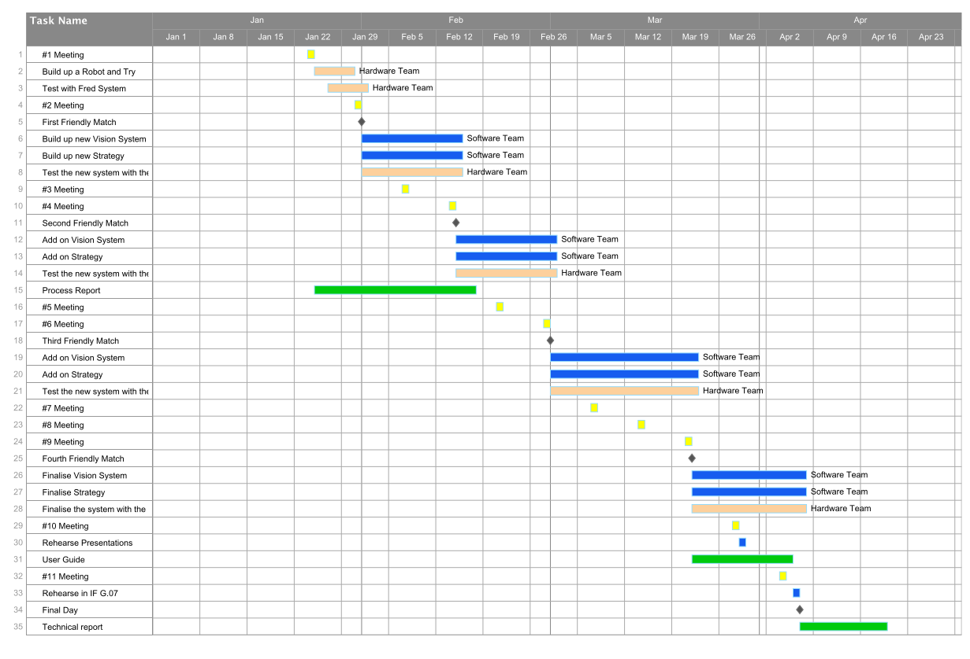
The yellow represents the weekly regular meeting
The pink represents the stuff that should be done by the hardware team
The grey represents each friendly match
The blue represents the development process of the vision system and strategy after each friendly match
The green represents the reports' progress

* how we will deal with new problems
Software
As we have been using control version system, we would get back to the lastest working version and investigate what is wrong with the new version of the software and debug it.

Hardware
Try to detect which part of the component is wrong and test it with some simple and effective tests (e.g. drive a motor with just a forward command). After confirming the problem, approach to Gary for exchanging a working component.

* outline of how we tried one organisation system at first and it didn't work, and so we chose to change the system after testing it during the first two weeks.

