ASSIGNMENT 2 – ROBOTICS

INTRODUCTION:

CHASSIS DESIGN:

The robots chassis design conformed to the base design recommended in the assignment (two wheels driven by separate motors and a third wheel behind for balance with a light sensor and ultrasonic). There were a couple additions of our own outline below:

1. Light Sensor Position: the position of the light sensor was moved further from the wheels and the robot's centre of gravity. This allowed the robot to have more reaction time when following a line.

(IMAGE OF LIGHT SENSOR)

2. Ultrasonic Position: the ultrasonic was moved from a position above the robot's main body, to a position below the robot's main body. The ultrasonic was also rotated 90 degrees to a vertical position. Having the ultrasonic lower allowed for a more sensible detection of objects that are actually in front of the robot. Rotating the ultrasonic helped to increase the accuracy of its detection on dislevel surfaces (i.e. corner of a square obstacle).

(IMAGE OF ULTRASONIC)

(IMAGE OF HOW TURNING ULTRASONIC IMPROVES IT)

3. Touch Sensor: the touch sensor was used as a safety trigger for when the robot has to rotate the ultrasonic sensor with the medium motor. If the ultrasonic rotates a full 90 degrees to the left (which it does when it detects an obstacle), the touch sensor will stop it from over-rotating and damaging the motor (as well as helping to determine when the ultrasonic is at 90 degrees.

METHODS:

evaluating the sensors and motors:

Before tackling the problems outlined in this assignment, it was first necessary to learn how the robot behaved during basic driving, sensing and actuating. Knowing how well the hardware performs is essential so that a plan for the robot can be built that does not incorporate the sources of error. We first measured for correlation between the robot's wheel encoders, the observed distance the robot travelled (in centimetres), and how long it took the robot to travel this distance.

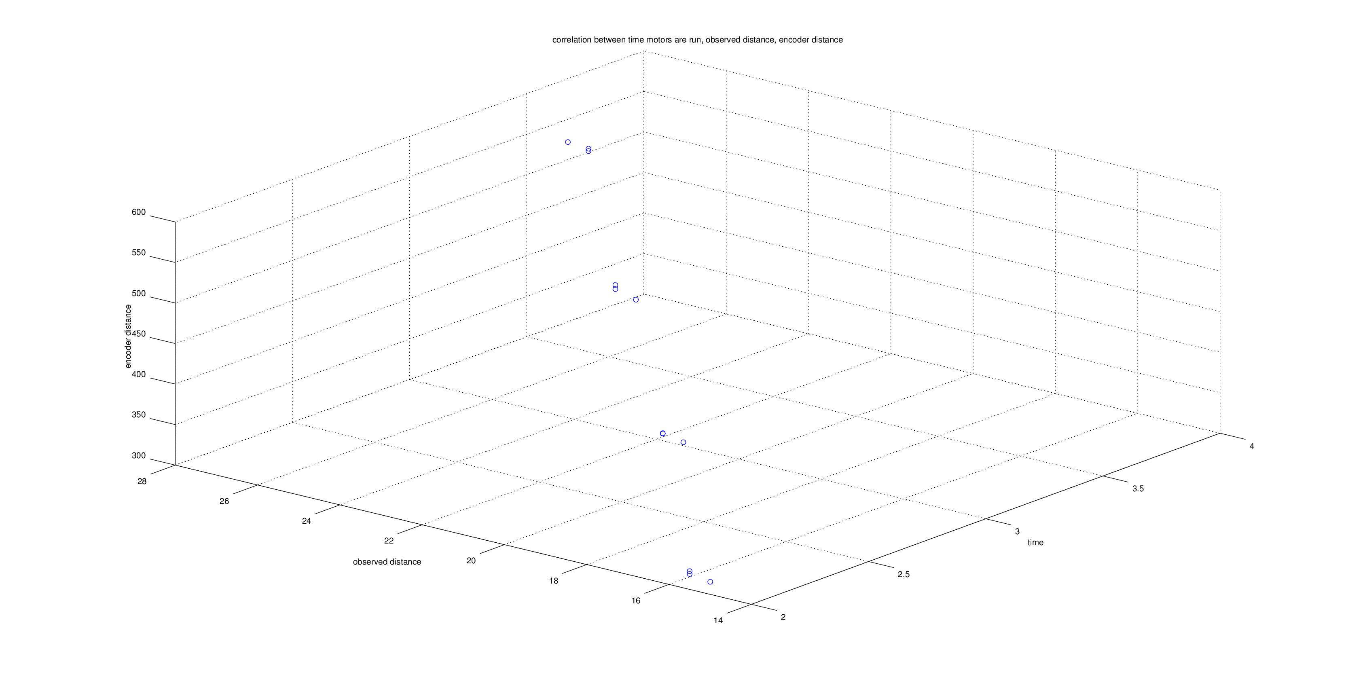
As expected, time is constant whether we are dealing with an encoder value or a measured distance, and therefore the encoder values are also proportional to the speed of the robot. If we now arrange the graph so that the correlation between measured distance and encoder value is shown, the results are as so:
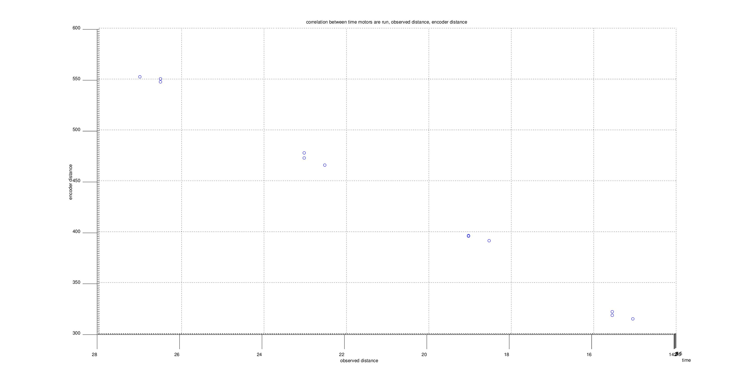
(A table displaying the numerical values can be found in the “Results” section)
Over a range of 14cm to 28cm the data displays a clear linear behaviour. To give a numerical value to this linearity of the data, we use the Pearson Correlation Coefficient (PCC) which values the correlation of a dataset from 1 (highly correlated) to 0 (not correlated) to -1 (inversely correlated):

(INSERT ALGORITHM HERE)

Dataset | Standard Deviation | Covariance | Pearson Cor. Coef.
Measured Distance | 4.4458 | 407.65 | 0.99882
Encoder Distance | 91.802 | 407.65 | 0.99882

With a PCC of 1.0, it shows the measured distance and the encoder and perfectly linearly correlated. Measuring the slope of this line will therefore represent the correlation constant (to make the robot drive a given distance, use this value in the encoders). The slope is: (550.167 – 319)/(26.27-15.33) = 20.385 encoder/cm (note the average value of the trials is used).

For the development of an accurate dead-reckoning system, it is also essential to measure how the error of the robots ability to turn to a specific angle relative to the motor power and time. The same process used for measuring actual distance versus encoder distance was used to evaluate the angle and motor power. Below are the two graphs representing the behaviour:
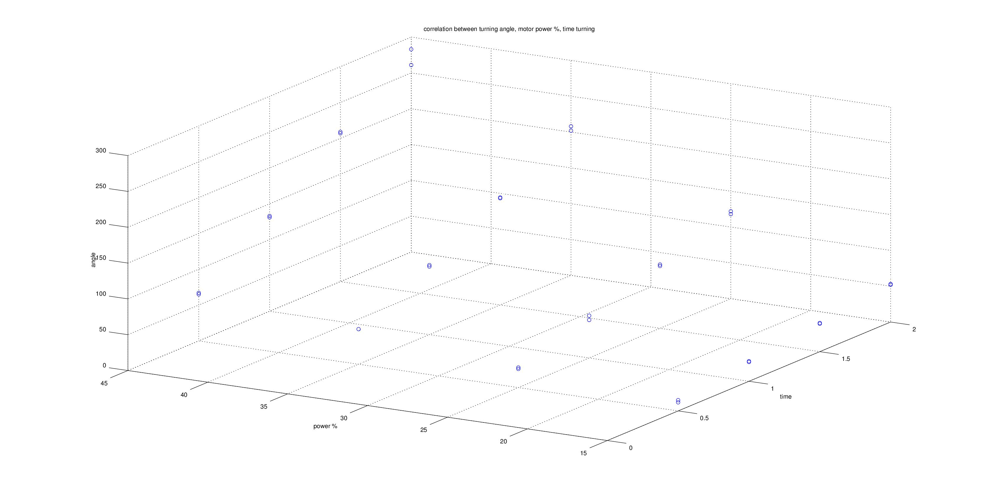
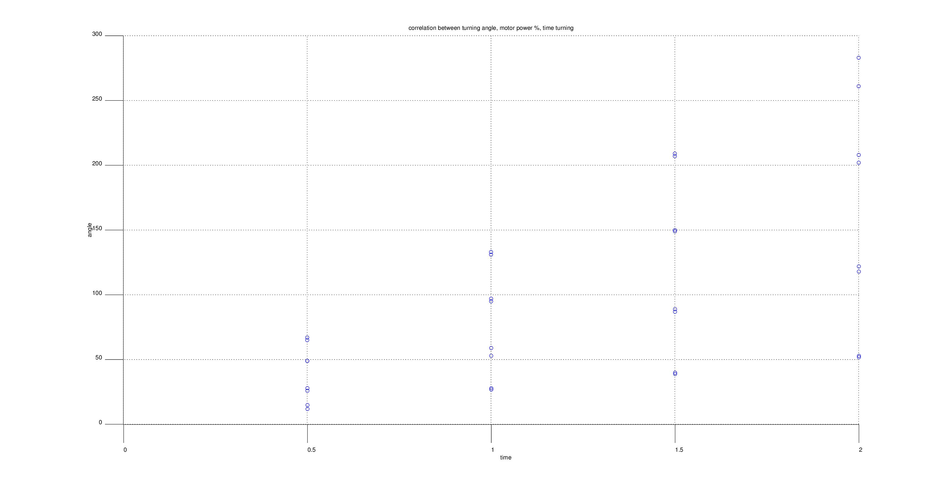
For the second graph, power was kept constant and only the angle to time correlation was measured. The four distinct lines correspond to 15%, 25%, 35%, and 45%. For determining a time/angle constant, 25% power was chosen as a constant (as it was high enough to drive the robot without lag, but did not drive too fast such that sensors would lose measurement accuracy). The analysis of the linearity using PCC is below:

Dataset | Standard Deviation | Covariance | Pearson Cor. Coef.
Time | 0.59761 | 32.929 | 0.86646
Angle | 63.592 | 32.929 | 0.86646

A PCC of 0.87 implies linear correlation between the time turned at 25% power and the angle of the robot. The slope of this dataset is therefore the time to angle constant: (120-27)/(2-0.5) = 62 degrees/second.

A dead-reckoning controller can now be designed using the above constants. The performance of the controller and its estimated errors are outlined below:

(TODO)

Target Angle (degrees) | Target Distance (cm) | Actual Angle (degrees) | Actual Distance (cm) | Error | Avg. Error of System

(TODO: sensor analysis)

Following the evaluation of the robot's behaviour, it is clear that the robot is accurate when driven within the testing environment, and therefore can be relied on to perform specific angle turns and driving tasks during this assignment.

following a line and the PID controller:

Developing an algorithm that was generic and adaptable to a multitude of scenarios was essential to the line following task. The classic line following technique involves driving the robot's left wheel forward when the colour detected is white/black and driving the robot's right wheel forward when the colour is the opposite. This is a naive approach that does not make use of the fact that when the robot is perfectly aligned, both wheels can be driven (and oscillation removed). Below is an example of the Naive Line Following Algorithm:

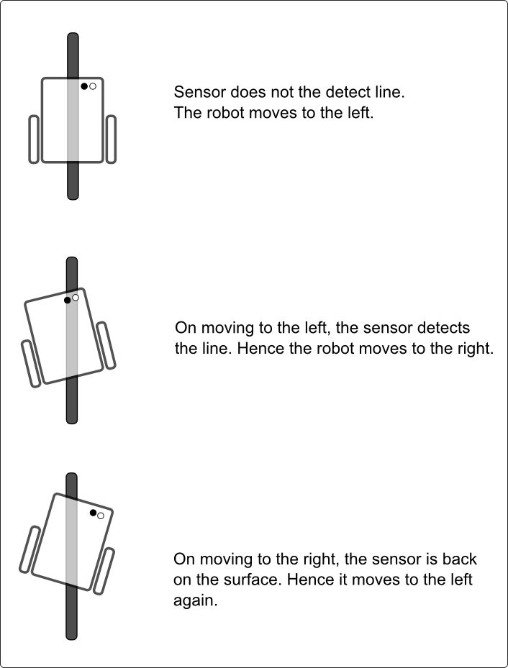
http://www.societyofrobots.com/member_tutorials/book/export/html/350

The less-naive approach is to devise a gradient, such that the further a robot is from the line, the sharper it will turn toward the line. For the sake of argument, we assume white colour has a value of 0 (sensor units) and black has a value of 100 (sensor units). As the light sensor value approaches 0, the error should approach a maximum value of 1 (TODO: use limit alg. representation) and as the light sensor value approaches 100, the error should approach the minimum value of -1. This method is shown below:
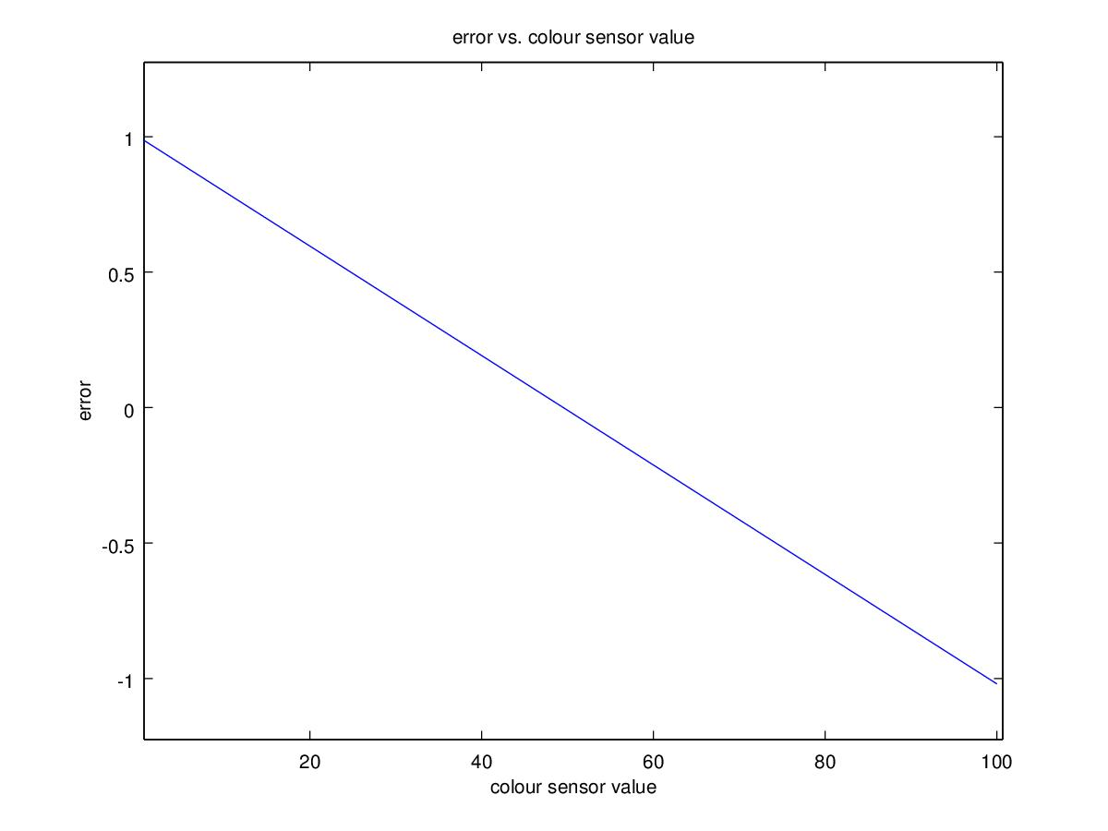
When there is no error (the robot is exactly on the boundary of on and off the line), the robot should drive straight; an error of 1 should increase the value of the power of the robot's left wheel and decrease the power of the robot's right wheel, and visa versa for an error of -1. The final step to complete the gradient line-following algorithm is to assign the robot a constant value for the wheel power, c, and a constant value to multiply the error by and power the turning. This entire process is no more than a P (Proportional) Controller system, where the constant for the error is k_{p} in the algorithm such that: d = k_{p} (t – l), where t = the light value of 50 (in the above graph) and t = the current light value.

To determine a value for k_{p}, a constant wheel power, c, was set to 25% (something low so that it is easy to analyse) and a range of values were assigned to k_{p}. Below are graphs of the robot's position over time, showing how much or how little the robot oscillated:

k_{p} = 10
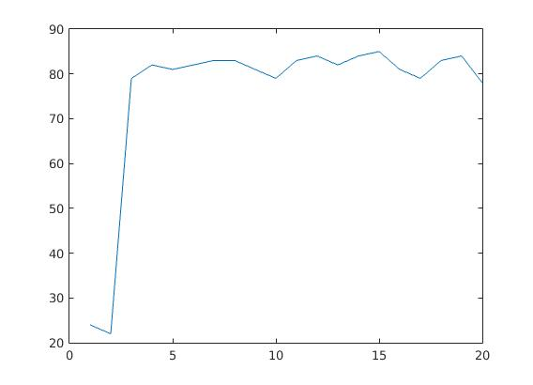
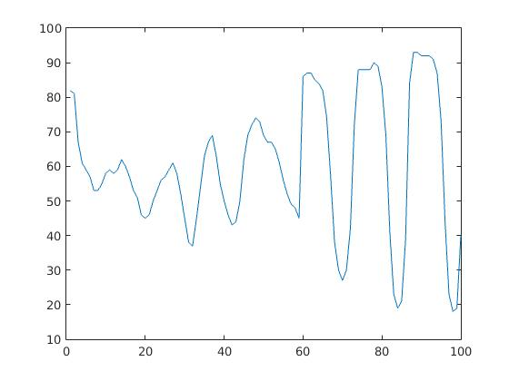
k_{p} = 15
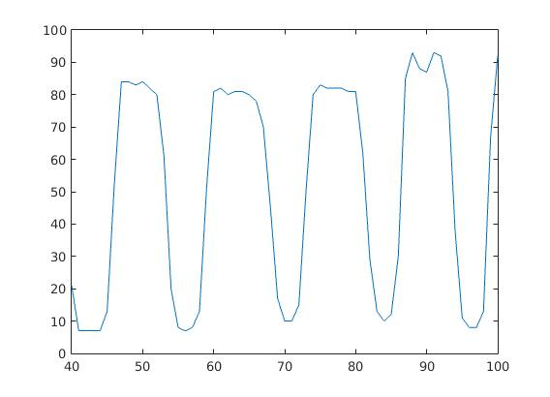
k_{p} = 20
k_{p} = 30
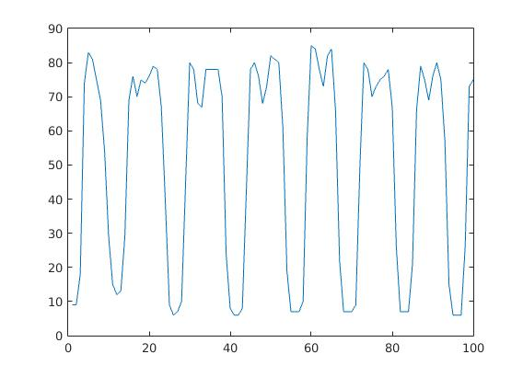
k_{p} = 40
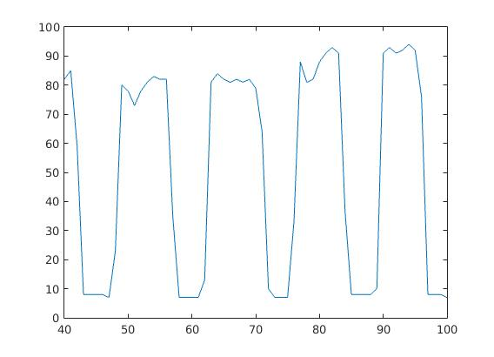
(TODO: determine where to put this part) The line following algorithm required a colour sensor value for both black light and white light. The naive approach to this is pre-determine the black and white colour values and and hand code these as constants. The problem with this approach is that changes in the environment's lighting, the height of the sensor, and other factors can cause the colour sensor values to change dramatically. To make the robot adaptable to a variety of line-following scenarios, the robot begins the line-following algorithm by completing a full 360 degree rotation using the gyroscope sensor and recording the range of light values it sees during this rotation. A histogram is then created using the light values. The largest maximum that is the lowest light value is selected as the black colour constant and the largest maximum that is the highest light value is selected as the white constant. The 'target' value for the line-following algorithm is the average of these two values. A plot of an example histogram is shown below:

(IMAGE OF LIGHT SENSOR HISTOGRAM)

robot states:

The design for the robot sensing utilised an approach that closer resembles the 'Alternative View' discussed in the lectures:

Task 1 Transduction → Task 1 Specific Preprocessing → Task 1 Specific Action
Task 2 Transduction → Task 2 Specific Preprocessing → Task 2 Specific Action
…
Task n Transduction → Task n Specific Preprocessing → Task n Specific Action

The robot was assigned three specific tasks: line following, line searching, and obstacle detection, each of which was a subclass of a controller, which handled a pre-defined robot class and provided an update loop. These update loops functioned as a 'Feedback Control' system where disturbances in the environment that affected the robot cased the robot to change state and therefore redefine the control laws, as outlined in the below diagram:

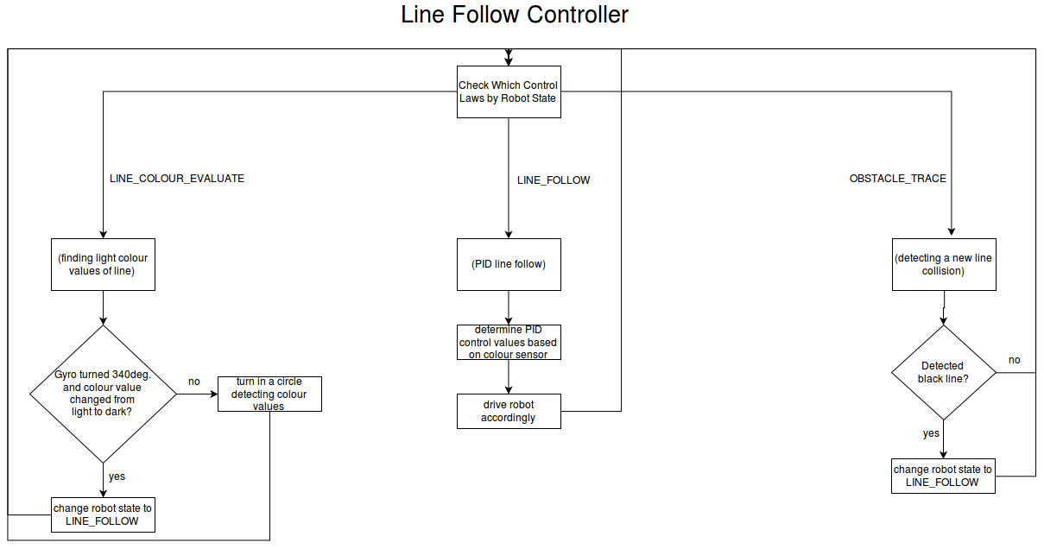

handling broken lines:

Handling the broken line problem required implementing two new features to the robot's control system. Firstly, a method for the robot to know when it has reached the end of a line and secondly, a method for the robot to find a new line and continue following it.

When solving the problem of detecting the end of the line, we begun by analysing the data our robot already provided us from its line-following control scheme (it would be pointless to create more control tests just for one new task without analysing the data we already get). Below are three graphs evaluating two metrics of our robot:

Line-Following-PID Integral Value over Time while robot is on the line
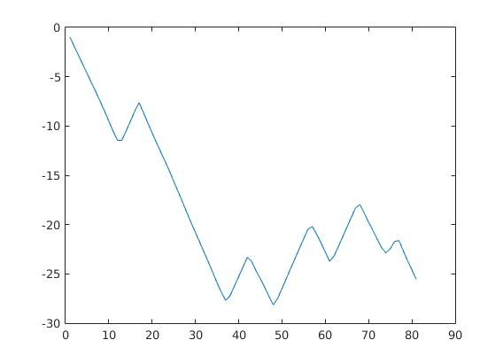
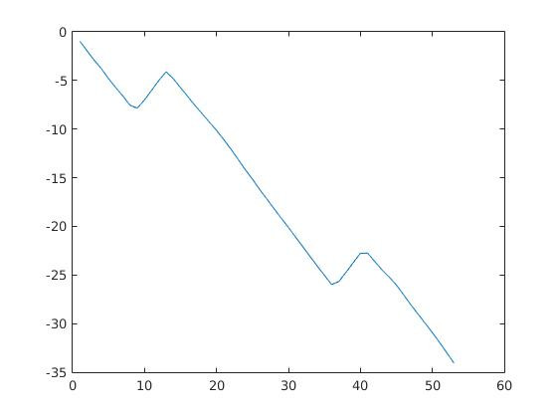
Line-Following-PID Integral Value over Time (robot goes off the line at time=40)

Line-Following-PID Control Value over Time (robot goes off the line at time=125)
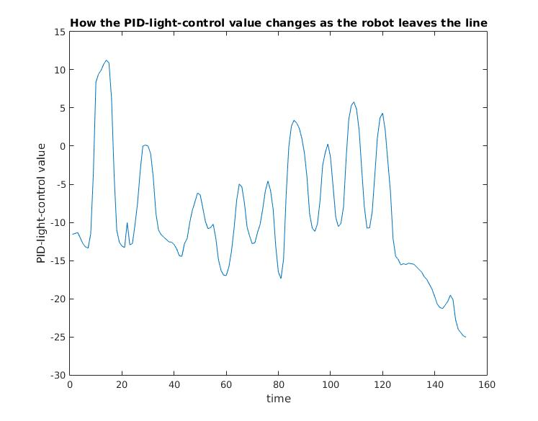
These graphs prove that when the robot leaves the line, drastic changes in the robot's line-following-PID control value (its output after PID processing) and the line-following-PID integral value occur. Both these values were tested with thresholds to see if they could trigger the robot to know when it has left a line. The threshold for the PID control value being between less than -20 and the threshold for the PID integral value being less than -30 (of course the closer the threshold value is to the maximum threshold, the more liable the robot is to believe it has left a line when it has not). The results of the experiment are below:

PID Integral/Control Value? | Threshold | Time robot takes to know it is off a line (approx.) | Robot behaviour during normal line following (no spaces in line) | Notes
Integral | -45 | FAILS | WORKS | Robot couldn't know it left line
Integral | -40 | 2.0sec (sometimes) | WORKS | Robot only knew it was off the line sometimes
Integral | -35 | 1.0sec | WORKS (partial) | If the robot is line following for more than 10 seconds, it detects being off the line
Integral | -30 | 0.3sec | FAILS | Robot is quick to know it is off the line, but detects being off the line after driving more than 5 seconds
Integral | -25 | Instant | FAILS | Robot is off the line after driving for more than 2 seconds
Control | -35 | 1.5sec | WORKS | Big delay when leaving line
Control | -30 | 1.3sec | WORKS | Big delay when leaving line
Control | -25 | 0.8sec | WORKS | Delay when leaving line, but effective otherwise
Control | -20 | 0.5sec | WORKS (partial) | Subtle delay when leaving line. Only fails on normal line following with sharp turns
Control | -15 | Instant | FAILS | Able to know it had left a line, but during normal line following any turning behaviour caused the robot to think it was off the line

From this experimental data, it is clear both methods have their benefits and drawbacks. The benefit to using PID Control value is that with a threshold of -25, the robot can follow a line normally and know when it is off the line; the drawback is that it takes almost a second to register it is off the line. The benefit to using the PID Integral value is that with a threshold of -30, the robot can quickly detect it is off the line; the drawback is that after periods of time, the integral value gradually increases and reaches the threshold during normal line following. It is more important that the robot be able to perform effective line following than be able to stop quickly at the end of a line, therefore the reasonable choice of method is to use the PID Control value with a threshold tuned around -25.

The process for finding a new line once the robot has reached the end of a line required less of a quantitative analysis and more of a qualitative planning approach. The general process is outlined in the control diagram. A brief dialogue of this process: The robot keeps track of whether it's state is a left or right line. Once the robot leaves the line, it turns perpendicular to its starting position (using the gyroscopic sensor) in the direction opposite to it's state line. The robot drives until it has detected the far end of the line (a change in colour from black to white) and then turns itself to face the angle of the starting position. It then changes the polarity of its line-following (because it has switched to the inside of the new line) and moves to the line-following state and the process repeats.

(POSSIBLE DIAGRAM OF ROBOT LINE SEARCH??)

avoiding obstacles:

The algorithm for avoiding obstacles was similar to the line following algorithm, but used the ultrasonic sensor to calculate and adjust the distance from the obstacle. The obstacle is first detected by the ultrasonic and then avoided. An important aspect of the obstacle detection was allowing the ultrasonic to turn relative to the rotation of the wheels during line-following. This meant that instead of a naive approach of swinging the ultrasonic randomly back and forth, a more controlled aiming of the ultrasonic occurs where a high-powered turn of the robot to the left, results in a high-powered turn of the ultrasonic to the left, and visa versa. This is portrayed below:

(IMAGE OF ULTRA TURNING RELATIVE TO ROBOT'S TURNING)

In order to drive the robot via a PID controller in this scenario, an error must be evaluated. A nice way to represent the error would be to assign the robot a target distance from the obstacle and the error would be evaluated as the target distance minus the current distance of the robot. If the error is positive, the robot should turn towards the obstacle (drive the outer wheel forward more). If the error is negative, the robot should turn away from the obstacle (drive the inner wheel forward more). This defines an algorithm for the robot ‘tracing’ the exterior of the obstacle from a safe distance.

The one aspect missing from this algorithm is how to determine the target distance from the object. A simple method would be to define a predetermined constant, but this does not generalise for various environments the robot is introduced to. Alternatively, we can dynamically calculate this value once the robot has detected and stopped at the object. After stopping at the object (which must use a predetermined constant to determine when to stop), the robot will progress to scanning the obstacle: turning a range of angles around the object, recording the different distances that are measured at each angle, and then finding the minimum ultrasonic value. This minimum value is the target value when tracing around the obstacle.

(IMAGE OF HOW THE ROBOT SCANS THE OBSTACLE)

During the testing of this algorithm, it became clear that the ultrasonic values were not linear in relation to the target distance. For example, if the target distance for the robot is 13cm, this leaves approximately 5cm of values between the robot and the obstacle (before the ultrasonic reports nonsense) and approximately 242cm of values between the robot and empty space (the ultrasonic reports a maximum range of 255cm). Therefore if a PID controller has a value of 10 for kp and the robot is 8cm from the obstacle, this will result in an error value of 13cm – 8cm = 5cm and robot will gain wheel power of 5cm * 10kp = +50 power. That’s fine. But in the other scenario where the robot is 70cm from the obstacle (going around the corner of the obstacle and detecting a long distance) then the error will evaluate to 13cm – 70cm = -57cm and the resulting power change will be -57cm * 10kp = -570cm and the robot will go careening off course. There were two methods that were tested in order to fix this problem:

method 1: The ultrasonic distance values can be converted to a logarithmic scale which will shorten the difference between the largest and smallest values to be shrunk (and hopefully converted to a linear model). Below is an example of ultrasonic distances before and after logarithmic scale is applied:
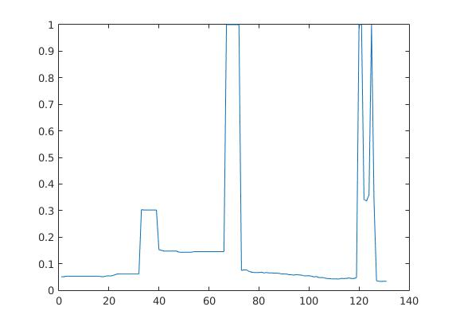
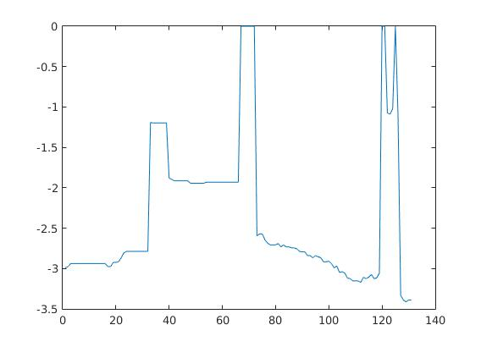
method 2: The larger ultrasonic values can be maximised such that if the target value is x, and therefore the minimum distance is 0cm, then the maximum allowed measurement is 2x. All values greater than 2x are converted to 2x before any PID processing. This allows for a design very similar to the light sensor, as shown below:

The results for both systems were tested and evaluated based on multiple variables. These results can be seen in the Results section under Table 1.0. Analysis of these results shows that a large amount of variable tweaking was required to obtain successes with the 'Log Method', but despite multiple attempts the success rate of this method was: 5 successes/14 runs = 36% success (keep in mind this was with non-constant parameters). The 'Log Method' seemed most generalised towards the task, and the simpler implementation, but failed to produce effective results. The 'Maximum Distance Method', after the correct parameter was assigned, had a success rate of 4 successes/4 runs = 100%. It is clear which method we then chose to use.

RESULTS:

Table 1.0: Obstacle Trace Tests

Test Number | Battery Val | Obstacle Position | Distance From Object | Log/Max Dist. Method | Notes | Success?
1 | 7.3 | Center Of Straight | 1 Hand | Log | Success | YES
2 | 7.35 | Center Of Straight | 1 Hand | Log | Failure- hit object on final turn (Overturned) | NO
3 |  | Center Of Straight | 1 Hand | Log | Failure- Same as 2. | NO
4 |  | Corner |  | Log | Success (overturning still possible issue) | YES
5 |  | Corner |  | Log | Failure (Same as 2)- Changed KP value to 25 from 20 | NO
6 |  | Corner |  | Log | Success but wasn’t tight on box on final turn | YES
7 |  | Center Of Straight |  | Log | Failure | NO
8 |  | Straight Parallel to Obstacle |  | Log | Failure- Changing integral value- KI to 0 from 0.0005 | NO
9 | 7.25 | Corner |  | Log | Failure- overturned on first corner | NO
10 |  | Corner |  | Log | Failure- overturned on second corner. - Turning speed down 55 – 40, | NO
11 |  | Corner |  | Log | Failure- Turning KP to 10 | NO
12 |  | Corner |  | Log | Success (quite wide from box) | YES
13 |  | Center Of Straight |  | Log | Semi- Failure( Went so wide that it hit line before turning second corner)- Tuning KP to 15 | NO
14 |  | Center Of Straight |  | Log | Success ( but very close to box on finish) | YES
15 |  | Center Of Straight |  | Max Dist. | Failure- Wide after first turn and overturned on second corner- Set maximum on data | NO
16 |  | Corner | 1 Hand | Max Dist. | Perfect | YES
17 |  | Corner | 1 Hand | Max Dist. | Perfect | YES
18 |  | Corner | 1 Hand | Max Dist. | Perfect | YES

Table 2.0: Broken Line Test
Test Number | Battery Val | Off Line Constant Value | Notes
1 | 7.41 | 25 | Success- Timed out early
2 | 7.46 | 25 | Failure- Overshot turn after initial line then undershot second line on left side.
3 | 7.48 | 25 | Moderate Success- Missed last line (Due to dodgy paper)
4 | 7.45 | 20 | Failure- Didnt detect new line as was off line for too long- OLC value no good
5 | 7.46 | 23 | Success
6 | 7.2 | 23 | Absolute Success

DISCUSSION:

