Introduction to Vision and Robotics
Robotics Assignment
Daniel Clemente (s1333465) & Levi Fussell (s1408726)
INTRODUCTION:
The assignment task was to construct and program the EV3 LEGO Mindstorms Robot to complete 3 main challenges.:
1. Following a black line on a white background.
2. Following a broken line.
3. Following a line to an obstacle, circumventing the obstacle and then following the line again.

CHASSIS DESIGN:

The robots chassis design conformed to the base design recommended in the assignment (two wheels driven by separate motors and a third wheel behind for balance with a light sensor and ultrasonic). There were some alterations outlined below:

1. Light Sensor Position: The position of the light sensor was moved further from the wheels and the robot's centre of gravity. This allowed the robot to have a quicker reaction time when following a line.

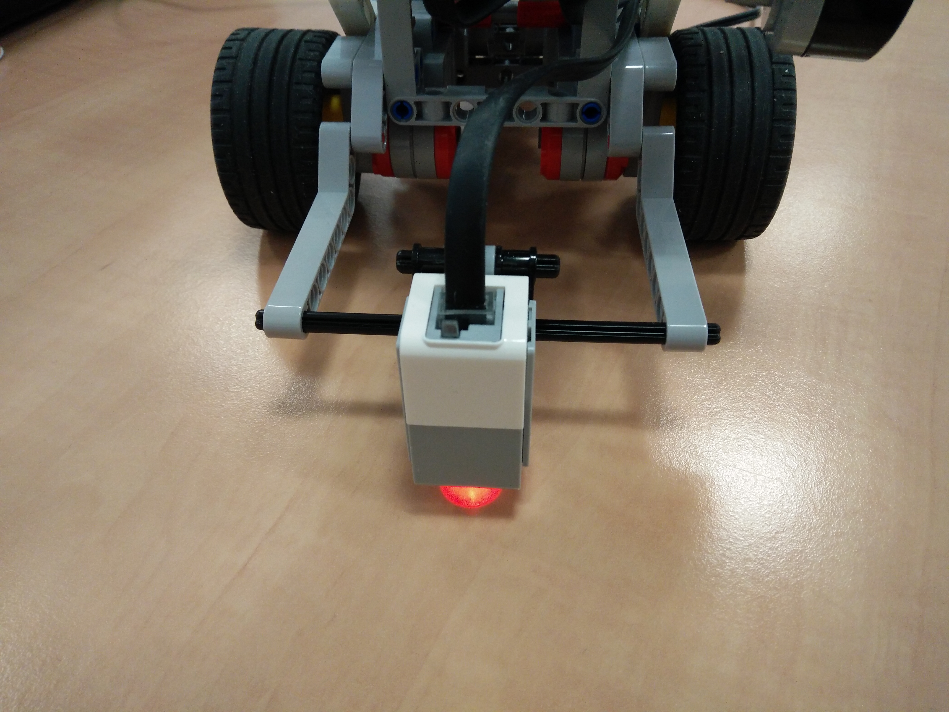

2. Ultrasonic Sensor Position: The ultrasonic sensor was moved from a position above the robots main body, to a position below the robot's main body and was also rotated 90 degrees to a vertical position. Having the ultrasonic lower allowed for detection of objects directly in front of the robot. Rotating the ultrasonic helped to increase the accuracy of its detection on irregular surfaces (e.g. the corner of a square obstacle).
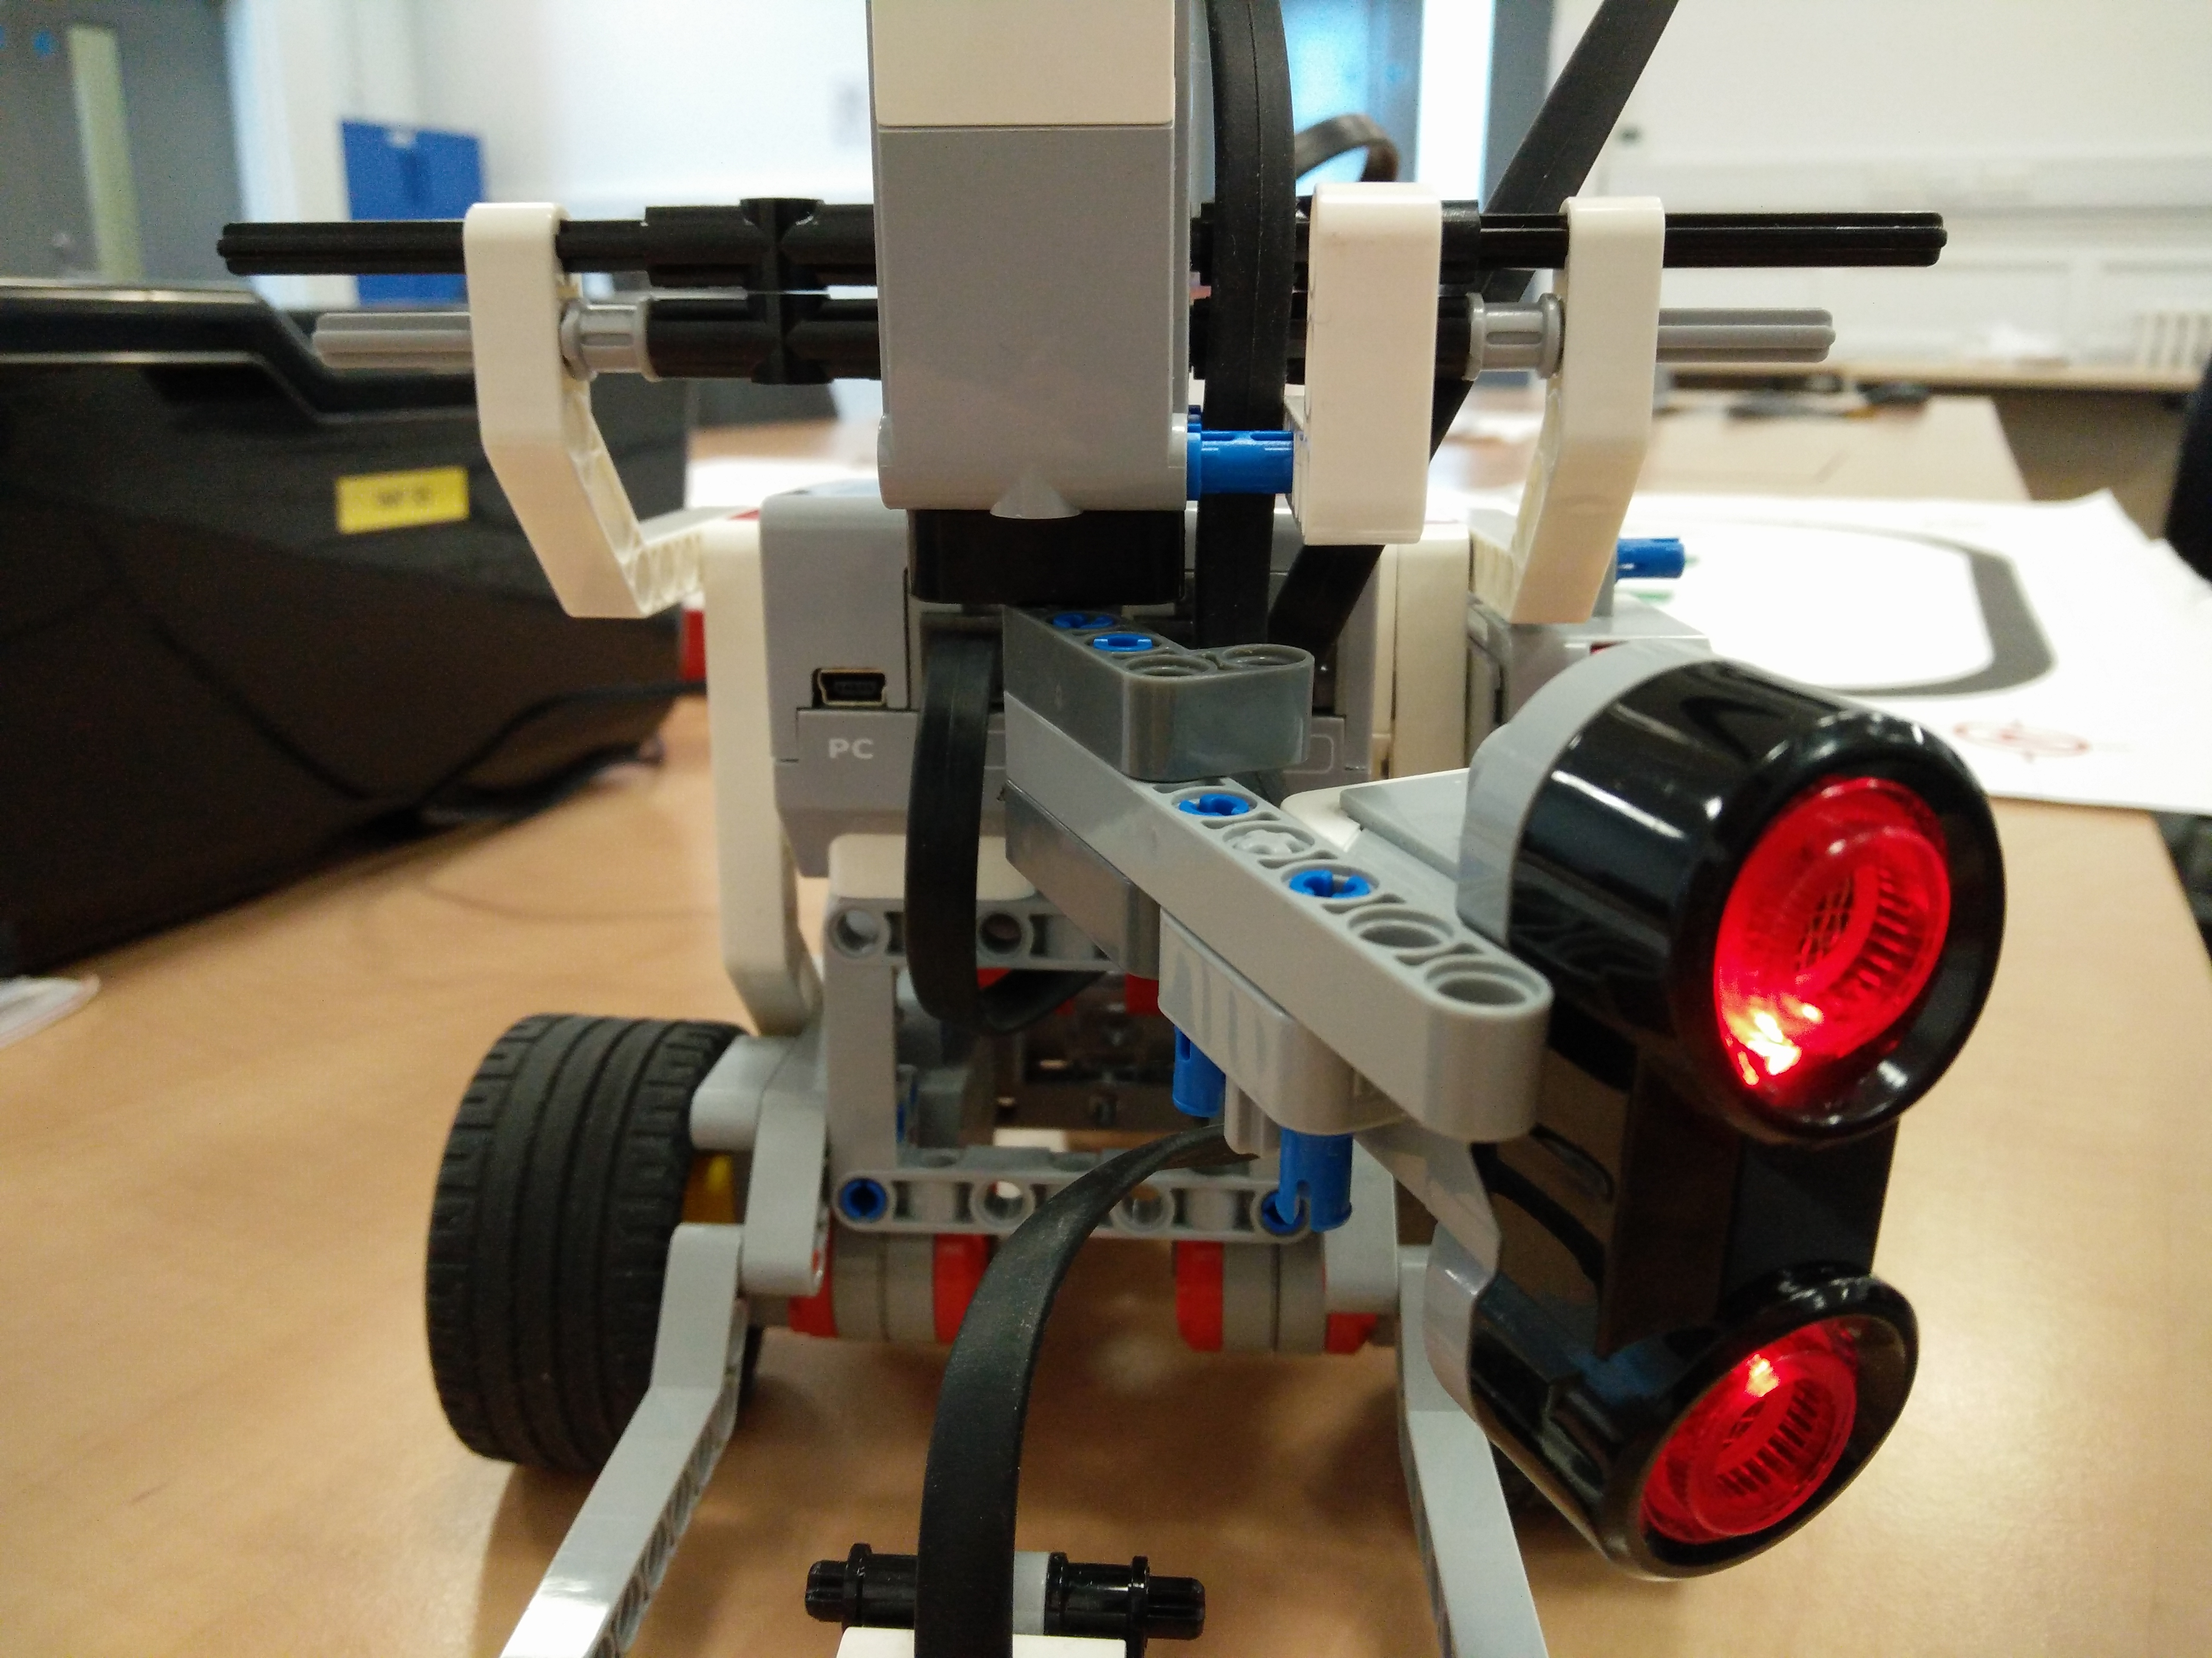

3. Touch Sensor: The touch sensor is used as a safety trigger for when the robot rotates the ultrasonic sensor with the medium motor. If the ultrasonic rotates 90 degrees to the left (which it does when it detects an obstacle), the touch sensor will stop it from over-rotating and damaging the motor (as well as ensuring the ultrasonic is at 90 degrees). This was more accurate than encoders on the medium motor.

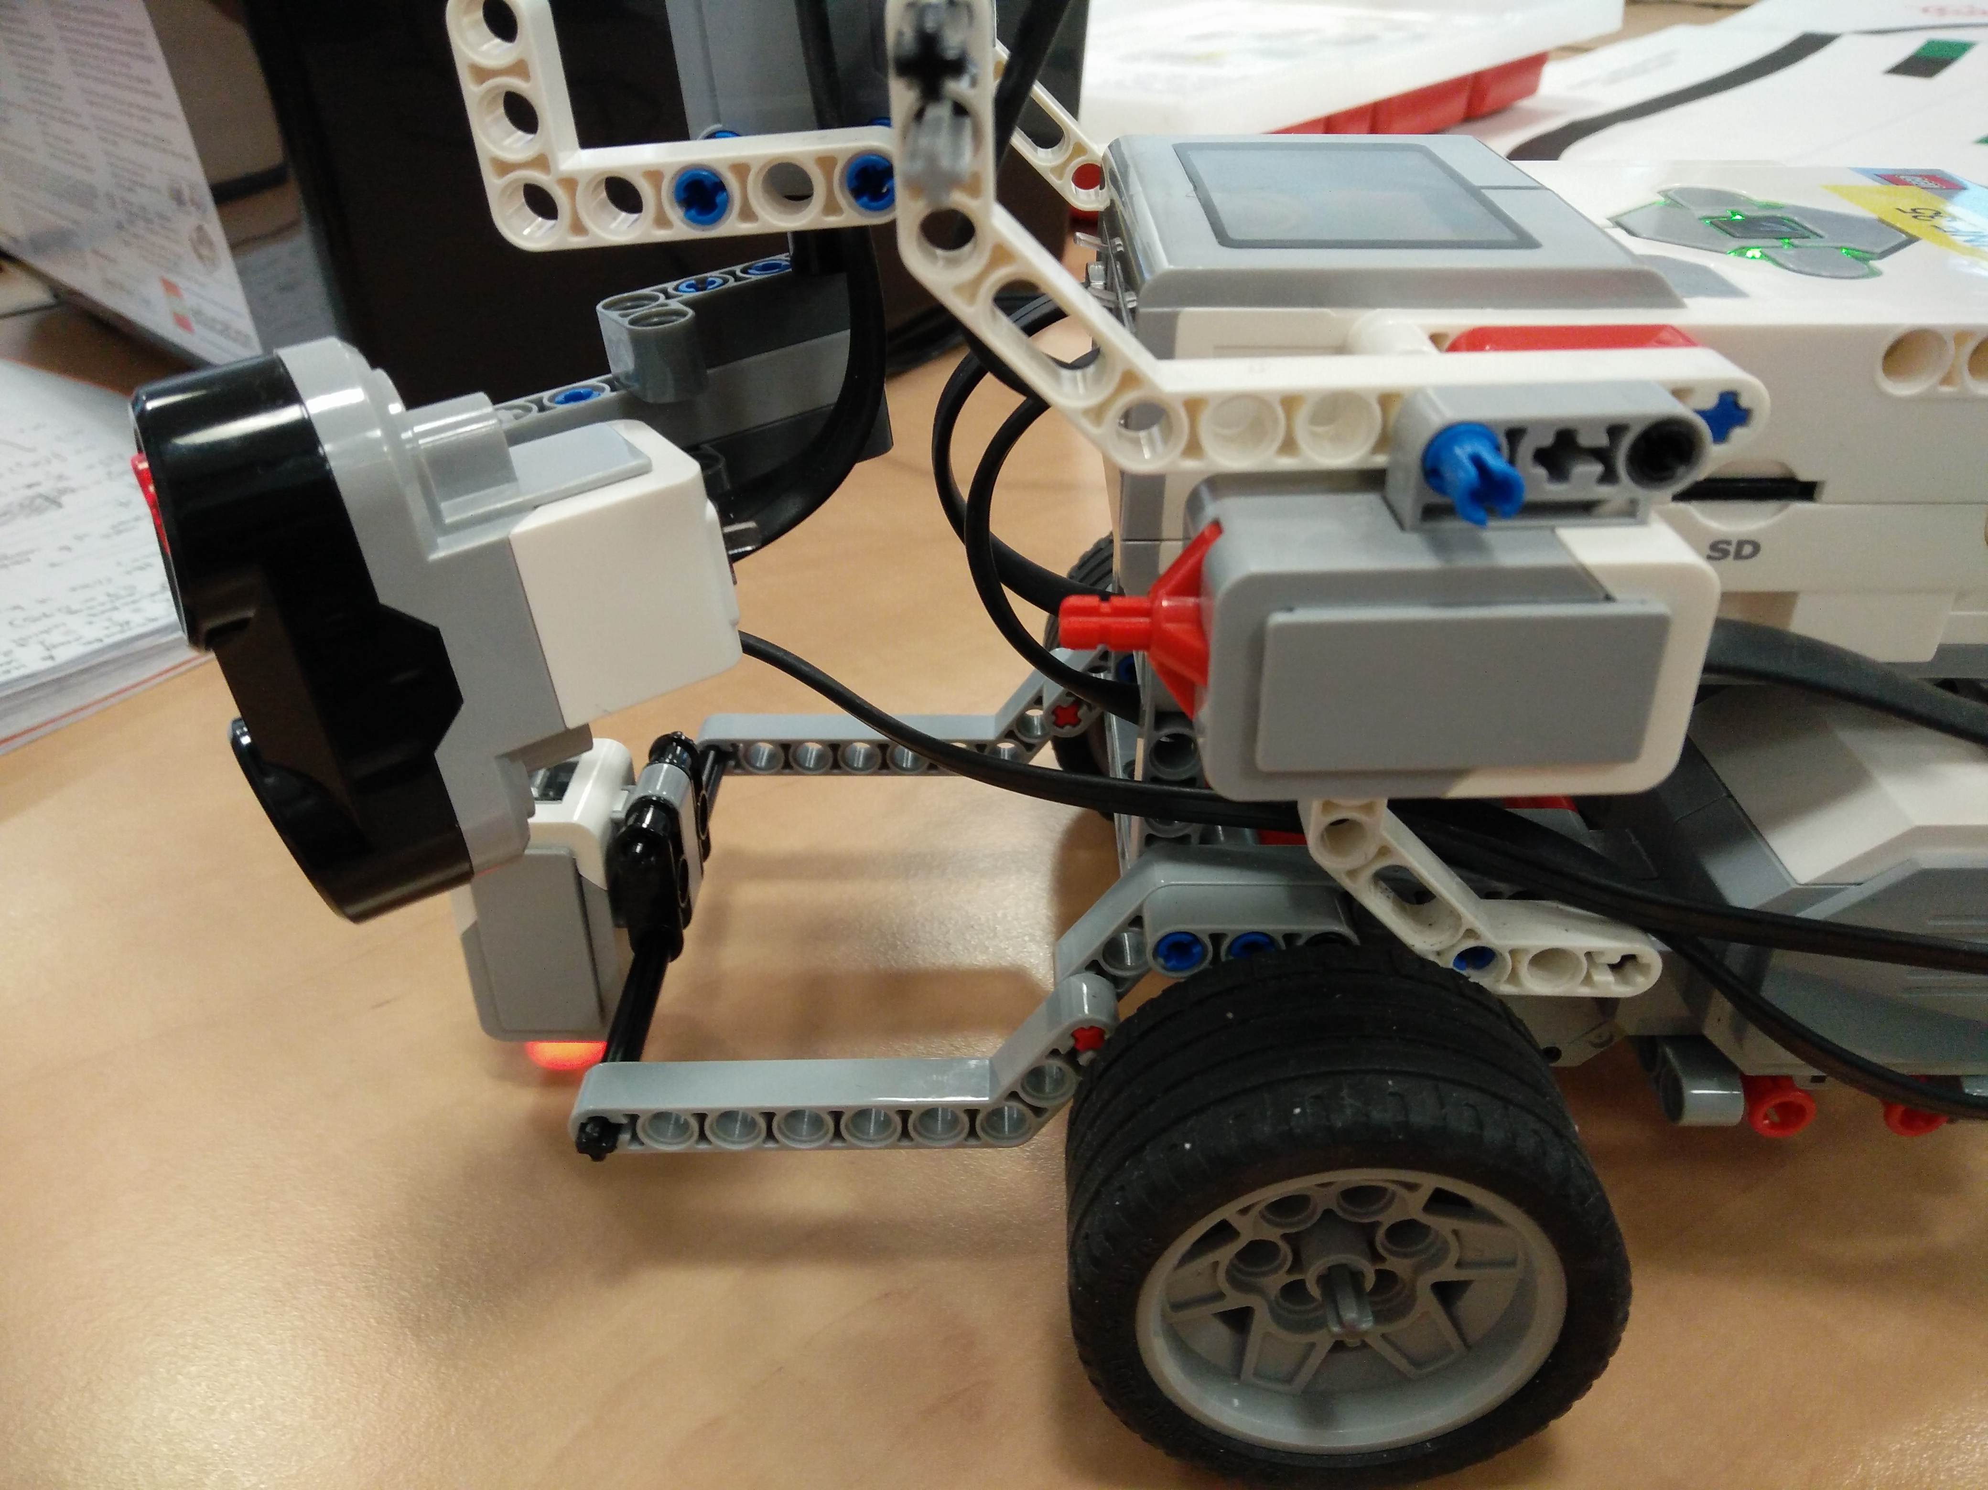

METHODS:

Evaluating the Sensors and Motors:

Before tackling the three tasks, it was first necessary to learn how the robot behaved during basic driving, sensing and actuating. Knowing how well the hardware performs is essential so that a plan for the robot can be built that does not carry through errors of the hardware. We first measured the accuracy of the robot's wheel encoders in relation to the observed distance the robot travelled (in centimetres) and how long it took the robot to travel the distance, obtaining results:
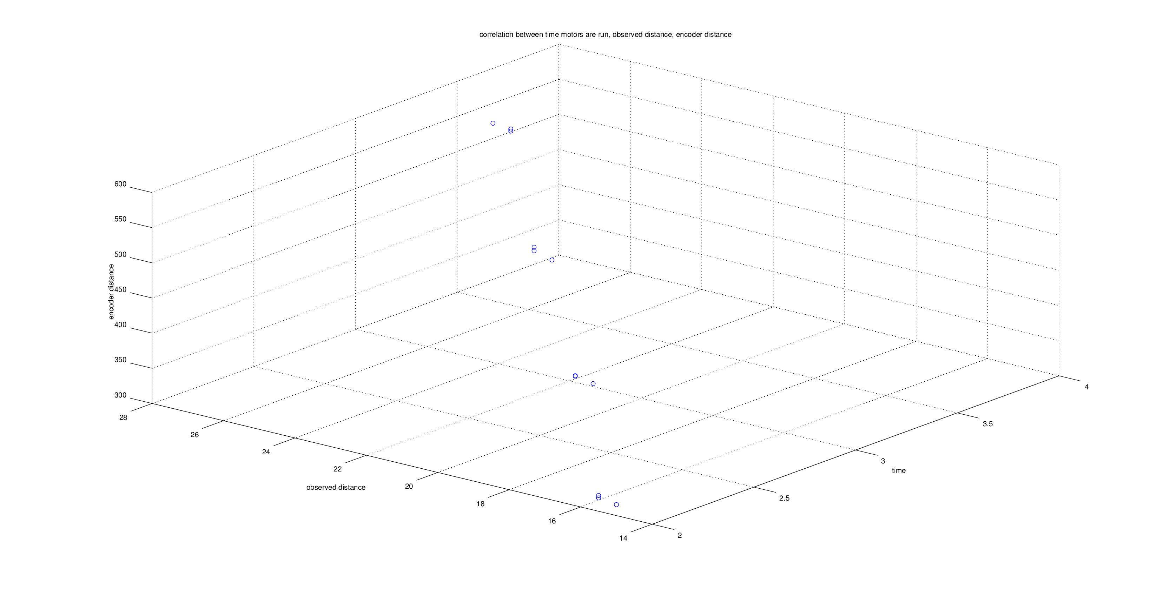
As expected, time is constant whether we are dealing with an encoder value or a measured distance, and therefore the encoder values are proportional to the speed of the robot. We can now observe the correlation between measured distance and encoder value:
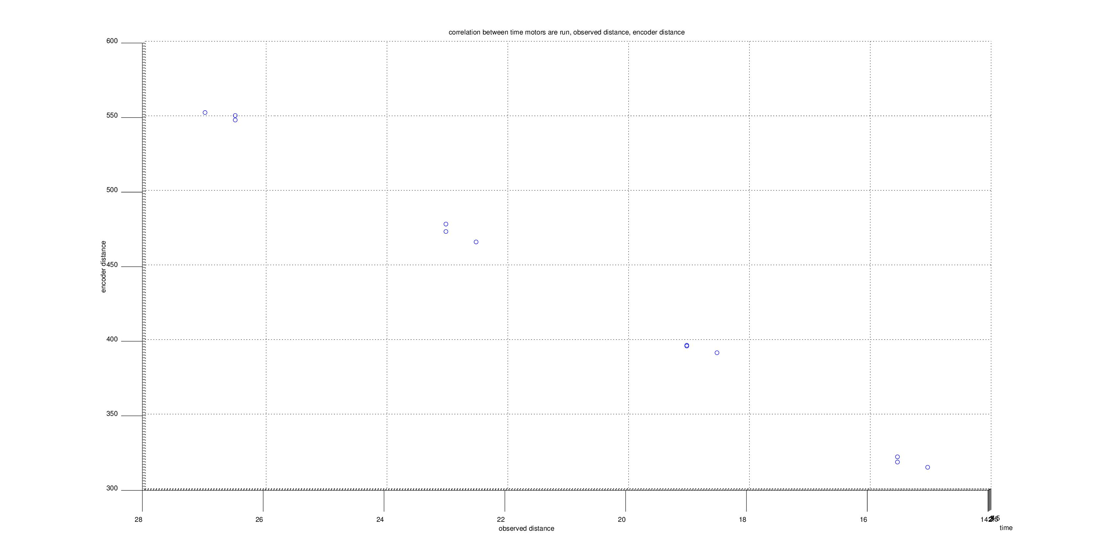
(A table displaying the numerical values can be found in the Results section)

Over a range of 14cm to 28cm the data displays a clear linear behaviour. To give a numerical value to this linearity of the data, we use the Pearson Correlation Coefficient (PCC) which values the correlation of two variables from 1 (highly correlated) to 0 (not correlated) to -1 (inversely correlated):

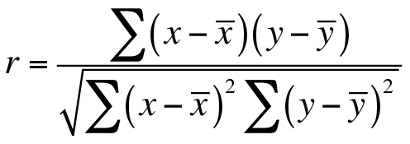
(http://www.dataanalytics.org.uk/Publications/S4E2e%20Support/exercises/spearman.htm)

(see Results Table 1.2) The calculated PCC between the encoders and the measured distance of the robot was 1.0 which entails that the measured distance and the encoder value of the wheels are linearly correlated. Measuring the slope of this linear behaviour will represent the correlation constant (to make the robot drive a given distance, measure this value in the encoders). The slope is: (550.167 – 319)/(26.27-15.33) = 20.385 encoder values/cm (note the average value of the trials is used).

For the development of an accurate dead-reckoning system, it is also essential to measure the error of the robot’s ability to turn to a specific angle relative to the motor power and time. The same process used for measuring actual distance versus encoder distance was used to evaluate the angle and motor power. Below are the two graphs representing the behaviour:
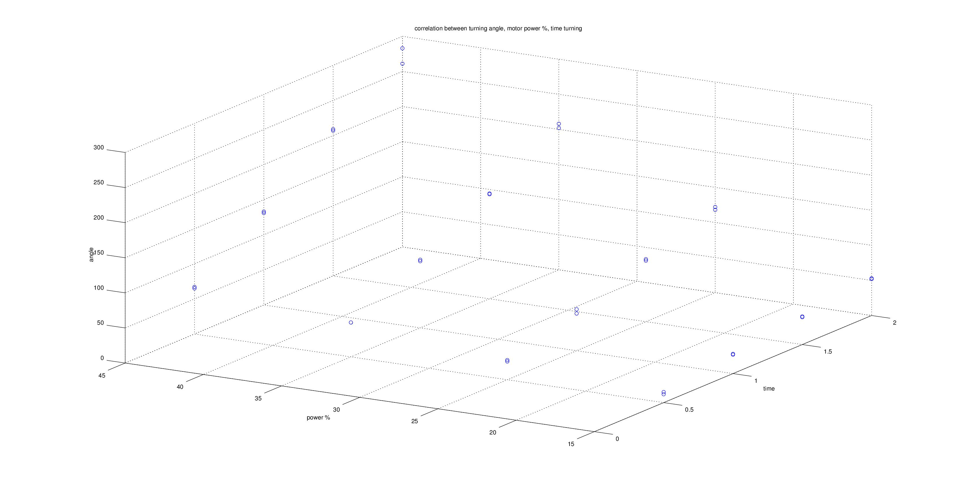
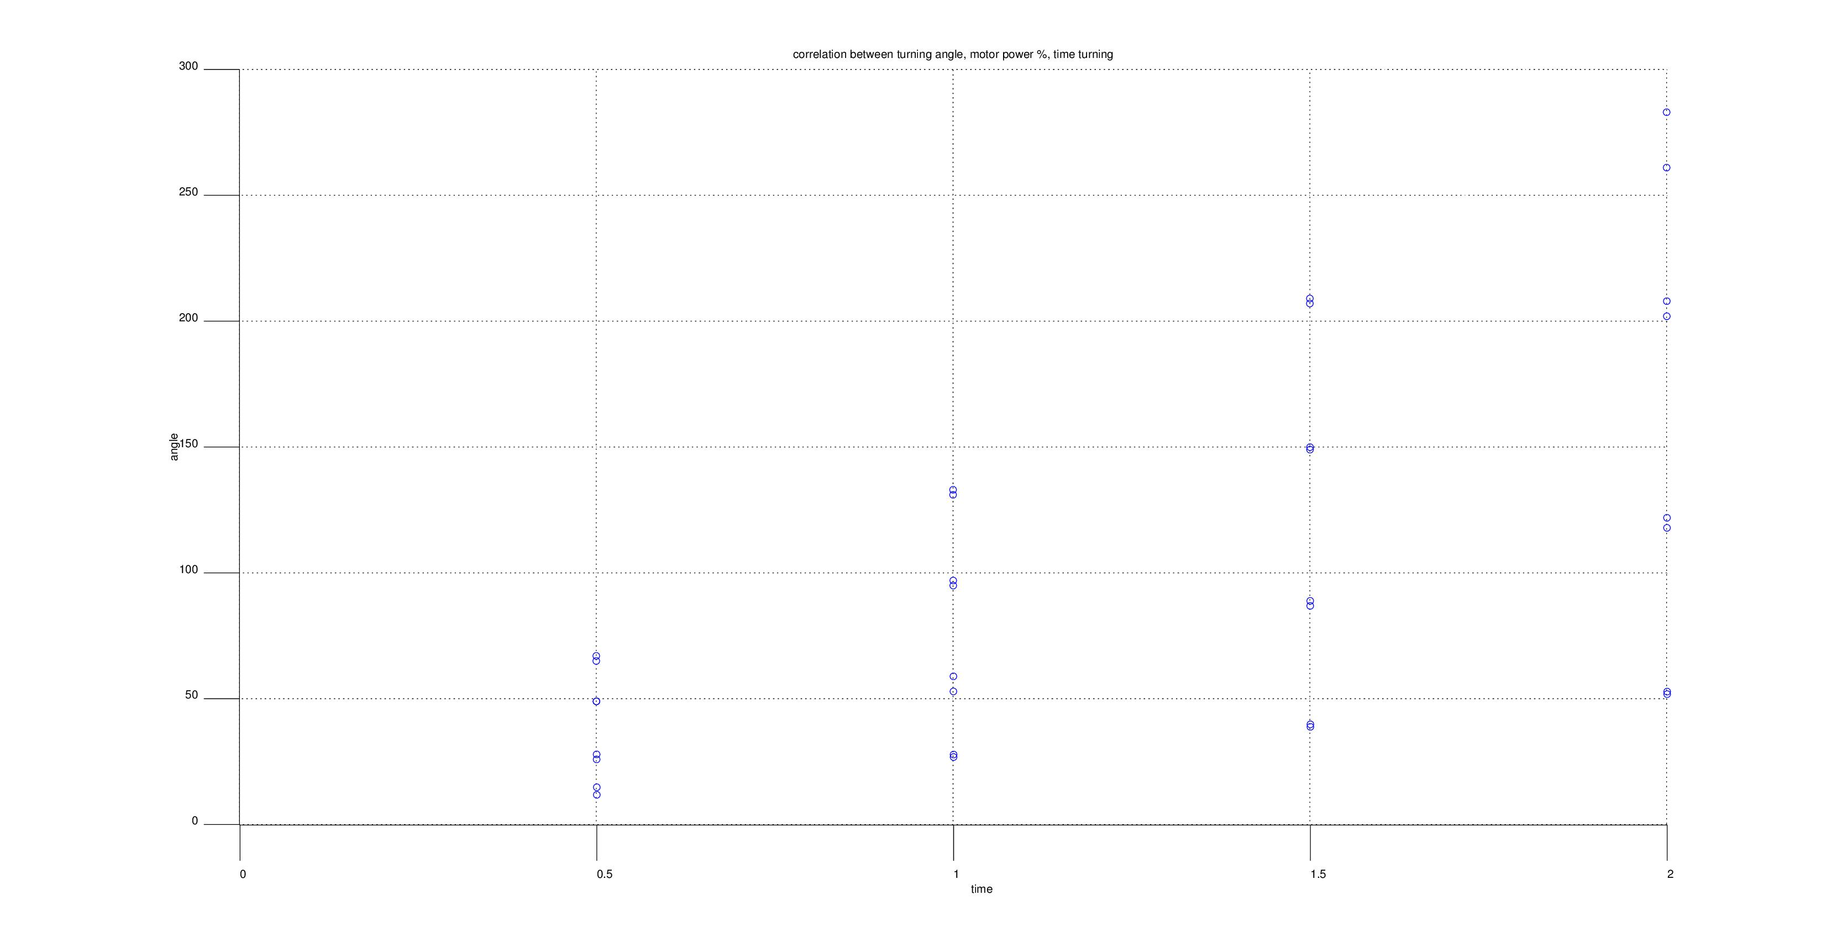
Power: 45%
Power: 35%
Power: 25%
Power: 15%
For the second graph, power was kept constant and only the angle to time correlation was measured. The four distinct lines correspond to 15%, 25%, 35%, and 45% power values. For determining a time/angle constant, 25% power was chosen as a constant (as it was high enough to drive the robot without motor strain, but not so fast that sensors would lose measurement accuracy).

(see Results Table 1.3) The calculated PCC between the angle and time of the robot was 0.87 which implies linear correlation between the time turned at 25% power and the angle of the robot. The slope of this dataset is therefore the time to angle constant: (120-27)/(2-0.5) = 62 degrees/second.

A dead-reckoning controller can now be designed using the above constants. The performance of the controller and its calculated errors can be found in Results Table 1.4

Following the evaluation of the robot's behaviour, it is clear that the robot is accurate when driven within the testing environment, and therefore can be relied on to perform specific angle turns and driving tasks during this assignment.

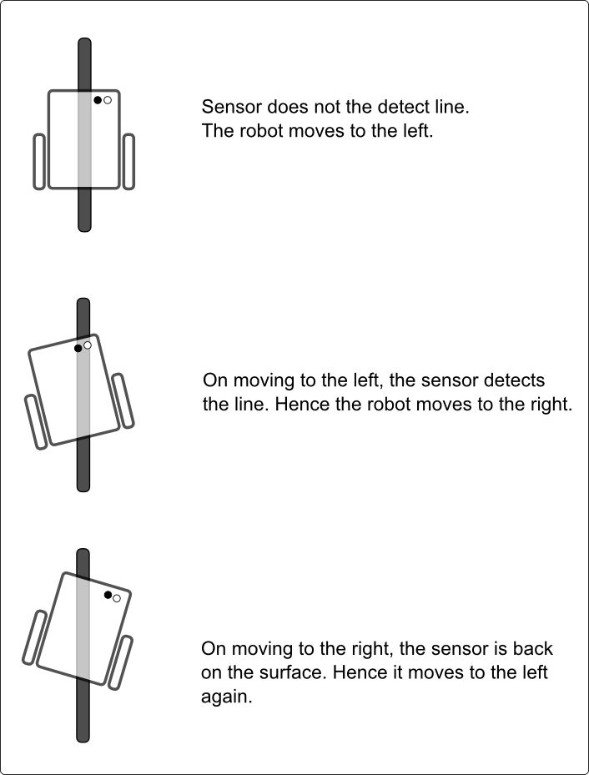
Following a Line and the PID Controller:

Developing an algorithm that was adaptable to any given line-path was essential to the line following task. The classic line following technique involves driving the robot's left wheel forward when the colour detected is white/black and driving the robot's right wheel forward when the colour is the opposite (depending on what side of the line the robot is following). This is a naive approach. To the right is an example of the Naive Line Following Algorithm:

The less-naive approach is to devise a gradient, such that the further a robot is from the line, the sharper it will turn towards the line. For the sake of argument, we assume white colour has a value of 0 (colour sensor units) and black has a value of 100 (colour sensor units). As the light sensor value approaches 0, the error should approach a maximum value of 1 and as the light sensor value approaches 100, the error should approach the minimum value of -1. This method is shown below:
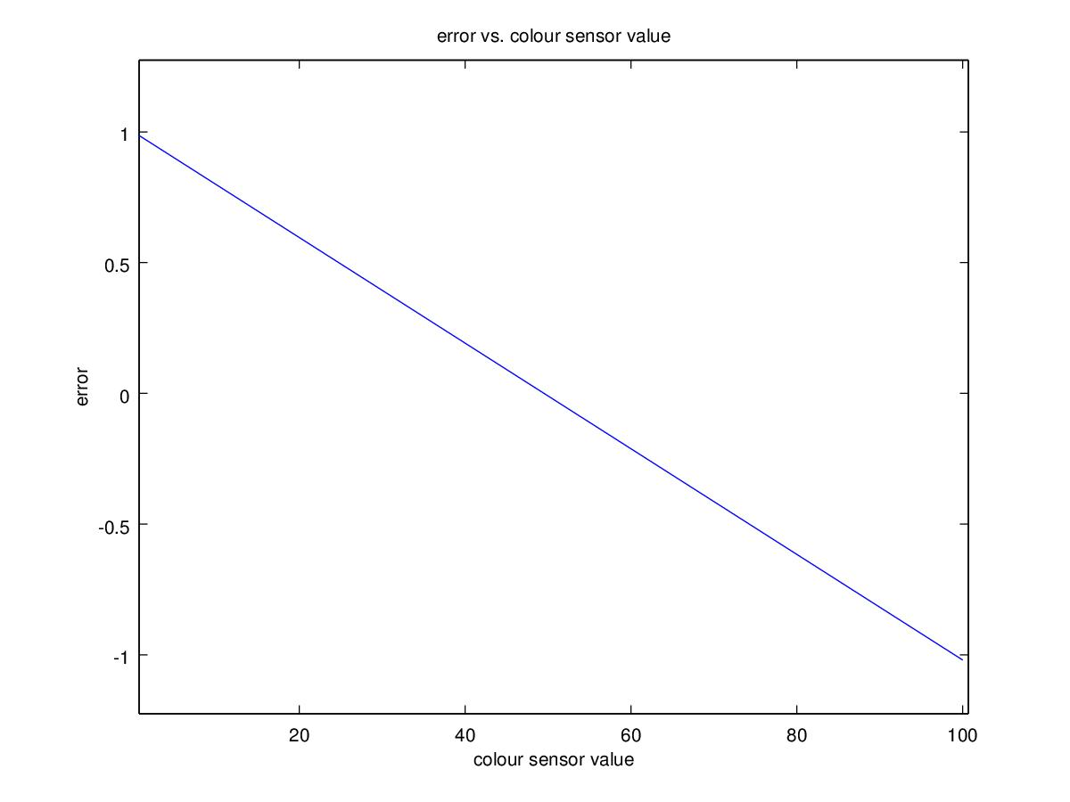
(http://www.societyofrobots.com/member_tutorials/book/export/html/350)
When there is no error (i.e. the robot is exactly on the boundary between being on and off the line), the robot should drive straight; an error of 1 should increase the value of the power of the robot's left wheel and decrease the power of the robot's right wheel, and vice versa for an error of -1. The final step to complete the gradient line-following algorithm is to assign the robot a constant value for the wheel power, c, and a constant value to multiply the error by to power the turning. This entire process is no more than a P (Proportional) Controller system, where the constant for the error is k_{p} in the algorithm such that: d = k_{p} (t – s), where t = target value = the light value of 50 (in the above graph) and s = the current sensor reading of the light value.

To determine a value for k_{p}, a constant wheel power, c, was set to 25% (something low so that it is easy to analyse. This can later be increased once the controller is accurate) and a range of values were assigned to k_{p}. Below are graphs of the robot's position over time, showing how much or how little the robot oscillated:

k_{p} = 10 k_{p} = 15
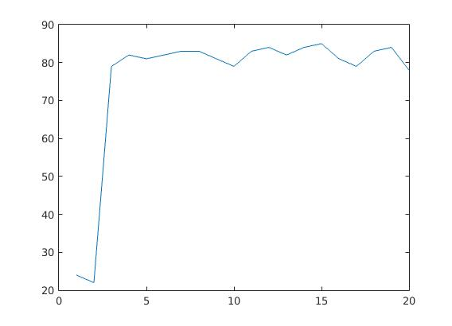
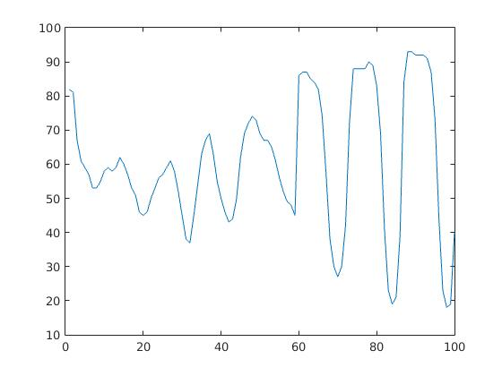
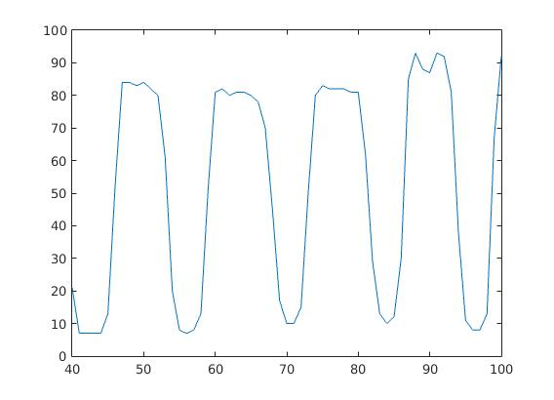
k_{p} = 20 k_{p} = 30
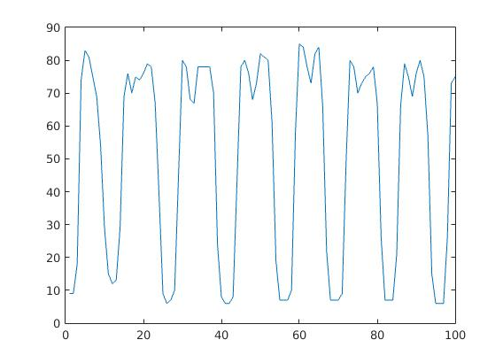
k_{p} = 40
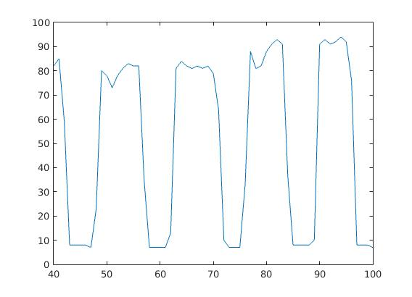
The choice of k_{p} = 10 was made for the P Controller as it performed only minor oscillations. The robot effectively follows the line, but the oscillating behaviour is not ideal for an efficient line-following program. The k_{i} value is introduced to dampen the oscillations by accounting for the total error overtime of the line-following. Various values of k_{i} are tested to attempt to dampen the robot’s oscillations (note that altering k_{p} proportionally to k_{i} is also required during testing and therefore a new range of k_{p} values are tested). A couple test examples are below:

k_{p} = 15.0, k_{i} = 0.02 k_{p} = 12.2, k_{i} = 0.1
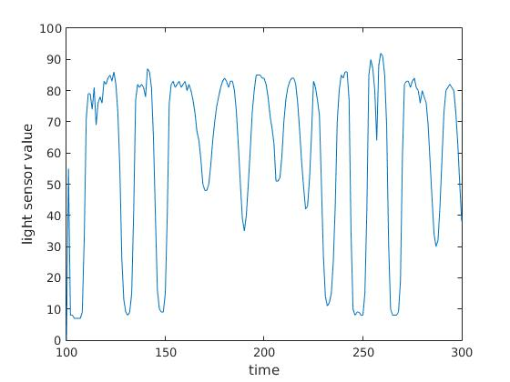
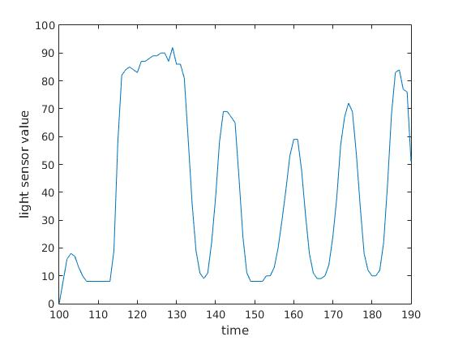
k_{p} = 12.2, k_{i} = 0.52
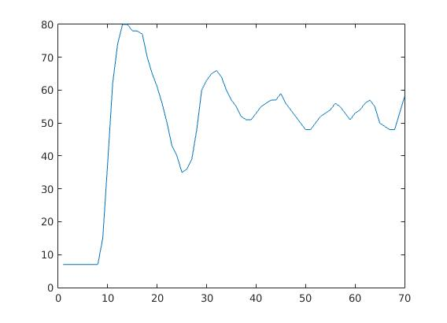
The line following algorithm required a colour sensor value for both black light and white light. The naive approach to this is pre-determine the black and white colour values and and hard-code these as constants. The problem with this approach is that changes in the environment's lighting, the height of the sensor, and other factors can cause the colour sensor values to change dramatically. To make the robot adaptable to a variety of line-following scenarios, the robot begins the line-following algorithm by completing a full 360 degree rotation using the gyroscope sensor and recording the range of light values it sees during this rotation. A histogram is then created using the light values. The largest maximum that is the lowest light value is selected as the black colour constant and the largest maximum that is the highest light value is selected as the white constant. The 'target' value for the line-following algorithm is the average of these two values. A plot of an example histogram is shown below:
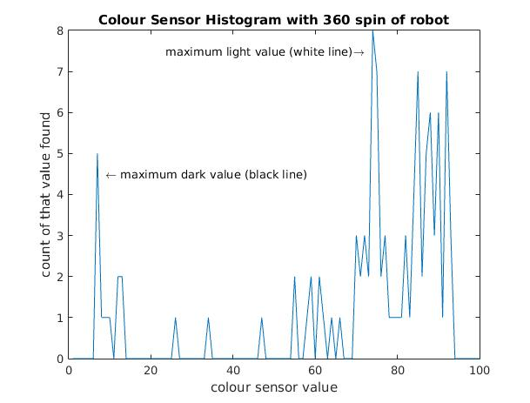

Robot States:

The design for the robot sensing utilised an approach that closer resembles the 'Alternative View' where a sequence of specific tasks are run in parallel, each with specific control laws, sensor processing, and actions:

The robot was assigned three specific tasks: line following, line searching, and obstacle detection, each of which was a subclass of a controller. The controller class handled a robot class and provided an update loop. The update loops functioned as a 'Feedback Control' system where disturbances in the environment that affected the robot caused the robot to change state and redefine the control laws, as outlined in the below diagram:

The control scheme for each subtask is outlined below:

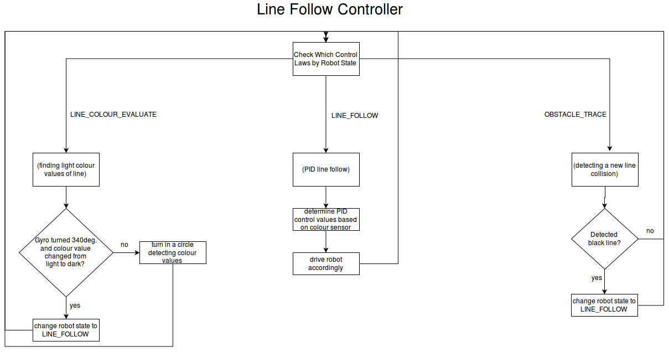

Handling Broken Lines:

Handling the broken line problem required implementing two new features to the robot's control system: a method for the robot to know when it has reached the end of a line, and a method for the robot to find a new line and continue line-following.

As it could be unnecessary additional work to create more control tests for a new task, we begun by analysing the data our robot already provided us from its line-following control scheme. Below are three graphs evaluating two metrics of our robot:

Line-Following-PID Integral Value over Time while robot is on the line
Line-Following-PID Integral Value over Time (robot goes off the line at time=40)

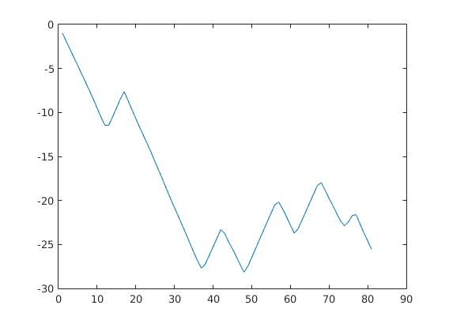
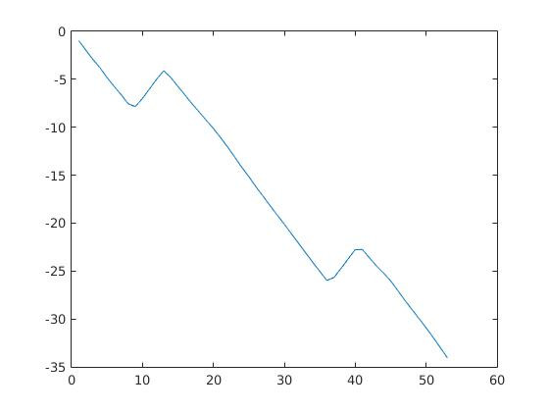

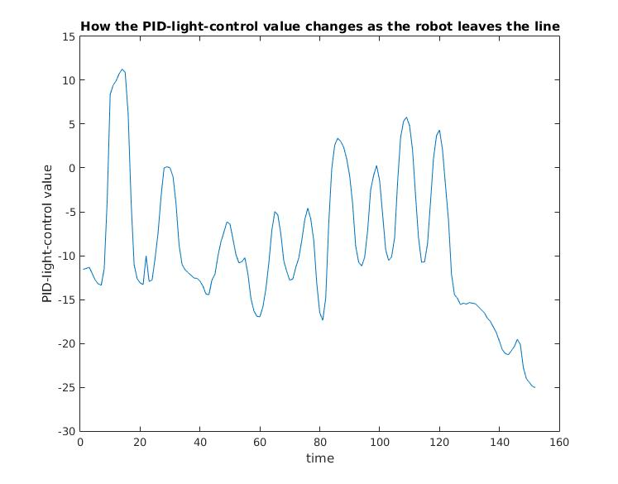
These graphs prove that when the robot leaves the line, drastic changes in the robot's line-following-PID control value (its output after PID processing) and the line-following-PID integral value occur. Both these values were tested with thresholds to see if they could trigger the robot to know when it has left a line. The threshold for the PID control value was assigned values less than -20 and the threshold for the PID integral value was assigned values less than -30. Our hypothesis was that the closer the threshold value is to the maximum threshold, the more liable the robot is to believe it has left a line when it has not. The results of the experiment can be found in Results Table 2.0.
Line-Following-PID Control Value over Time (robot goes off the line at time=125)

From the experimental data in the table, it is clear both methods have their benefits and drawbacks. The benefit to using the PID Control value is that with a threshold of -25, the robot can follow a line without disruption and detect when it has left the line; the drawback is that the time it takes the robot to register leaving the line is almost a second. The benefit to using the PID Integral value is that with a threshold of -30, the robot can quickly detect it is off the line; the drawback is that over time, the integral value gradually increases and passes the threshold during normal line following, causing the robot to incorrectly determine that it is off the line. It is more important that the robot performs effective line following rather than stopping quickly at the end of a line; therefore the reasonable choice of method is to use the PID Control value with a threshold tuned around -25.

The process for finding a new line once the robot has reached the end of a line required less of a quantitative analysis and more of a qualitative approach. The general process is outlined in the control diagram (shown on the right). A brief dialogue of this process: The robot monitors whether it's state is a left or right line. Once the robot leaves a line, the robot turns perpendicular to its starting position (using the gyroscopic sensor) in the direction opposite to it's current line state. The robot drives until it has detected the far end of the line (a change in colour from black to white) and then turns itself to face the angle the robot started in (forward). It then changes the polarity of its line-following (because it has moved to the opposite line position) and reverts to the line-following state and the process repeats.

Avoiding Obstacles:

The algorithm for avoiding obstacles is similar to the line following algorithm. It uses the ultrasonic sensor to calculate and adjust the robot’s distance from the obstacle, similar to how the line-following algorithm adjusts line error. The obstacle is detected by the ultrasonic sensor when a specific threshold is reached. An important aspect of the obstacle detection was programming the ultrasonic to turn relative to the rotation of the wheels during line-following. This meant that instead of a naive approach of swinging the ultrasonic periodically back and forth, a more controlled aiming of the ultrasonic occurs. A high-powered turn of the robot to the left results in a high-powered turn of the ultrasonic to the left, and vice versa. This is portrayed on the right.

In order to drive the robot via a PID controller around the obstacle, an error must be evaluated. A simple way to represent the error is: error = (t – s) where t = target distance from the obstacle and s = the current distance of the robot from the obstacle. If the error is positive, the robot should turn towards the obstacle (drive the outer wheel forward more). If the error is negative, the robot should turn away from the obstacle (drive the inner wheel forward more). This defines an algorithm for the robot to trace the exterior of the obstacle from a “safe range”. Only a P Controller was needed for the obstacle tracing, the testing of this is found in Results Table 3.0.

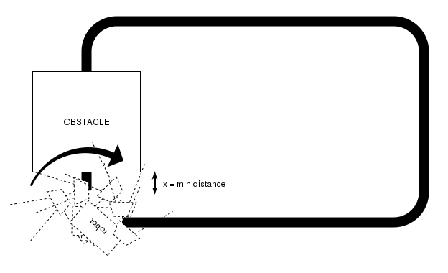
The one aspect missing from this algorithm is how to determine the target distance from the object. A naive method would be to define a predetermined constant, but this does not generalise for various environments the robot is introduced to. Alternatively, we can dynamically calculate this value once the robot has detected and stopped at the object. After stopping at the object, the robot scans the obstacle by rotating through a range of angles facing the object, recording the different distances that are measured at each angle, and then finding the minimum ultrasonic value. This minimum value is the target value when tracing around the obstacle. This method is portrayed on the right.

The advantage to this method is that it is not necessary to test the accuracy of individual sensors. As only real-time sensor values are used, these are relative to previous measured sensor values in the same trial (whether or not there are discrepencies in the sensors). This is also the case for the line recognition algorithm using the light sensor.

During the testing of this algorithm, it was clear that the ultrasonic values were not linear in relation to the target distance. For example, if the target distance for the robot from the obstacle is 13cm, this leaves 9-13cm of values between the robot and the obstacle (before the ultrasonic reports nonsense) and approximately 242cm of values between the robot and empty space (the ultrasonic reports a maximum range of 255cm). Therefore if a PID controller has a value of 10 for k_{p} and the robot is 8cm from the obstacle, this will result in an error value of 13cm – 8cm = 5cm and robot will gain wheel power of 5cm * 10kp = +50 power. That’s fine. But when the robot is 70cm from the obstacle (for example when going around the corner of the obstacle and detecting a long distance) then the error will evaluate to 13cm – 70cm = -57cm and the resulting power change will be -57cm * 10kp = -570cm and the robot will careen off course. There were two methods that were tested in order to fix this problem:

METHOD 1 (Log): The ultrasonic distance values are converted to a logarithmic scale which will shorten the difference between the largest and smallest values (and convert it to a linear model). Below is an example of ultrasonic distances before and after logarithmic scale is applied (the high plateaus are where the robot drives around the corner of the obstacle):

With Log
Without Log
Without Log
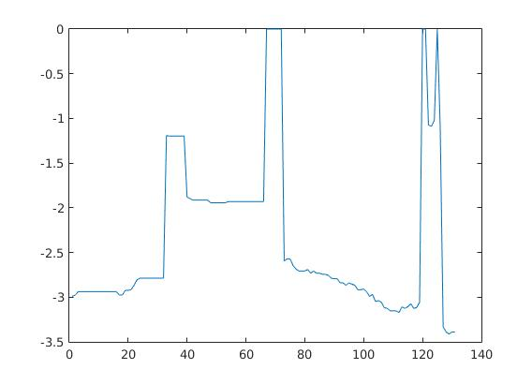
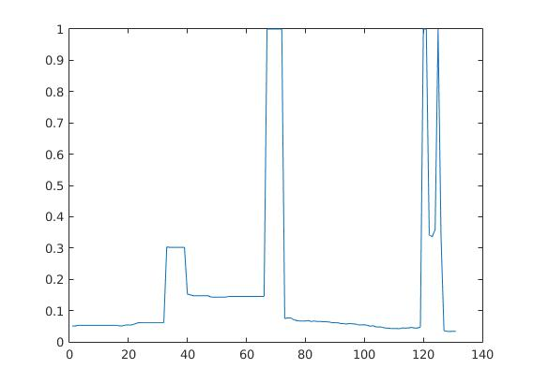
Normalised Distance from Obstacle
Time
Time
Log of the Normalised Distance from Obstacle
METHOD 2 (Max. Dist.): The larger ultrasonic values can be thresholded such that if the target value is x, and the minimum distance is 0cm, then the maximum allowed measurement is 2x. All values greater than 2x are converted to 2x before any PID processing. This allows for a design similar to the light sensor PID error, as shown below:

The results for both systems were tested and evaluated based on multiple variables (Results Table 3.0). Analysis of these results shows that a large amount of variable tweaking was required to obtain successes with the 'Log Method', and despite multiple attempts the success rate of the ‘Log Method’ was: 5 successes/14 runs = 36% success (keep in mind this was with non-constant parameters). The 'Log Method' seemed most generalised towards the task and a simpler implementation, but failed to produce effective results. The 'Maximum Distance Method', had a success rate of 4 successes/4 runs = 100% once the correct parameters were assigned to the PID controller. The clear choice was to use the ‘Maximum Distance Method’.

RESULTS:

Table 1.0: Encoder Accuracy Measurements:
Power (% NXT) | Time (seconds) | Encoder Distance Motor B (NXT encoder value) | Encoder Distance Motor C (NXT encoder value) | Observed Distance (cm)
25 | 2 | 312 | 319 | 15.0
25 | 2 | 325 | 320 | 15.5
25 | 2 | 328 | 310 | 15.5
25 | 2.5 | 395 | 389 | 18.5
25 | 2.5 | 391 | 402 | 19
25 | 2.5 | 395 | 399 | 19
25 | 3 | 477 | 479 | 23
25 | 3 | 478 | 468 | 23
25 | 3 | 463 | 469 | 22.5
25 | 3.5 | 558 | 543 | 26.5
25 | 3.5 | 549 | 546 | 26.5
25 | 3.5 | 563 | 542 | 27

Table 1.1: Gyroscope Accuracy Measurements:
Time (seconds) | Power (% NXT) | Angle (Degrees)
0.5 | 15 | 12
0.5 | 15 | 15
0.5 | 25 | 26
0.5 | 25 | 28
0.5 | 35 | 49
0.5 | 35 | 49
0.5 | 45 | 67
0.5 | 45 | 65
1.0 | 15 | 27
1.0 | 15 | 28
1.0 | 25 | 53
1.0 | 25 | 59
1.0 | 35 | 95
1.0 | 35 | 97
1.0 | 45 | 133
1.0 | 45 | 131
1.5 | 15 | 39
1.5 | 15 | 40
1.5 | 25 | 87
1.5 | 25 | 89
1.5 | 35 | 149
1.5 | 35 | 150
1.5 | 45 | 207
1.5 | 45 | 209
2.0 | 15 | 53
2.0 | 15 | 52
2.0 | 25 | 118
2.0 | 25 | 122
2.0 | 35 | 202
2.0 | 35 | 208
2.0 | 45 | 283
2.0 | 45 | 261

Table 1.2: calculations of encoder and measured distance values
Dataset | Standard Deviation | Covariance | Pearson Cor. Coef.
Measured Distance | 4.4458 | 407.65 | 0.99882
Encoder Distance | 91.802 | 407.65 | 0.99882

Table 1.3: calculations of angle and time
Dataset | Standard Deviation | Covariance | Pearson Cor. Coef.
Time | 0.59761 | 32.929 | 0.86646
Angle | 63.592 | 32.929 | 0.86646

TODO
Table 1.4: dead-reckoning controller error analysis
Target Angle (degrees) | Target Distance (cm) | Actual Angle (degrees) | Actual Distance (cm) | Error | Avg. Error of System

Table 2.0: Threshold Comparison of two PID values for robot leaving a line
PID Integral/Control Value? | Threshold | Time robot takes to know it is off a line (approx.) | Robot behaviour during normal line following (no spaces in line) | Notes
Integral | -45 | FAILS | WORKS | Robot couldn't know it left line
Integral | -40 | 2.0sec (sometimes) | WORKS | Robot only knew it was off the line sometimes
Integral | -35 | 1.0sec | WORKS (partial) | If the robot is line following for more than 10 seconds, it detects being off the line
Integral | -30 | 0.3sec | FAILS | Robot is quick to know it is off the line, but detects being off the line after driving more than 5 seconds
Integral | -25 | Instant | FAILS | Robot is off the line after driving for more than 2 seconds
Control | -35 | 1.5sec | WORKS | Big delay when leaving line
Control | -30 | 1.3sec | WORKS | Big delay when leaving line
Control | -25 | 0.8sec | WORKS | Delay when leaving line, but effective otherwise
Control | -20 | 0.5sec | WORKS (partial) | Subtle delay when leaving line. Only fails on normal line following with sharp turns
Control | -15 | Instant | FAILS | Able to know it had left a line, but during normal line following any turning behaviour caused the robot to think it was off the line

Table 3.0: Obstacle Trace Tests
Test Number | Battery Val | Obstacle Position | Distance From Object | Log/Max Dist. Method | PID Controller k_{p} value | PID Controller k_{i} value | Notes | Success?
1 | 7.3 | Centre Of Straight | 10cm | Log | 40 | 0.001 | Success | YES
2 | 7.35 | Centre Of Straight | - | Log | 40 | 0.001 | Failure- hit object on final turn (overturned) | NO
3 | 7.36 | Centre Of Straight | - | Log | 20 | 0.0 | Failure- Same as 2. | NO
4 | 7.36 | Corner | 10cm | Log | 20 | 0.0 | Success (overturning still possible issue) | YES
5 | 7.34 | Corner | - | Log | 25 | 0.0 | Failure (same as 2)- Changed k_{P} value from 20 to 25 | NO
6 | 7.32 | Corner | 15cm | Log | 25 | 0.0 | Success but wasn’t tight on box on final turn | YES
7 | 7.32 | Center Of Straight | - | Log | 25 | 0.0 | Failure | NO
8 | 7.28 | Straight Parallel to Obstacle | - | Log | 25 | 0.0005 | Failure- Changing integral value- k_{i} to 0 from 0.0005 | NO
9 | 7.25 | Corner | - | Log | 20 | 0.0005 | Failure- overturned on first corner | NO
10 | 7.26 | Corner | - | Log | 20 | 0.0005 | Failure- overturned on second corner. - Turning speed down 55 – 40, | NO
11 | 7.25 | Corner | - | Log | 10 | 0.0 | Failure- Turning k_{P} to 10 and removing k_{i} | NO
12 | 7.25 | Corner | 20cm | Log | 10 | 0.0 | Success (quite wide from box) | YES
13 | 7.24 | Center Of Straight | - | Log | 15 | 0.0 | Semi- Failure( Went so wide that it hit line before turning second corner)- Tuning k_{P} to 15 | NO
14 | 7.25 | Center Of Straight | 5cm | Log | 15 | 0.0 | Success (but very close to box on finish) | YES
15 | 7.2 | Center Of Straight | - | Max Dist. | 15 | 0.0 | Failure- Wide after first turn and overturned on second corner- Set maximum on data | NO
16 | 7.27 | Corner | 10cm | Max Dist. | 25 | 0.0 | Perfect | YES
17 | 7.25 | Corner | 10cm | Max Dist. | 20 | 0.0 | Perfect | YES
18 | 7.2 | Corner | 14cm | Max Dist. | 20 | 0.0 | Perfect | YES

Table 2.0: Broken Line Tests
Test Number | Battery Val | Off Line Constant Value | Notes
1 | 7.41 | 25 | Success- Timed out early
2 | 7.46 | 25 | Failure- Overshot turn after initial line then undershot second line on left side.
3 | 7.48 | 25 | Moderate Success- Missed last line (Due to dodgy paper)
4 | 7.45 | 20 | Failure- Didnt detect new line as was off line for too long- OLC value no good
5 | 7.46 | 23 | Success
6 | 7.2 | 23 | Absolute Success

