IMAGE SEGMENTATION:

The whole process of segmenting the image was divide into four distinct steps: Edge Detection, Pre-Processing, Clustering, Minimum-Bounding Box

Edge-Detection:

Although it's a simple process for our human eyes to simply segment, remove and distinguish objects within these images, this does not mean the process to accomplish this should be approached lightly. Before objects can be analysed for what they are, they first have to be distinguished from any background and noise they are overlapped with. The coursework mentioned an approach of background removal by taking the mean pixel values of all the images to construct an artificial background. Although this approach produced an effective background, it was not a general enough approach to prove satisfying if one were not given the luxury of such an abundance of images and orientations. Instead we looked into an approach of removing the background by using a single image and a general algorithm for all ranges of backgrounds (referring to backgrounds with little noise and consistent patterns).

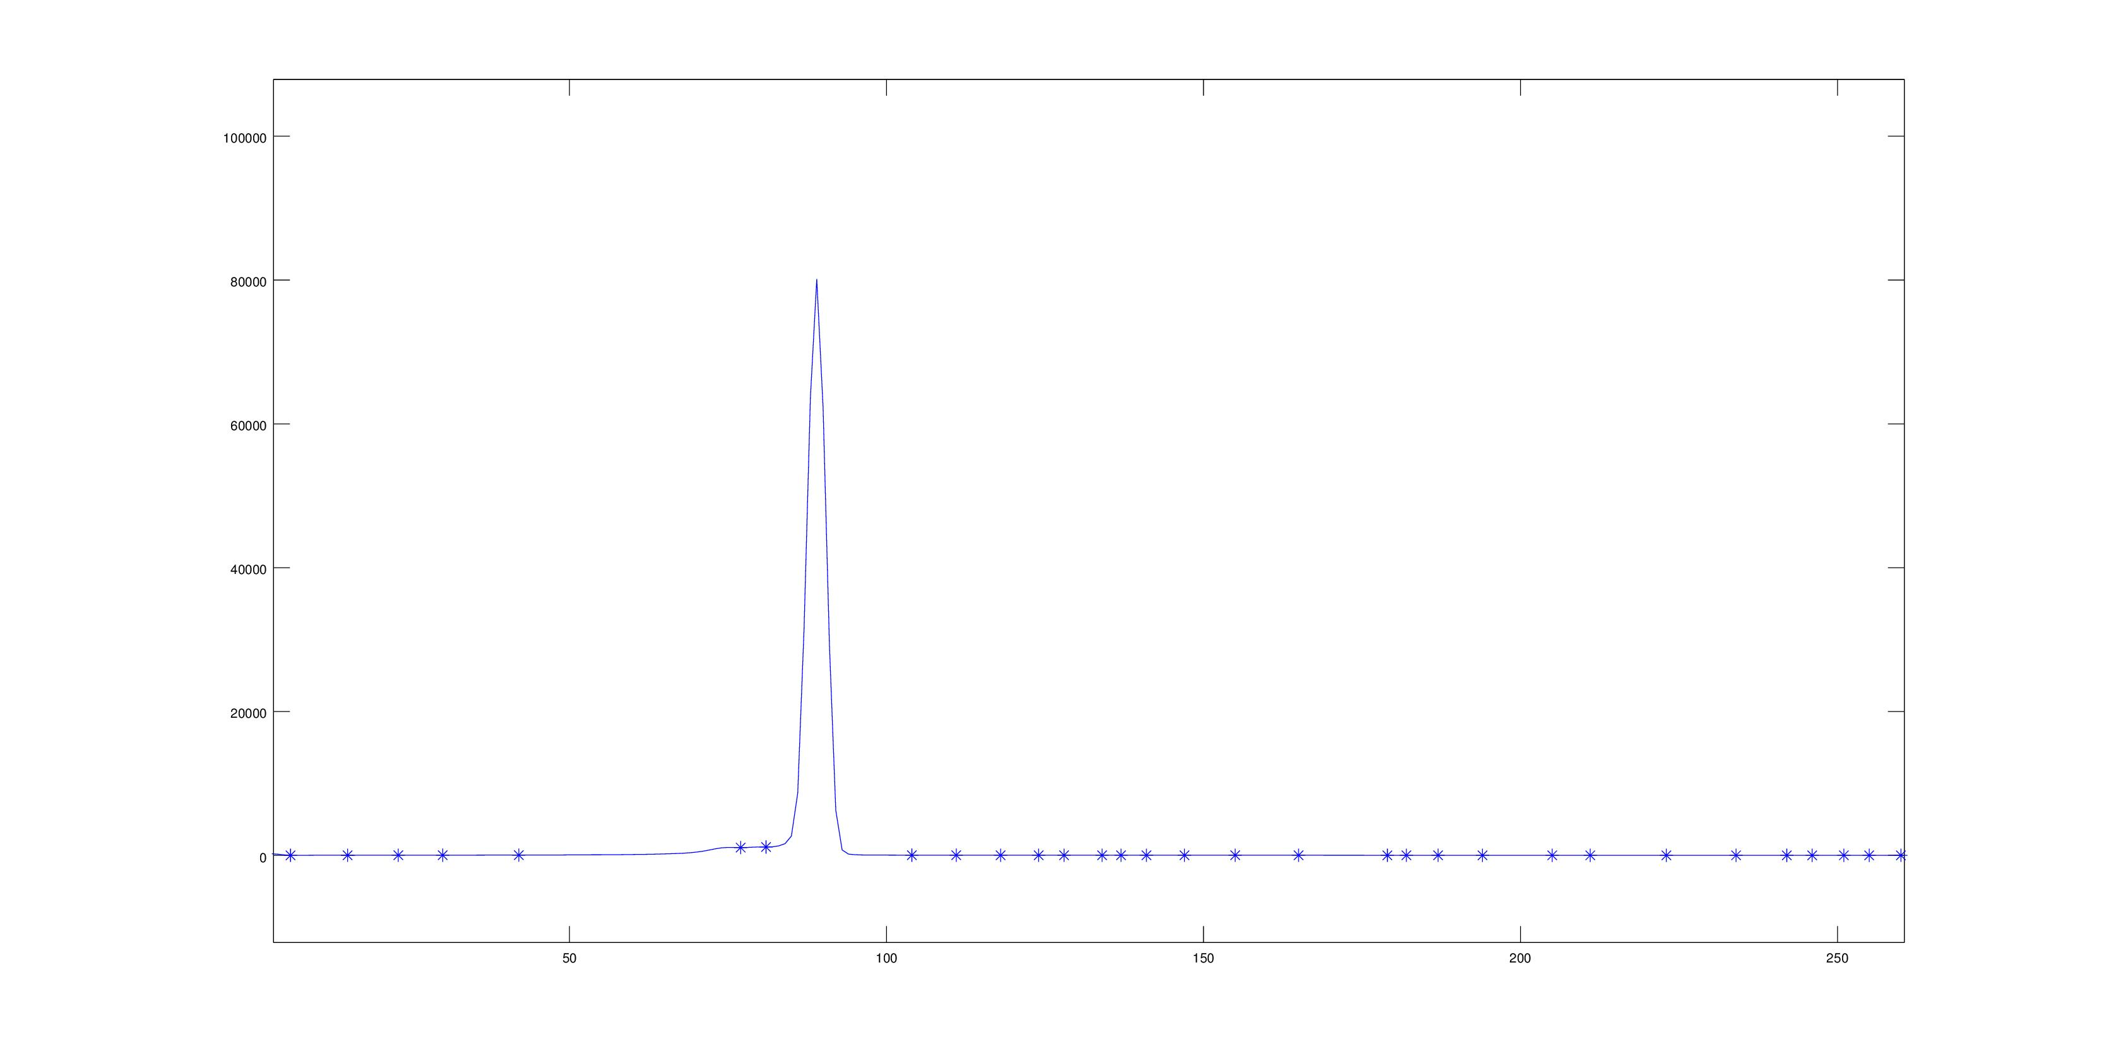
As discussed in class, the histogram representation of an image is a powerful and informative graph to present the distribution of pixel values in an image. Usually represented by a series of spikes, finding the minimum of these spikes (after smoothing), gives general threshold boundaries for significant portions of an image.

The image was first normalised to remove shadows and inconsistencies in areas of the image, then each red, green and blue matrix was converted to a smoothed histogram and thresholds were defined by the minimums. Notice in the the histogram above there are a large number of thresholds; this is intentional, as it allows the image to obtain important details without blending the background to the foreground by over-generalising. After applying these threshold boundaries to the image:
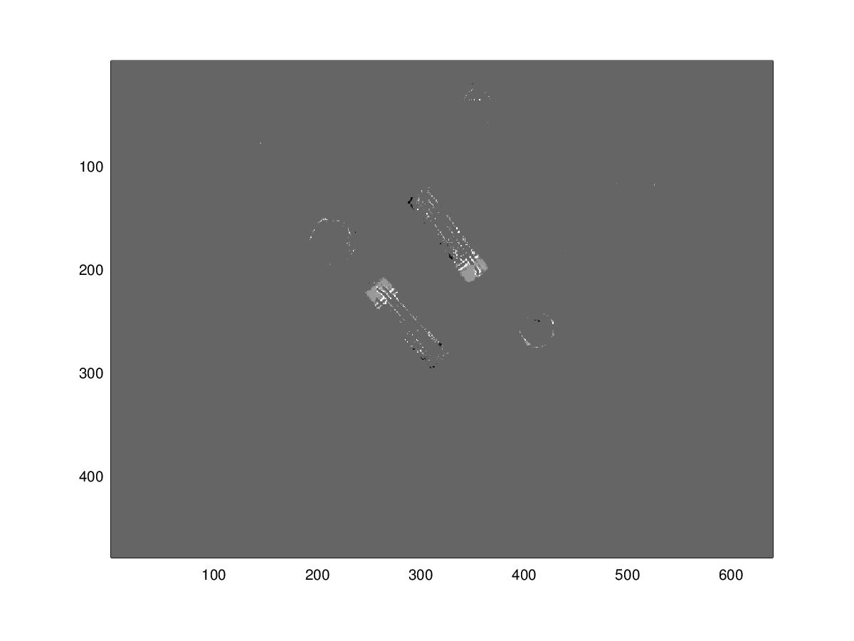
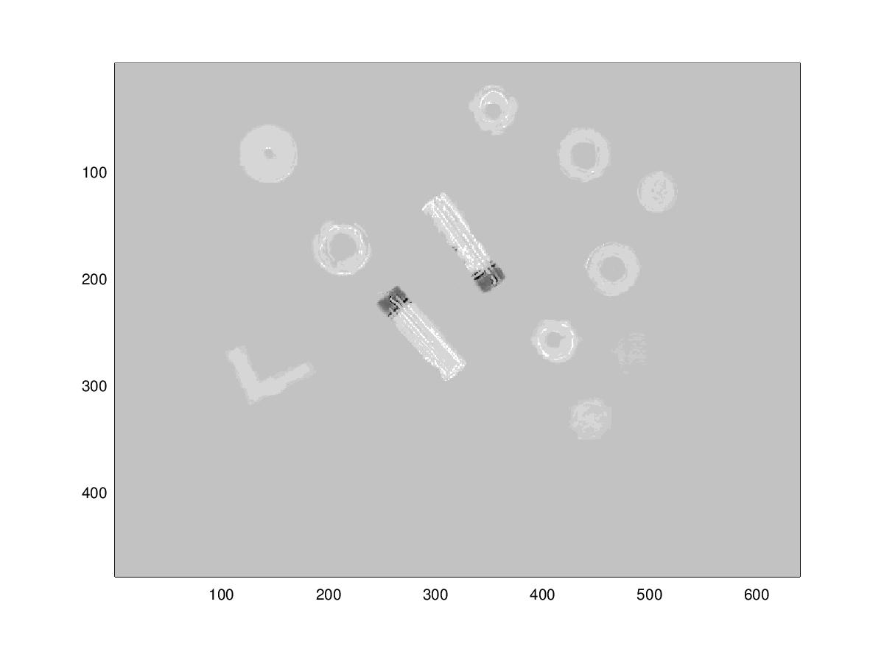
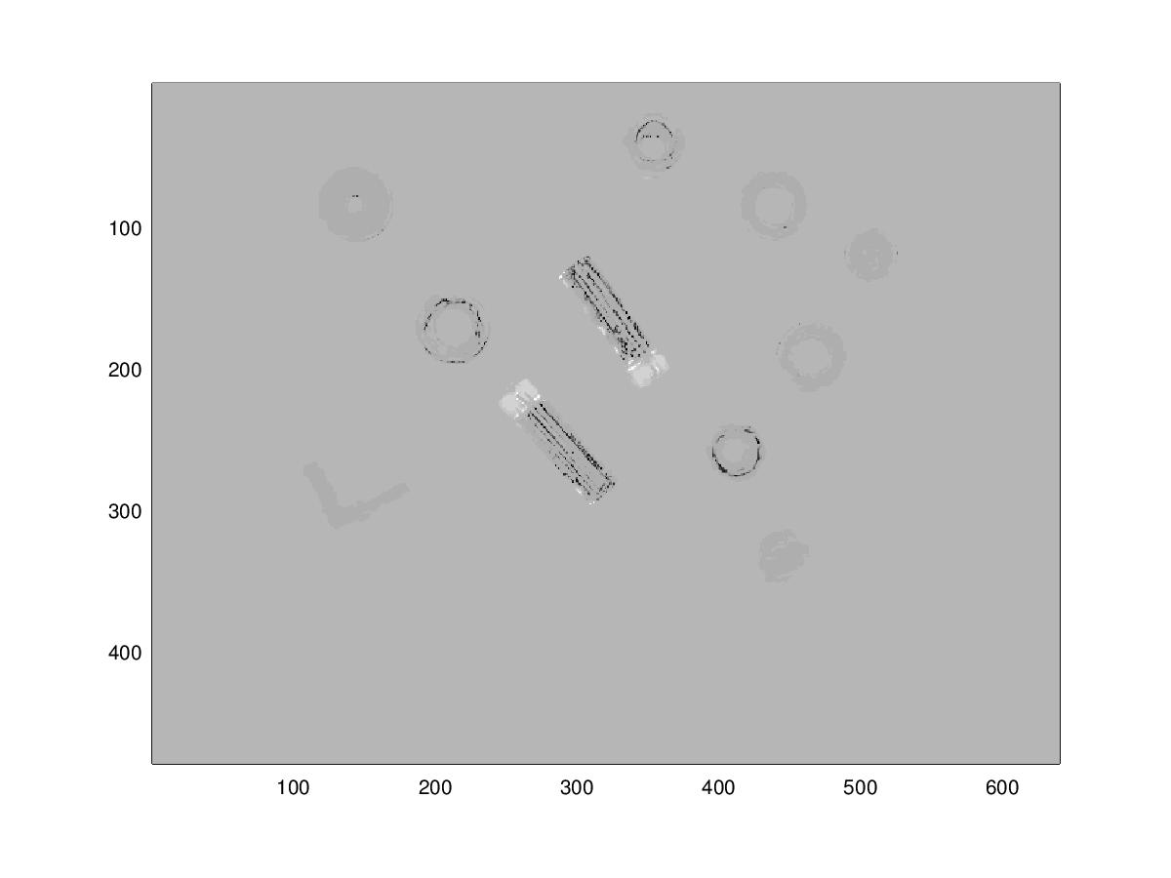
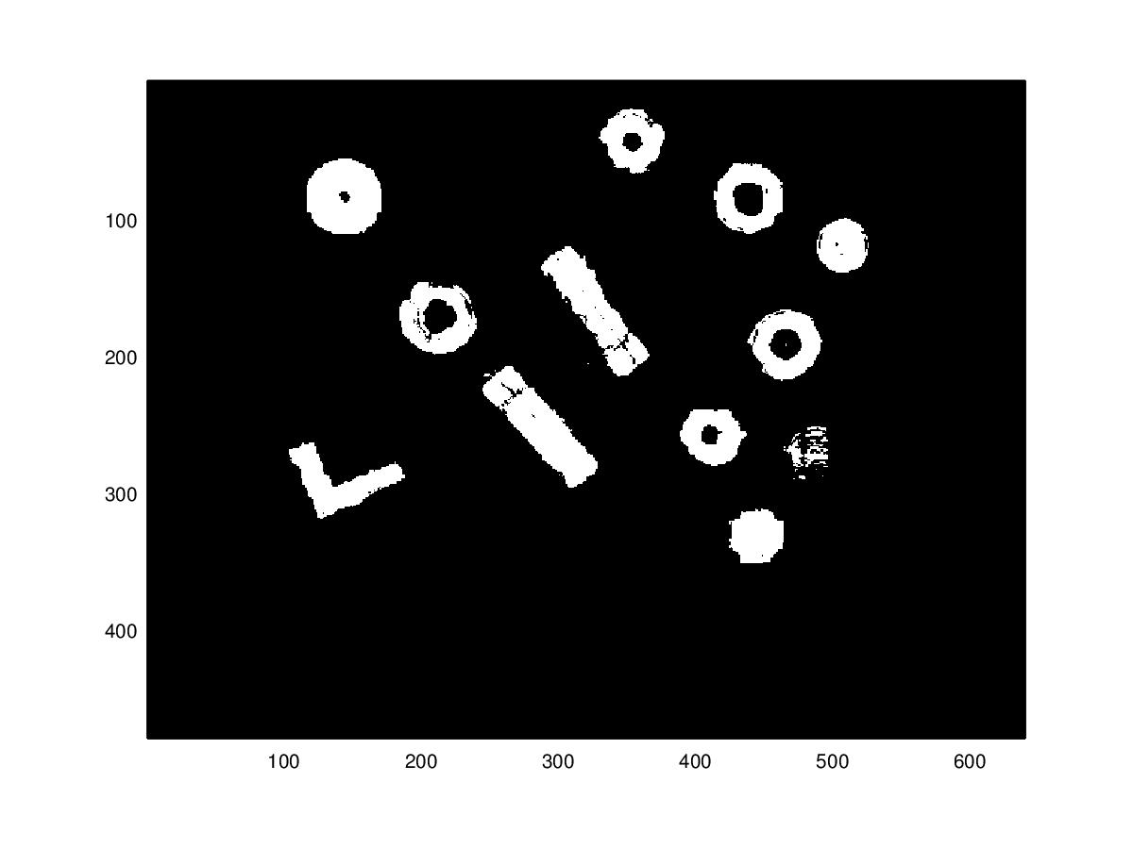
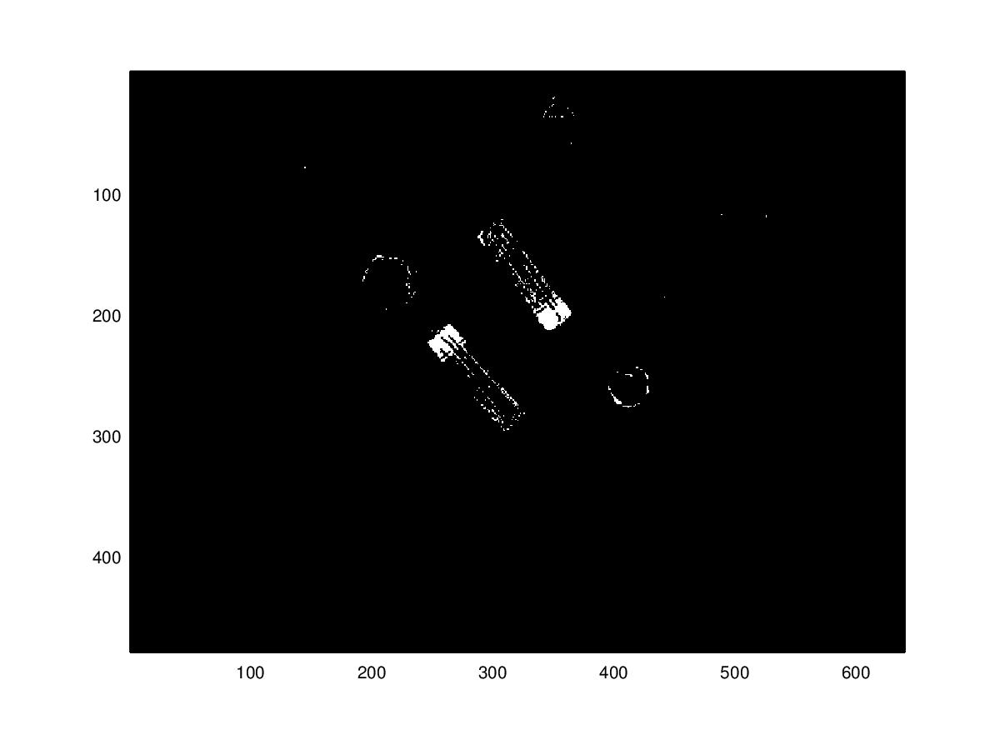
It is now clear that the image has been considerably simplified in its range of colour values. An important thing to note is that the background in all three threshold images has been converted to a constant colour and the noise has been removed. At this point it is easy to remove the background by finding the mode colour in all three images that occurs the most and use that as the new threshold to create three binary images:

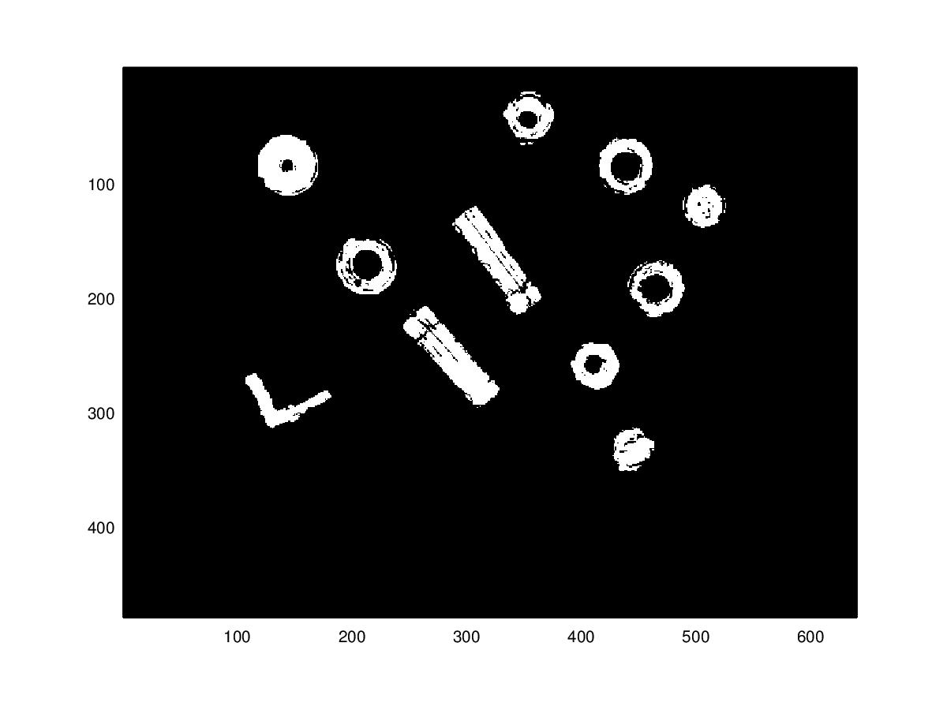
It is important to note that this threshold process has to be done on all three colour types red, green and blue. This can be proven by observing the above binary images and seeing how different detail is selected by each colour type; if the green image was chosen to be used, only the batteries would be identified, if the blue path was chosen, most of the image would be identifies, but without the red path the coin in the bottom right hand side would be lost in the thresholds. Hence all three images are used to give us three “attempts” at defining thresholds correctly. Merging the binary images with an OR statement gives us a single image matrix to work with where all the colour types are overlaid:
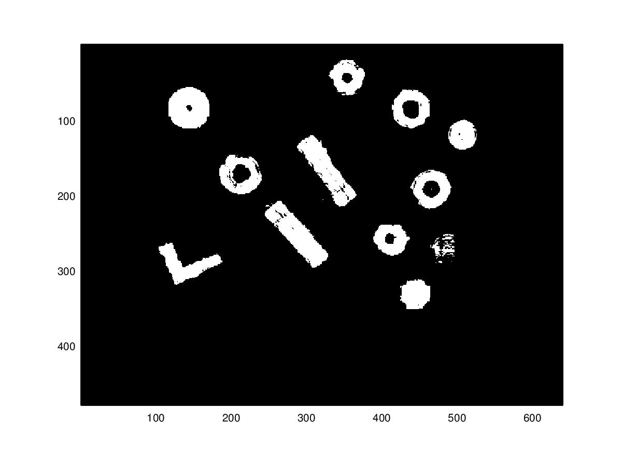
At this point it may seem that this is an almost perfect result and the next steps would be to cluster, feature-select, etc. and we have our individual image data. The above result is a very ideal example of the process. Take a look at the example below on another image:

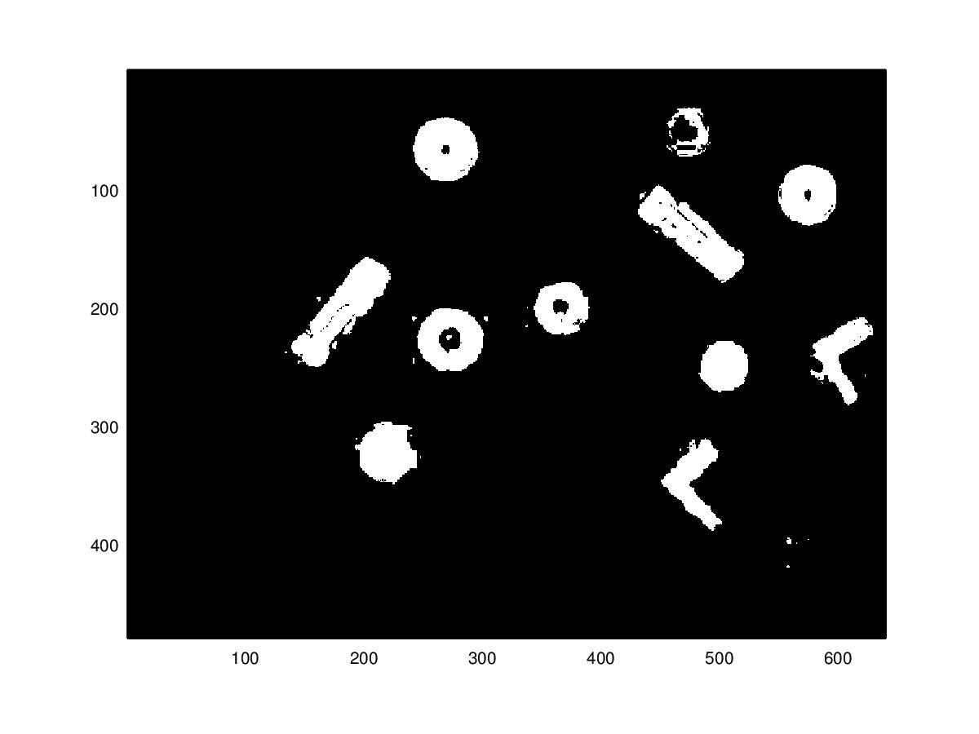
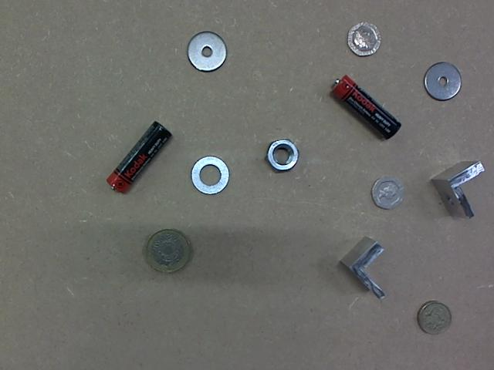
In this example, the image has done well to do a binary segmentation, but in the process it has kept some noise around the washers and batteries and also completely removed the one pound coin in the bottom right, leaving a tiny speck of white. Obtaining information from this binary image and further removing noise is what led to the perform further preprocessing for easier segmentation.

Pre-Processing:

The inspiration for the methods in pre-processing come from a pre-processing approach used in a modern Machine Learning model called Convoluted Neural Networks. These complex Neural Networks use multiple layers of convolution matrices and max-pooling matrices to bisect significant features from images, learning and evolving the weights of these matrices for the best output. Implementing an actually CNN would be far too complex and require a larger dataset for this task, therefore the methods of merging layers of max-pooling and convolutions are used with pre-set matrices.

Max-pooling an image gives two advantages; it reduces the size ratio of the image so that it is easier to perform algorithms on (i.e. searching during clustering) and reduces the noise in the image and emphasises unique features by selecting pixels with only the largest (and therefore most noticeaeble) value. The disadvantage to max-pooling is that it can be computationally expensive if the image is large and the pool size is small (the smallest case being a pool size of 1 and therefore having to traverse every pixel in the image).

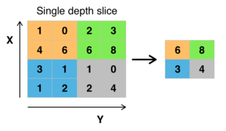
Source: https://upload.wikimedia.org/wikipedia/commons/thumb/e/e9/Max_pooling.png/314px-Max_pooling.png

Convolution is used to smooth the image and act as another noise filter, removing any spiky colour diffferences in pixels in a similar area, as it was used to smooth the histograms for threshold analysis.

Both these filtering algorithms can be chained together in many orders and with their parameters set to many different values (hence why using them in Neural Networks made it easier for the network to determine the values), therefore experimenting a tweaking of values is required to get the best results from these filters. Experimentation showed that two max-poolings and one convolution was generally the best approach due to computation and time constraints. A few filter orders are shown below; these demonstrate how much variation there is in filter choice and order:

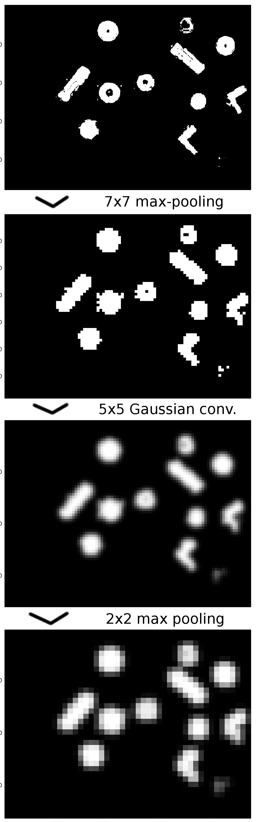
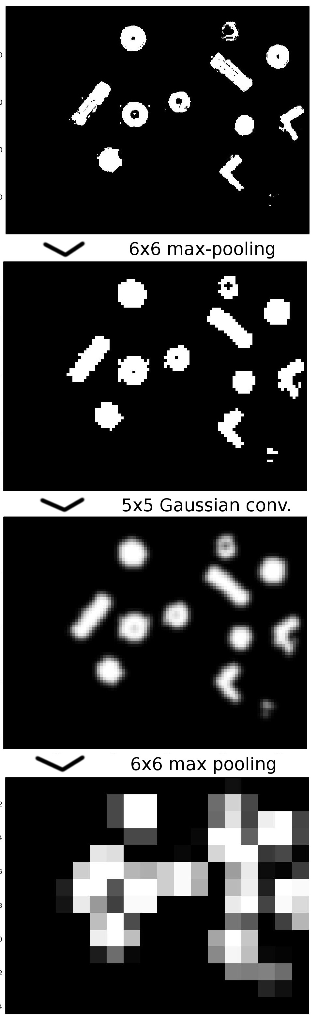
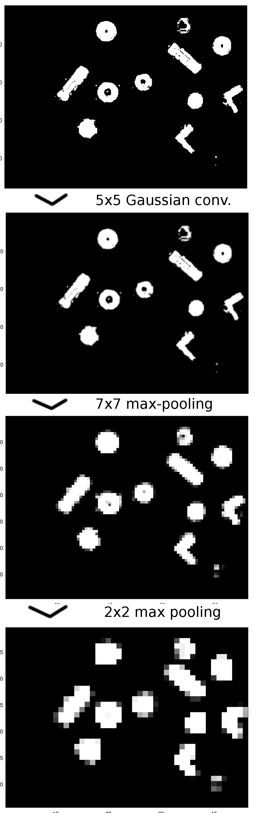
(Analysis of the max-pooling and convolution filters will be provided later in the report after the whole method is introduced. Tests will be run on filters of different values and parameters and the amount of objects correctly segmented will be recorded as the accuracy measurement.)

Link Clustering:

Pseudo code for link clustering below:

1. while (true) {
2. if queue == empty {
3. a = get next non-zero value in binary image matrix M
4. if a == NULL
5. exit()
6. else
7. a.class ← nextClass
8. queue.add(a)
9. M{a} ← 0
10. nextClass++
11. }
12. else {
13. b ← queue.pop()
14. {C} ← horiz. and vert. neighbours to b in matrix M
15. foreach c in {C} {
16. c.class ← b.class
17. queue.add(c)
18. M{c} ← 0
19. }
20. }
21. }

Once a series of blobs had been created from the image, it was necessary to extract these blobs as separate entities from the image so that features could be individually selected from each blob. The obvious method to extract these blobs is via a clustering algorithm – the obvious ones of which are to use k-means clustering on a range of possible clusters,or mean-shift clustering. Both these clusters have their drawbacks (k-means requires knowing the cluster count beforehand and mean-shit can be computationally expensive) and do not utilise an important aspect of the blobs in the image. Due to the pre-processing of the image, the image complexity (aspect ratio) has been greatly reduced. Any blob in the image will contain pixels that are neighboured to one another:
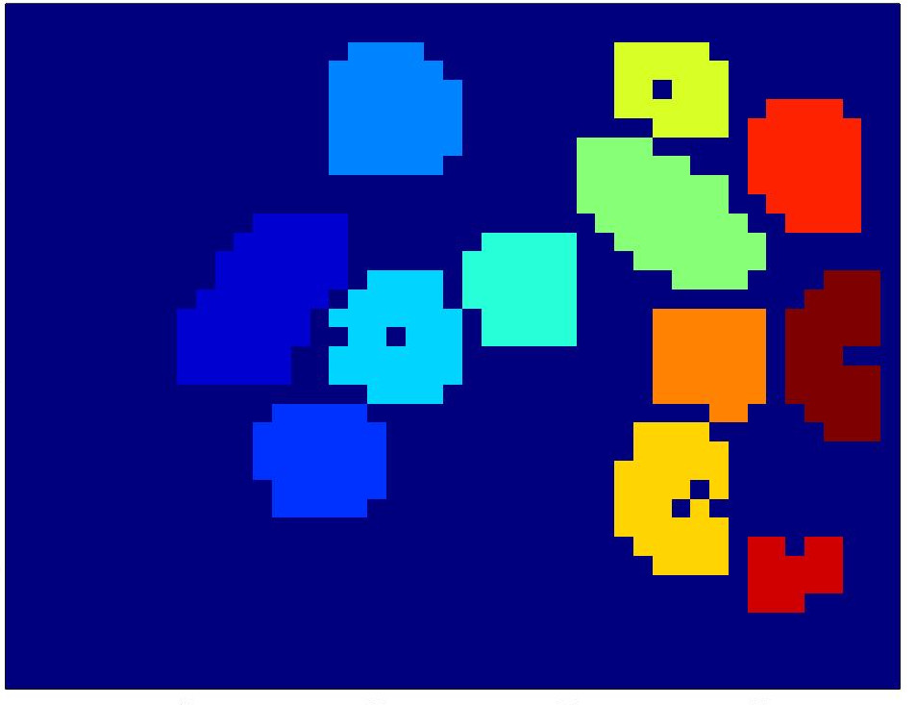

This allows us to create an algorithm that clusters in linear time, such that each pixel is only processed once by the algorithm. This faster algorithm does come with a drawback. Because link clustering relies on blobs being composed of neighboured pixels, there are cases where the algorithm can fail:

1. A blob overlaps with another blob in the image, resulting in the algorithm clustering these two blobs as a single blob.
2. A blob is not extracted correctly and has 'breaks' in its pixel composition, resulting in the one blob being clustered as two blobs.

Both these cases can be avoided by performing the correct pre-processing of the image such that blobs are segregated appropriately. Of course there are still cases where bad lighting, shadows and similarity to the background can cause blobs to be incorrectly segmented. Avoiding these scenarios would require more powerful pre-processing methods and possibly and advancement on the current clustering technique to incorporate a degree of 'error freedom' when choosing neighbours.

Minimum-Bounding Box:

The hardest part of the segmentation has been performed once the individual items in the image have been clustered into unique blobs. The next step involves either analysing each blob based on its relative location in the image (using moments, etc), or to separate each blob into a minimum-bounding image to make it easier to calculate features such as compactness, area, etc. The latter method was chosen for two reasons:

1. Allows the analysis of features such as perimeter, area, compactness and pixel counting to be easier
2. If a box is drawn around the blob and then that box is cut from the original image (not the clustered image), some information may be restored that was lost in the segmenting of the image (i.e. colours, shapes, holes in objects).

The algorithm for the minimum bounding box is very simplified and, if more time permitted, could probably be improved by more modern approaches:

1. data_gain ← MAX_INT
2. box_offset ← 5
3. while(data_gain > 0) {
4. b_left ← cluster.centre.x - box_offset
5. b_right ← cluster.centre.x + box_offset
6. mb_box = image(b_left:b_right, :)
7. data_gain ← num new non-zero pixels in new box
8. }
9. data_gain ← MAX_INT
10. box_offset ← 5
11. while(data_gain > 0) {
12. b_top ← cluster.centre.y - box_offset
13. b_bottom ← cluster.centre.y + box_offset
14. mb_box = image(b_left:b_right, b_top:b_bottom)
15. data_gain ← num new non-zero pixels in new box
16. }
17. return mb_box
Here are some examples of segmented images without using the bounding box to get the whole image area around the blob (blob has been cropped from the larger image for convenience):

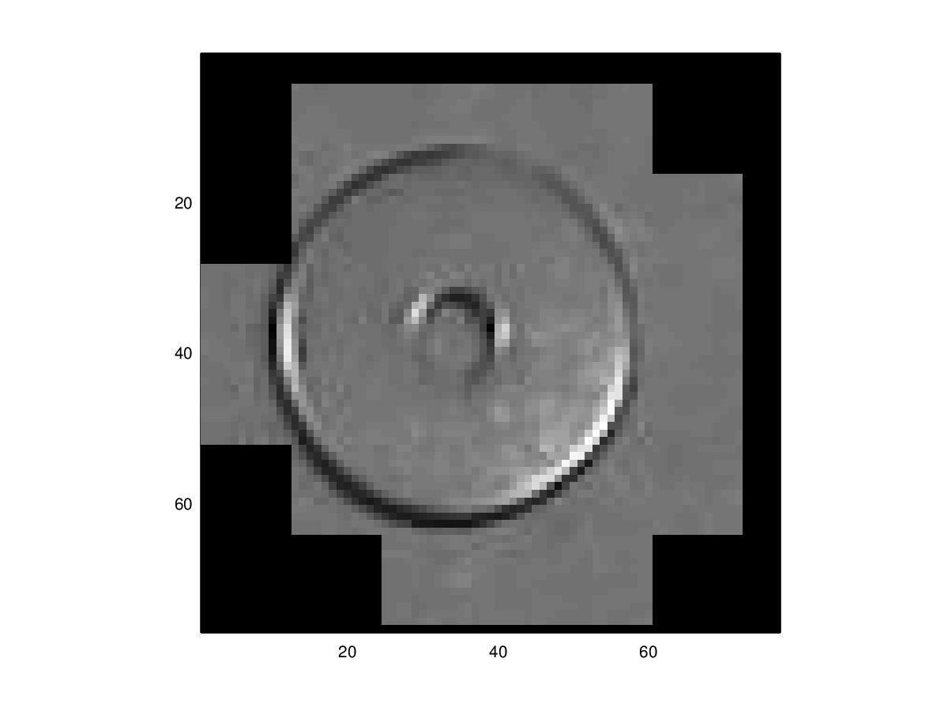
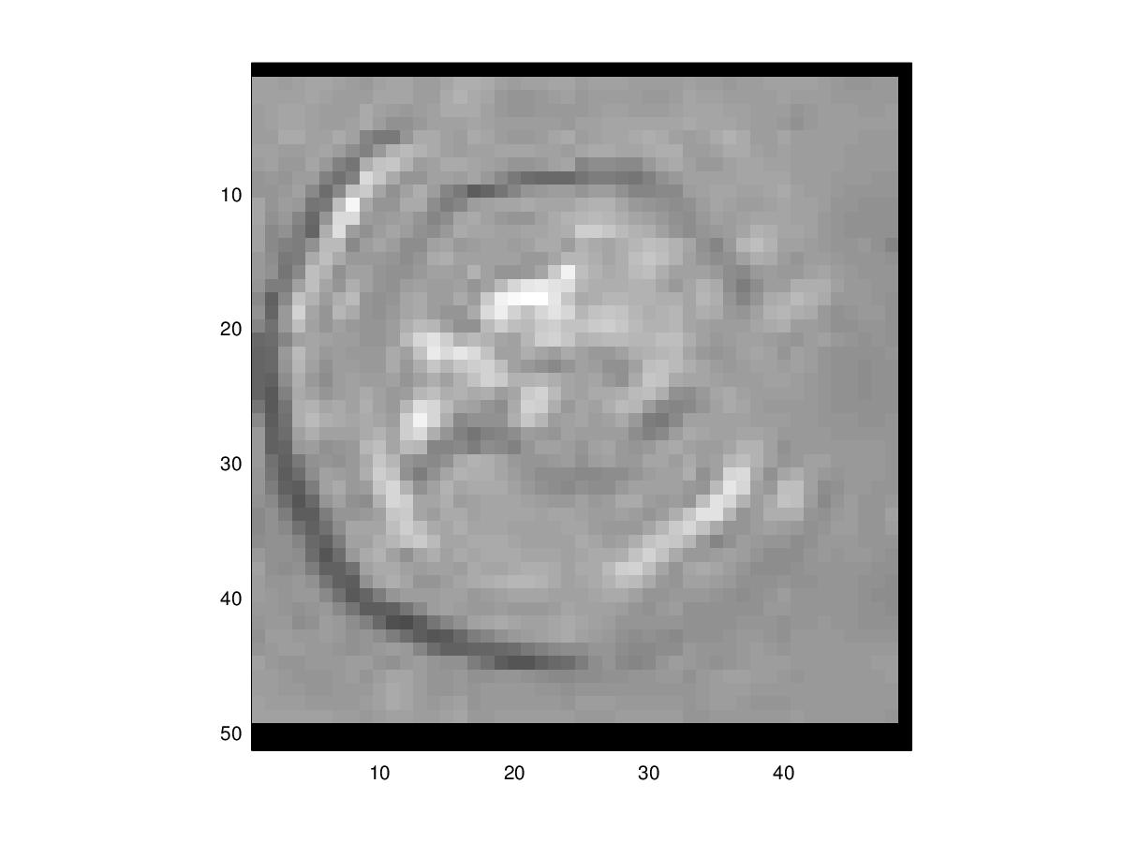
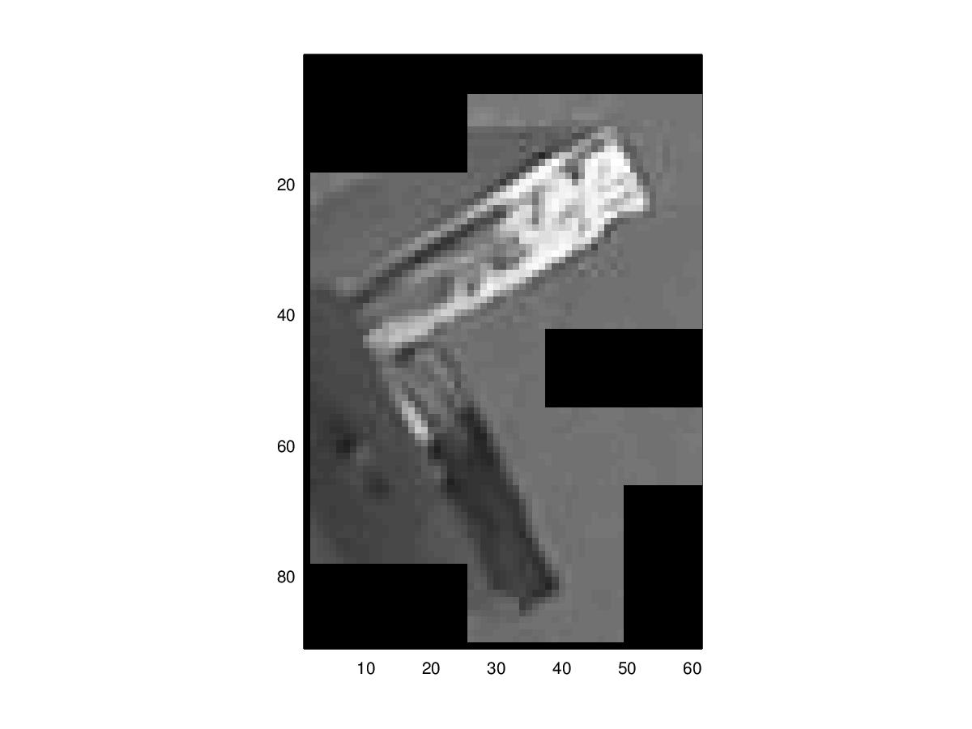
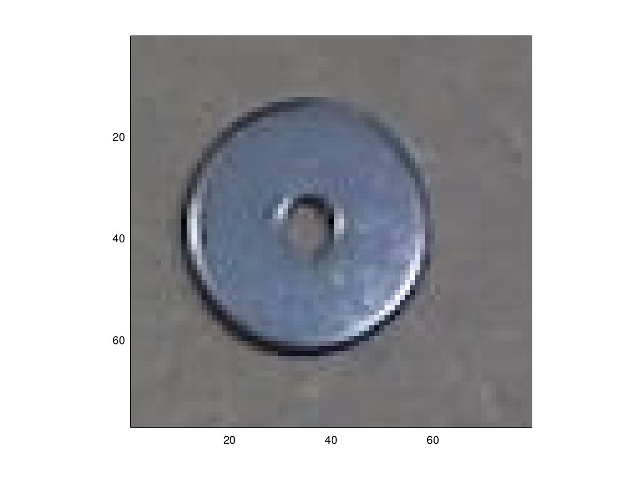
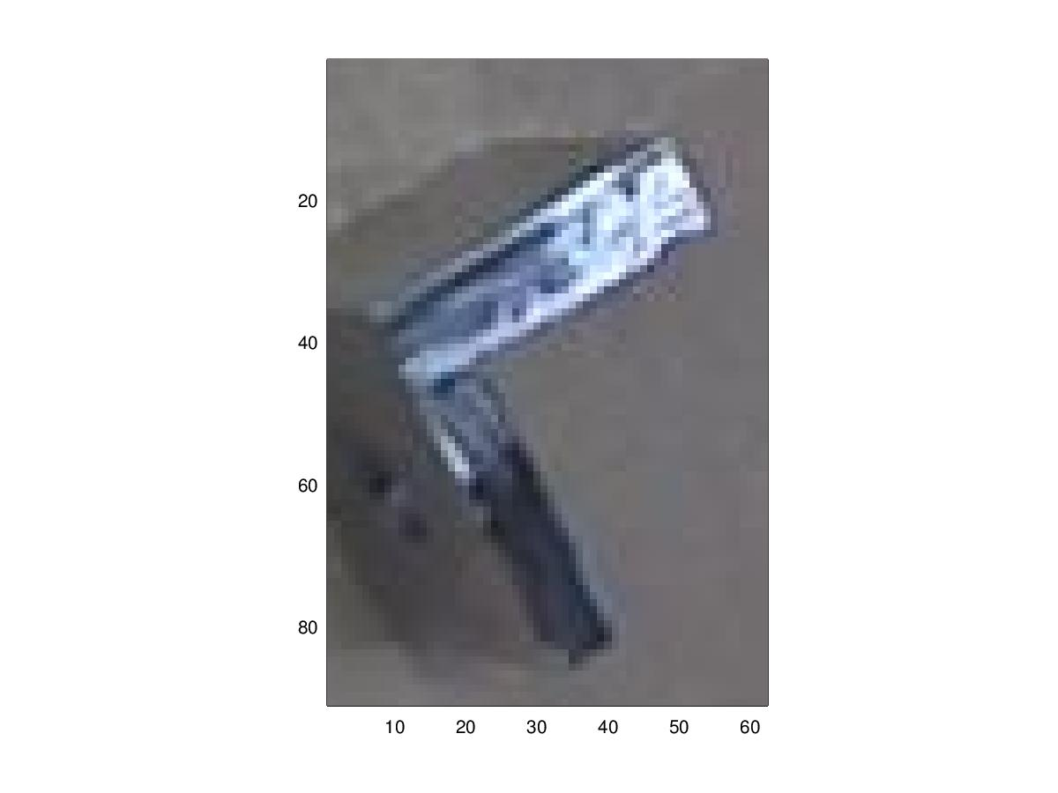
Note that the image on the right and middle are the only ones that fully preserved the entire image. After applying the minimum-bounding box, the whole image is available to analyse.
Segmentation Analysis:

Class | Ration Correctly Segmented | Best Segmentation | Worst Segmentation
One Pound | 4/12
Two Pound | 4/7
50p | 4/4
20p | 5/10
5p | 6/7
Washer Small Hole | 8/12
Washer Large Hole | 10/12
Angle Bracket | 11/11
AAA Battery | 10/10
Nut | 9/9
TOTAL | 71/94 = 76.0% acc.

Below is the best and worst segmentation of each class

BEST WORST
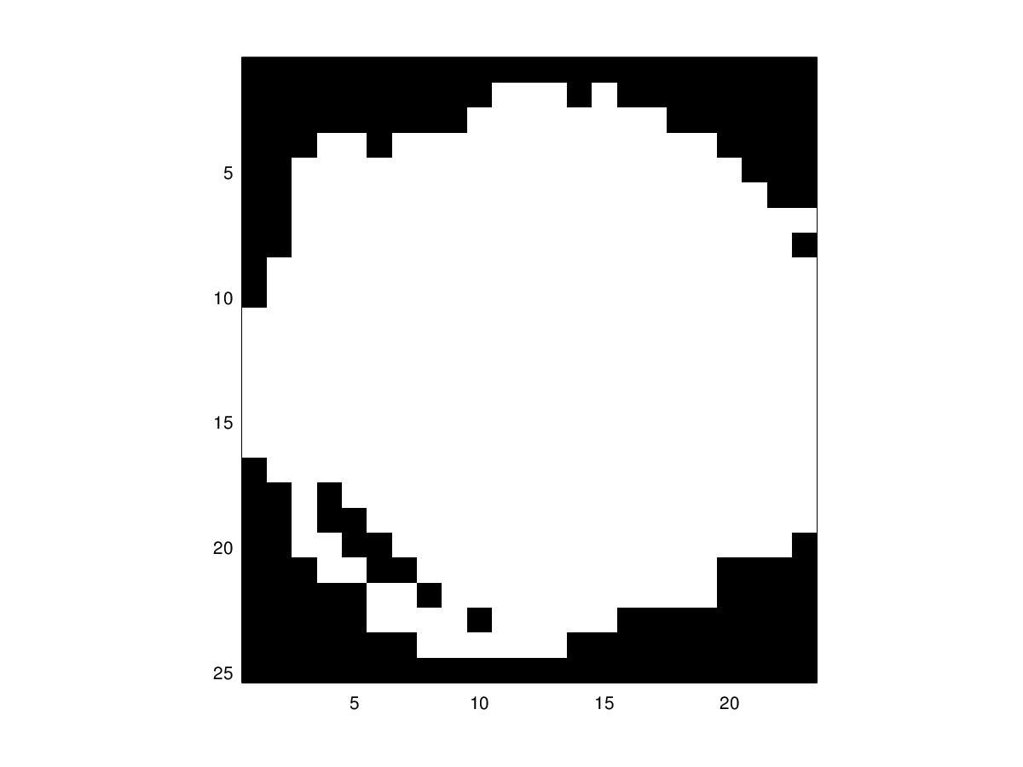
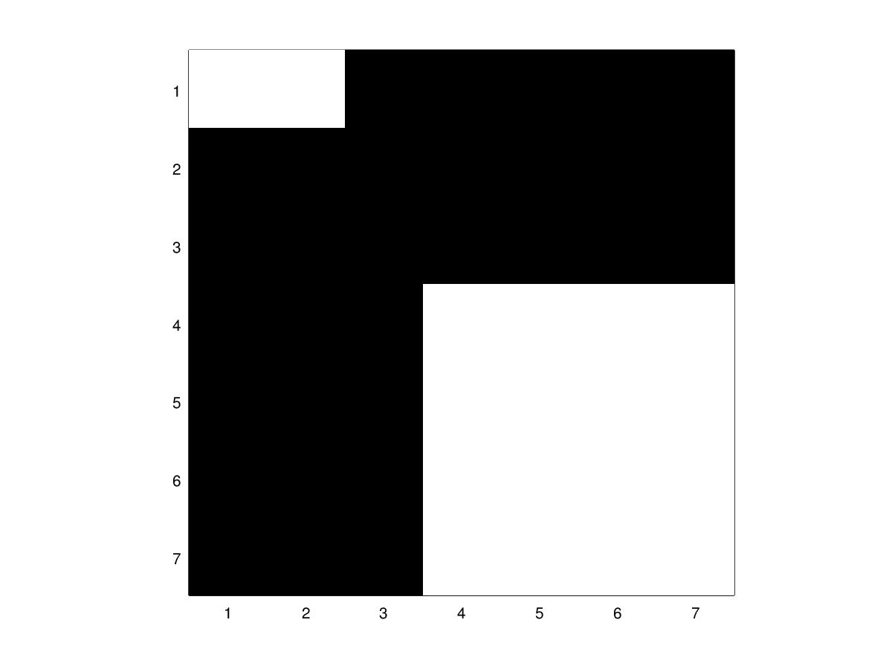

ONE POUND
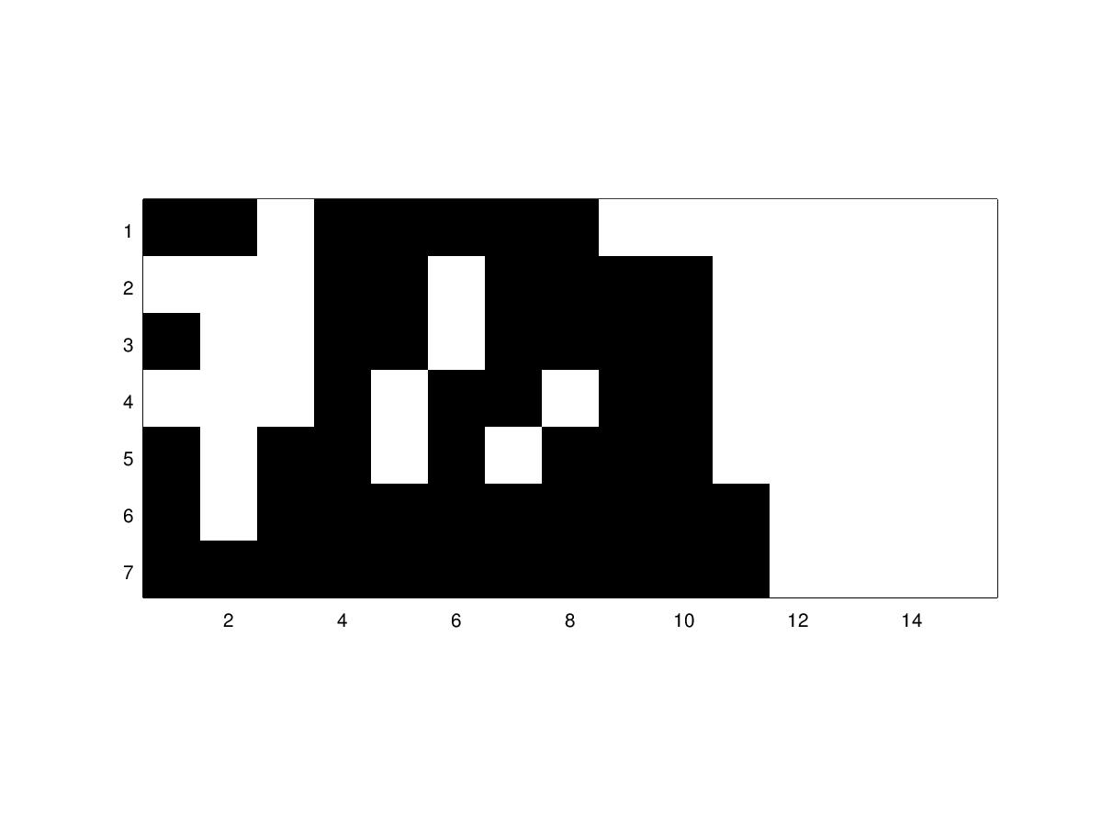
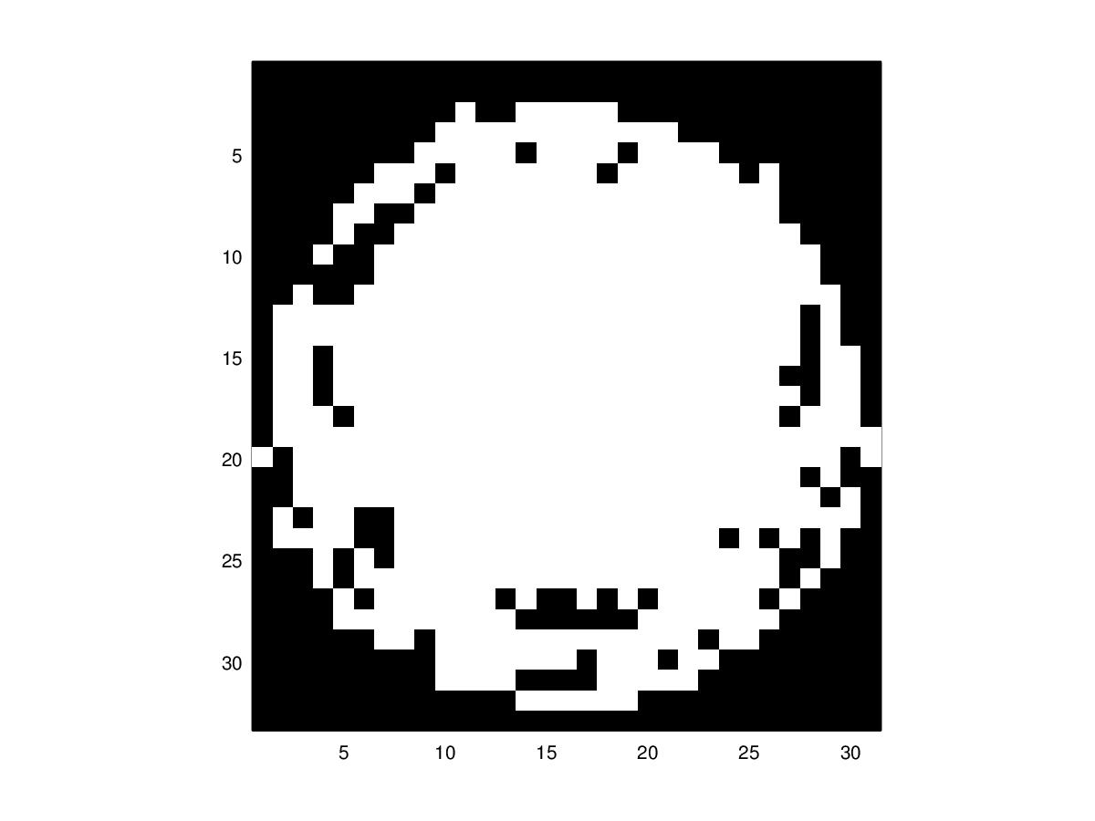

TWO POUND

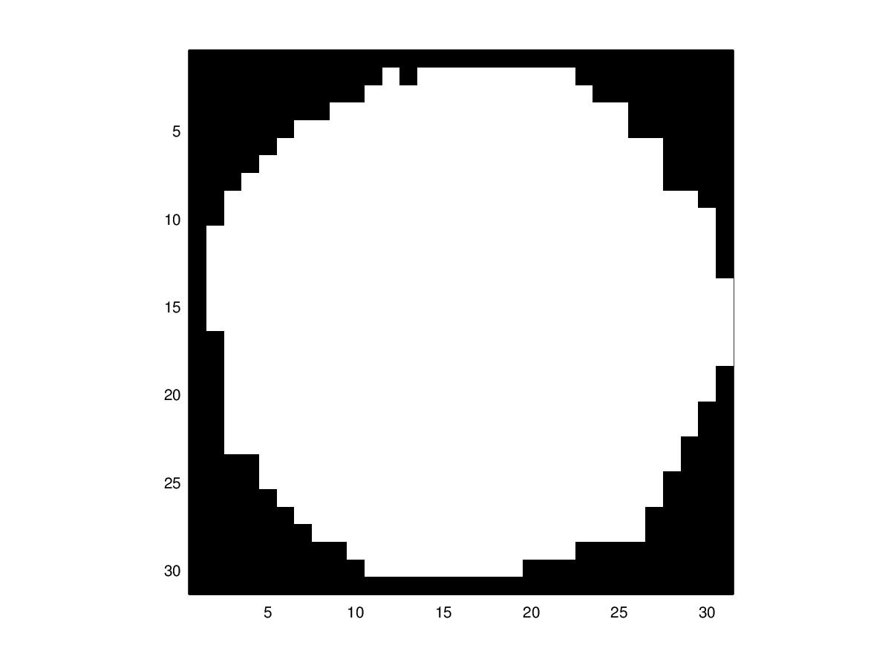
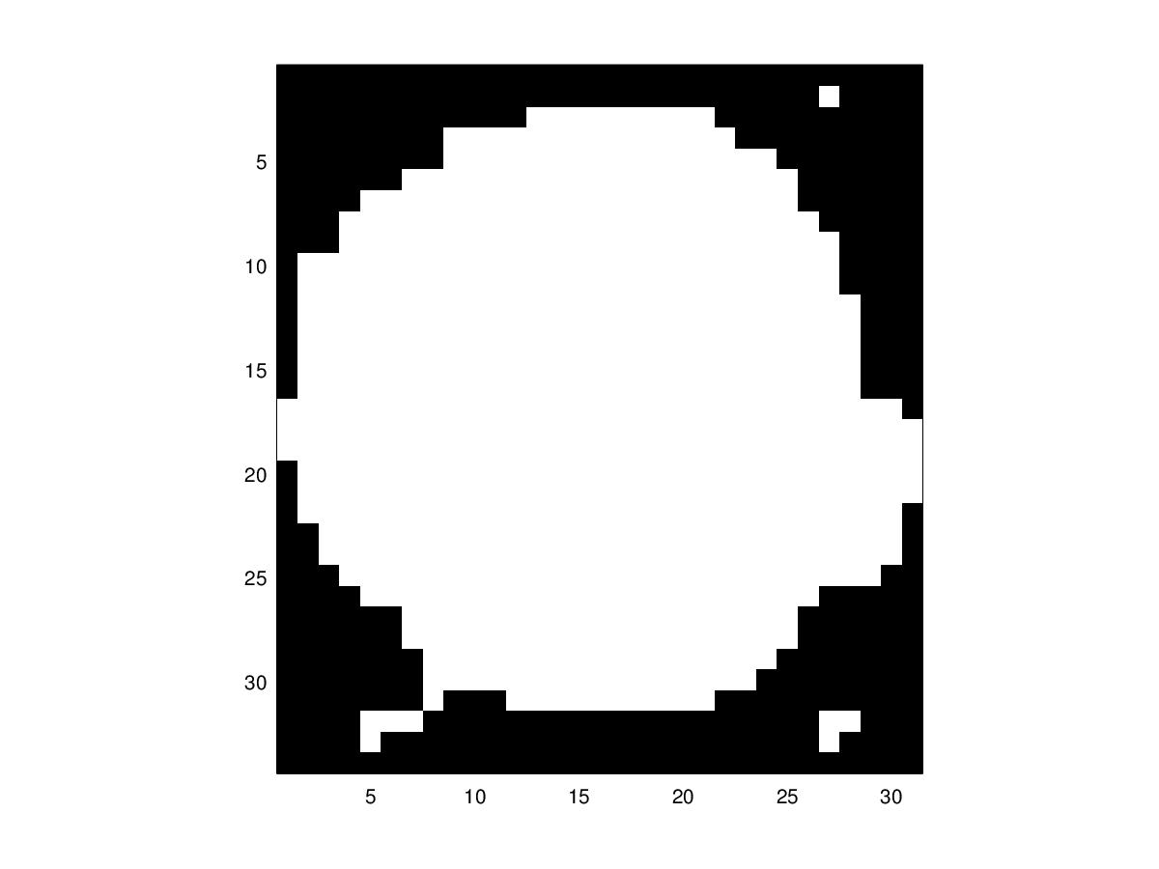

50P

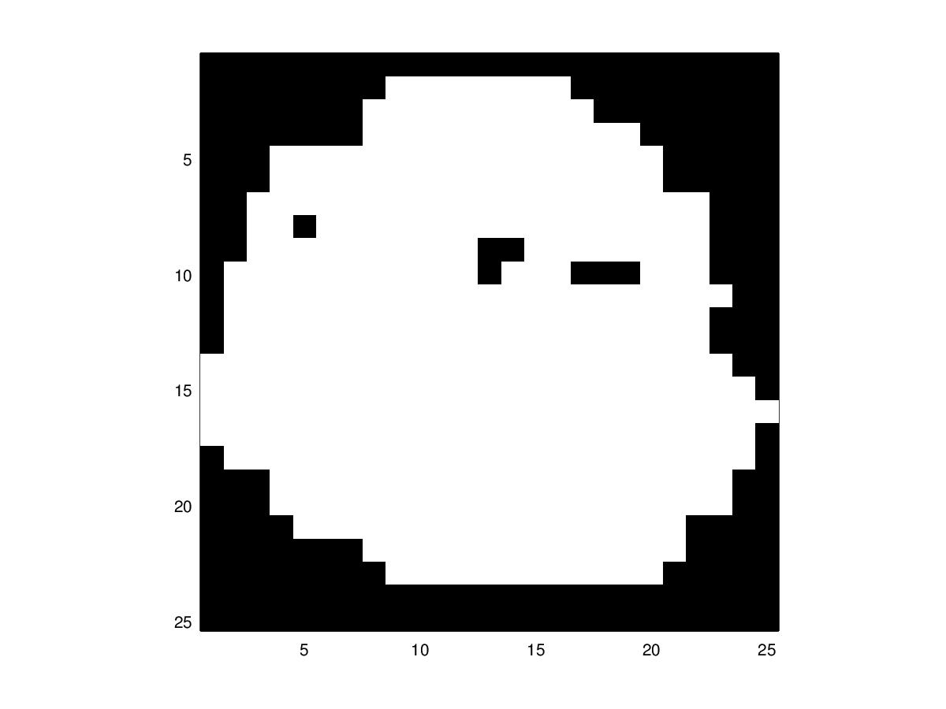
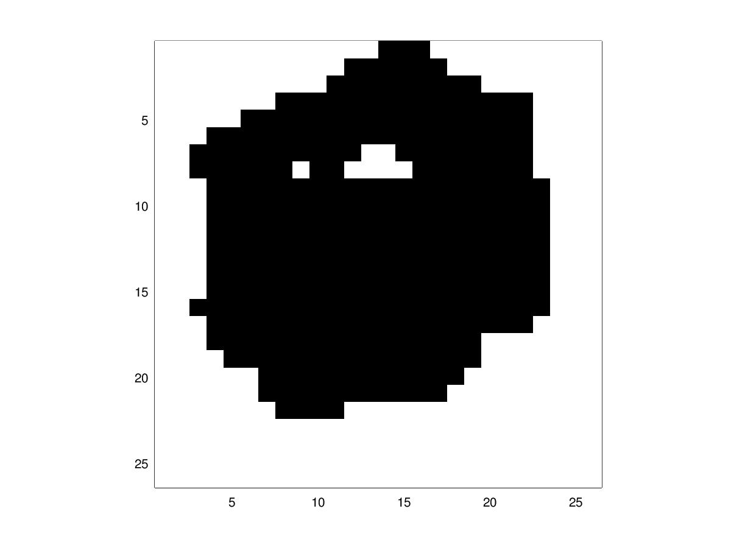

20P

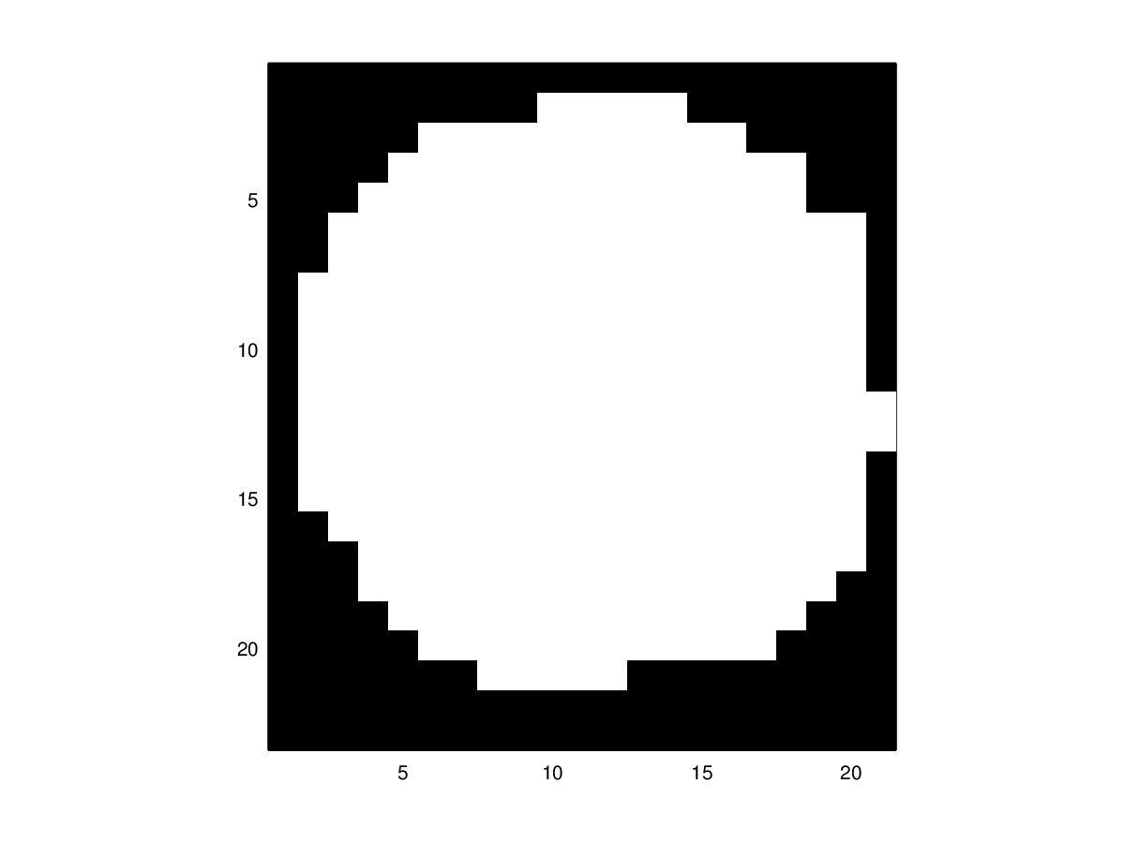
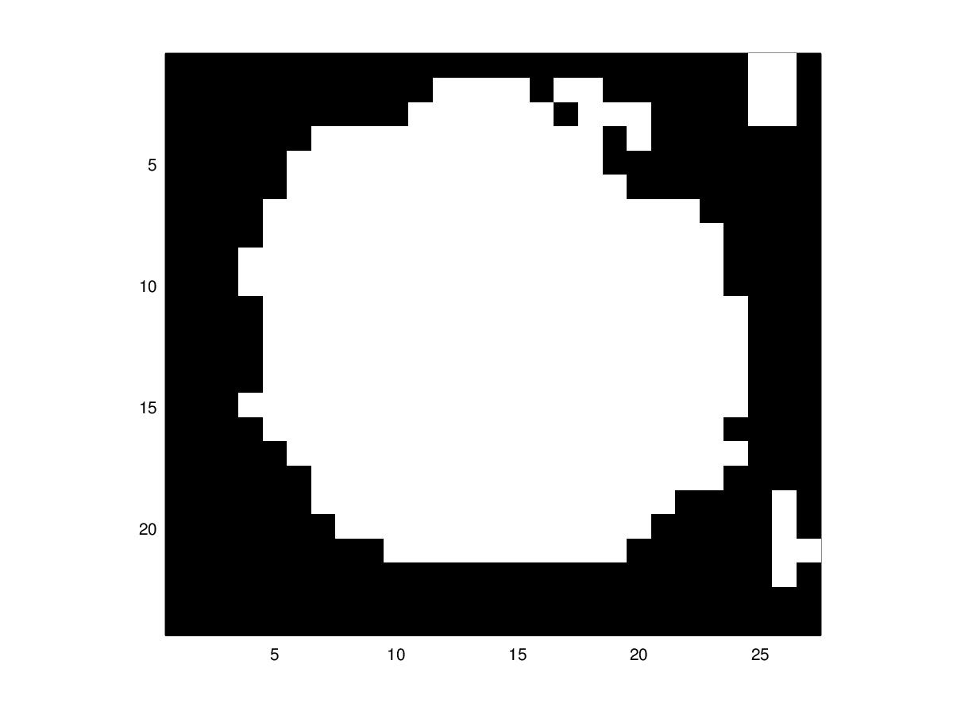

5P
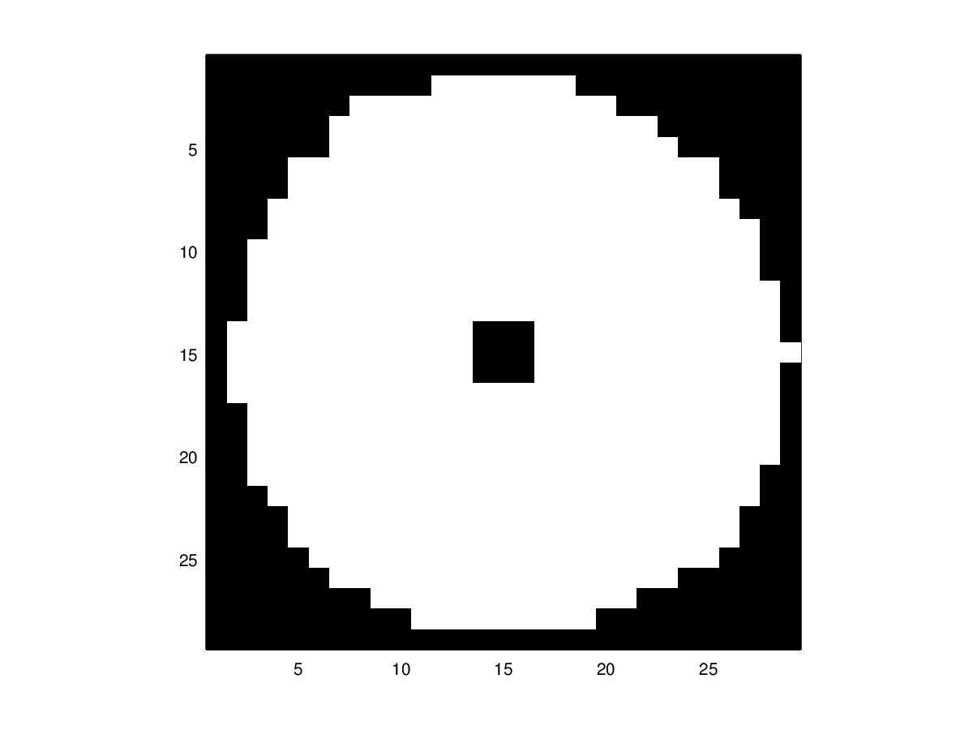
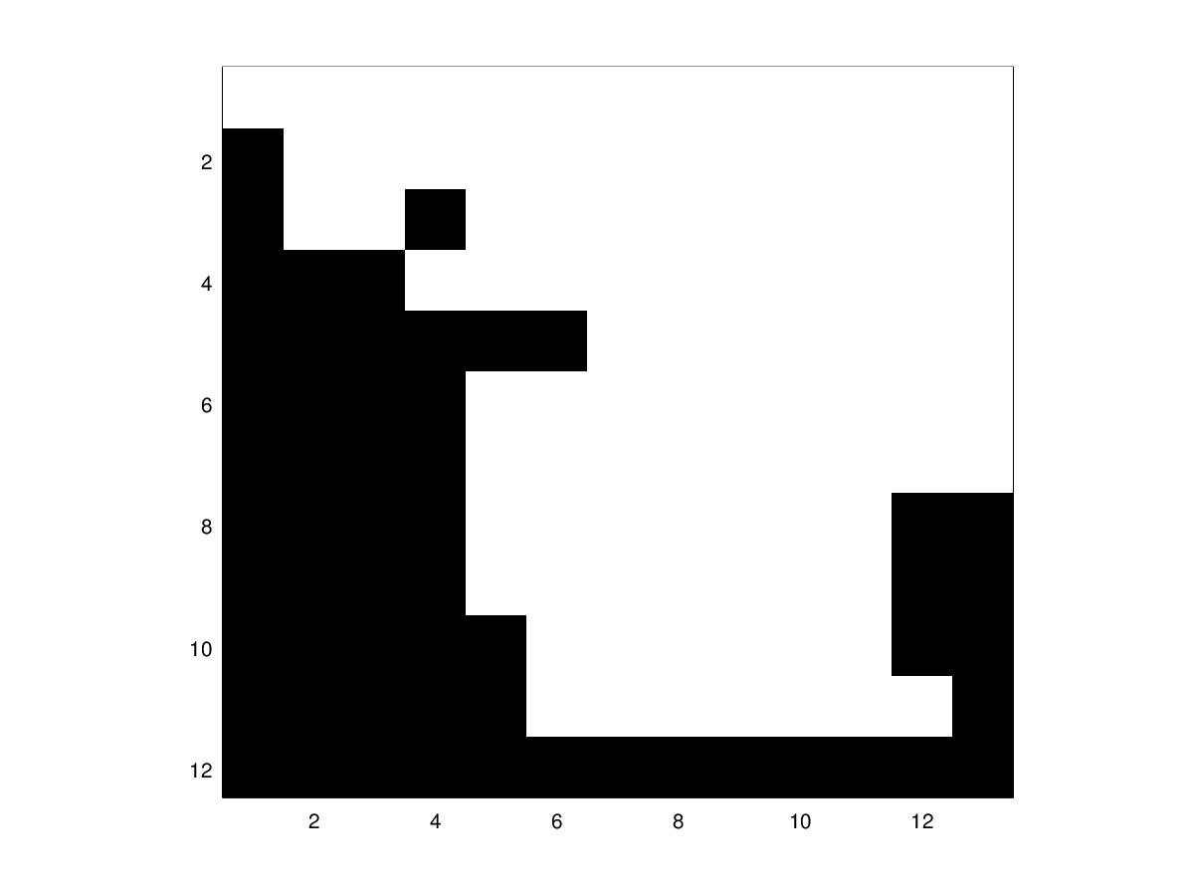

WASHER SMALL HOLE
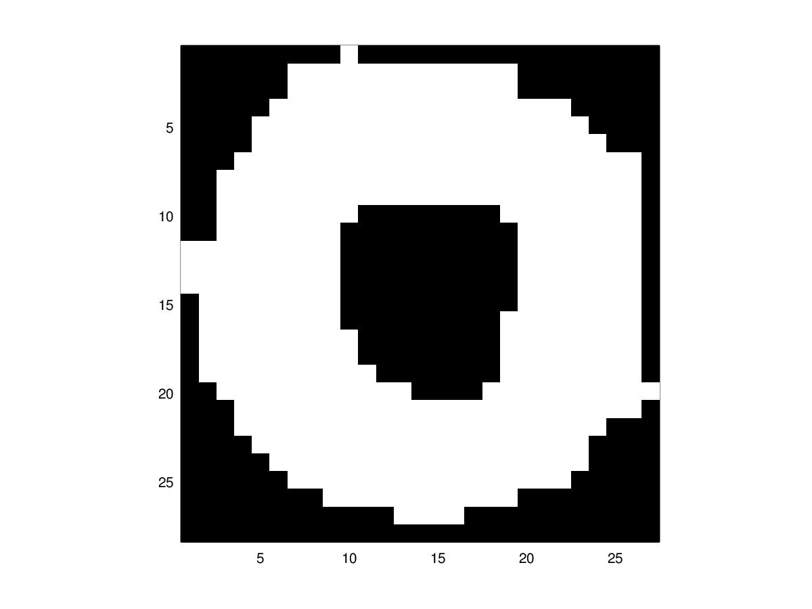
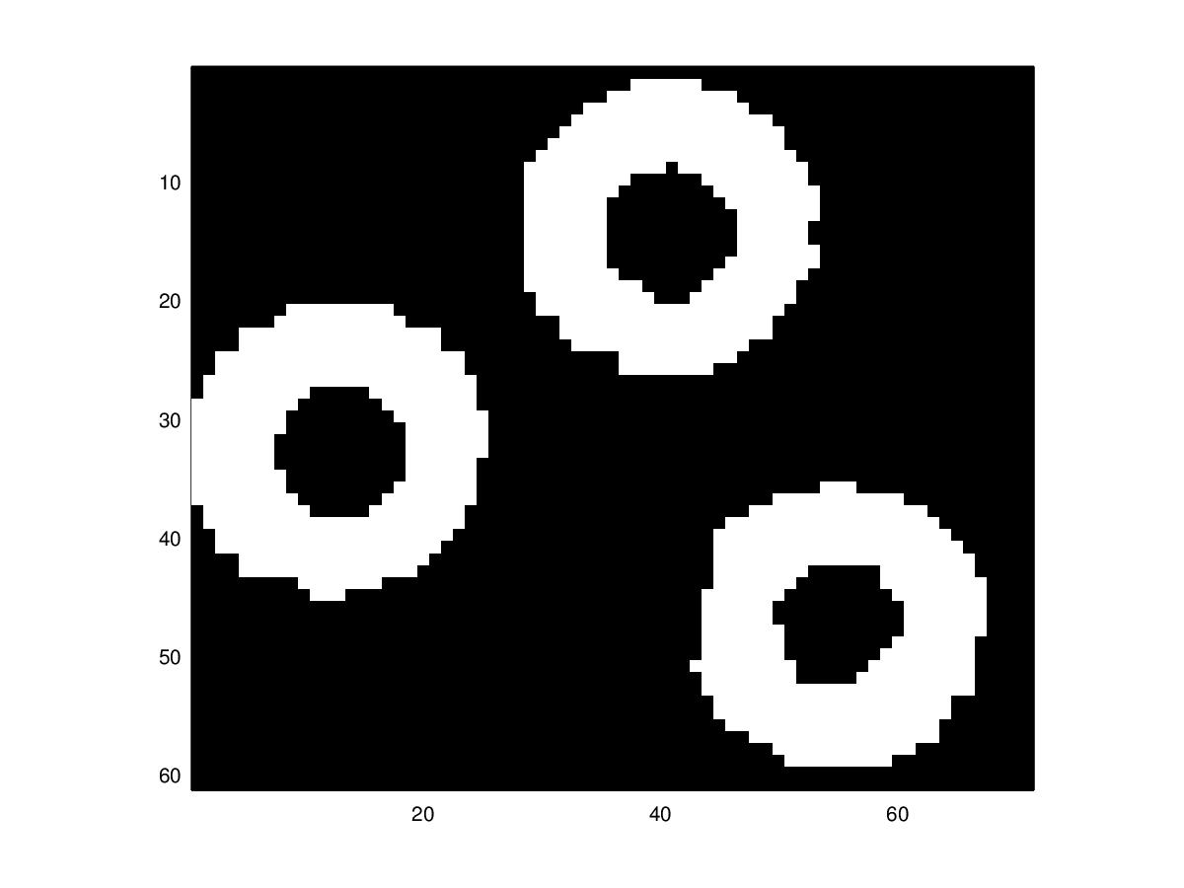

WASHER LARGE HOLE
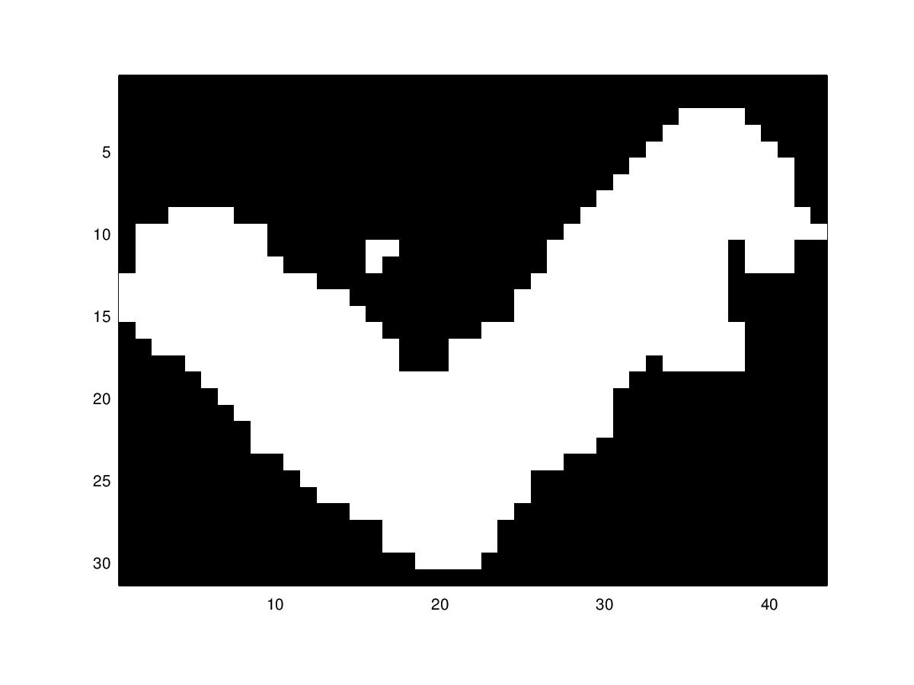
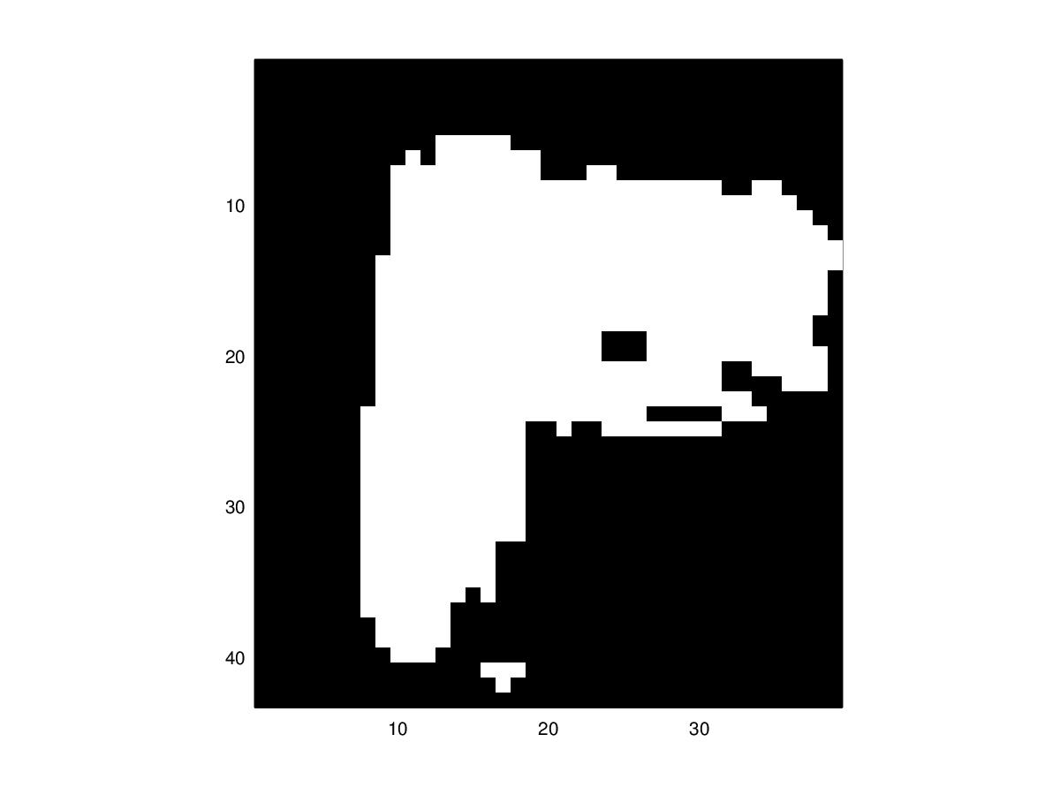

ANGLE BRACKET
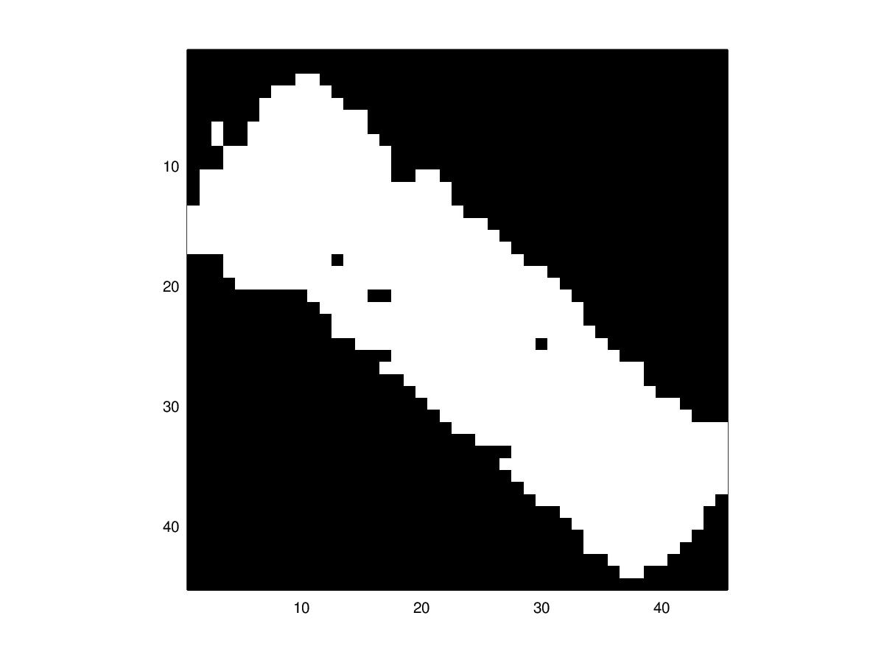
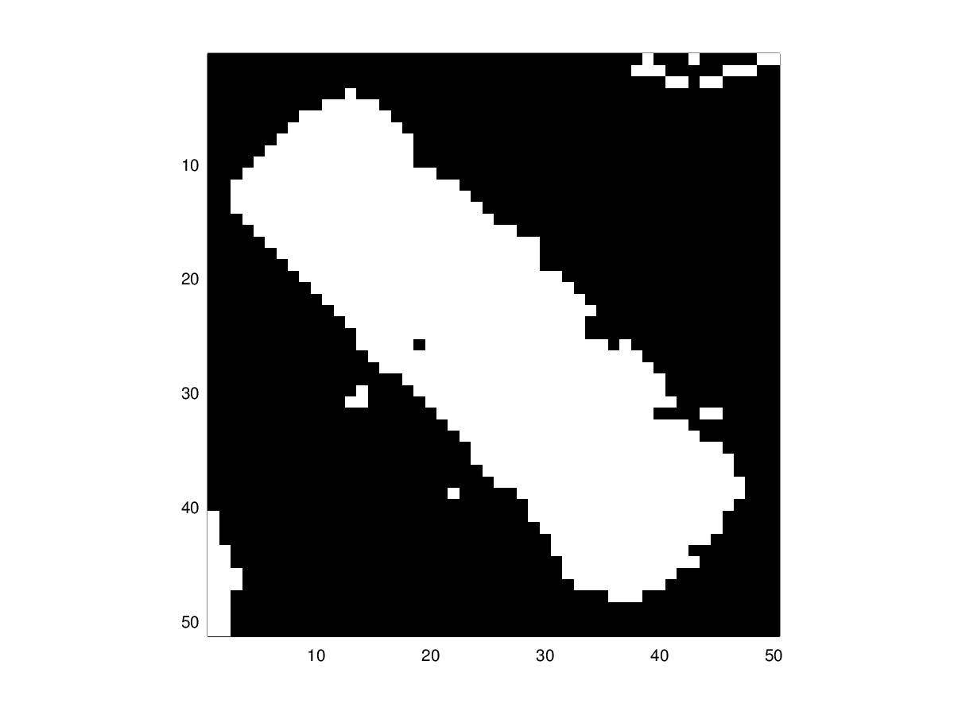

AAA BATTERY
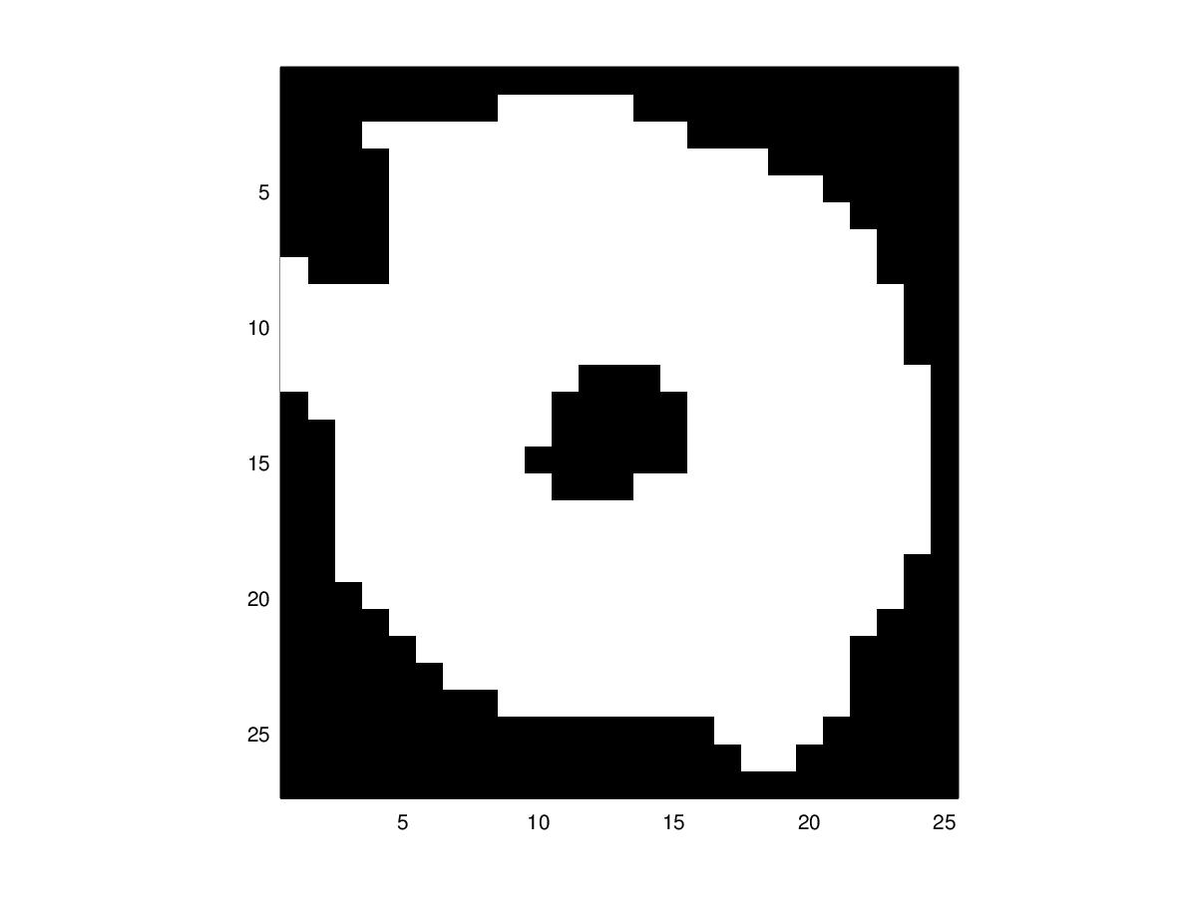
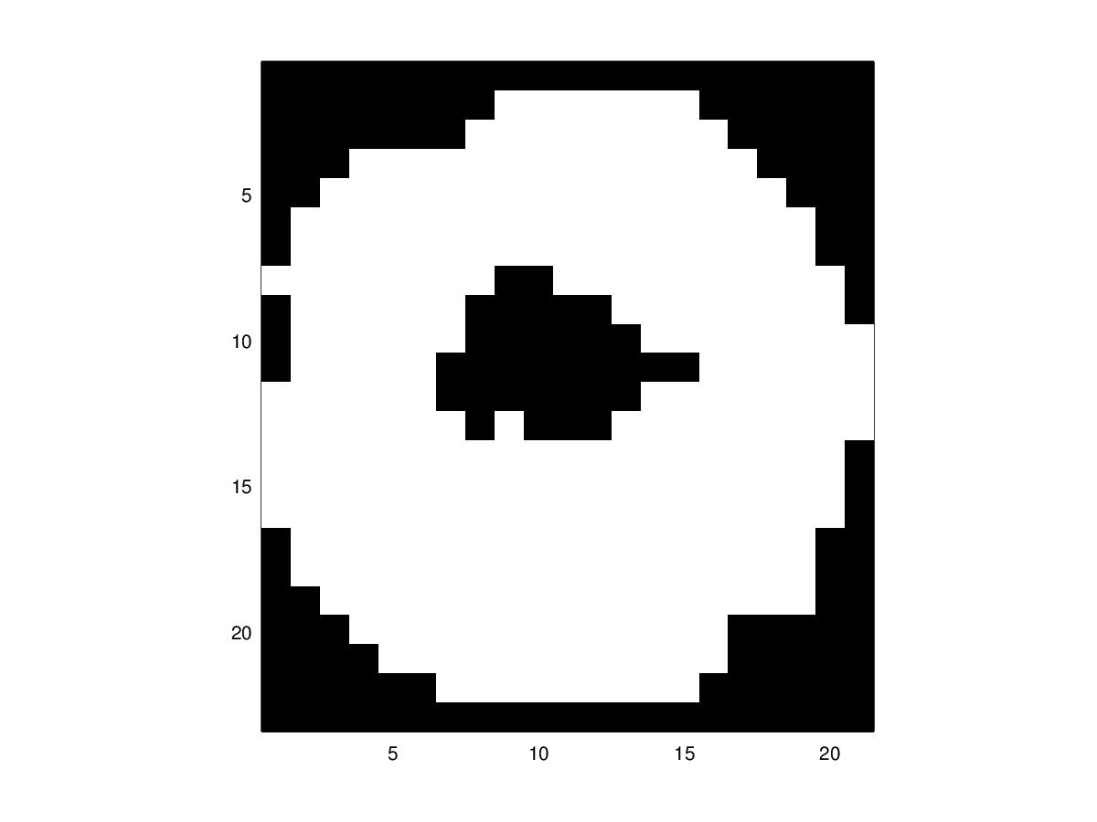

NUT

FEATURE SELECTION:

Feature Pre-processing:

Features cannot be selected from the objects without first converting them to a higher-resolution binary image. Using the binary image from the segmentation step would not provide a high enough level of detail, due to the nature of max-pooling and convolution filtering. The process of segmenting the image from the background and then converting to binary is almost the same as the process used to segment the objects from the main background, excluding the clustering portion of the process.

First the images are converted to normalised RGB values. Each RGB matrix has a threshold applied to it such that the object is segmented into approx. 10-15 different colour bins; the mode of these colour bins (the colour that is most frequent) is used as a final threshold to remove the background and convert the image to binary. Noise is removed from the image by doing a single max pooling of size 2. Additionally, this halves the size of the image and makes it easier to work with computationally. Now that the segmented object image has been converted to a simpler binary format, the next process is to extract features.
R CHANNEL G CHANNEL B CHANNEL
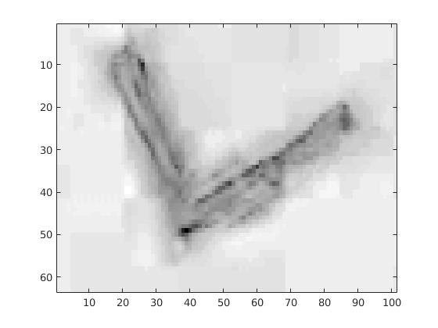
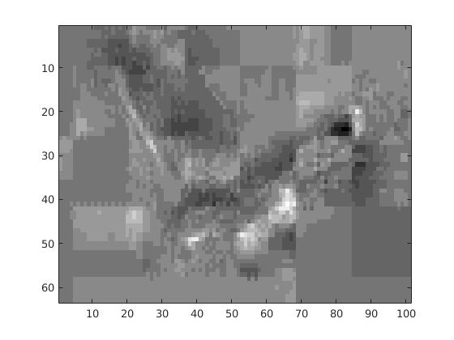
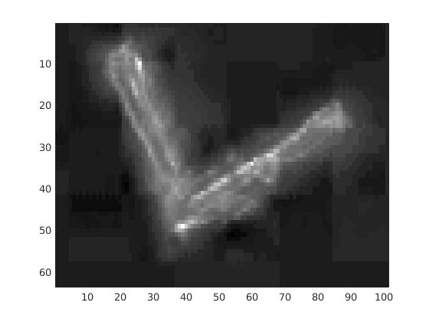
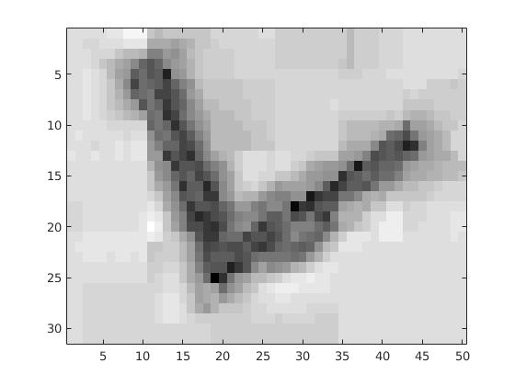
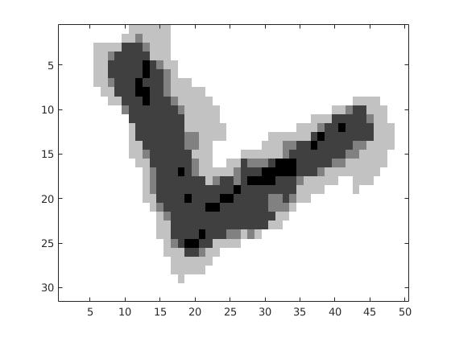
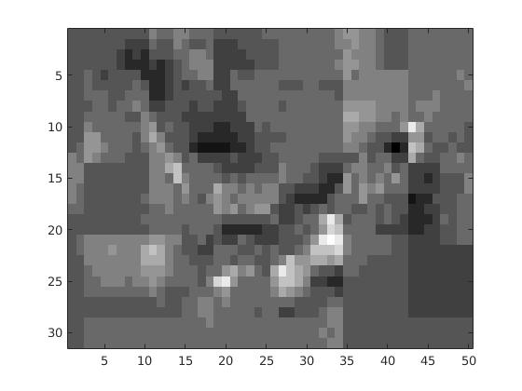
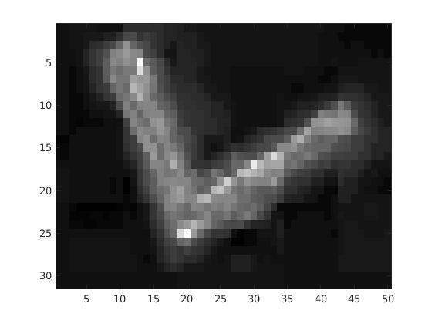
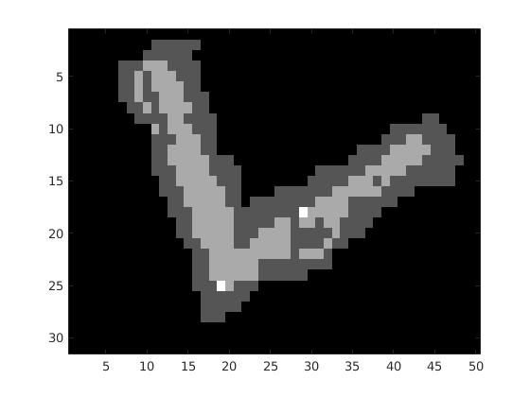
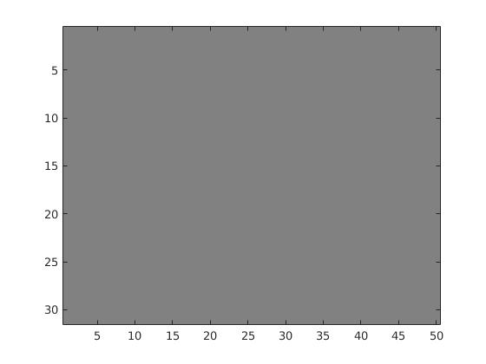

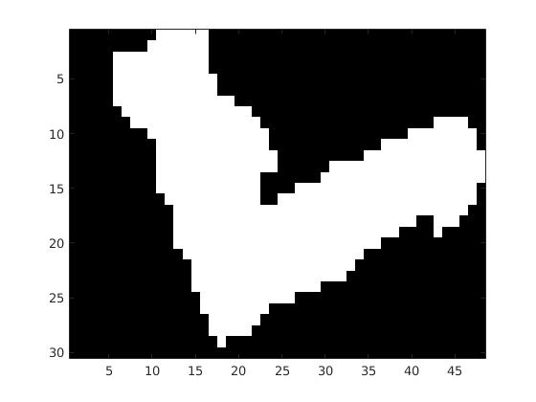
Convert R, G, and B channels to binary and then merge with OR.

Displace the binary image over the original segmented image to obtain the removed image.
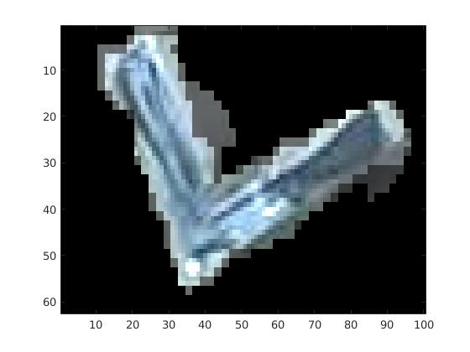

Choosing Features:

Before arbitrarily choosing a random set of features to train a classifier on, it was first important to analyse the aspects of the different objects and determine what the minimum number of features required to classify the objects could be (without using moments in this case, because this does not allow us to understand the model and the features it is being supplied – at least with our level of understanding). Here is a layout of the objects' analysis:

 | Features
 | Class | has_hole | size_hole | is_circle | size_circle | colour
 | One Pound |  |  | x | med | gold
 | Two Pound |  |  | x | large | gold/silver
 | 50p |  |  | x | large | silver
 | 20p |  |  | x | med | silver
 | 5p |  |  | x | small | silver
 | Washer Small Hole | x | small | x | medium | silver
 | Washer Large Hole | x | medium | x | medium | silver
 | Angle Bracket |  |  |  |  | silver
 | AAA Battery |  |  |  |  | black
 | Nut | x | small | x | small | silver

If each bold feature above was perfectly identified (focusing on the three bold features, the other two features are just binary values which could be replaced by setting their corresponding 'size' feature to 0), the classification between the objects would be simple, as each object would contain its own unique vector of values. The problem is, accurately measuring these features 100% of the time is almost impossible, and relies heavily on the object being segmented and the bounding box being accurate.

(IMAGE OF PERFECT SEGMENTED IMAGE W/ BOUNDING BOX)

Under the assumption that the object (in the ideal case), would be centred with a minimum-bounding box around it, the following algorithms were devised for the features:

circle comparison = % of all white pixels that are within a maximum circle drawn on the image

(IMAGE)

hole-iness = (# black pixels in a half-radius max. circle) / (# white pixels in a half-radius max. circle)

(IMAGE)

colour hash = red + (green + 1.0)^2 + (blue + 2.0) ^ 3 [NOTE: assume rgb values are doubles from 0 to 1]

(IMAGE)

Classifying Objects:

- one pound: (0, 222, 255)
- two pound: (218, 2, 251)
- 50p: (0, 255, 151)
- 20p: (255, 246, 0)
- 5p: (255, 138, 0)
- washer small hole: (30, 0, 254)
- washer large hole: (254, 0, 0)
- angle bracket: (0, 255, 49)
- AAA battery: (132, 1, 255)
- nut: (180, 255, 0)

Feature Analysis:
Mean Feature Evaluation (rounded to 2 digits)
Class No. | Class | Circle Comparison | Hole Value | Hashed Colour
1 | One Pound | 0.60 | 0.51 | 15.
2 | Two Pound | 0.83 | 0.23 | 16.
3 | 50p | 0.95 | 0.0055 | 16.
4 | 20p | 0.80 | 0.42 | 20.
5 | 5p | 0.96 | 0.011 | 20.
6 | Washer Small Hole | 0.91 | 0.13 | 22.
7 | Washer Large Hole | 0.86 | 0.59 | 20.
8 | Angle Bracket | 0.67 | 0.27 | 19.
9 | AAA Battery | 0.76 | 0.30 | 11.
10 | Nut | 0.89 | 0.33 | 17.

First Attempt Confusion Matrix: (without using logs)

 | Actual
 |  | 1 | 2 | 3 | 4 | 5 | 6 | 7 | 8 | 9 | 10
P  r  e  d  i  c  t  e  d | 1 | 0 | 0 | 0 | 0 | 0 | 0 | 0 | 0 | 0 | 0
P  r  e  d  i  c  t  e  d | 2 | 0 | 0 | 0 | 0 | 0 | 0 | 0 | 0 | 0 | 0
P  r  e  d  i  c  t  e  d | 3 | 0 | 0 | 0 | 0 | 0 | 0 | 0 | 0 | 0 | 0
P  r  e  d  i  c  t  e  d | 4 | 3 | 2 | 1 | 3 | 2 | 2 | 1 | 3 | 3 | 3
P  r  e  d  i  c  t  e  d | 5 | 0 | 0 | 0 | 0 | 0 | 0 | 0 | 0 | 0 | 0
P  r  e  d  i  c  t  e  d | 6 | 0 | 0 | 0 | 0 | 0 | 2 | 2 | 0 | 0 | 0
P  r  e  d  i  c  t  e  d | 7 | 0 | 0 | 0 | 0 | 0 | 0 | 0 | 0 | 0 | 0
P  r  e  d  i  c  t  e  d | 8 | 0 | 0 | 0 | 0 | 0 | 0 | 0 | 0 | 0 | 0
P  r  e  d  i  c  t  e  d | 9 | 0 | 0 | 0 | 0 | 0 | 0 | 0 | 0 | 0 | 0
P  r  e  d  i  c  t  e  d | 10 | 0 | 0 | 0 | 0 | 0 | 0 | 0 | 0 | 0 | 0

Second Attempt Confusion Matrix: (using logs)

 | Actual
P  r  e  d  i  c  t  e  d |  | 1 | 2 | 3 | 4 | 5 | 6 | 7 | 8 | 9 | 10
P  r  e  d  i  c  t  e  d | 1 | 2 | 1 | 1 | 0 | 0 | 0 | 1 | 1 | 0 | 0
P  r  e  d  i  c  t  e  d | 2 | 0 | 0 | 0 | 1 | 0 | 0 | 0 | 0 | 0 | 0
P  r  e  d  i  c  t  e  d | 3 | 0 | 0 | 0 | 0 | 0 | 0 | 0 | 0 | 0 | 0
P  r  e  d  i  c  t  e  d | 4 | 0 | 0 | 0 | 0 | 0 | 0 | 0 | 0 | 0 | 0
P  r  e  d  i  c  t  e  d | 5 | 0 | 0 | 0 | 0 | 2 | 0 | 0 | 0 | 0 | 0
P  r  e  d  i  c  t  e  d | 6 | 0 | 1 | 0 | 0 | 0 | 2 | 0 | 0 | 0 | 0
P  r  e  d  i  c  t  e  d | 7 | 0 | 0 | 0 | 1 | 0 | 1 | 2 | 0 | 0 | 1
P  r  e  d  i  c  t  e  d | 8 | 1 | 0 | 0 | 1 | 0 | 0 | 0 | 2 | 0 | 1
P  r  e  d  i  c  t  e  d | 9 | 0 | 0 | 0 | 0 | 0 | 0 | 0 | 0 | 3 | 0
P  r  e  d  i  c  t  e  d | 10 | 0 | 0 | 0 | 0 | 0 | 0 | 0 | 0 | 0 | 1

